News from the Parishes

Church of the Ascension, Annahilt Magherahamlet Parish Church

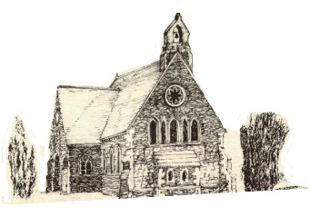

September 2026



Rector: The Revd Canon Robert Howard
15 Ballykeel Road, Hillsborough
BT26 6NW
Tel: 028 9263 8218
E-mail: jrobert.howard@btinternet.com
Website: www.annahiltandmagherahamlet.org

The Rector writes….
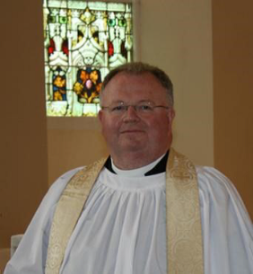

My dear Parishioners

SEPTEMBER
Whilst researching facts about September I came across this beautiful line of poetry by Raquel Franco describing the autumn season:
‘And the sun took a step back, the leaves lulled themselves to sleep and Autumn was awaked.’
So often we think of autumn as the season when foliage starts to die down but I loved the idea of leaves simply going to sleep -such gentle imagery. September is a time when we start to think about the year winding down, the trees changing their leaf colour so beautifully before preparing for their winter rest and looking to the gathering in of the harvest. I discovered a few local harvesting traditions elsewhere in the United Kingdom which I found fascinating:
Traditionally on September 24th farmers would gather the final sheaf of their harvest to create a straw mare. This mare would then be sent to a neighbouring farm with shout of “Mare! Mare!”-a playful reminder to complete the harvest promptly. The last farmer to finish would display the mare until the following year, signifying that they were the slowest. This custom, known as “Crying the Mare”, was prevalent in parts of Devon and Cornwall.
Another ritual, again prevalent in Devon and Cornwall, was “Crying the Neck”, where the last sheaf of corn was held aloft and honoured with chants and celebrations. This practice symbolises gratitude for a successful harvest and the hope of future abundance, reflecting the deep connection between communities and the land they tend.
I wonder if you’ve ever seen, or been part of, such traditions. The latter reminds me of the need to be grateful. As we, like nature around us, start to wind down towards the end of the year, let us pause and think about the delights we have experienced during the past few months. No doubt there will have been moments of sorrow and sadness but let’s take the opportunity to be positive and look for the good and give thanks. Gratitude is good for our mental health – apparently being grateful releases chemicals in the brain, lessening stress and boosting heart health!
So let me finish with a few words of gratitude from Psalm 67:
‘May the peoples praise you, God; may all the peoples praise you! The earth has yielded its harvest; God, our God blesses

With love, prayers and blessings
Your sincere friend and Rector
Robert Howard

Recent Bequest to Annahilt Parish
The Parish of Annahilt recently was bequeathed a very generous legacy by a parishioner, Terence Hasley, who died earlier this year.
Terence left a bequest of £10,000, to be disposed of at the absolute discretion of the Select Vestry.
We are deeply grateful that Terence thought about our Parish in this way which will be of significant benefit to us.

Congratulations……….

…… to Victoria Robinette who married Mr Daniel Jenkins, Manchester, on Thursday 23rd July at The Tithe Barn, Bolton Abbey, Skipton. Victoria and Daniel have set up home in Manchester.

……. To Dr David Keith on his recent 90th birthday

The Rector making a presentation to Dr David Keith on behalf of the Parish to mark his 90th birthday.

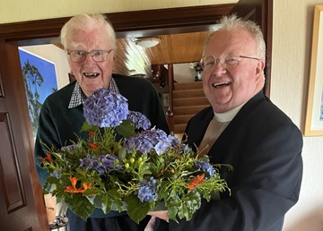

…. to all who were successful in recent school examinations. We hope that all students will continue to give of their best whatever the circumstances. We would be pleased to hear news of the achievements of all of our parishioners.


PRAYER WARRIOR
Do you have a concern or problem and would like someone to pray for you?
If so, contact the Rector who will be willing to help.
This is completely confidential and no details will be passed on to anyone else unless you want them to.
028 9263 8218

Decoration of Annahilt Church for Harvest
Saturday 26 September
From 9.30am
Your assistance with the decoration will be greatly valued
Gifts of flowers, greenery, corn, fruit, vegetables and other foodstuffs will be very gratefully received at the Church on the day before (Friday) from 4.00 – 6.00pm

Church Services in the Parishes of Annahilt and Magherahamlet

‘I was glad when they said to me: “Let us go to the house of the Lord”’

Sunday 6 September Trinity XV
10.00 Parish Communion Annahilt
12.00 Parish Communion Magheraghamlet

Sunday 13 September Trinity XVI
10.00 Family Service Annahilt Service Sheets
12.00 Family Service Magherahamlet Service Sheets

Sunday 20 September Trinity XVII
10.00 Morning Prayer Annahilt
12.00 Morning Prayer Magherahamlet

Sunday 27 September Trinity XVIII
12.00 Morning Prayer Magherahamlet

Annahilt Harvest Festival

Sunday 27 September 2026

10.00 Harvest Parish Communion Service Sheets

Preacher: The Revd Canon Myrtle Morrison

Rector of Newcastle

7.00 Service of the Word Service Sheets

With the Lurgan Salvation Army Band

Preacher: The Revd Bobby Liddle

Former Minister of Legacurry Presbyterian Church

Supper afterwards in the Parochial Hall

Sunday 4 October Trinity XIX
10.00 Parish Communion Annahilt
12.00 Parish Communion Magherahamlet

Sunday 13 October Trinity XX
10.00 Family Service Annahilt Service Sheets
12.00 Family Service Magherahamlet Service Sheets

Annahilt Harvest Appeal
Included with this magazine is a Harvest Thank Offering Envelope. You are asked to think prayerfully about missionary work throughout the world and our obligation to support it. There is also our ongoing responsibility to the poor and destitute. Then please share what you have with the needy by making as worthwhile and generous a thank offering as you can. The Thank Offering envelope may be returned at either of the Harvest Services. By putting your name and/or number on it, tax relief may be claimed through Gift Aid if you pay tax. Mark your Envelope “Gift Aid”.
Those Parishioners who view the magazine online may send donations directly to Patricia Halliday (35, Cabra Road, Hillsborough, Co Down, BT26 6NB) either by post or put an envelope on the plate in church marked accordingly.
This year we make our Harvest offerings to: The Church Missionary Society, Crosslinks, Christian Aid, Mission to Seafarers, South American Missionary Society.

Annahilt Harvest Supper
Following the success of such events on previous occasions, with great pleasure it is announced that the Harvest Supper will take place this year in the Parochial Hall following the Evening Service on Sunday 27 September at 7.00 pm.
It is hoped that parishioners, visitors and friends will avail of this occasion for engaging in face-to-face fellowship and conversation.
Canon Myrtle Morrison will be making her first visit to Annahilt Parish as a visiting preacher The Revd Bobby Liddle, a well known figure in our Parish and a regular preacher in our Church especially on successive Christmas Eve Services will be making his first return to our pulpit since his retirement as Minister of Legacurry Presbyterian Church. It would be lovely to have a fully representative gathering of parishioners and friends at each Service to welcome them.
Also we are welcoming back at one of our Harvest Thanksgiving Services, instrumentalists from The Salvation Army in Lurgan who were so very well received in our Church last year. We look forward very much to welcoming them at our Evening Harvest Service.

Children’s Harvest Offerings
The younger members of the congregation are asked to bring a non-perishable item of food (eg a packet of biscuits or a tin of fruit) to the 10am service on Harvest Sunday. They will have the opportunity of making their own Harvest Offerings during the service.
Magherahamlet Harvest Thanksgiving
Sunday 25 October 2026


On 7 May 2026 the General Synod agreed to implement a new Child Safeguarding policy to replace Safeguarding Trust, with immediate effect.
The Child Safeguarding Policy is available on the Church of Ireland website https://safeguarding.ireland.anglican.org/child-safeguarding/. This website contains the policy and all associated guidance. A link can be found on our Parish website.
One of the major changes in this policy is the reporting procedures. All suspicions, concerns, knowledge or allegations no longer go to the Parish Panel but are instead referred to the RCB Casework Team, who will then make the referral if the information meets the threshold for reporting, before passing this information to the Diocese, by informing the Bishop and Diocesan Safeguarding Panel. For Northern Ireland the Casework Team will be Gillian Taylor and Anthony Russell, who can be contacted between 9.30am and 5pm Monday to Friday on 02897441245 or by email on safeguarding@rcbcoi.org .
Emergency and Out of Hours - If you are concerned about immediate risk to any child or adult, contact the PSNI on 999. If you require Social Services advice and support out of hours in regards to a potential safeguarding concern for any child or adult, contact 028 9504 9999.
Updated online training on the Child Safeguarding policy for staff, volunteers and Parish Panel members is being made available within the Diocese.
The Diocese has arranged for online training on the following dates:
Thursday 17 September 7.30pm
Wednesday 30 September 7.30pm
Monday 26 October 7.30pm
Access to the online Child Safeguarding Training is through the link below to the diocesan website:
Safeguarding Training | Down and Dromore

It is essential that staff, volunteers and Parish Panel members avail of this training as soon as possible.

Prayers for the world

Loving God, Lord of heaven and earth, this earth, our home, belongs to you. Give us grace to love it as you do. Give us courage to give ourselves, as you do, for the good of all people and all of your creation. Strengthen us to stand, as you do, with the vulnerable poor. Give us wisdom to know when we have enough, and the voice to say “enough” to all that harms creation and hurts the poorest.
This earth, our home, belongs to you.
Amen.

Dear Lord, you hold our world in your hands. You hear your creation groaning but you have promised to liberate it from its pain. We pray: renew our world. Forgive those of us who haven’t used their power wisely. Give us and our leaders the courage to think beyond our own economies; to seek genuine partnerships so that all people can experience the fullness of life, and that our planet is known to be the common home for all creation and future generations.
Amen.

Lord, we pray for our leaders whose decisions and policies have the potential to impact the lives of millions of people around the world - people who they may never meet, know, or be aware of, but who are your sons and daughters. God, we pray that your spirit will fill our leaders’ hearts and heads that they might hear the voices of the impoverished, the oppressed and the vulnerable. God help them see the impact of their actions, and the potential to release healing and hope through just policies.
Amen.

For His Majesty, The King following the Anniversary of his Accession, 8 September
Lord God, the Ancient of Days,
you are sovereign over all your people;
Give to His Majesty, King Charles
enduring wisdom and faith
in the service of the people of this land
and of you, his Lord and master.
Grant that his reign may be one of faithful witness
And prove to others a source of hope,
that they may come to know more fully
your Son Jesus Christ,
who is alive and reigns with you and the Holy Spirit,
one God, now and forever.
Amen.
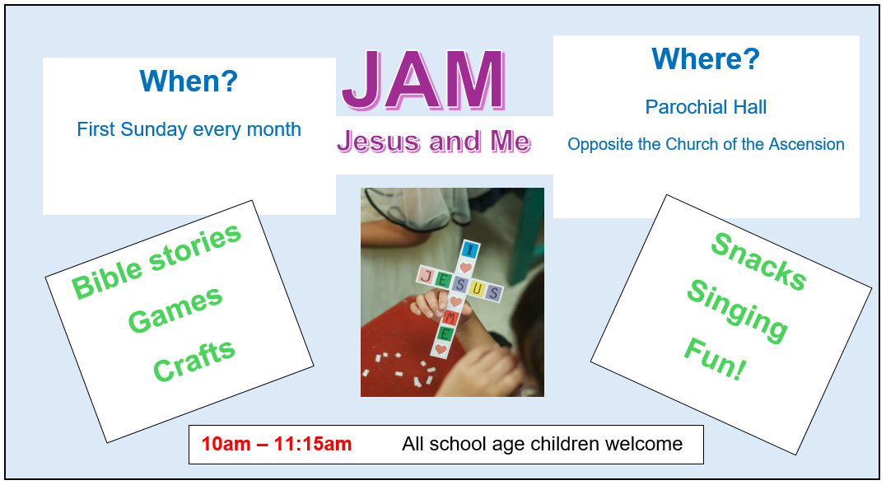

Beginning on Sunday 4 October Children’s Activity on a Sunday in Annahilt JAM (Jesus And Me) will resume following the Summer Break.

JAM (Jesus and Me) normally meets on the FIRST Sunday of each month beginning at 10.00 am and finishing at 11.15 am. On this Sunday parents and guardians are invited to bring children of school age directly to the Parochial Hall rather than to Church beforehand. The illustrated notice above lists some of the activities that will take place. We very much look forward to seeing our young people of school age at JAM on the first Sunday morning of each month. The First Sunday of the month has been specifically chosen in the hope that it is easy to remember!

On the second Sunday of each month young people are encouraged to come to the Family Service in Church at 10.00 am. On other Sundays in the month children are welcome at the usual Church Service at 10.00 am.

Magherahamlet

Sunday School will resume on Sunday 20 September at 11.00 am in the Parochial Hall.

We look forward very much to welcoming new attendees.


From the Parish Registers

Holy Baptism
‘Go therefore and make disciples of all nations, baptising them in the name of the Father and of the Son and of the Holy Spirit’
Magherahamlet Parish Church
5 July 2026
Zac Harry, son of James and Debbie McCurry
26 July 2026
Paige Jane, daughter of Ryan and Laura Sweeney

Christian Marriage
‘What God has joined together let no one put asunder

23 July 2026

Victoria Robinette, Annahilt, married Mr Daniel Jenkins, Manchester, at The Tithe Barn, Bolton Abbey, Skipton.

Christian Burials
‘In Christ shall all be made alive’

8 July 2026

Mary Elizabet (Beth) Harrison, Benson Street, Lisburn

Following Services at home and in the Church of the Ascension, Annahilt burial took place in adjoining Churchyard

Beth was born on 8 November 1940 to Joseph and Jayne McClurg and brought up on the Cargygray Road. She was the youngest of five siblings: Margaret, Willa, Joan, Bobby and Beth, all of whom were educated locally. Beth learned Book Keeping at Ballynahinch Tech. She then worked in Belfast and later at Wallace High School in Lisburn where she remained until she retired.

Beth was preceded in death by her dear husband, Isaac. The story is told of how he and two other friends were going to the Harvest Thanksgiving Service in Loughaghery Presbyterian Church when members of the Congregation invited them to come along. Knowing in their own minds who else was expected to be there, Isaac and his friend responded ‘Yes, we’ll go with you but WE’RE taking the girls home. And they did! It must have all gone well as Isaac kept coming, culminating in he and Beth being married on 1 June 1963 in Edengrove Presbyterian Church. They set up home in Benson Street, Lisburn where they would live their entire married life of 58 years.

The apostle Paul discusses how each of us experiences at least one type of birth, and for believers there are two births. There is a mortal body, a physical birth that each of us experiences, and with that birth, there is a life. Each of us is given the gift of life on earth to spend. It has been rightly said that life is like a coin. You can spend it any way you want, but you only get to spend it once. Beth spent her life, and we all have as a result a lifetime of memories and thoughts to fill your hearts and minds.

The Rector suggested that David and Elaine, Linda and James, Helen & Jonathan, Alison and David were a really fortunate family, for theirs was a loving mother. As they think back over the long years, each of them will remember varying and distinctive ways that their mother demonstrated the love and care she had for each of them and also for others who were close and amongst whom she loved a ‘Laugh’. These included her life-long friends from work, in the Church where she sang in the Choirs of both Annahilt and Magherahamlet, in the Bowling Club where she served as Secretary. She was synonymous with The Mothers’ Union where she served in different positions of leadership over very many years both as Branch Leader and Honorary Secretary. Beth was a person who demonstrated love not just in words, for words in a sense are meaningless unless there are actions to back them up.

Whether it was at picnics, where family members would sit on the grass and have lunch together, or the meals she and Isaac took time to prepare before having the entire family circle of 40 or so people at their home on a Sunday, or catering at the extended family gathering on Christmas Eve or on numerous occasions at functions in the Parochial Hall, Beth’s life represented a life that should be honored and cherished. For the most part, she was a very active person and made a big impression, wherever she decided to land at the time. More recently as she dealt with failing health, she remained always the optimist, believing that there would be another day, another opportunity, another visit.

Beth was a great joy, and I know that the life she shared with us all will be greatly missed. The opportunities to call in with her, or to talk on the phone with her, or to transport her wherever she wanted or needed to go have passed, but the memories do not have to. Family and friends can create a memory book of photos, of stories, of favourite recipes and other such stuff. When we are feeling down in times to come, and we will, we can pull it out and share a laugh, enjoy the memories, and pass on a great heritage of a wonderful mother with their children and grandchildren for years to come.

The Second Thing You Can celebrate Is Beth’s Witness.

For too many people, the sad reality is that the first birth is all that will be experienced. For those who are wise, who realize that the end of this mortal life is death and that death without Christ is to spend an eternity outside the heavenly places, there is a second birth, a spiritual birth. The apostle Paul said that this corruptible shall have put on incorruption, and this mortal shall have put on immortality.

Our loving and caring thoughts are with the entire family circle to whom we extend our deep and prayerful sympathy.



Flowers for the Churches

Annahilt Magherahamlet
September
6 In memory of Bert & Ruth Carlisle Miss V Begley
13 Beth Wilson Mrs F Magorrian
20
27 Harvest


Church Cleaning, Annahilt
Month

September
4-5 Mrs S Chapman Mr S Chapman
11-12 Mrs A Maxwell Mr R Maxwell
19-20 Mrs S Chapman Mr S Chapman
25-26 Mrs E Crawford

October
2-3 Mrs S Chapman Mr S Chapman
9-10 Mrs L McCambley Mrs E Harrison
16-17 Mrs S Chapman Mr S Chapman
23-24 Mrs H Hill Mr T Hill
30-31 Mrs S Chapman Mr S Chapman

November
6-7 Mrs J Guiney Mrs H Cardosi
13-14 Mrs S Chapman Mr S Chapman
20-21 Mrs E Finney Mr P Finney
27-28 Mrs S Chapman Mr S Chapman

The number on the rota of volunteers who clean the Church of the Ascension has significantly declined. It would now be unviable except that one couple has offered to clean the Church every 2nd week.
It really would be very helpful if there were additional volunteers who would ease the burden on those who already faithfully fulfil this important role. If you would be willing to help, please contact the Rector (Tel 028 9263 8218) or the Secretary to the Vestry, Colin Hassard (Tel 028 9263 8263)

Dear Members and Friends

We sincerely hope that you and your families have benefitted from the beautiful weather we have enjoyed over the past summer.
150 years of the founding of Mothers’ Union was celebrated on Sunday 9 August in Saint Patrick’s Cathedral Dublin. A coach travelled from Knockbreda with some twenty members from Down & Dromore and Connor dioceses, including representatives from our local branches.

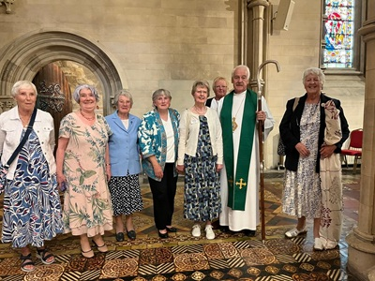

The service was introduced by Kay Clarke. It followed the Order of Holy Communion with the Archbishop of Dublin, the Most Revd Dr Michael Jackson presiding. The Address was given by Lady Eames, a former World President of the Mothers’Union, reflecting on ‘Mothers’ Union around The Corner and The World. The Music was led by a united Choir. At this event, The Revd Alistair Doyle was commissioned as All-Ireland Mothers’ Union Chaplain. All present spoke afterwards of having a very enjoyable afternoon together.
In late June Annahilt Branch members enjoyed a very enjoyable evening with parishioners and friends at Fernhill Cottage Gardens, Spa, Ballynahinch.

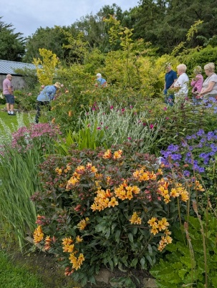
The weather was perfect and everyone present enjoyed the garden tour and beautiful surroundings where Thomas and Thomas shared their wealth of extensive plant and floral knowledge.

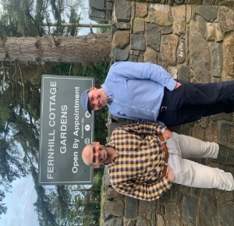

We also enjoyed the warm hospitality and friendship over supper.
Both Branches are looking forward to meeting again as the new Season begins.
Annahilt Mothers' Union are holding a fundraising event for Church which will be a "Pudding Party" on Monday 21st September. This Branch fundraiser has a suggested minimum donation of £10.00. Everyone is welcome to come along and sample the puddings and we look forward to seeing as many of you as possible there. Bring your friends and neighbours!
Magherahamlet Branch will next meet on Tuesday 21 September at 8.00 pm in the Parochial Hall. It is intended to plan a Programme for the coming year.
It is with deep sadness that Mothers' Union records the death of Mrs Beth Harrison, a longstanding Member and supporter of our branch.
Beth held many offices over the years, including Branch leader, secretary and committee member. She was tireless in her various roles and always full of enthusiasm for any ideas for meetings and events.
We will all miss her thoughtfulness and her caring nature for everyone.
We extend our sympathy to the entire Harrison family circle at this very sad time.

Edwina Avril
Elaine Sally
Jen Frances
Linda Avril B
Patricia Virginia
Susan

Mothers’ Union Midday Prayers - September 2026

Theme: Peace and Reconciliation

Reflection for the theme of peace and reconciliation (from the Prayer Diary 2026)
Each September Mothers’ Union celebrates its strong connection with the Community of the Cross of Nails (CCN) - a worldwide network of churches and peace-building organisations, inspired by the Coventry story of destruction, rebuilding, and renewal. The concepts of forgiveness, healing, development, shared understanding and of course peace lie at the heart of all the work we undertake in MU and are at the core of our Christian faith. As we pray especially this month for peace, reconciliation, hope and unity in our world and in our lives, let us reiterate the prayer central to CCN worship - “Father Forgive.”

Monday – Forgiveness
Then Peter came to Jesus and asked,
“Lord, how many times shall I forgive my brother or sister who sins against me? Up to seven times?” 22 Jesus answered, “I tell you, not seven times, but seventy-seven times”. (Matthew 18:21-22)
God of mercy, forgive us when we fail to love, and heal the wounds we cause.
Give us grace to forgive those who have hurt us, courage to seek reconciliation, and hearts shaped by your compassion.
Make us instruments of your peace and your reconciling love. Amen.

Tuesday – Reconciliation
All this is from God, who reconciled us to himself through Christ and gave us the ministry of reconciliation: that God was reconciling the world to himself in Christ, not counting people’s sins against them. And he has committed to us the message of reconciliation. (2 Corinthians 5:18-19)
God of peace, draw us together in your love. Where there is division, bring understanding; where there is hurt, bring healing; where there is conflict, bring reconciliation. Help us to build bridges of hope and become instruments of your peace. Amen.

Wednesday – Healing
Therefore, confess your sins to each other and pray for each other so that you may be healed. (James 5:16)
God of peace, bring healing where hearts are wounded and relationships are broken. Replace division with understanding and help us to be instruments of your peace and reconciliation. We ask this in Your name. Amen.

Thursday – Hope
May the God of hope fill you with all joy and peace as you trust in him, so that you may overflow with hope by the power of the Holy Spirit.
(Romans 15:13)
God of hope, fill us with joy and peace as we trust in you. By your Spirit, help us to abound in hope, trusting that your love can bring reconciliation where there is division. Through Jesus Christ our Lord.
Amen.

Friday – Unity
Make every effort to keep the unity of the Spirit through the bond of peace. (Ephesians 4:3)
God of unity, help us to keep the unity of the Spirit through the bond of peace.
Draw us together, bound in Your love, and make us instruments of your peace.
We ask this in Your name, our Lord and Redeemer. Amen.

Saturday – Peace in our hearts and our world
Peace I leave with you; my peace I give you. I do not give to you as the world gives. Do not let your hearts be troubled and do not be afraid.
(John 14:27)
God of Peace, plant your peace within our hearts and let it flow into our world.
Give us the peace that Christ promises, calming our fears and strengthening our hope. Where there is conflict, bring understanding; where there is division, bring unity. Help us to be instruments of your peace. Amen.

Final Blessing Prayer (monthly prayer from the Prayer Diary 2026)
God of mercy and love, we come before You seeking peace and reconciliation. Heal the wounds of division within our hearts, families, and communities. Teach us to forgive as You forgive, to speak with kindness, and to listen with compassion. May Your Spirit guide leaders toward justice and unity among nations. Calm our anxious thoughts and renew our spirits with Your peace that surpasses all understanding. Help us to become instruments of Your love, building bridges where walls have stood. May Your light shine through us, bringing healing, hope and harmony to a hurting world.
In Your name, we pray.
Amen.

Wave of Prayer

1-2 September: Harare in Zimbabwe; Machakos in Kenya; Ogori-Magongo & Ekiti in Nigeria; Southwark in England and Phulbani in India
3-5 September: Khartoum in Sudan; Dar es Salaam in Tanzania; Bari & Ilesa in Nigeria; Gloucester in England and Dugapur in India
7-9 September: Pacong in South Sudan; Southern Nyanza in Kenya;Kutigi & Ijesha North in Nigeria; Bristol in England and Karnataka Central in India
10-12 September: Pretoria in South Africa; North Mbale in Uganda; Oke-Osun in Nigeria; Exeter in England and Barbados
14-16 September: Mthatha in South Africa; Namirembe in Uganda; Pankshin & Sabongidda-Ora in Nigeria; Dublin & Glendalough in All Ireland and Central Solomons in Solomon Islands
17-19 September: Buye in Burundi; Sebei in Uganda; Abakaliki & Ekiti-Oke in Nigeria; Southwell & Nottingham in England and Belize
21-23 September: Rumbek in South Sudan; Soroti in Uganda; Aba Ngwa North & Oyo in Nigeria; Peterborough in England and North Eastern Caribbean & Aruba
24-26 September: Makamba in Burundi; North Karamoja in Uganda; Lokoja & Sapele in Nigeria; Truro in England and Tirunelveli in India
28-30 September: Katanga in DR Congo; Rwenzori in Uganda; Mbaise & Egba in Nigeria; Meath & Kildare in All Ireland and Tiruchirappalli Thanjavur in India



Annahilt Wednesday Club

Annahilt Wednesday Club will resume its activities on Wednesday 16th September at 11am.
The Club is aimed at Retirees and Seniors in the wider Annahilt area. We have had great support from the community over the last two years and wish to continue to build on that.
We have a varied programme arranged for the incoming season and are also pleased to report that increased funding has been made available from Lisburn and Castlereagh City Council towards the new season up until March 2027.
The Club runs each month from 11am - 12.30pm and all retirees and newly retired are welcome. We usually start with Coffee/tea & scones and a bit of chat around the tables, followed by a visiting speaker on a topic of interest or some other activity.

September 16th James Bingham, Police and Community Safety Partnership

October 21st Stephen Wood, Tools for Solidarity (Bring your old tools to donate)

November 18th Tom Saunders, The Somme

December 2nd Festive Lunch - Booking required

The early 2027 dates are as follows: January 20th, February 17th & March 10th. Details of 2027 activities will be available in due course.
Any queries contact Patricia on 07713 257691 or Violet on 07866 914651

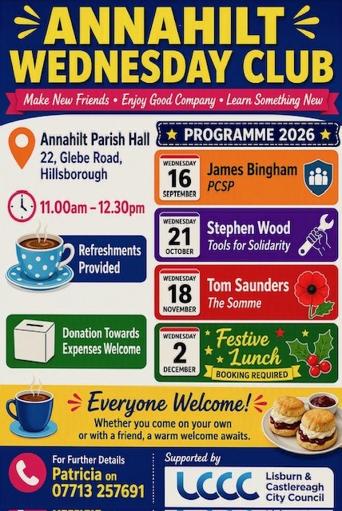


Annahilt Parish Bowling Club

It was with great sadness that members of the Bowling Club mourned the passing of our former Hon. Secretary, Mrs Beth Harrison during the summer break. Beth had been a stalwart of the club for many years and, while unable to participate as her health declined, she was still a member of the club and took a keen interest in our activities. The Club passed its sympathies to Beth’s family and was well represented at her funeral.

The Bowling Club season will resume on 16th September. We normally meet on a Wednesday evening, though “Away” League matches could be on any weekday evening. We also meet a couple of Saturdays per month and again these dates will be publicised in due course. New members welcome. Contact Patricia for further information.


Lunch Club
The next time we meet will be Friday 25 September in the Pheasant at the usual time of 12.30pm.
Subsequent Lunch Club meetings will take place on the following dates:
30 October
27 November
The Lunch Club is a very relaxed and enjoyable occasion, giving retired and semi-retired members an opportunity to connect with each other. If you would like the opportunity of enjoying a lunchtime meal in the company of established friends or perhaps some new ones, do come along. Please contact Violet Swarbrigg (Telephone 07866914651) for further information.



Financial matters

Gift Aid

Many more people are now once again paying Income Tax since the Personal Allowance has been frozen for a number of years.
If you are now paying Income Tax or Capital Gains Tax and have not already completed a Gift Aid Declaration in favour of Annahilt or Magherahamlet Parish Church you can do so by contacting Patricia or Abbie. This does not cost you anything but currently means that the respective Parish will benefit by being able to claim a tax refund equal to 25% of your giving.
At this time when many Parishes have financial challenges this additional income is highly valuable.

Harvest envelopes

Annahilt Harvest envelopes are included with this month's magazine for your contribution to the Mission organisations we support at this time of year. These can be returned up to the third week in October. If you view your magazine online, you can either pick up an envelope from the table at the church door, post a contribution to the Treasurer or contact the treasurer for Parish bank details and make a direct bank transfer.
Honorary Treasurers
Annahilt
Patricia Halliday, 35 Cabra Road, Hillsborough, BT26 6NB
028 92665310, mobile 07713 257691
email patriciaapc@btinternet.com
Magherahamlet
Abbie Stanford - mobile 07753746940
email abigailstanford@btinternet.com

LISBURN FOODBANK
The Lisburn Foodbank is providing an essential service to those within our community who are experiencing difficult times, often due to circumstances beyond their control.

The Foodbank provides emergency food and support to local people in crisis in the Lisburn area.
Parishioners may leave items for the Foodbank in the basket in Annahilt Church Porch, on the FIRST and SECOND Sunday of each month.
A particular request from the Foodbank is for the following items:
- Tinned fruit
- Bags for life
- Salt and pepper
- Super noodles
- Red and brown sauce
- Unisex / Male deodorant

YOUR HELP WOULD BE GREATLY APPRECIATED.

Recording of Annahilt Church Services
Free recordings (CD format) are available weekly of the Church services or requested special services.
These CDs are delivered free of charge. If you would like to receive a CD copy, please contact Shirley Robinette on 07974093382

Parish Website: AnnahiltAndMagherahamlet.org
Parishioners are reminded that the website annahiltandmagherahamlet.org has been created to provide information on church related activities and organisations for parishioners and the wider community. The website also continues to host online services each Sunday. In addition, the website contains a list of upcoming church services and news from our group of parishes, as well as downloadable versions of the parish magazine. The site will be continually developed, so if you have any submissions, suggestions or requests relating to the website, these can be sent to admin@annahiltandmagherahamlet.org.



www.annahiltandmagherahamlet.org

Parish Magazine
Any contributions for the next edition of the Parish Magazine should be left with the Rector or Roger Maxwell (roger.maxwell1@btinternet.com) by Sunday 28 September 2026.

Registered as a charity with The Charity Commission for Northern Ireland
NIC103246 (Annahilt) and NIC102122 (Magherahamlet)

