News from the Parishes

Church of the Ascension, Annahilt Magherahamlet Parish Church
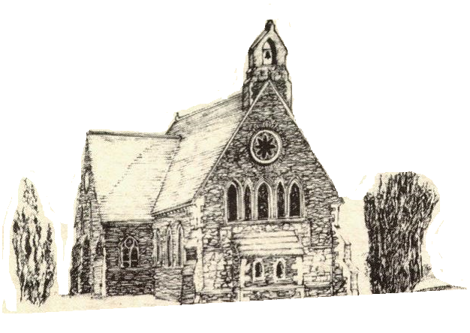

June, July and August 2023



Rector: The Revd Canon Robert Howard
15 Ballykeel Road, Hillsborough
BT26 6NW
Tel: 028 9263 8218
E-mail: jrobert.howard@btinternet.com
Website: www.annahiltandmagherahamlet.org

The Rector writes….

My dear Parishioners
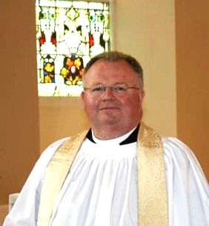

In my previous parish there was a long tradition of having photographs of previous Rectors hanging in the Church Vestry. Affectionately known as ‘The Rogue’s Gallery’, it represented the church’s ancestry list of past Incumbents.
Today’s Christians everywhere, lay and ordained, are spiritual descendants of those who in times past, often at great cost, witnessed to the faith. For example, in June we remember: Barnabas (11th), John the Baptist (24th), Peter and Paul (29th).
Barnabas was “a good man”. Thoughtful, compassionate, generous and caring, he was “full of the Holy Spirit and of faith”.
John the Baptist was a prophetic character with an uncompromising message: “be prepared for the Lord”. People turned to John, but he had the humility to point them away from himself towards the Lord.
Peter was the rock, the key, on whom Jesus relied. But, just like us, he often let his Lord down. Peter was also a reconciler: he held together the traditional views of the earliest leader of the new church in Jerusalem (James, Jesus’s brother) and the revolutionary missionary zeal of the apostle Paul.
Peter and Paul are often celebrated jointly. Paul was a tireless visitor, founding new churches, supporting fledgling ones, and engaging with people who had no allegiance to Christ.
Maybe June’s saints are a hint of the “spiritual DNA” we should hope and pray to find in ourselves who belong to these Parishes of Annahilt and Magherahamlet: people who know personally the power of God’s presence, and who have prayerful and pastoral hearts; and are committed to getting alongside the whole community amongst whom they live. Of course, like Peter and all of us, we will make mistakes; but will also be blessed by being welcoming and loving Christians at our respective Churches. Through Word and Sacrament, may we know Christ better and make Him better known. May we hold before us the vision of that ultimate spiritual mix - of being Christ-like in all that we are and do. We can’t alter our ancestors’ physical DNA; but we can, Rector and People together, change our spiritual genes for the better. As another June saint, Richard of Chichester (16th), prayed long ago to our Lord: “May we know Thee more clearly, love Thee more dearly, and follow Thee more nearly”. Let us strive to do that – day by day.
I take this opportunity to wish those who have been or are doing examinations well in their tasks. Some have been preparing for important examinations in schools and universities. Some are preparing to finish schools and move from primary to second level education and others are anticipating the transition from second to third level. We wish all our parishioners well in their educational endeavours.
The summer holiday period looms large. Whether ‘at home’ or away, I wish you all a refreshing, relaxing and enjoyable break from routine.
With love, prayers and blessings

Your sincere friend and Rector

Robert Howard

CELEBRATING THE CORONATION

The beginning of May saw the amazing spectacle of the Coronation of King Charles III, the first British monarch crowned in over 70 years. It marked the beginning of an additional bank holiday weekend which featured special events throughout the nation and Commonwealth.
The Service on Saturday 6 May was a wonderful mix of ancient tradition and modern additions. For many, one of the most moving moments was the greeting of the King into Westminster Abbey by a small choirboy and the reply of “I come to serve, not to be served.” What a perfect and simple phrase; one for us all to keep uppermost in our lives. We keep King Charles in our prayers as he develops his new role.
On the Eve of the Coronation (Friday), Magherahamlet held a Vintage Tea Party and Fun Evening in the Parochial Hall, with delicious sandwiches, savouries and amazing cakes and traybakes contributed by parishioners. Music was by Baillies Mills Accordion Band. The Coronation Cakes were cut by Mrs Lynne Green and Mrs Jean Cherry.
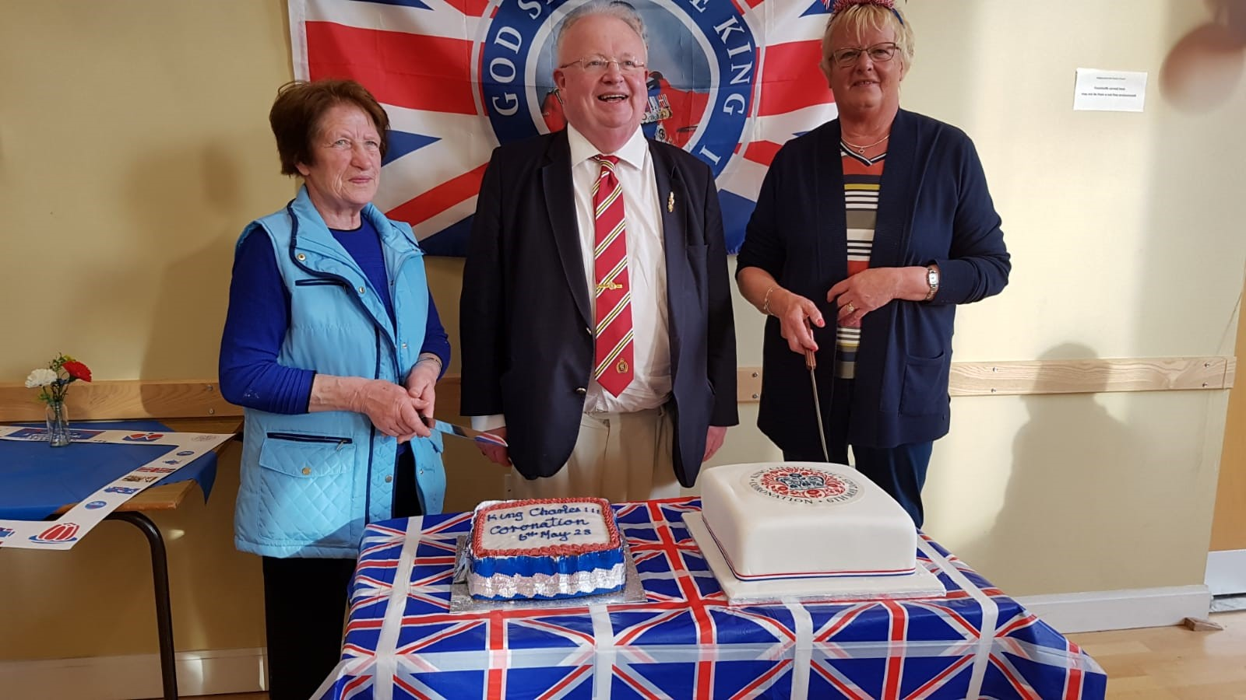
The hall was very well filled. It was an evening of lovely sunshine with children taking full advantage of the weather by playing games outside. Many adults and children dressed up for the occasion The event was not only great fun but also a wonderful way to celebrate a historic event. Thanks must go to so many people – but especially to all who provided food, all who ensured the grounds looked so splendid, all who helped with the preparation and decoration of the hall, and to the Band for their wonderful music entertainment.
On the day following (Sunday) the Church Service in Magherahamlet was a celebration of Holy Communion. It was most appropriate that our worship that morning was set in the context as the Sacrament of the Lord’s Supper which had featured in the Coronation Service the day before.
In the afternoon, there was a special Service of Celebration in the Church of the Ascension, Annahilt with the music led by Organist Tim Howe and Baillies Mills Accordion Band. The congregation included many visitors as well as regular worshippers from the Parish.
We were very honoured to have The Mayor, Councillor Scott Carson as well as our MP, the Rt Hon. Sir Jeffrey Donaldson both of whom read the Lessons from Holy Scripture.
At both Churches we were privileged to have as our Special Preacher, the Rt Revd the Lord Eames of Armagh who was present at the previous day’s Coronation Service representing holders of the Order of Merit.
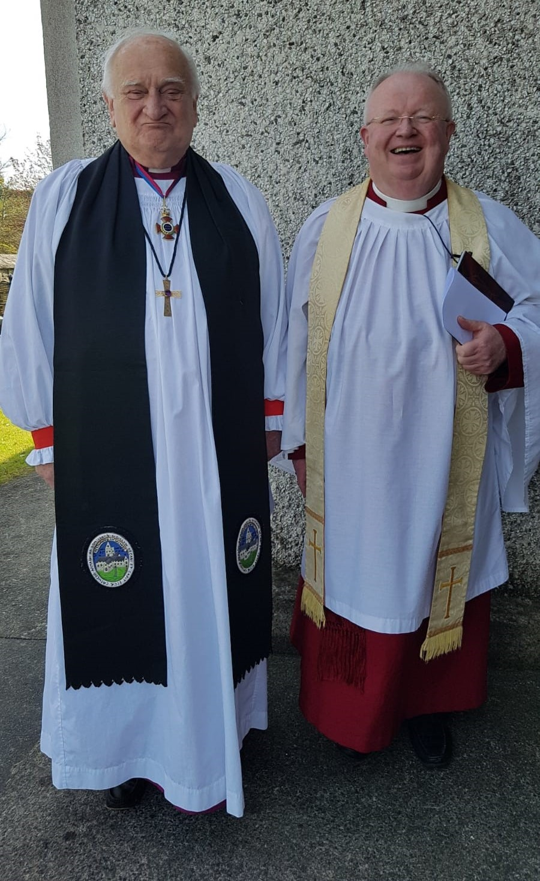
Following the Annahilt Service there was a Picnic at a marquee in the grounds of Larchfield, by kind permission of Gavin and Sarah Mackie and with the wholehearted co-operation and support of their daughters and of Gavin’s parents, Leslie & Anne Mackie. Although the weather forecast hadn’t been encouraging, it turned out a lovely afternoon with large numbers present who all enjoyed the beautiful Estate surroundings. Access to The Lake was specially made available to us with many taking the opportunity of walking down to see this lovely feature.
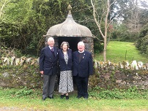
Following both Services each household was presented with a specially commissioned book of photographs and the text of the Gospel according to Saint Matthew called “Crowned King” to celebrate this unique occasion. At Larchfield people brought their own picnic but in addition were served delicious scones (with lovely jam and cream) and beautiful cupcakes generously donated by the Mackie Families.

Everyone was also given a suitably engraved souvenir pen. The children present took part in the activities provided, especially the making of crowns. The Band made their way from the Church to Larchfield and suitably entertained us.
The Rector expressed thanks to everyone who had contributed to such a memorable event. He said he had heard memories of sometime pupils at the time of the last Coronation in 1953 who walked from Anahilt Primary School to Larchfield for a Soorts Day. He was delighted that we in our day had the opportunity of making our own memories in the beautiful surroundings of Larchfield as we celebrated the Coronation of our new King.
There was much anticipation in advance of our various local celebrations of this very special event in the life of our Nation and Commonwealth, and we in Annahilt and Magherahamlet were not disappointed.

Prayers For the King
Lord God, in your power you provide for your people
and rule over them in love:
Grant to your servant Charles, our King
the spirit of wisdom and government,
that being devoted to you with his whole heart,
he may so wisely govern,
that during his reign your church may be protected,
and Christian devotion may continue in peace;
that so persevering in good works to the end,
he may by your mercy enter your everlasting kingdom;
through Jesus Christ, your Son, our Lord,
who lives and reigns with you in the unity of the Holy Spirit,
one God now and for ever. Amen.

Lord God, the Ancient of Days,
You are sovereign over all your people;
Give to His Majesty, King Charles enduring wisdom and faith
in the service of the people of this land
and of you, his Lord and Master.
Grant that his faithful witness
may be to others a source of hope,
that they may come to know more fully
your Son Jesus Christ,
who is alive and reigns with you
and the Holy Spirit,
one God, now and for ever. Amen.

Church Services in the Parishes of Annahilt and Magherahamlet

‘I was glad when they said to me: “Let us go to the house of the Lord”’

Sunday 4 June Trinity Sunday
10.00 Parish Communion Annahilt
12.00 Morning Prayer Magherahamlet

Sunday 11 June Saint Barnabas’ Day
10.00 Morning Prayer Annahilt
12.00 Morning Prayer and Holy Baptism Magherahamlet Service Sheets

Sunday 18 June Trinity III
Father’s Day
10.00 Parish Communion Annahilt
12.00 Parish Communion Magherahamlet

Sunday 25 June Trinity IV
10.00 Children’s Day Service & Prize Distribution Annahilt Service Sheets
Preacher: Mr Josh Thornbury, Diocesan Youth Officer
12.00 Children’s Day Service & Prize Distribution Magherahamlet Service Sheets
Preacher: Preacher: Mr Josh Thornbury, Diocesan Youth Officer

3.30 Evening Prayer Annahilt Service Sheets
with Legacurry LOL in attendance
Sunday 2 July Trinity V
10.00 Parish Communion Annahilt
12.00 Parish Communion Magherahamlet

Sunday 9 July Trinity VI
10.00 Morning Prayer Annahilt
12.00 Morning Prayer Magherahamlet

Sunday 16 July Trinity VII
10.00 Parish Communion Annahilt
12.00 Morning Prayer Magherahamlet

Sunday 23 July Trinity VIII
10.00 Morning Prayer Annahilt
12.00 Morning Prayer Magherahamlet

Sunday 30 July Trinity IX
10.00 Morning Prayer & Litany Annahilt
12.00 Morning Prayer & Litany Magherahamlet

Sunday 6 August Transfiguration of Christ
10.00 Parish Communion Annahilt
12.00 Parish Communion Magherahamlet

Sunday 13 August Trinity XI
10.00 Morning Prayer & Holy Baptism Annahilt Service Sheets
12.00 Morning Prayer Magherahamlet

Sunday 20 August Trinity XII
10.00 Parish Communion Annahilt
12.00 Morning Prayer Magherahamlet

Sunday 27 August Trinity XIV
10.00 Morning Prayer Annahilt
12.00 Morning Prayer Magherahamlet

Sunday 3 September Trinity XV
10.00 Parish Communion Annahilt
12.00 Parish Communion Magherahamlet

Sunday 10 September Trinity XVI
10.00 Family Service Annahilt Service Sheets
12.00 Family Service Magherahamlet Service Sheets

Father’s Day, 18 June

On 18 June we celebrate fathers on Father’s Day. Unlike Mothering Sunday, this doesn’t have a distinctly Christian origin. However, it does provide an opportunity the celebrate God’s fatherhood and what it means for us.
At His baptism, as Jesus came out of the water: ‘heaven was opened, and He saw the Spirit of God descending like a dove and alighting on Him. And a voice from heaven said, ‘This is my Son, whom I love; with Him I am well pleased.’ (Matthew 3:16,17).
What can we learn about Jesus’ relationship with His Father, the role of fathers and our relationship with God?

The Father’s presence
When Jesus was baptized, the Father made His presence real by the Holy Spirit. It’s the Spirit who enables us to call God ‘Daddy’ (Abba, Galatians 4:6). God is with us and knows our joys and sorrows, fears and trials. In this way, Dads can relate to their children.

The Father’s love
The Father described His Son as ‘beloved’, who like us, is subject to His unconditional love. Dads should be constant in assuring their children of their love.

The Father’s pleasure
The Father tells Jesus that He is ‘well pleased’ with Him. We also need to hear this, if we feel that we are disappointing God or letting Him down. Fathers should use every opportunity to demonstrate their pleasure in their children, especially when things go wrong.



A Prayer for Children

Loving God,
your Son told his disciples to become like little children.
Lead us to work for the welfare and protection of all young people.
May we respect their dignity that they may flourish in life,
following the example of the same Jesus Christ our Lord. Amen.

CHILDREN’S DAY & SUNDAY SCHOOL PRIZE-GIVING

The Church Loyalty and Sunday School prize-giving will take place at our 10.00 am Service in Annahilt and our 12.00 noon Service in Magherahamlet on Sunday 25 June. The Special Speaker will be Mr Josh Thornbury, Youth Officer of the Diocese of Down & Dromore. This is the first occasion Josh will be visiting our Group of Parishes and we assure him of a warm welcome. We would like to encourage all our children to make a special effort to attend that Sunday to receive their prize and join fully in the occasion. It is also an opportunity to thank all our teachers who have worked with dedication and commitment to pass on the Faith to the next generation. Parents, grandparents and other parishioners are also encouraged to come in support of our young people, their teachers and our visiting Speaker.

Looking ahead….

Sunday School…

…Sunday School in both Parishes will resume on Sunday 3 September 2023.. There will be further notification nearer the time.

Sunday 25 September

Annahilt Harvest Festival

Clergy Emergency Cover

During the period when the Rector is on holiday, please contact one of the following who will advise you of the Clergyperson answering emergency calls:
David Browne (Rector’s Churchwarden, Annahilt) 028 9263 9034
Stephen Chapman (People’s Churchwarden, Annahilt) 028 9263 8079
Colin Hassard (Honorary Secretary, Annahilt Vestry) 028 9263 8263
Mrs Avril McKeown (Graveyard Secretary, Annahilt) 07801 449244
Ms Abbie Stanford (Rector’s Churchwarden, Magherahamlet) 07753 746940
George McCurry (Rector’s Glebewarden, Magherahamlet) 028 9756 3955
Mrs Avril Burrows (People’s Churchwarden, Magherahamlet)

Flowers for the Churches

Annahilt Magherahamlet

June
4 Mr & Mrs RT Carlisle

11 Mrs S McCurry
18 Mrs L Crompton
25
July
2
9 Mrs B Oliver
16 Mrs B Oliver The Rector
23
30 Dr W & Mrs Chambers

August
6 Miss V Begley
13
20
27

Church Cleaning, Annahilt

June
2-3 Mrs L McCambley Mrs E Harrison

9-10 Mrs E Crawford
16-17 Mrs J Guiney Mrs H Cardosi
23-24 Mrs E Crawford
July
7-8 Mrs S Chapman Mr S Chapman
14-15 Mrs H Hill Mr T Hill
21-22 Mrs L McCambley Mrs E Harrison
28-29 Mrs A Maxwell Mr R Maxwell

Aug
4-5 Mrs J Bolas Mr A Bolas
11-12 Mrs J Guiney Mrs H Cardosi
18-19 Mrs E Crawford
26-27 Mrs S Chapman Mr S Chapman

Sept
1-2 Mrs J Guiney Mrs H Cardosi
8-9 Mrs H Hill Mr T Hill
16-17 Mrs L McCambley Mrs E Harrison
22-23 Mrs A Maxwell Mr R Maxwell

PRAYER WARRIOR
Do you have a concern or problem and would like someone to pray for you?
If so, contact the Rector who will be willing to help.
This is completely confidential and no details will be passed on to anyone else unless you want them to.
Telephone: 028 9263 8218


From the Parish Registers

Holy Baptism
‘Go therefore and make disciples of all nations baptising them in the name of the Father and of the Son and of the Holy Spirit’
Magherahamlet Parish Church
11 June 2023
Charlie James, son of James and Debbie McCurry

Christian Marriage ‘Those whom God has joined together let no one put asunder’
Magherahamlet Parish Church
8 June 2023
Michael Kelly and Sarah McCurry
We congratulate Michael and Sarah and wish them every happiness.

General Prayers

Loving God, in Christ Jesus, the servant of all, you call us to the service of others. Grant to the Members of Parliament and the members of the Legislative Assembly of Northern Ireland, the skill to recognise its urgent needs and the strength to pursue the common good. Endow us all with patience and courage, that we may care for the suffering, feed the hungry, shelter the homeless and sustain the needy, through Jesus Christ our Lord.
Amen.

Christ be with me, Christ within me,
Christ behind me, Christ before me,
Christ beside me, Christ to win me,
Christ to comfort me and restore me,
Christ beneath me, Christ above me,
Christ in quiet, Christ in danger, Christ in hearts of all that love me,
Christ in mouth of friend and stranger.
Amen.

Spirit of wisdom, Creator God, we give you thanks for all the ways you inspire your people, the ways you provide for them, and set great paths before them. We are grateful for the many small business owners who felt your creative call and pursued their dreams.
Gracious God, we know that you are the sustainer of our dreams, in prosperity and in hardship.
We pray for all those businesses who are suffering hardship because of the present cost of living crisis.
May the communities these businesses serve rally to support them. Provide for all the people being impacted by this economic crisis, O God, the people employed by these small businesses and the families that are supported by their income. Protect them in this time of economic uncertainty, and fill their spirits with hope.
Amen.

Dear Lord, You have commanded us to love our neighbours as ourselves. Help us to do that in our community and throughout our country. Help us understand the problems our fellow citizens are going through and find ways to help them in ways they need it most. Help us to love others no matter what their race, religion or other differences. Help us to receive their love as well. Help us to not allow grievances to block giving or receiving love.
Amen.

God, our rock, we pray for stability in this country that has been affected with disunity and discontent. Give us all wisdom to enable us to move forward successfully. Help us to strive to understand the others’ perspectives and to find common ground. Give us insight into what will best solve the complex problems we are facing. Help us to negotiate a new path that will be better and brighter than before. Amen.

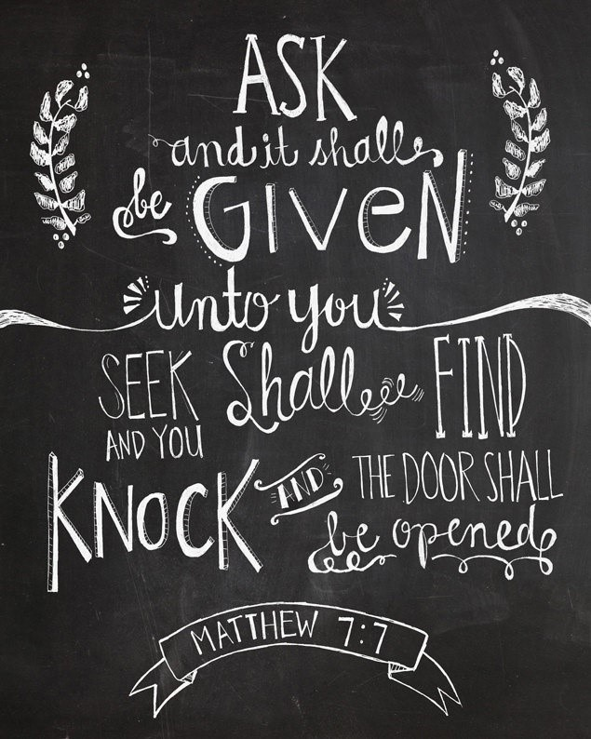



Hello everyone
The founder of The Mothers’ Union was, of course, Mary Sumner. In her husband’s Parish (Old Alresford, Hampshire) in 1876, she felt led to start a group to encourage young mothers by offering them support in their family life through Bible teaching, prayer and practical help. From these humble beginnings the organisation grew and is now a global organisation operating in 86 countries with over 4 million members. Below, you will find Mary Sumner’s personal prayer and the Mothers’ Union Prayer to help keep us mindful of how to keep close to our roots.

It’s hard to believe that apart from our outing we will next meet in October! Have a lovely summer and hopefully make some time for rest and recreation with family and friends.

With Kind Regards,

Beth Avril Esme Frances

REMINDER: Mulberry Tree Restaurant - Wednesday 28 June 2023 7.00 pm for Dinner. Any queries, please phone Beth 028 9267 8057

The MU Midday Prayers for June can be found below.

THE MARY SUMNER PRAYER

All this day, O Lord
Let me touch
As many lives as possible for thee;
And every life I touch,
Do thou by thy spirit quicken,
Whether through the word I speak, The prayer I breathe, Or the life I live.
Amen.

THE MOTHERS’ UNION PRAYER
Loving Lord,
We thank you for your love so freely given to us all.
We pray for families around the world. Bless the work of the Mothers' Union as we seek to share your love through the encouragement, strengthening and support of marriage and family life.
Empowered by your Spirit, may we be united in prayer and worship, and in love and service reach out as your hands across the world.
In Jesus' name.
Amen.

Mothers’ Union - Midday Prayers - June 2023 Serving Christ in every way

Monday: Serving wholeheartedly
Lead lives worthy of the Lord, fully pleasing to him, as you bear fruit in every good work and as you grow in the knowledge of God. Colossians 1:10
Thank you, Lord, that as we grow in faith so we grow in commitment to those you call us to serve.
May we serve with the love of Christ and bring comfort that comes from God. May we share burdens through the power of Christ and bring strength that comes from God. May we view others through the eyes of Christ and show compassion that comes from God. May we respond with the forbearance of Christ, and show grace that comes from God.
May our faith in Christ inspire us to lives of wholehearted service.
Amen.

Tuesday: Serving with love
My children, we should love people not only with words and talk, but by our actions and true caring. 1 John 3: 18 (NCV)
Lord, we hear your word; let us be doers of your will.
Thank you, Lord for showing us that love has no boundaries or end but listens, has patience, compassion, grace, and gives without counting cost. Thank you for granting us a heart for those you love, and a willingness to step out in faith and service. Thank you, Lord for showing us true love can be ours to know and give.
Loving Lord, help us to follow your ways to enable our work to flourish. May your living Word inspire us for lives of loving service.
Amen.

Wednesday: Worship through serving
Offer yourselves as a living sacrifice to God, dedicated to his service and pleasing to him. This is the true worship that you should offer. Romans 12:1
Loving Lord, we worship you. We offer up our lives as a sacrifice of praise.
May the works of our hands to serve others be reflected as hands raised in worship. May our words of support for the vulnerable echo in the heavens as songs of praise to our God.
May each step that we take to alleviate need be woven into dancing in the presence of our Lord.
May all that we do in the service of Christ be an offering of true worship.
May our worship of God be manifest through our lives of faithful service.
Amen.

Thursday: Serving with our hands
You obey the law of Christ when you offer each other a helping hand. Galatians 6:2 Lord, we hear your word; let us be doers of your will.
God, help me to cherish the last time I used my hands to touch someone with love, to hold someone with comfort, to reach out to someone with compassion to make something constructive to place power into another’s hands… So that I may always touch, hold, reach out, make and place; and let my hands lead me in a life of action where my words may follow. Amen
Rachel Halsall
Loving Lord, help us to follow your word enable our work to flourish. May the love of God inspire us to reach out our hands in service.
Amen.

Friday: Serving with our voice
To give an appropriate answer is a joy; how good is a word at the right time!
Proverbs 15:23
Loving Lord, use our voices in service to comfort the suffering, and proclaim the mercy of God.
Living Word, give us your compassion to speak words of comfort to the troubled.
Lord, give us your words of life.
Living Word, give us your insight to speak words of encouragement to the weary.
Lord, give us your words of life.
Living Word, give us your mercy to speak words of relief to the suffering.
Lord, give us your words of life. Loving Lord, help us to follow your word to enable our work to flourish. May the love of God inspire us to speak out in faithful service.
Amen.

Saturday: Serving Christ in every way
Now you are the body of Christ, and each one of you is a part of it. 1 Corinthians 12:27
Christ has no body now on earth but yours, no hands but yours, no feet but yours.
Yours are the eyes through which he must look with Christ’s compassion on the world.
Yours are the feet with which he is to go about doing good, yours are the hands with which he blesses now.
St Teresa of Avila
Loving Lord, thank you for your unfailing love and continued guidance as we follow in the footsteps of our Servant King.
Fill us with your grace equip us to serve that we may reach out to the world you love.
Amen.

Wave of Prayer for Mothers’ Union
Lord, we pray for Mothers’ Union worldwide.

1 Eastern Zambia in Zambia; Mombasa in Kenya; Gwagwalada & Ekiti-West in Nigeria; Leicester in England and Temotu in Solomon Islands

2 – 4 Renk in South Sudan; Cyangugu in Rwanda; Arochukwu/Ohafia & Ile-Oluji in Nigeria; St Andrews, Dunkeld & Dunblane in Scotland and Sittwe in Myanmar

5 Mothers’ Union worldwide

6 –8 Wad Medani in Sudan; Kondoa in Tanzania; Ikwo & Remo in Nigeria; Montreal in Canada and the Windward Islands in St Lucia, Grenada, St Vincent & The Grenadines

9 – 11 El Obeid in Sudan; Butere in Kenya; Nnewi in Nigeria; London in England and the Province of the USA

12 Mothers’ Union worldwide

13 – 15 Toliara in Madagascar; Mbale in Uganda; Zaria & Ndokwa in Nigeria, Rochester in England and Chhattisgarh in India

16 – 18 Lake Malawi in Malawi; Byumba in Rwanda; Jalingo in Nigeria; St Edmundsbury & Ipswich in England and Lucknow in India

19 Mothers’ Union worldwide

20 – 22 Gitega in Burundi; Murag’a South and Mbeere in Kenya; Enugu North in Nigeria; Tonga in Diocese of Polynesia and Jaffna in Diocese of Church of South India

23– 25 George in South Africa; Bungoma in Kenya; Western Tanganyika in Tanzania; Ideato in Nigeria; Sodor & Man in Isle of Man and Toronto in Canada

26 Mothers’ Union worldwide

27 - 29 Northern Zambia in Zambia; Mpwapwa in Tanzania; Gusau & Osun in Nigeria; Sydney in Australia and Rayalaseema in India

30 – 31 Boga in DR Congo; Manicaland in Zimbabwe; Tanga in Tanzania; Ogoni in Nigeria; Carlisle in England and Melbourne in Australia

Final Blessing

May the blessing of God strengthen and encourage us as we go from here
to live lives of gratitude and service.
Amen
Transformation – Now! July - Gratitude

Monday: Gratitude to God
Be thankful people. Sing to God with gratitude in your hearts.
Colossians 3:15, 16 (CEB)
Give thanks to the Lord, for he is good.
His love endures forever.
Give thanks to the God of gods.
His love endures forever.
Give thanks to the Lord of lords:
His love endures forever.
Give thanks to God who alone does great wonders,
His love endures forever.
Let the redeemed of the Lord share our story – we who unite in prayer across the world, from east and west, from north and south.
Let us give thanks to the Lord for his unfailing love and his wonderful deeds through all the earth. Give thanks to the Lord, for he is good.
His love endures forever. Amen
From Psalms 107; 136

Tuesday: Gratitude for the past
Jesus Christ is the same yesterday and today and forever.
Hebrews 13:8
God of history and eternity, as we celebrate your faithfulness, deepen our gratitude for the past and envision us for the future.
Loving Lord, we look back down the years and see the imprint of your faithfulness on all that has come to pass. We thank you for those who led the way in worship and service to your world. For those who faithfully served you in quiet and unseen ways.
Loving Lord, we look back down the years and remember your faithfulness to us with thankfulness and praise.
As we look back with gratitude, so we look forward with faith.
We place our trust in our loving God whose faithfulness spans all ages.
Amen

Wednesday: A heart of gratitude
I will give you a new heart, and I will put a new spirit in you.
Ezekiel 36:26 (NLT)
Lord, give me this day a heart of gratitude:
Give me a heart of gratitude which is so filled with thanksgiving that worry and concern have no room.
Give me a heart of gratitude which remembers you as the present Giver who is my refuge and my portion.
Give me a heart of gratitude which cries out thanksgiving and praise even in the midst of anguish, pain, and frustration.
Give me a heart of gratitude which is capable of love, hope, and peace despite the tensions, hurts, and foolishness of this world.
Give me a heart of gratitude which is ever and always yours. Amen
James Spencer (adapted)

Thursday: Gratitude for Christ
Just as you received Christ Jesus as Lord, continue to live your lives in him, rooted and built up in him, strengthened in the faith as you were taught, and overflowing with thankfulness.
Colossians 2:6-7
We give thanks for the sacrificial love of Christ with deeply grateful hearts.
Dear Heavenly Father, thank you for the joy, peace, help and blessings that you give to us each day.
Thank you for this wondrous world filled with all the wonderful gifts you have given to us.
Thank you for our families, friends and the fellowship of your Church.
And we thank you for the most wondrous gift of all – the forgiveness of our sins,
bought for us by the love of your most blessed Son, our Saviour Jesus Christ. Amen
Kilskeery & Trillick Mothers’ Union, Province of All-Ireland

Friday: Gratitude for each other
I never stop thanking God for you. I always remember you in my prayers.
Ephesians 1:16 (GW)
Heavenly Father, we celebrate and give thanks for the people who are part of our lives.
Help us to appreciate each other’s unique qualities. Help us to treasure each other’s special gifts.
May we be slow to judge and quick to forgive; ready to treat others as we wish for ourselves.
Let us seek each other’s good by encouragement and support that our relationships may flourish and reflect your perfect love.
Heavenly Father, we celebrate and give thanks for the people who are part of our lives. Fill us with your love for one another that our relationships may flourish and grow. Amen

Saturday: Gratitude for life
Jesus said: I have come that they may have life, and have it to the full.
John 10:10
How lavish is our God! We celebrate the gift of life with grateful hearts.
What wonders we find in the gift of life.
Our joy in the beauty of nature;
our delight in loving relationships;
our pleasure in a job well done or a new skill mastered.
Each facet of life adds richness to our days.
A foretaste of the glory that awaits when we step into the realm of eternity and our cup overflows.
Generous God, we thank you for the imprint of heaven which enhances our gift of the here and now.

How lavish is our God! We celebrate the gift of life with grateful hearts.
Amen

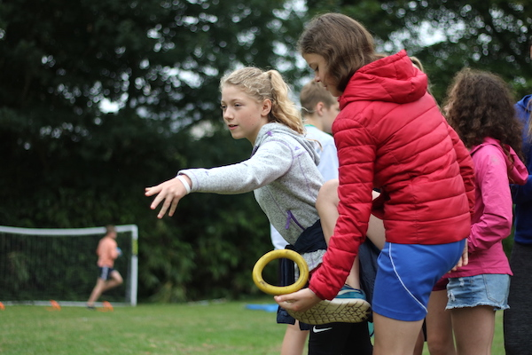
Diocesan Youth Events

Each summer we run the hugely popular Kilbroney Adventure Camps and the J.A.M Big Day(s) Out. Booking is live for 2023 but please note that only the Senior Camps and the J.A.M. Days have spaces.

The Kilbroney Adventure Camps are for any young person who would like to try new things, make friends, learn about God and have a bit of an adventure! They can come with a group from their church or by themselves as we have plenty of leaders on site. We’ll assign them a friendly leader as soon as they arrive.
The Kilbroney Centre has made some exciting changes to develop new outdoor areas, refurbish the accommodation and extend the Games Room for larger meetings.
Cost
The price has remained the same at £165 for the 5 days, which will cover all accommodation, food, activities, packs. This is incredibly competitive considering all that the camps offer. (Please note that each booking is secured with a £65 deposit).

Adventure Camps
In 2023 our Junior, Middle and Senior Camps will run consecutively from 27 July–12 August.
Three J.A.M. Day Camps will run on 24, 25 & 26 July.

27–31 July SENIOR CAMP (For those going in to Yr. 12, 13 & 14). BOOK on Diocesan Website
2–6 August JUNIOR CAMP (For those going in to Yr. 8, 9 & 10). FULL
8–12 August MIDDLE CAMP (For those going in to Yr. 10, 11 & 12). FULL
APPLY TO BE A LEADER (£20) via Eventbrite On Diocesan Website. (Details at this link show what age you need to be to lead at a particular camp).

J.A.M. Big Day(s) Out (For children from P.5 – Yr. 8)
Three days to choose from: 24, 25 & 26 July. BOOK ON DIOCESAN WEBSITE

Bible Week 2023

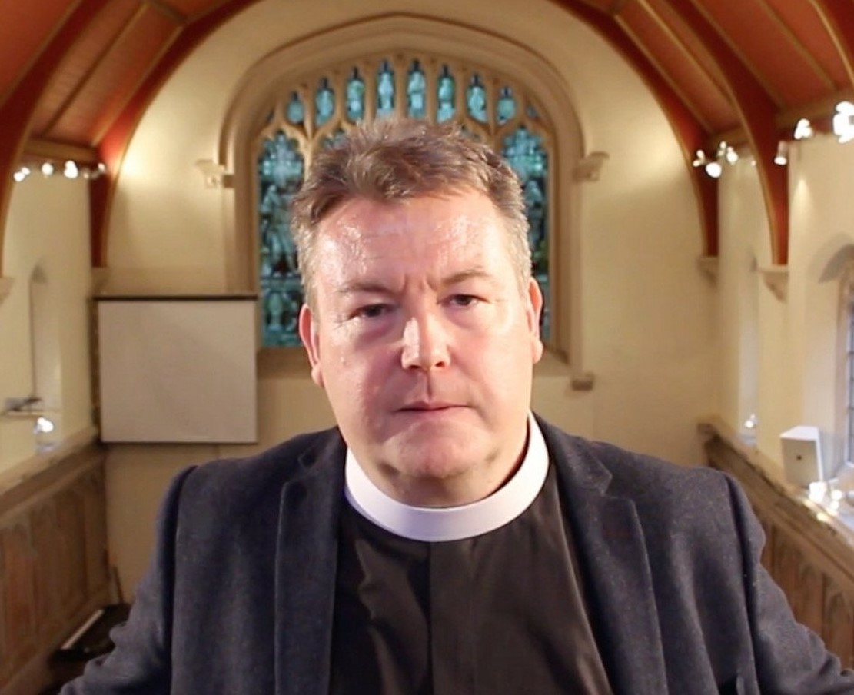

Bible Week 2023 will run from Tuesday 29 August to Friday 1 September in Willowfield Parish Church and the speaker will be the Revd Greg Downes.
Greg is a full–time evangelist and before that he was Director of Ministerial Training and Dean of the Wesley Centre for Missional Engagement at Wycliffe Hall Oxford.
Greg will also be with us in the Diocese for the month of September 2023 when he will engage in mission throughout the diocese.
Our annual Bible Week is an opportunity for worship, teaching and ministry as the autumn term begins.

Freewill Offering
The Parish Treasurers would like to thank those Parishioners who responded to previous invitations to arrange a standing order, make a direct bank payment to the Parish or post a cheque to the Treasurer in lieu of or as a supplement to their weekly envelopes during the current emergency.
If you have not yet availed of one of these methods of giving and would wish to do so, please contact:
Annahilt – Miss Patricia Halliday Email patriciaapc@btinternet.com Telephone 028 9266 5310 Mobile 07713 257691
Magherahamlet – Hillary Edgar Email: hillary.edgar01@btinternet.com Telephone 028 4481 1361

LISBURN FOODBANK
The Lisburn Foodbank is providing an essential service to those within our community who are experiencing difficult times, often due to circumstances beyond their control.

The Foodbank provides emergency food and support to local people in crisis in the Lisburn area.
Parishioners may leave items for the Foodbank in the basket in Annahilt Church Porch, on the FIRST and SECOND Sunday of each month.
A particular request from the Foodbank is for items listed below:
Cleaning products
Nappies
Sugar
Tea
Coffee
Biscuits
Rice Pudding
YOUR HELP WOULD BE GREATLY APPRECIATED.

Parish Website: AnnahiltAndMagherahamlet.org
Parishioners are reminded that the website annahiltandmagherahamlet.org has been created to provide information on church related activities and organisations for parishioners and the wider community. Although circumstances have changed considerably since the various lockdown periods the website continues to host online services each Sunday. It also contains a list of upcoming church services and news from our group of parishes, as well as downloadable versions of the parish magazine. The site will be continually developed, so if you have any submissions, suggestions or requests relating to the website, these can be sent to admin@annahiltandmagherahamlet.org.



www.annahiltandmagherahamlet.org

Parish Magazine
Any contribution for the next edition of the Parish Magazine should be left with the Rector or Roger Maxwell (roger.maxwell1@btinternet.com) by Sunday 20 August 2023.

Registered as a charity with The Charity Commission for Northern Ireland
NIC103246 (Annahilt) and NIC102122 (Magherahamlet.
Top of Form

