News from the Parishes
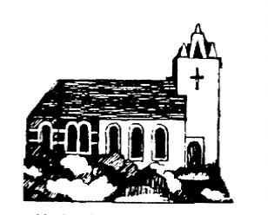
Church of the Ascension, Annahilt Magherahamlet Parish Church
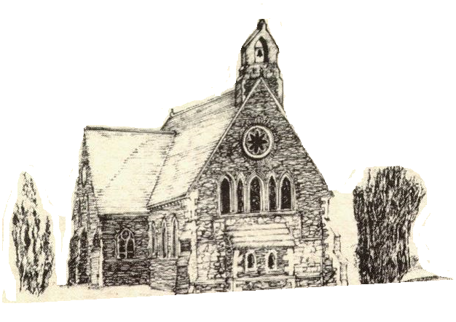

November 2021



Rector: The Revd Canon Robert Howard
15 Ballykeel Road, Hillsborough
BT26 6NW
Tel: 028 9263 8218
E-mail: jrobert.howard@btinternet.com
Website: www.annahiltandmagherahamlet.org

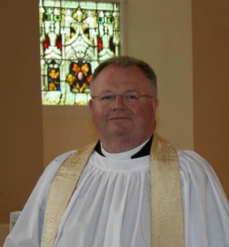
The Rector writes….

My dear parishioners

One of the key aspects of November in our parish life is remembering. On the first Sunday in the month, 7 November, we celebrated the Festival of All Saints when we traditionally remember with thanksgiving those who were associated with our parish in some way and have died in the course of the past year. On the second Sunday, 14 November, we join with the entire Nation and Commonwealth in remembering those who gave their life in the two World Wars and in other conflicts since.
These are solemn and significant occasions. The Festival of All Saints is important particularly for those who have perhaps had to hold funeral services with many restrictions. As we continue to journey through this time of pandemic, the news reminds us of rising figures through the Delta variant of Coronavirus. It’s important to stay vigilant especially as restrictions begin to ease, it’s important to pause to remember.
On Remembrance Sunday, when we remember those Service personnel who made the Supreme Sacrifice, the Services of Morning Prayer in both Annahilt and Magherahamlet will be preceded by an Act of Remembrance. If you intend being in Church on Remembrance Sunday, may I please request that you ‘book in’ as normal. I mention it because I realise it is a day when people who are not regular church attenders like to come to church and we are still operating in a situation of restrictions with regards to numbers as we do all in our power to keep everyone safe.
As we think about remembrance this month, it’s important to bring our organisations to people’s thoughts and consideration. The Sunday Schools in both Parishes and the Rainbow Guides in Annahilt have resumed their activities. The leaders are vigilant in putting safety measures in place to keep us all safe and help us adhere to the current guidelines and restrictions.
While we recognise that many people are understandably cautious about returning to activities, we do need people to support them to make them viable. Therefore, we remember our organisations and leaders this month in our prayers asking for God’s protection and wisdom as we cautiously reopen these groups.
In these times of remembering, we are grateful for the Technology Team of Colin Robinette and William Mathers which enables people who cannot attend church to stay connected virtually and which enables people abroad and overseas to share our services and events in church with us. These are not things we should take for granted. They reflect a huge amount of investment and effort on the part of Colin and William and other people behind the scenes and we are very grateful.
As we think about remembrance, one of the important things for all of us to do as a church community is to remember each other. I know there are many who have been remembering others through phoning and writing cards and in their prayers and this is greatly valued.
As we observe a time of remembrance in November we also look forward to the season of Advent. Further details of our Advent services will be available in this month’s and next month’s magazine.

With every good wish to everyone

Your sincere friend and Rector

Robert Howard

Congratulations.....

....to Emeryn Erwin, Annahilt on her engagement to Peter Verhoeven.

Reflections on Harvest Time in Magherahamlet
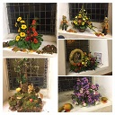
This year’s Harvest Festival in Magherahamlet (24 October) took place with restrictions still in place. Nonetheless there was a genuine atmosphere of praise and thanksgiving throughout. As always, the Church was beautifully decorated with suitably imaginative and appropriate floral arrangements and other decorations.
On Sunday morning there was a celebration of Holy Communion with the Rector presiding. The visiting preacher was the Revd Bruce Hayes, Rector of Dalkey (Dublin).. The special music included the anthem ‘All things bright and beautiful’ sung as a solo by Mrs Hailey Howe.
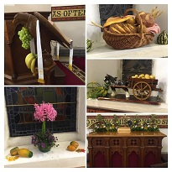
Sunday evening’s Service was a celebration of the Harvest in Readings and Music, conducted by the Rector. The special music included the anthems ‘Let all creation dance’, ‘God in his love for us lent us this planet’ and ‘Think of a world without any flowers’ and the Vesper ‘God who made the earth and heaven, darkness and light’ which were again sung as solos.
At the conclusion of the services, the Rector thanked all who had decorated the Church so splendidly and those who had very generously contributed various gifts for the decoration including the non perishible items for the Foodbank. He also expressed appreciation to the Organist Mrs Frances Magorrian, the soloist Mrs Hailey Howe (and her husband Tim who accompanied her), the various readers and the visiting preacher at the morning service, the Revd Bruce Hayes.
Remembering the Fallen

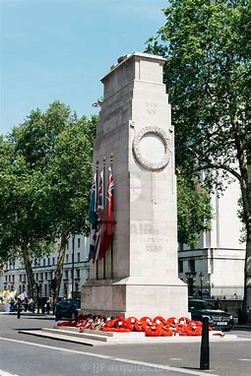
The Cenotaph positioned on Whitehall in London has become the central focus for the remembrance and commemoration events in Britain since the First World War – however it was never intended to be permanent.
Cenotaph means 'empty tomb'. It symbolises the unprecedented losses suffered during the First World War and is dedicated to 'The Glorious Dead'. There are no names inscribed on the Cenotaph, which allowed individuals to assign their own meaning to the memorial. It also provided a tangible place of mourning for those whose husbands, sons, brothers, friends and relations died during the war without a known grave. This symbolism also resonates through the introduction of the two minutes silence on Armistice Day and the interment of the Unknown Warrior.
In 1919, British architect Edwin Landseer Lutyens (1898-1944) was approached by Sir Alfred Mons, First Commissioner of Works, to design a catafalque – a raised platform to hold a casket or tomb – to stand on Whitehall. After an official approach by Prime Minister David Lloyd George, Lutyens produced the design for a cenotaph that would be erected to coincide with the Peace Day celebrations in July 1919.
The original wood and plaster structure was only intended to stand for one week, but it proved so popular that a permanent replacement was commissioned. After the original was removed in January 1920, the new Portland stone memorial was completed and installed, ready to be unveiled by King George V on Armistice Day – 11 November 1920, exactly 101 years ago.
After the original Cenotaph was removed, the wooden top was displayed by the Imperial War Museum, then located at Crystal Palace. It became a focus for remembrance activities at the museum during the 1920s.

A Prayer to be said by families visiting a war grave or memorial:

Lord Jesus, we believe that you stood beside N and his fellow-soldiers as they fought to bring peace to your world.

We believe that you have stood among us as we have tried to imagine the fear and pain and loneliness of the wounded and the dying on the battlefield.
We believe that you stand beside us now, as we remember and honour N.
In your great mercy, bless our good memories, comfort us when we grieve for the life that might have been, and strengthen us in all we do to seek the peace and freedom which are your desire for the world. Amen.

In-Church Worship in Church of the Ascension, Annahilt and Magherahamlet Parish Church

Numbers are reduced at Services in both Churches because of the legal requirement to facilitate safe distancing. Because of this, it would be very helpful if those intending to come to church would give notice of their intentions.
Annahilt
Trevor Hill trevorhill111@btinternet.com
Magherahamlet
Hillary Edgar hillary.edgar01@btinternet.com

Alternatively, you may contact by telephone:
Annahilt
Trevor Hill 07890552930
Magherahamlet
George & Sally McCurry 028 9756 3955
Hillary Edgar 028 4481 1361

For Annahilt, notification of attendance can also be given via the Parish website up to the Friday before.

Church Services in the Parishes of Annahilt and Magherahamlet

‘I was glad when they said to me: “Let us go to the house of the Lord’ Psalm 122 v1

Sunday 7 November Festival of All Saints
10.00 Parish Communion Annahilt
12.00 Parish Communion Magherahamlet

Sunday 14 November Remembrance Sunday
10.00 Morning Prayer & Act of Remembrance Annahilt 12.00 Morning Prayer & Act of Remembrance Magherahamlet

Sunday 21 November Christ the King
10.00 Parish Communion Annahilt
12.00 Morning Prayer Magherahamlet

Sunday 28 November Advent I
10.00 Hymns & Readings for Advent Annahilt
12.00 Hymns & Readings for Advent Magherahamlet

Sunday 5 December Advent II Bible Sunday
10.00 Parish Communion Annahilt
12.00 Parish Communion Magherahamlet
From the Parish Registers


Holy Baptism ‘Go therefore and make disciples of all nations, baptising them in the name of the Father and of the Son and of the Holy Spirit’

Magherahamlet Parish Church

7 November 2021

Quinn Ruth, daughter of Sam McCurry and Shauna Gargan, Demesne Road

Funerals
‘In Christ shall all be made alive’

8 October 2021

James (Jim) Luke, Woodfall Manor, Annahilt

Service at Roselawn Crematorium was followed by cremation

Jim Luke was born in 1923 at his parents’ home in Markethill which would be very unusual today and would likely have been uncommon all those years ago as well. As he grew up, Jim developed a love for Mathematics and apparently much later in life he remarked that if he had to live life over again, he might have become an accountant.
Jim joined the Royal Air Force. As an RAF mechanic in the Second World War, he served in Yemen and other places, servicing planes for the French who had been given British aircraft.
Following the War, Jim went on to work in the north of Canada in a communications network system. He would spend up to 6 months at a time in extreme arctic conditions, where many colleagues would only spend periods of 3 months.
It was in Canada that Jim met his future wife Marie who came from Holland. They were married for 63 years.
On returning to Northern Ireland, Jim worked at Shorts Brothers in the aeronautical factory. He later went ‘back to school’ where he obtained a teaching diploma and went on to teach aeronautical engineering.
We give thanks to God for Jim’s full, busy, interesting and long life and extend our deepest sympathy to Jim’s wife Marie, his sons Henry and Jamie and their families, as well as his cousin Nora Banks who was always very close to the family circle.

15 October 2021

Mary Colleen Ward, Begney Hill Road

Following Services at home and in Magherahamlet Parish Church, burial took place in adjoining churchyard.

Colleen was one of a family of six, born to the late Stanley and Winnie Green and was raised at the family homestead on Dromara Road. She received her primary education at Croob Park School. Later she attended and was a Classroom Assistant in Ballynahinch High School.
Colleen’s first job was as a Domestic Assistant at Purdysburn Hospital. Following a period living in Wales, Colleen returned home to Northern Ireland. She held various part time jobs until she was employed as a civil servant until her health first declined. That was 19 years ago and in the years which followed, Colleen bravely fought very serious illness and underwent four major operations. Ultimately, she triumphed and made a remarkable recovery which enabled her to return to leading a very full life indeed. Colleen attended the Harvest Thanksgiving which clearly was her personal expression of thanks to God for restoring her to health. She was a faithful attendee at Harvest Services in future years and also, along with her mother and sister Ann was a great supporter of fund raising events in the Parochial Hall.
Prior to her illness, she met Alister whom she married on 10 July 2015. Together they had a very happy marriage and shared a fulfilling life together.
We remember Colleen as a consistently active person. She travelled extensively at home and abroad. On four occasions she visited Australia. She and Alister also travelled especially on cruises, while her daughter Cerri-Ann and son James brought her on a trip to Paris to mark her 50th birthday.
Collen loved flowers and gardening. She also enjoyed watching television especially the Soaps!
Colleen sought to look after everybody else consistently putting others first and herself last. She was devoted in her support of her parents during their advanced years.
Throughout her life Colleen was a devoted family person. Always anxious to keep the extended family together, she was instrumental in organising family occasions.
We extend our heartfelt sympathy to Colleen’s husband Alister, sons & daughters Cerri-Ann, James, Samuel and Suzanne, daughter-in-law Sonia, grandson Jackson, brothers Billy, Walter and Robert, sisters Eleanor and Ann and the entire family circle.

Flowers for the Churches
Annahilt Magherahamlet

November
7 Mrs A Edgar
14 Remembrance Sunday Remembrance Sunday
21 Mrs M McAuley
28


Church Cleaning, Annahilt

November
5-6 Mrs J Bolas Mr A Bolas
12-13 Mrs L McCambley Mrs E Harrison
19-20 Mrs E Ogle
26-27 Mrs J Guiney Mrs H Cardosi

December
3-4 Mrs A Maxwell Mr R Maxwell
10-11 Mrs H Hill Mr T Hill
17-18 Mrs E Crawford Mrs M Finlay
HERE’S TO TODAY

There are two days in each week about which we should not worry. One of these is yesterday and the other is tomorrow.

Yesterday, with its misunderstandings, faults and blunders, aches and pains, has passed forever beyond our control.

We cannot undo a single act that was performed or erase a single word that was spoken.
Yesterday is gone.

And tomorrow is beyond our immediate control. The sun will rise, maybe in splendour or behind a mask of clouds.
But it will rise.
And until it does, you have no stake in tomorrow.

This leaves only one day to concentrate on— today.
And anyone can fight the battles of just one day. It’s when we add the burdens of yesterday and tomorrow that we break down.

Live one day at a time.

Author unknown


Prayers for the current situation
Ever present God, we thank you for having been with us in our isolation, close to us in our distancing, and healing in our sickness,
May you continue to be joy in our sadness, light in our darkness and wisdom in our confusion,
We praise you for being all that is familiar when all all has been unfamiliar. Now that doors reopen we may with the zeal of Pentecost inhabit our communities and speak of your goodness to an emerging world.
For Jesus’ sake.

Amen.

Father, please hear us when we tell You of our concerns of re-emerging from isolation.
Know that we are striving to make all of the right decisions and need Your love and power to help us overcome any difficulties.
Please watch over everyone as times and routines change.
We know that we can do anything through You, so please help us ensure health and semi-normalcy in the coming months.
We give our hearts to You, now and forever.

Amen.

New CMSI parish link in Nepal: Sundar Dhoka Saathi Sewa (SDSS)

Nepal is beautiful, friendly & mountainous country incorporating the Himalaya (including Mount Everest) on the northern border with China, and dry, flat plains to the south on the Indian border. With a centuries old tradition as a proud and independent Hindu Kingdom, the first Christian missionaries were invited in from India in 1951. Since that time the church has grown through loving service, medical work and courageous witness, and although still a tiny minority, it is growing at 11% per year, faster than anywhere else on earth.

Nepal is one of the world’s 50 least developed countries, ranked 145th out of 187 in the 2015 UN Human Development Index. An estimated 44% of the Nepalese population lives below the poverty line with 50% of children under the age of five suffering from malnutrition. Nepal is also prone to natural disasters such as earthquakes (notably in 2015), floods and landslides, with medical responses often hampered by the inaccessibility of remote mountain communities and the relative lack of health facilities. Since March 2020 the country has been struggling to cope with the Covid-19 pandemic, with waves of infection arriving from India when tens of thousands of Nepali workers returned to their homeland, and a general scarcity of vaccines.

Introducing SDSS
Sundar Dhoka Saathi Sewa is an independent faith-based community outreach for marginalised people which has been partnering with CMS Ireland for over 30 years. Offering support to people with disabilities, those suffering from leprosy, the sick and the poor, it derives its name from Acts 3 and the story of Peter and John’s healing of the lame man at the beautiful gate (‘Sundar Dhoka’ in Nepali). The organisation is based in Kathmandu, but its impact and reach is across the whole of Nepal, running a series of health and social welfare programmes - ‘Saathi Sewa’ means ‘Friends Service’.
SDSS is led by Bikash and Bijata Adhikari - who also act as the main contact points for CMSI.
The range of initiatives and programmes run by SDSS is staggering. In recent years, some of the programmes that CMSI has supported have included:
- Patient Navigator Programme - supporting patients who come to Kathmandu for specialist medical care
- Earthquake response - providing medical and housing following the 2015 earthquake
- Pharakilo Ghar (‘Spacious House’) Disabled Children’s Rehabilitation Centre, founded as a response to the 2015 earthquake
- Girls Health Project - Women’s hygiene classes in 5 Kathmandu Secondary Schools
- Covid-Response Educational Programme & Food Relief to disabled people & vulnerable families

Partnership with SDSS
SDSS is a vibrant, exciting Global Partner. It gives churches in Ireland a chance to participate in an incredible story of new life and growth across Nepal. Annahilt Parish greatly look forward to developing this partnership over the next three years.

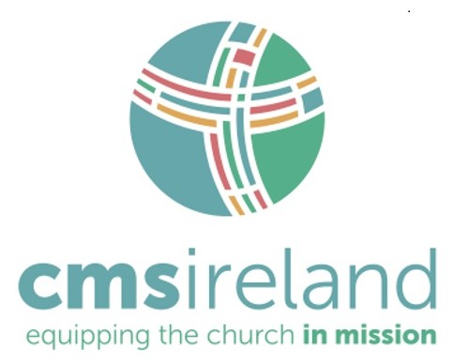


Dear Mothers’ Union Members and Friends,

By now, the farmers have harvested their crops and have them safely stored to keep their families and animals well fed and healthy over the winter. You too have been working hard throughout the year, to ensure that there are enough provisions readily available to keep people safe and well cared for in times of need. You have been engaged in collecting toiletries and making up soap bags, some of which are already on their way to the Emergency Departments of hospitals such as Craigavon Area Hospital and Daisy Hill in Newry. Each toiletry bag also contains a card stating that it has been donated by a member of Down and Dromore Mothers’ Union and this beautiful prayer has been included to comfort the recipient:
Calm me O Lord, as you stilled the storm,
Still me O Lord, keep me from harm
Let all the tumult within me cease,
Enfold me Lord in your Peace.

Mothers’ Union has received many messages of thanks and appreciation for your thoughtfulness in gifting these tokens of your love and concern.
Similarly our talented knitters and crocheters have been hard at work as usual, creating exquisite little baby cardigans, hats, pram covers and blankets. The latest donations of over one hundred items are on their way to the Baby Basics Project which receives requests from Community Midwives who visit new mums and their babies who are just out of hospital. Also some are donated to Women’s Aid shelters which are a refuge for women and their children in times when they have to leave home due to domestic violence and adversity. Your hard work and generosity in supplying baby clothes at these most vulnerable times is very much appreciated.
Huge thanks also go to all Mothers’ Union members for your very generous responses to topping up funding for the Worldwide/Overseas Project and the Mums in May Project. There are no plans at present to organize Branch meetings but a service to mark the 16 Days of Activism Against Gender-Based Violence is being held on Global Day Saturday 27th November in St Mark’s Dundela at 12.45pm. More details and information will be circulated in the near future. Please let Esme or Ann know if you are interested in going. Take care everyone and please keep in touch with each other.
We are very sorry to report that Ruth Carlisle is unwell and in hospital. We wish her God’s blessing and a speedy recovery following her recent surgery

Kind regards

Beth Avril
Esme Ann


The Mothers’ Union Midday Prayers for November are detailed once again for your use:

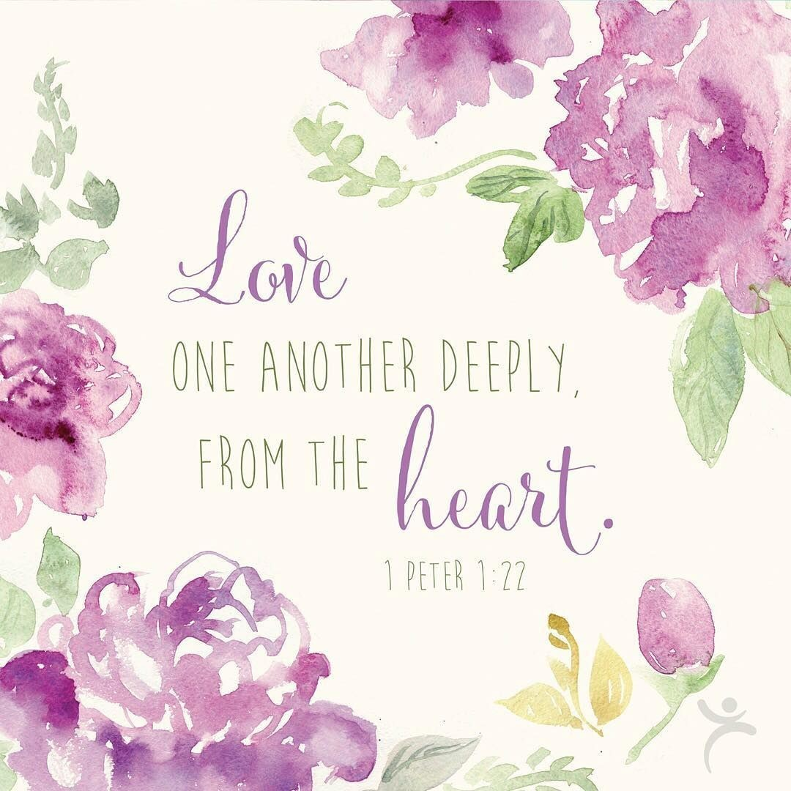

Mothers’ Union—Midday Prayers—November 2021
Rebuilding hope and confidence. Who is my neighbour?

Monday: Who is my neighbour?
You shall love your neighbour as yourself.
That is, unselfishly seek the best or higher good for others.
Matthew 22:39 (AMP)

Living God, you have taught us through Jesus that our neighbours are not just those who live next door, or live nearby, but everyone, everywhere.
And so, we pray for our world, our neighbours near and far.
Lord of heaven and earth, hear our prayer.

Help us to reach out to our troubled, divided world, recognising the call of our neighbour in the cry of the needy;
May the time come when as individuals and nations we live together as neighbours – members of the extended family of humankind, for we ask it in the name of Christ. Lord of heaven and earth, hear our prayer.

Amen.

Tuesday: Love your neighbour
In humility value others above yourselves, not looking to your own interests but each of you to the interests of the others.
Your attitude should be the same as that of Christ Jesus.
Philippians 2:3-5

Loving Lord, who has created us in your image, show us how to value the people who are part of our lives.
Let us embrace our differences and not see them as a threat. Let our attitude to each other reflect the acceptance of Christ. May all our relationships be based on mutual respect as we recognise the face of Christ in the image of our neighbour.
Loving Lord, give us your grace to accept each other unconditionally that we may truly love our neighbours as ourselves.

Amen.

Wednesday: Love your vulnerable neighbour
Speak up for those who cannot speak for themselves, for the rights of all who are destitute. Speak up for the poor and helpless, and see that they get justice.
Proverbs 31:8-9

Lord, you call us to love our neighbour as ourselves. Help us to be their advocates in an often loveless world.
Use us to speak against social injustice with a clear and influential voice in a world where the vulnerable strive to be heard. Give us resolve to speak boldly on behalf of those who suffer in silence. Make us strong and effective advocates for those whose voice is too weak to be heard.
Amen.

Lord, you call us to love our neighbour as ourselves.
Help us to act with the mercy of Christ.

Amen.

Thursday: Love your neighbour in adversity
Then the king will answer, “The truth is, anything you did for any of my people here, you also did for me.”
Matthew 25:40 (ERV)

Lord, help us to love our neighbour as ourselves:
Turn our gaze to see the need around us. Help us to give without reservation whatever the cost to ourselves. Touch our hearts with the pain of adversity. Make us willing to sacrifice our comfort to support our neighbours in need. Use our hands in service to others. Guide us in deeds of kindness; actions of grace which show your love in action.
May we see the image of God in the face of our neighbour and lovingly care for their needs as though we were serving Christ.

Amen.

Friday: Neighbours near and far
I thank my God through Jesus Christ for all of you, because your faith is proclaimed throughout the world.
Romans 1:8 (NRSV)

Lord, open our eyes, open our hearts to our neighbours who live nearby.
Show us how to relate together to build friendship and mutual trust. Encourage us to offer a helping hand wherever we sense a need.
Lord, open our eyes, open our hearts to our neighbours across the world.
Show us the significance of relationship with people worldwide; those known to us or not. Help us to gladly respond in faith with love and practical support.
In word, deed and prayer, may we reach out as your hands across the road and across the world to love our neighbours as ourselves.

Amen.

Saturday: Who is my neighbour?
He asked Jesus, “And who is my neighbour?”
“Who was a neighbour to the man who fell into the hands of robbers?”
The expert in the law replied, “The one who had mercy on him.”
Jesus told him, “Go and do likewise.”
Luke 10:29, 36-37

Lord, you call us to love our neighbour as ourselves.
Help us to offer the mercy of Christ. Forgive us, Lord, who call ourselves your own but daily cause you pain, who see someone in need and walk across the road, hear about injustice and fail to say a word.
Forgive us, Lord, who call ourselves your own.
Renew our hearts, our souls and minds; Strengthen our faith and make us a people who are your hands, your feet and voice within this world.

Amen.



Thank you…..
……to all who contributed to this year’s Harvest Appeal

Annahilt £924
Magherahamlet £1600 (to date)

WEEKLY GIVING – ANNAHILT & MAGHERAHAMLET
The 2021 FWO envelopes will be prepared towards the end of November and if anyone wishes to have envelopes or wishes to amend their requirements, would they please contact the Hon Treasurers.
Annahilt Miss Patricia Halliday 028 9266 5310/ 07713 257691 patriciaapc@btinternet.com

Magherahamlet Hillary Edgar 02844811361 hillary.edgar01@btinternet.com

We would also encourage parishioners to pay some of their giving by Bankers Standing Order and anyone who would be interested in discussing this should also contact Patricia or Hillary.

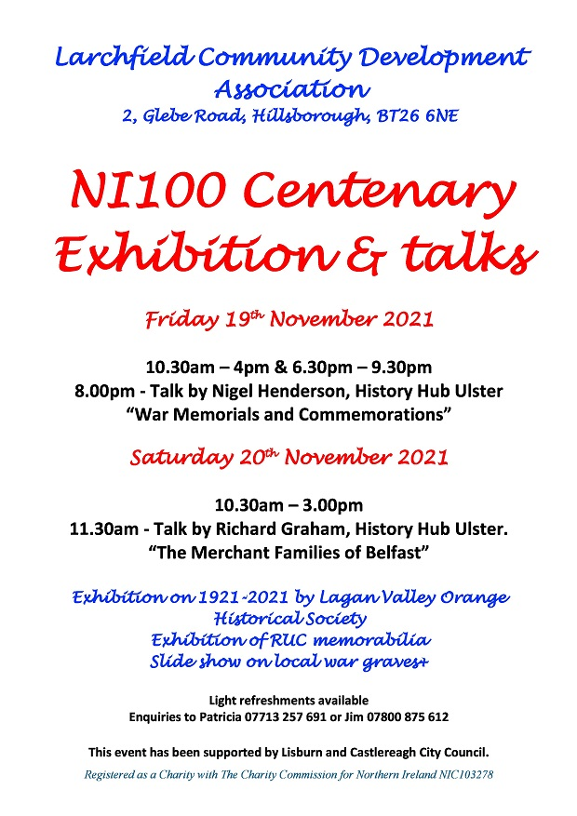
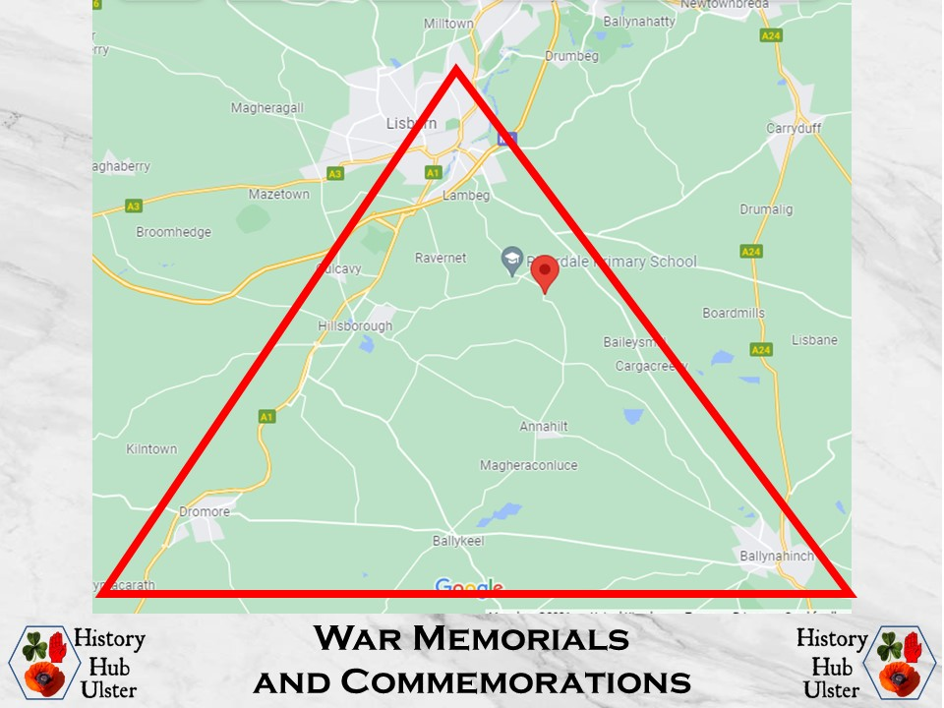

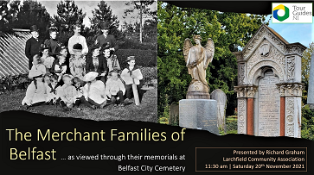

LISBURN FOODBANK – CHRISTMAS PARCELS
I would first of all like to take this opportunity to thank you for your continued support for the Lisburn Foodbank which provides 3-day emergency food parcels to people facing financial crisis.
The Foodbank works with over 70 referral agencies, such as the Northern Ireland Housing Executive, Community Advice Lisburn and Castlereagh, South Eastern Health and Social Care Trust etc.
Since opening in June 2013, Lisburn Foodbank has collected 27 tonnes of food and helped 2,700 individuals with emergency food parcels. But this work would not be possible without donations of food and other necessities from members of the public.

In preparation for the Christmas season, Lisburn Foodbank is hoping to make up around 400 hampers to be given to those in need and have asked us to help by donating bottles of Shloer and small selection boxes.


As the items are needed well in advance of Christmas, to allow for the hampers to be made up, we have been asked to collect items by the end of November, so if you would like to help, please leave items in the Church Porch on Sunday 28th November (or Sunday 5th December at the latest).
In addition, if anyone would prefer to leave items in the hall, it will be open for donations on Monday 29th November at 7 pm.

As always, your help would be greatly appreciated.

Thanks
Louise McGregor

Parish Website: AnnahiltAndMagherahamlet.org
Parishioners are reminded that the website annahiltandmagherahamlet.org has been created to provide information on church related activities and organisations for parishioners and the wider community. Since lockdown began in March, the website has hosted online services each Sunday. It also contains a list of upcoming church services and news from our group of parishes, as well as downloadable versions of the parish magazine. For those wishing to attend a service at Annahilt, notification of attendance can also be given via the Parish website up to the Friday before.
The site will be continually developed, so if you have any submissions, suggestions or requests relating to the website, these can be sent to admin@annahiltandmagherahamlet.org.



www.annahiltandmagherahamlet.org

Parish Magazine
Any contribution for the December edition of the Parish Magazine should be left with the Rector or Roger Maxwell (roger.maxwell1@btinternet.com or magazine@annahiltandmagherahamlet.org) by Sunday 21 November 2021.

Registered as a charity with The Charity Commission for Northern Ireland
NIC103246 (Annahilt) and NIC102122 (Magherahamlet)
Top of Form

