News from the Parishes

Church of the Ascension, Annahilt Magherahamlet Parish Church

February & March 2024

Rector: The Revd Canon Robert Howard
15 Ballykeel Road, Hillsborough
BT26 6NW
Tel: 028 9263 8218
E-mail: jrobert.howard@btinternet.com
Website: www.annahiltandmagherahamlet.org

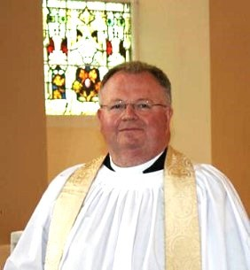
The Rector writes…..

While I enjoy very much New Year’s Day each year, especially listening to the wonderful Concert transmitted on both tv and radio from Vienna, I have to say that I do not really like the month of January. And I don’t feel any great regret that it’s now over. Although there is a very gradual ‘stretch’ in the evenings, days often are dull and still seem to ‘close in’ early with the absence of the bright lights of Christmas decorating our trees both inside and outside. Furthermore, you may have made various New Year’s Resolutions and failed to keep them and then double guilt-tripped yourself on your failure to observe them. There’s also the fact that the credit card bill covering Christmas comes in during January.
So, hurrah for February and March! Here’s a chance for a new start. Indeed, it is. Ash
Wednesday (14 February) was an invitation to think over any sort of new resolution. It began a good time to reflect on life and how we are living it. But remember that 14 February was also St Valentine’s Day., a day you might also have given or received a mystery card, and / or some chocolates, saying ‘I love you’!
It is good to ponder this reminder of love as Lent progresses. Let that love shape how you see your Lent, as filled with God’s love, even if not filled with chocolates.
All relationships involve some laying aside of one’s agenda for the sake of the other. Therefore, in your Lenten observance perhaps you might see that whatever you have passed from, that it is driven by your love for God.
Don’t fear the failure of your Lenten fast. Instead, take it as an invitation to pray and to see how much we need the love of God, the sacrifice of Jesus, the daily help of the Holy Spirit in our lives.
Or it might be that instead of abstaining for Lent, you have taken up some act of service, perhaps helping on a rota of volunteers to clean and / or maintain the Church and Parochial Hall?
Lent can be an emotionally challenging time. Add to it Mothering Sunday (10 March) which for some is an opportunity to be pampered, quite rightly, whilst for others it is painful when long-prayed prayers for the gift of children have not been answered in the way we had hoped for. For some parents, it is also painful if their children have had shorter lives than themselves. And for others Mothering Sunday is a difficult time as they miss their adult children who are now away from home.
We may find it helpful to remember that Mothering Sunday is not only about us or our parents. This could give you a good reason to give thanks to God for all those who have been involved in mothering you.
As we enter deeper into Lent, might I suggest that you read the Gospel according to Saint Mark over this penitential season. We will be hearing from Mark on Sundays of Lent this year. It’s the shortest gospel, and often written in the present tense. This means that Mark 9, in the Greek would read more along the lines of ‘there’s this Jesus and he takes three disciples with him up a mountain and there he transfigures in front of them’. The glorious moment of the transfiguration is written up for us but in what my English teacher ‘back in the day’ would have described as ‘poor’.
But this koinonia Greek (so called common Greek) in using the ‘historic present tense’ succeeds in making us feel as if we are there too. We are up this mountain, with this Jesus, who stands before us in blinding array, shining like the sun, and he’s having a conversation with Moses and Elijah, which given that Moses died perhaps 1300 BC and Elijah in 900 BC, just adds to the awe of the moment. Now we remember Jesus explaining how God is the God of Abraham, Isaac and Jacob. God IS the God of …. NOT God WAS the God of. God is the God of the living. So this means that to Jesus, Moses and Elijah are as alive as you and I are. And that feeds into our faith and hope when we remember the Saints we have known who have died.

I wish you a holy and spiritually refreshing Lent.

Your sincere friend and Rector

Robert Howard

Congratulations…

..... to Bert Carlisle, Annahilt on the recent celebration of his 85th birthday.
….to Barbara Oliver, Annahilt on the recent celebration of her 80th birthday.
…to Andrew McGregor, Annahilt on his recent engagement to Ellen Heslip.

Memories of Christmas 2023

It was wonderful that we were able to celebrate this past Christmas with all who attended and supported the various seasonal events in our Group of Parishes being very appreciative of everything that took place.
Unfortunately, it was not practical for the Sunday School in Annahilt to hold its traditional Nativity Pageant. However, an All-Age Christingle Service took place in the Church of the Ascension on Christmas Eve with The Baillie’s Mills Accordion Band participating. While the Band have been regular visitors to Annahilt Parish over the years, a visit at Christmas was a first when they were very well received. Everyone joined wholeheartedly with the Band in singing the familiar carols and also listened to a selection played by the Band alone.
Also on Christmas Eve, a Nativity Pageant took place in Magherahamlet which was very moving and was performed excellently.
Christmas gifts donated by families in both parishes on Advent Sunday in Annahilt and at a Crib Service in Magherahamlet on Sunday 17 December. All gifts were given afterwards to Star NI.
On Sunday 17 December in the afternoon there was the Festival of Nine Lessons and Carols in Annahilt The music was led by a united Choir of both Annahilt and Magherahamlet. This was the first such occasion at which Mr Timothy Howe played since his appointment as Organist and Choir Director. It was wonderful to have boys and girls from Anahilt Primary School participating again. The lessons were read by representatives of the parochial organisations, the Principal of the School and the Mayor who was Guest of Honour.
After an absence from our various Church schedules during the years of the pandemic restrictions, we were thrilled that it was possible to resume the traditional United Carol Service in Spa and Magherahamlet this year. It took place in Spa Presbyterian Church Church on the evening of 17 December. There were readers from Spa and Magherahamlet Presbyterian and the Parish Church. The music, led by choir members from all three churches, consisted of many traditional congregational carols and a number of choir anthems.
The First Communion of Christmas was celebrated in Annahilt with representation from parishioners of ‘the Glebe’ and other visitors. On account of the current Ministerial vacancy at Legacurry Presbyterian Church, it was not possible to hold the usual reciprocal Christmas / New Year visit to Legacurry this year
The customary Christmas Day Family Service in Annahilt and the Parish Communion Service in Magherahamlet took place.
To all who contributed in any way we say ‘well done’ and a sincere ‘thank you’. The very positive feedback from parishioners has been very much appreciated.

Dear Canon Howard and Parishioners of Annahilt and Magherahamlet Churches,

We are writing to thank you for your ongoing support of STAR NI – your generous donations of Christmas gifts for the children we work with in December and the monetary donations you also sent us.

Your generosity enabled us to provide gifts to the children in the run up to Christmas. It will also continue to help us with the running costs of providing a crucial therapeutic service to children and adolescents who have been subjects to abuse. This includes enabling us to keep resourcing band running our specialist playroom. This is a welcoming and safe environment in which children can express and make sense of their feelings and experiences.

It was lovely to be able to meet you again and be part of your Christmas Services. Thank you again for all your support.

The STARNI Team

A prayer for all in positions of civic responsibility, especially the First Minister Michelle O’Neill, Deputy First Minister, Emma Little-Pengelly and the Executive:
Lord God, we pray for those to whom you have entrusted the power to rule among people.
Help them to remember their responsibility to you, and to be trustworthy in using it until the day of account that your kingdom shall be prospered and they shall be found your good servants; in Christ our Lord. Amen.

A Prayer for use during Lent:
Teach us, O God, so to use this season of Lent that we may draw closer to our Lord, and in fellowship with him may learn to hate sin, to overcome temptation and to grow in holiness, that our lives may be strengthened for your service and used for your glory.
We ask this in Christ’s name. Amen.

A prayer for the sick, those recovering from sickness and all those in need, in particular the King, the Princess of Wales and Sarah, Duchess of York:
O God, we pray for one another;
Give us each on the blessing we need.
We ask your healing for the sick, your strength for the tempted and your joy for the downcast.
Answer the prayers which we try to put into words, and the prayers which you read in our hearts,
According to your perfect love made known in Jesus Christ your Son our Lord. Amen.

Prayers for Ukraine

The following prayers are appropriate for use on the 2nd anniversary of the Russian invasion of Ukraine:

O Lord our Governor, whose glory is in all the world:
We commend to your merciful care the people and government of Ukraine that, being guided by your providence, they may dwell secure in your peace.
Grant to their leaders and all in authority, wisdom and strength to know and to do your will.
Fill them with the love of truth and righteousness, and make them ever mindful of their calling to serve their people; through Jesus Christ our Lord. Amen.

Grant, O God, that your holy and life-giving Spirit may so move every human heart in the nations of the world, that working and witnessing together, we may live in justice and peace and change the hearts of those who would make for conflict and war; through Jesus Christ our Lord. Amen.

PRAYER WARRIOR

Do you have a concern or problem and would like someone to pray for you?
If so, contact the Rector who will be willing to help.
This is completely confidential and no details will be passed on to anyone else unless you want them to.
028 9263 8218

Death of Walter Love
It is with deep regret that we record the recent death of Walter Love, a highly esteemed broadcaster especially on BBC Radio Ulster.
Walter was well known in our Parish over many years. He spoke on different occasions on ‘The Making of Champagne’. Over the years he became the ‘resident’ Master of Ceremonies at the annual Burns Supper.
We extend our deep sympathy to the Family Circle

Church Missionary Society, Ireland Sunday

This was observed this year on the Sunday before Lent 11 February. The preacher was the Revd Roger Thompson who we were delighted to welcome back to both Churches.
Light Refreshments of Tea / Coffee, scones with jam & cream and biscuits in support of CMSI were served following the Service in Annahilt by the Sunday School.
In Magherahamlet, there was the customary ‘Famine Lunch’ of soup, cheese, bread & shortbread served by the Mothers’ Union.

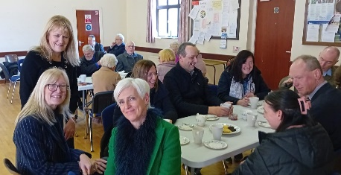

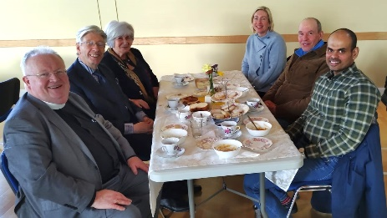

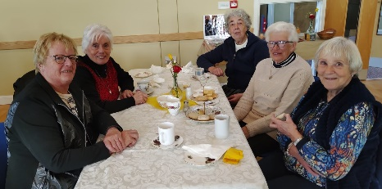

30 years in the Group of Parishes

Both Annahilt and Magherahamlet recently marked the 30th anniversary of Canon Robert Howard’s Institution as Rector of the Group of Parishes which took place on 4 February 1994.

On the Sunday following the Anniversary, the Rector received presentations in the form of a very appropriate gift token from each Parish. At the conclusion of the Service in Annahilt, he was presented with a voucher for a meal at ‘The Pheasent’ by Colin Hassard, Honorary Secretary of the Select Vestry. In Magherahamlet he was given an M&S Gift voucher by Abbie Stanford, Secretary to the Vestry. Speaking on behalf of all parishioners Colin and Abbie spoke appreciatively of the Rector’s ministry in the parish over such an extended period.

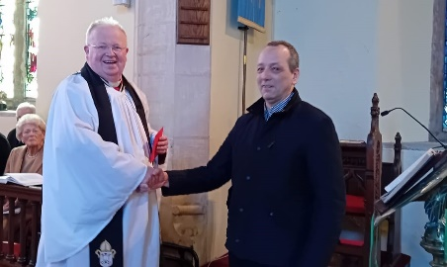

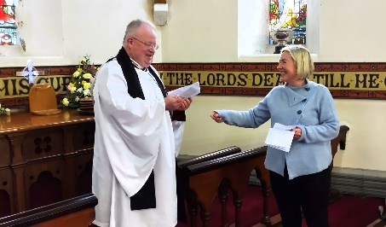
At both Services the Rector expressed how fulfilled he had felt in ministering in the Group of Parishes over the years and how touched he was by the gestures made by parishioners of both Annahilt and Magherahamlet for which he was very grateful.

Church Services in the Parishes of Annahilt and Magherahamlet

‘I was glad when they said to me: “Let us go to the house of the Lord”’ Psalm 122 v1

Sunday 3 March Lent III
10.00 Parish Communion Annahilt
12.00 Parish Communion Magherahamlet

Sunday 10 March Lent IV (Mothering Sunday)
10.00 Family Service Annahilt Service Sheets
12.00 Family Service Magherahamlet Service Sheets

Sunday 17 March Saint Patrick’s Day
10.00 Parish Communion Annahilt Service Sheets
followed by Light Refreshments in the Parochial Hall
12.00 Morning Prayer Magherahamlet Service Sheets
followed by Stew Lunch in the Parochial Hall

HOLY WEEK
Sunday 24 March
10.00 ‘The Cross of Christ’ Annahilt Service Sheets
A Holy Week Devotional of Readings, Anthems & Hymns
12.00 ‘The Cross of Christ’ Magherahamlet Service Sheets
A Holy Week Devotional of Readings, Anthems & Hymns

Throughout Holy Week, Monday 25 to Good Friday 29 March there will be a series of addresses ‘A Journey from darkness to light’ given by the Dean of Armagh, the Very Revd Shane Forster.
Monday
8.00 pm Evening Service Magherahamlet Service Sheets
‘In the shadow of betrayal’
Tuesday
8.00 pm Evening Service Annahilt Service Sheets
‘In the shadow of denial’
Wednesday
8.00 pm Evening Service Magherahamlet Service Sheets
‘Overshadowed by loneliness’
Maundy Thursday Commemoration of the Institution of the Lord’s Supper
8.00 pm Holy Communion Annahilt Service Sheets
‘Overshadowed by suffering’
followed by light refreshments in the Parochial Hall
Good Friday
8.00 pm Tenebrae Service Annahilt Service Sheets
‘In the valley of the shadow of death’

Sunday 31 March Easter Day
Clocks go FORWARD 1 hour
8.30 Holy Communion Annahilt
10.00 Parish Communion Annahilt Service Sheets
12.00 Parish Communion Magherahamlet Service Sheets

Sunday 7 April Easter II
10.00 Parish Communion Annahilt
12.00 Morning Prayer Magherahamlet

Sunday 14 April
10.00 ‘Risen with Christ’ Annahilt Service Sheets
12.00 ‘Risen with Christ’ Magherahamlet Service Sheets

Sunday 21 April Easter III
10.00 Parish Communion Annahilt
12.00 Parish Communion Magherahamlet

Looking Ahead……

You are invited to the 40th Anniversary of the Ordination of The Revd Canon Robert Howard as Deacon on St Peter’s Day 29 June 1984
RUBY JUBILEE SERVICES
Sunday 16 June 2024
10.00 am Annahilt
12.00 Magherahamlet
and afterwards at Larchfield (by kind permission)

WORLD DAY OF PRAYER

England, Wales & Northern Ireland

FRIDAY 1 MARCH 2024
8.00 pm
Ballynahich Methodist Church

TRANSFORMATIONS

The Bishop, the Rt Revd David McClay commends this year’s diocesan Lenten Initiative:

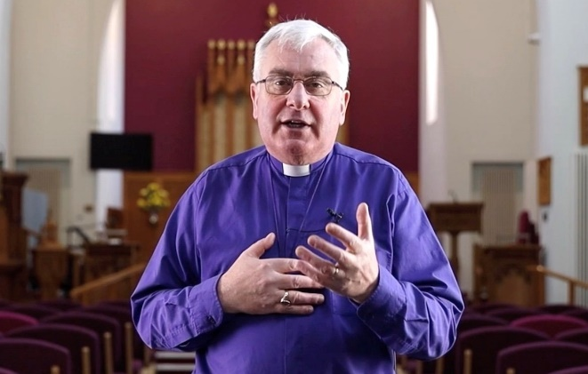

The Bishop has recorded a series of evening devotions on Haggai to take us through the 40 days of Lent from Ash Wednesday to Palm Sunday. The short films are being released each day on the Diocesan Website, YouTube and Facebook channels. from 14 February – 24 March 2024.

Saint Patrick celebrated in Saul and Downpatrick on Saturday 16 March
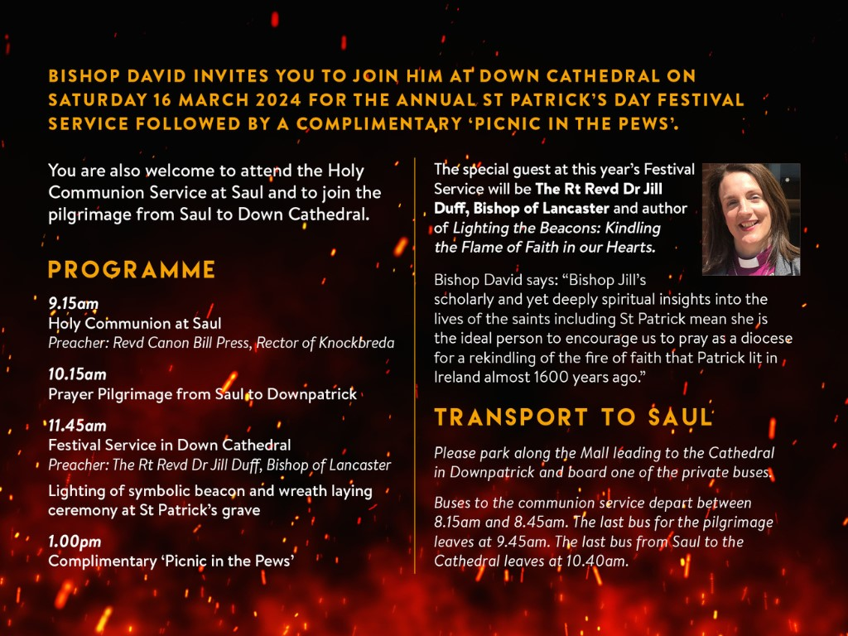

PROGRAMME

9.15am: Holy Communion at Saul
10.15am: Prayer Pilgrimage from Saul to Downpatrick
11.45am: Festival Service in Down Cathedral with Bishop Jill Duff
Wreath laying ceremony at St Patrick’s Grave and lighting of symbolic beacon
1.00pm: Complimentary ‘Picnic in the Pews’

Transport to Saul
From 8.15 am private buses will leave from the Mall for the communion service and pilgrimage.
The last bus for the communion service leaves at 8.45 am.
The last bus for the pilgrimage leaves at 9.45 am.
The last bus from Saul to the Cathedral leaves at 10.40 am.

Light the Beacons: St Patrick’s Day Celebrations 2024

‘Light the Beacons’ is the theme for this year’s annual St Patrick’s Day festival which will focus on praying for a rekindling of the fire of faith that Patrick lit in Ireland almost 1600 years ago.
The diocesan celebrations will take place on Saturday 16 March and include special prayer services in parishes on Sunday 17 March.
Our guest preacher at the Festival Service at 11.45am in Down Cathedral is Rt Revd Dr Jill Duff, Bishop of Lancaster.
The Bishop says: “Bishop Jill’s scholarly and yet deeply spiritual insights into the lives of the saints including St Patrick (see her book Lighting the Beacons: Kindling the Flame of Faith in our Hearts). means she is the ideal person to encourage us to pray as a diocese for rekindling of the fire of faith that Patrick lit in Ireland almost 1600 years ago.
“In 433AD in defiance of the pagan king, Laoise, Patrick lit a Paschal fire to celebrate Easter. It was said that if that Paschal fire was not put out on that day it would never be extinguished. Almost 1600 years later the fire of the gospel has not been put out but needs fanned into flame in Ireland again.”
The Bishop will light a symbolic fire at the end of the Festival Service and a representative from each church in the diocese will take a torch and a container of concentrated paraffin oil back to their parish.
On 17 March, St Patrick’s Day, every church large and small, will hold a short time of prayer for revival, in Annahilt and Magherahamlet following the morning services. With beacons lit, we’ll be asking God to light the fire of the gospel in Ireland and in that local church context once again.

Parochial Annual General Meetings or Easter Vestries 2024

Please note the Annual General Meeting or Easter Vestry of each parish in the Group:

Annahilt Monday 11 March 8.00 pm Parochial Hall

Magherahamlet Wednesday 13 March 8.00 pm Parochial Hall

As usual, the past year will be reviewed and the Churchwardens and Select Vestries for another year will be elected.
While only registered Vestrypersons may vote, attendance is open to all parishioners. The meetings are occasions when we may learn more about what is happening in our own parish, diocese and the wider Church, as well as participating in the annual elections.

Flowers for the Churches
Annahilt Magherahamlet

March
3
10
17
24
31 Easter Easter

Church Cleaning, Annahilt
Month

March
1-2 Mrs J Bolas Mr A Bolas
8-9 Mrs J Guiney Mrs H Cardosi
15-16 Mrs H Hill Mr T Hill
22-23 Mrs A Maxwell Mr R Maxwell
29 - 30 Mrs S Chapman Mr S Chapman

April
5-6 Mrs E Crawford
12-13 Mrs L McCambley Mrs E Harrison
19-20 Mrs J Bolas Mr A Bolas
26-27 Mrs J Guiney Mrs H Cardosi

May
3-4 Mrs H Hill Mr T Hill
10-11 Mrs A Maxwell Mr R Maxwell
17-18 Mrs S Chapman Mr S Chapman
24-25 Mrs E Crawford

New gates for Annahilt Parish Hall

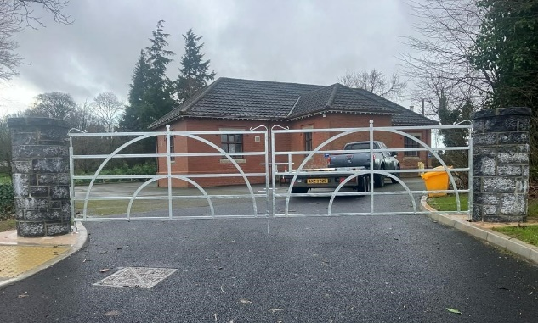

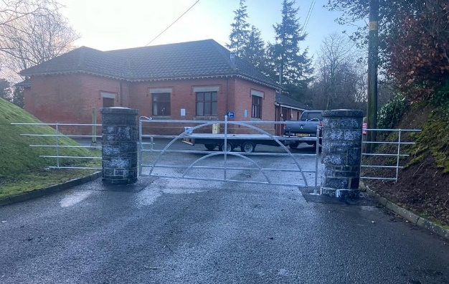
The new gates are now in place and look splendid.
The entire new entrance project has been the object of very favourable comment from both parishioners and visitors alike. The overall appearance of the site is superb. There is also real appreciation that access to and from the Hall is now so much safer.
We renew our thanks to the Builder, William Kelly and the Building Sub Committee who oversaw the long journey to completion. Our particularly grateful thanks to Dr John Erwin who meticulously guided us on our way throughout.

Dear Mothers’ Union Members and Friends,

Unfortunately, both our Branches had to cancel their January meetings on account of the snow and icy conditions.
However, in Annahilt we really enjoyed our Visitors Evening on Monday 19th February when the guest speakers were Ronnie and Maggie Briggs, formerly our Mission Partners with CMSI who have now set up a new charity called ‘Water Drops Partnership’ This project enables a working partnership with rural communities across Kenya to access clean and safe drinking water.
It was uplifting to hear about the positive outcomes of this project. A summary of what Ronnie & Maggie said is included separately.
In March, instead of meeting on the 18th which is a Bank Holiday, we will attend the Maundy Thursday Service in Church on 28th at 8.00 pm and afterwards at the Parochial Hall for refreshments.
In Magherahamlet, at our rescheduled meeting on 21 February, Lynne Green gave us a comprehensive and informative talk on her years as a Nurse over a period of almost five decades.. It was very worthwhile hearing Lynne’s changing and evolving experiences of serving the needs of so many in A&E over the years surrounding ever increasing issues in society and how they may be addressed.
Magherahamlet Branch are also reminded of the World Day of Prayer Service in Ballynahinch Methodist Church on Friday 1 March.
Both Branches are reminded of the Diocesan Festival Service on Thursday 21 March at 7.30 pm in Dromore Cathedral.

With Kind Regards to Everyone

Beth, Esme, Elaine Avril, Frances, Virginia

Introduction to ‘Water Drop’

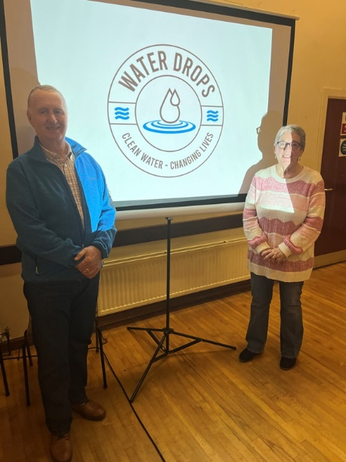
Maggie and I were delighted to be able to join with the MU on Monday 19th February. I have great memories of Annahilt as that is where I was baptized and spent my early years growing up in Sunday School and in the fellowship of the Church family.

Our contract as Mission Partners with CMSI came to an end in 2019 and shortly after that we set up a new charity called Water Drops Partnership which aims to support remote communities in the Anglican Diocese of Kajiado to have access to clean and safe drinking water.
As the meeting started we began by asking a question: ‘How far do you have to walk to get clean drinking water?’ After a moment’s thought someone said ‘Only a few feet.’ So, for most of us it is just the distance from our living room to the kitchen.
We then asked another question: ‘How far would you go to find clean drinking water? The answer to this one was a bit more difficult but we all agreed that we would go as far as was needed, because we all need drinking water for our very survival.
We went on to explain that amongst the Maasai people of Kajiado Diocese in Kenya the average distance people have to walk to find drinking water is 10 miles! We tried to imagine where 10 miles would take us if we started from the Parish Hall – the answer was Magherahamlet! Imagine having to walk that distance with 20 ltr water containers, and then carry them back full of water! This is the reality for people in Kajiado. What Water Drops is essentially trying to do is to reduce this distance by as much as possible and bring clean and safe drinking water to within easy reach for many remote communities.
Searching for drinking water in Maasai culture is the role of women and teenage girls. It is a full day’s work so the girls are not able to go to school and so lose out on the life opportunities that they should expect. Bringing a water source closer to home allows these girls to regularly attend school and opens up a more positive future for them.
Water Drops works alongside the Bishop of the Diocese and he enables us to have access to these remote communities. The Bishop is always looking for opportunities to establish new church congregations across his diocese, which is even bigger than Northern Ireland and has a very poor road network, making travel to these areas a challenge. The Bishop told us that Water Drops really helps him in his ministry. He said: ‘Water Drops makes my role of spreading the Gospel easier, as I can go with the Bible in one hand and a cup of water in the other.’ This follows along the lines of what the Apostle Paul said in Philippians 1: 3–5, when he is thanking the Philippians for their ‘Partnership in the Gospel.’ A partnership that meets the spiritual needs of people as well as their physical needs – a practical outworking of our faith.
Water Drops depends on various partnerships in order to make our work a success, and there is always room for more people and churches to partner with us – together we can make a difference.
What we all know for sure is that clean water really does change lives.
Check out our website at www.waterdrops.uk for more information on how you can help and to read of the real difference clean water can make to people’s lives.

Thank you and God bless.
Ronnie & Maggie Briggs

Midday Prayers 2024:
Transformation – Now!
March: Inspiring Women

Monday: Clothed with Strength & Dignity

Opening Words: Loving God, we come into your presence in faith and hope. Be with us as we pray and help us to listen to your Word.

The LORD is my rock, my fortress, and my deliverer, my God, my rock in whom I take refuge, my shield and the horn of my salvation, my stronghold, my refuge and my Saviour. 2 Samuel 22:2-3
Living Lord,
Open our ears to hear Your promises and open our eyes to see Your provision. May we pursue Your call, despite obstacles. May our eyes and hearts be open to recognise and encourage the gifts of others, and may we learn to be content with our weakness as much as we rejoice in your strength.
Encourage us, like Mary, to listen. Inspire us, like Martha, to serve.

Tuesday: In spite of my weakness

Opening Words: Loving God, we come into your presence in faith and hope. Be with us as we pray and help us to listen to your Word.

‘My grace is sufficient for you, for my power is made perfect in weakness.’
2 Corinthians 12:9

Prayer of personal commitment:
God of Grace,
You are familiar with all my ways and failures. Here I am, Lord, in all my brokenness and humanity.
I give myself to You.
In Your grace and mercy, make me useful in Your plan to redeem the world. Amen

Dear Lord, You created within us a capacity to love and nurture. You gave us understanding and patience in a troubled world. Walk beside us, every moment of each day.
Guide us, encourage us and lead us, to reflect more and more of your life within our own. Amen

Wednesday: Growing Membership

Opening Words: Loving God, we come into your presence in faith and hope. Be with us as we pray and help us to listen to your Word.
‘Happy are those who hear the joyful call to worship, for they will walk in the light of your presence, LORD.’ Psalm 89:14-15 NLT
Almighty Lord, thank you that we are joined together in unity through the love of Christ. Strengthen our bonds of worship and service that together we may share your love with those you bring into our lives.
‘First at the cradle and last at the cross.’ Women from every walk of life continue to inspire us. Whether we are like ‘Mary ’or ‘Martha’.
We pray to be blessed with a prayerful heart and a spirit of hope that brings encouragement and light to others.

Thursday: The Ministry of Reconciliation

Opening Words: Loving God, we come into your presence in faith and hope. Be with us as we pray and help us to listen to your Word.
‘The LORD is my light and my salvation— whom shall, I fear? The LORD is the stronghold of my life— of whom shall I be afraid? Psalm 27:1
Father, who formed humanity to live in harmony and peace; we acknowledge before you our divisions, our hatreds, injustice and greed. May we demonstrate before the world, the power of the gospel to destroy divisions, so that in Christ Jesus there may be no barriers and that all should come to know you.
Everyone a child of God, members with one another and heirs together of your everlasting kingdom.

Friday: Mothers Everywhere

Opening Words: Loving God, we come into your presence in faith and hope. Be with us as we pray and help us to listen to your Word.
‘When Jesus saw his mother and the disciple whom he loved standing beside her, he said to his mother, ‘Woman, here is your son.’ Then he said to the disciple, ‘Here is your mother.’ And from that hour the disciple took her into his own home.
John 19.25-27
Loving God, we pray for single parents, and those who have unexpectedly found themselves alone with the responsibility of raising a family.
May they know Your comfort and your companionship.

A prayer from a mother in Sri Lanka Lord, we thank you for your love and compassion to us. Whenever we face difficult situations in life, you are there to provide us strength and guidance to overcome them. Lord, we pray for your presence through all losses, trauma, and adversity we face in our daily lives.
May your guiding hand be upon us, may your strength and our faith in your presence help us to have resilience to face the future.
We pray in Jesus’s name. Amen
Uthpala Kalpage, Sri Lanka.
Heavenly Father,
Give us grace in all our family relationships. May hope be stronger than struggle, celebrations more frequent than trials, May kindness prevail over anger, and may love build bridges.
Keep us safely gathered in the love of Christ, members of your worldwide family

Saturday: Holy Ground

Opening Words: Loving God, we come into your presence in faith and hope. Be with us as we pray and help us to listen to your Word.

‘Know that the LORD, he is God! It is he who made us, and we are his; we are his people, and the sheep of his pasture.’
Psalm 100
God of creation, we give thanks for all that you have made.
We see the beauty of our planet that nurtures us. We hear your word that enlightens us.
We wonder at all you have done for us
And we pray that you will make us better stewards of the environment.

Father,
we thank you for the gift of Jesus Christ to be the Way, the Truth and the Life. As we walk the earth, the holy ground of your creation, as we breathe the air, and drink of the water of life,
Show us the way to treasure the living world for all the families of the future.

Financial matters

Thank you……

……to all who contributed to the special collections in support of the following charities:

Annahilt

Bible Society NI £ 51.00

Star NI £ 52.00

Mayor’s Charity £350.00

Dean of Belfast’s Sit Out £405.00

Save the Children £ 114.00

Leprosy Mission NI £120.00

CMSI Coffee Morning £ 115.00

Magherahamlet

Bible Society NI £ 31.00

Star NI £116.00

Romania Orphanages £182.00

Marie Curie £170.00

Leprosy Mission NI £148.00

CMSI Famine Lunch £ 200.00

LISBURN FOODBANK
The Lisburn Foodbank is providing an essential service to those within our community who are experiencing difficult times, often due to circumstances beyond their control.

The Foodbank provides emergency food and support to local people in crisis in the Lisburn area.
Parishioners may leave items for the Foodbank in the basket in Annahilt Church Porch, on the FIRST and SECOND Sunday of each month.
A particular request from the Foodbank is for cleaning items such as:
- small packs of toilet roll
- nappies
- baby wipes
- shower gel
- soaps
- washing powder

YOUR HELP WOULD BE GREATLY APPRECIATED.

Larchfield Community Development Association

Big Breakfast

Saturday 16th March 2024
10am -12.30pm

Legacurry Orange Hall
2, Glebe Road, Hillsborough,
BT26 6NE

Admission £10.00
All welcome

Lunch Club
The next time we meet will be Friday 22 March in the Pheasant at the usual time of 12.30pm.
Numbers are creeping up and it is a very relaxed and enjoyable occasion, giving retired and semi-retired members an opportunity to connect with each other. If you would like the opportunity of enjoying a lunchtime meal in the company of established friends or perhaps some new ones, do come along. Please contact Violet Swarbrigg (Telephone 028 9263 8952) for further information.

ANAHILT PRESBYTERIAN WOMEN COFFEE MORNING

Anahilt Presbyterian Women warmly invite you to their Coffee Morning to be held on Saturday 23 March 2024 from 10am until 12.30pm in Anahilt Presbyterian Church Hall.

Proceeds raised will support Presbyterian Women projects at home and abroad

Everyone welcome

Parish Website: AnnahiltAndMagherahamlet.org
Parishioners are reminded that the website annahiltandmagherahamlet.org has been created to provide information on church related activities and organisations for parishioners and the wider community. Although circumstances have changed considerably since the various lockdown periods the website continues to host online services each Sunday. It also contains a list of upcoming church services and news from our group of parishes, as well as downloadable versions of the parish magazine. The site will be continually developed, so if you have any submissions, suggestions or requests relating to the website, these can be sent to admin@annahiltandmagherahamlet.org.

www.annahiltandmagherahamlet.org

Parish Magazine
Any contributions for the next edition of the Parish Magazine should be left with the Rector or Roger Maxwell (roger.maxwell1@btinternet.com) by Sunday 10 March 2024.

Registered as a charity with The Charity Commission for Northern Ireland
NIC103246 (Annahilt) and NIC102122 (Magherahamlet.

