**News from the Parishes**



**Church of the Ascension, Annahilt Magherahamlet Parish Church**

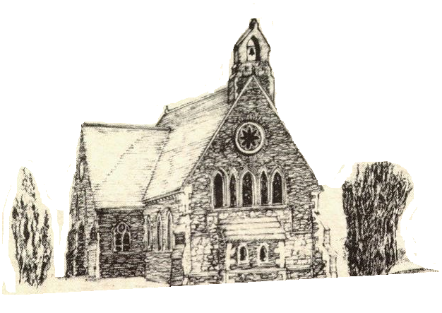

**April and May 2023**

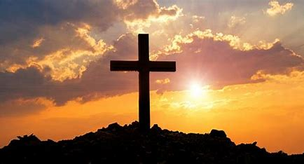

**Rector: The Revd Canon Robert Howard**

**15 Ballykeel Road, Hillsborough**

**BT26 6NW**

**Tel: 028 9263 8218**

**E-mail:** [**jrobert.howard@btinternet.com**](mailto:jrobert.howard@btinternet.com)

**Website:** [**www.annahiltandmagherahamlet.org**](http://www.annahiltandmagherahamlet.org)

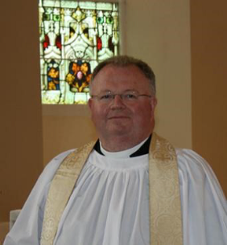**The Rector writes….**

My dear Parishioners

Do you recall any significant encounters or conversations that changed the course of your life? Perhaps it was a doctor sharing news about a diagnosis for yourself or for a family member? Maybe it was a parent or teacher sharing thoughts with you about a possible career path you had never considered before? Maybe it was a creative conversation with a friend that became a business idea and changed the direction of your life or an interview which encouraged you into making a significant choice or decision? These important encounters so often change everything for us.

I often think the season we are about to enter, the season of Holy Week and Easter, is incredibly powerful. If we make the choice or decision to come to some of our Holy Week Services there is the distinct possibility that we encounter the Lord Jesus himself in worship and that can change our perspective on everything. It might be for the first time in a personal way or maybe those occasions act like an ignition switch which reopens our eyes to His significance and importance, not only as a historical figure, but as our Lord and Saviour. Each night during Holy Week we will be using liturgies from the book ‘Week of All Weeks’ written by our former Bishop, the Right Reverend Harold Miller. I would suggest that if we engage with the events in the last week of the life of Jesus on earth, they change us in a profound way. They make us think about what is truly important and view the world differently.

On Palm Sunday, 2 April in both Annahilt (10.00 am) and Magherahamlet (12.00 noon) we especially invite children and young people and their families. On Monday 3 (in Magherahamlet), Tuesday 4 (in Annahilt), Wednesday 5 (in Magherahamlet0 and on Good Friday 7 (in Magherahamlet) each night at .8.00pm in Holy Week, I will be leading the Devotions this year. On Maundy Thursday in Annahilt also at 8.00 pm the preacher will be the Revd Bobby Liddle, Minister of Legacurry Presbyterian Church. On Easter Day, 9th April we will celebrate the resurrection of Jesus with celebrations of Holy Communion at 8.30am (in Annahilt), 10.00 am (in Annahilt) and 12.00 noon (in Magherahamlet).

I began by asking if you recall any significant and life-changing encounter that changed the course of your life made possible by the influence and friendship of someone we know and respect? Holy Week and Easter is an opportunity for us. Could we invite someone we know to these special services? Maybe someone who is searching for faith or going through a testing time? Maybe a friend who we would love to experience the kindness and goodness of God as we ourselves have received those things?

It’s a great thing to pray for people God may have placed upon our hearts. Perhaps we can be the facilitator of a life-changing encounter between that person and the Lord Jesus through our personal invitation?

Just as we look forward to the events of Holy Week, we look forward next month to a week end of events for the Church and the Community to mark the Coronation of King Charles III on 6, 7 and 8 May. Details are included elsewhere in this magazine of how we plan to celebrate locally as we anticipate a ceremonial event not seen in this country for 70 years.

Please do get in touch in the coming weeks if you would like to have Holy Communion at home before Easter and it is difficult for you to get out to services. I would be delighted to come and share that special service with you.

I wish you all a peaceful and blessed Easter

Your sincere friend and Rector

Robert Howard

**Parish of Annahilt – Easter General Vestry Meeting – Tuesday 21 March 2023**

In his remarks from the Chair, the Rector reported that In 2022 the Parish’s official membership (those households who are subscribers) stood at 111 family units. However, there are additional households who have called on the Rector’s ministrations although they have no formal link with the Parish or who wish to identify with the Parish without making any official commitment. There were two Baptisms, two Marriages and four Funerals. The Rector referred in particular to the very sad and unexpected death of Stephen Connolly. He would be fondly remembered as a gifted communicator and preacher whose ministry in the conduct of Services was greatly appreciated in our Parish.

Each of the following parochial activities implemented the advancement of religion in our community.

Worship and prayer were paramount during 2022 which contributed to the spiritual well-being of participants and the reinforcement of Christian values.

With the easing of coronavirus pandemic restrictions, a full nightly schedule of Services in Church was resumed during Holy Week. The Devotional Speaker throughout was the Revd Canon Dr Ian Ellis, retired Rector of Newcastle.

A special Service of Thanksgiving took place on the morning of 5 June to mark the Platinum Jubilee of HM The Queen with Lord Eames as preacher. In the afternoon a special interdenominational event, ‘Picnic and Praise’ took place on a glorious sunny summer afternoon in the grounds of Anahilt Primary School. The Baillie’s Mills Accordion Band led the music. Special Guests were the Mayor and the Rt Hon. Jeffrey Donaldson MP.

Later in the month members of the Select Vestries and other parishioners from both Annahilt and Magherahamlet attended Services in both Churches to mark the 40th Anniversary of the Parochial Grouping. On 11 September there was a Service of Thanksgiving for the life of Her late Majesty Queen Elizabeth II which also marked the Accession of King Charles III was held. The following week there was a special Service to mark the 70th Anniversary of The Mothers’ Union Branch in the Parish followed by a celebratory lunch in the Parochial Hall with Magherahamlet MU members who were celebrating their 60th Anniversary. The Guest of Honour was the Bishop’s wife, Mrs Hilary McClay who also preached at the Service. The traditional Harvest Festival Services were held on the last Sunday in September with the Most Revd John McDowell, Archbishop of Armagh & Primate of All Ireland preaching in the morning. The Baillie’s Mills Accordion Band led the music at the evening service. Afterwards the Harvest Supper was held in the Parochial Hall for the first time since the pandemic restrictions and was very well supported.

The Parochial Hall is a very useful facility which has again more than proved its worth in advancing Christian activity in our parish. Its use has of course continued to develop in a post-covid situation. Sunday School resumed meeting in the Hall during the Church Service. The Parish Indoor Bowling Club also resumed its normal schedule of activity. The Mothers’ Union Branch also resumed its meetings.

With the lifting of various public health restrictions, it was wonderful to hold the traditional Christmas Fair again at the beginning of December and to have the Choir of Annahilt Primary School taking part in the Christmas Carol Service.

The Report following the 2019 Quinquennial Inspection of the Church and Rectory was on the agenda of the Select Vestry and its recommendations continue to be acted upon. The tarmac at the front driveway into the Rectory was extended to double the size. A new burglar alarm was also installed in the house. The routine maintenance of the Parochial Hall continued throughout the year. The Select Vestry remain committed to the upkeep and development of all parochial property and assets for the future benefit of the Parish and the public.

Various steps were taken throughout the year to ensure that the Parish is compliant with Safeguarding and GDPR regulations.

Drawing his remarks to a close The Rector thanked all those who contributed to Parish Life throughout the year, During the meeting the Trustees Annual Report was presented by the Honorary Treasurer, Miss Patricia Halliday, the annual and triennial elections were held and light refreshments were served.

**Parish of Annahilt**

**Easter General Vestry Elections 2023 (Triennial Year)**

Rector’s Churchwarden David Brown People’s Churchwarden Stephen Chapman William Mathers Rector’s Glebewarden William Mathers People’s Glebewarden

*In addition to the above Officers, the following were elected to the Select Vestry:*

A Campbell Miss P Halliday RT Carlisle C Hassard L Clarke Mrs L Hassard Mrs E Crawford Mrs A McKeown

**Parochial Nominators**

Les Clarke

Mrs Edwina Crawford

Colin Hassard

**Supplemental Parochial Nominators**

1. Miss Patricia Halliday
2. Colin Robinette
3. Mrs Aileen Maxwell

**Diocesan Synod Representative**

Miss Patricia Halliday

**Supplemental Diocesan Synod Representative**

Mrs Edwina Crawford

**Additional Supplemental Diocesan Synod Representative (age 18-30)**

Ms Beth Wilson

**Independent Evaluator**

Steven Patterson

Colin Hassard Honorary Secretary Miss Patricia Halliday Honorary Treasurer Trevor Hill Honorary FWO Treasurer Roger Maxwell Health & Safety Officer Aubrey Campbell Parochial Insurance Mrs Avril McKeown Graveyard Secretary

**Parish of Magherahamlet – Easter General Vestry Meeting – Monday 27 March 2023**

In his remarks from the Chair the Rector reported that in 2022 the Parish’s official membership (those households who are subscribers) stood at 63 family units. However, there are additional households who have called on the Rector’s ministrations although they have no formal link with the Parish or who wish to identify with the Parish without making any official commitment. Pastoral care which generally entails visits and ministry at home and / or in hospital, especially during illness, occasions of bereavement or at other times of crisis is always provided whether people are officially members of the parish or not.

Worship and prayer were paramount during 2022 which contributed to the spiritual well-being of participants and the reinforcement of Christian values.  At the principal Sunday service, the sacrament of Holy Communion was normally celebrated monthly, an All Age / Family Service was also usually held one Sunday each month while the Office of Morning Prayer was normally conducted on other remaining Sundays. There were Services on Ash Wednesday and Ascension Day in Annahilt which were also supported by Some Magherahamlet parishioners.

With the easing of coronavirus pandemic restrictions, a full nightly schedule of Services in Church was resumed during Holy Week. (Monday to Good Friday before Easter). One had no idea what the response would be following the 2 years of pandemic restrictions. However, attendances did prove encouraging.

A special Service of Thanksgiving took place in the morning of 5 June to mark the Platinum Jubilee of HM The Queen with Lord Eames as preacher. In the afternoon a special interdenominational event, ‘Picnic and Praise’ took place on a glorious sunny summer afternoon in the grounds of Anahilt Primary School. This consisted of a ‘Songs of Praise’ type service with music led by Baillie’s Mills Accordion Band which was followed by a Picnic. This very moving and enjoyable occasion was also well supported by Parishioners and Friends from Magherahamlet. On the eve of the Jubilee Weekend, we had a magnificent celebratory Bar-b-Que here at the Hall which proved a hugely enjoyable event for all ages. The Baillie’s Mills Accordion Band entertained us very appropriately in their choice of music.

Later in the month members of the Select Vestries and other parishioners from both Annahilt and Magherahamlet attended Services in both Churches to mark the 40th Anniversary of the Parochial Grouping. On 11 September there was a Service of thanksgiving for the life of Her late Majesty Queen Elizabeth II which also marked the Accession of King Charles III. The following week there was a special Service to mark the 60th Anniversary of The Mothers’ Union Branch in the Parish followed by a celebratory lunch in Annahilt Parochial Hall with Annahilt MU members who were celebrating their 70th Anniversary. The Guest of Honour was the Bishop’s wife, Mrs Hilary McClay who also preached at the Service. The traditional Harvest Festival Services were held on the 4th Sunday in October. The Baillie’s Mills Accordion Band led the music at the evening service. It was thought to be the first occasion this Band had played at a Harvest Service in Magherahamlet and they very well received. Afterwards the Harvest Supper was held in the Parochial Hall for the first time since the pandemic restrictions and was very well supported. Unfortunately, due to circumstances beyond our control, once again it was not possible to hold the traditional Community Christmas Carol. However, on the Sunday before Christmas we did hold a Parochial Carol Service in which the Sunday School also enthusiastically participated. The presence of an electric lit star at the top of the Church Tower was a delightful addition over the Festive Period.

The Parochial Hall is a very useful facility which has again more than proved its worth in advancing Christian activity in our parish. Its use has of course continued to develop in a post-covid situation. Sunday School resumed meeting in the Hall prior to the Church Service. The Parish Indoor Badminton Club also resumed its normal schedule of activity. The Mothers’ Union Branch also resumed its meetings.

With the lifting of various public health restrictions, it had been hoped to hold the traditional Christmas Fair at the beginning of December. Unfortunately, this did not take place on account of other unforeseen circumstances.

The Report following the 2019 Quinquennial Inspection of the Church and Rectory was on the agenda of the Select Vestry and its recommendations continue to be acted upon.

Various steps were taken throughout the year to ensure that the Parish is compliant with Safeguarding and GDPR regulations.

The Rector concluded his remarks by thanking all who had contributed to parish life during the past year. During the Meeting the Trustees’ Annual Report was presented by the Honorary Treasurer Mr Hillary Edgar, the annual and triennial elections were held and light refreshments were served.

**Parish of Magherahamlet Annual General Vestry Elections (Triennial Year 2023)**

Rector’s Churchwarden Ms Abbie Stanford People’s Churchwarden Mrs Avril Burrows Rector’s Glebewarden George McCurry People’s Glebewarden Norman Hughes *In addition to the above Officers the following were elected to the Select Vestry*

Miss Virginia Begley Walter Kelly William Chambre Mrs Frances Magorrian Hillary Edgar Mrs Sally McCurry Larry Fryers Mrs Linda Vladeanu

**Parochial Nominator**

Hillary Edgar

**Supplemental Parochial Nominator**

Mrs Sally McCurry

**Diocesan Synodsperson**

Mrs Frances Magorrian

**Supplemental Diocesan Synodsperson**

Miss Virginia Begley

**Supplrmental Diocesan Synodsperson (Age 18-30)**

Charles Millsop

**Independent Evaluator** Mrs Carol Shields

Honorary Secretary Ms Abbie Stanford Honorary Treasurer Hillary Edgar

Honorary FWO Treasurer Mrs Sally McCurry

Health & Safety Officers Hillary Edgar . . Mrs Linda Vladeanu

Top of Form

Bottom of Form

**Easter Festival**



This seems an ideal opportunity to ask and answer some questions about Easter. It’s not a quiz as answers are being provided as well as questions but it will hopefully be interesting.

Easter is a Christian festival that people are very familiar with, not just Christians but people of many different faiths and none. Shops are full of Easter eggs; our schools have a holiday over the Easter period and many people who work will have extra bank holidays on Good Friday and Easter Monday. But for Christians, Easter is not about eggs and holidays, and, although we may think we know the Easter story well, it is always good to ask questions and to think of things in deeper and more challenging ways.

**WHY DOES THE DATE OF EASTER CHANGE?**

Easter falls on the first Sunday after the Paschal Full Moon — Paschal is Greek meaning Passover— which is the first full moon after the Spring Equinox. The reason for this is that the early Church wanted the feast of Easter to coincide with the Jewish Passover and because the Jewish calendar is in line with lunar cycles, the Christian festival of Easter also changes. Spring equinox is taken to be 21 March, so this year Easter is 9 April.

Easter can fall within the period from 22 March to 25 April.

**WHAT IS HOLY WEEK?**

Holy Week is the week that begins on Palm Sunday and ends on Easter Sunday. It is a journey which begins with Jesus’ triumphant entry into Jerusalem with the crowd joyfully shouting *‘Hosanna’.* Just a few days later we remember the Last Supper on Maundy Thursday. At this meal with his friends Jesus gives us the famous words that we use at Holy Communion including *‘take, eat. This is my body*’ and *‘this is my blood of the new covenant which is poured out for many for the forgiveness of sins’*. These words, commonly known as the Institution Narrative, have been used since the early church as Christians celebrate Holy Communion, and it all began that night as Jesus broke bread and poured wine the night before he died. It was also at the Last Supper that Jesus washed his disciples’ feet, a sign that he came to serve others in love.

Good Friday is when we remember Jesus’ death and the crowds are now shouting *‘crucify him’*. Often Christians observe the Last Hour from 2pm-3pm and this is a time to reflect on the words Jesus spoke on the cross before he died. Finally, we celebrate the joy of the Resurrection at the great feast of Easter, when we proclaim *‘Alleluia!’* Holy Week is a week of mixed emotions and it is an important journey for Christians each year.

**WHY DID JESUS DIE?**

A simple answer is that Jesus died to reconcile the world with God. Of course, it is more complicated than that, but we see throughout the Old Testament that God’s people repeatedly turn from him, disobey his law and turn to false idols. The world that God created in love had become a mess. Humankind had strayed from God’s way and so the world needed to be saved. Our Saviour came in the form of Jesus, who was both fully human and fully divine, God Incarnate. The question as to how Jesus’ death and resurrection achieved this reconciliation is one that has many theories and has been debated by theologians for over a thousand years!

**WHAT IS HAPPENING IN OUR CHURCHES THIS EASTER?**

There are Services throughout Holy Week, beginning with Family Services on Palm Sunday (2 April) and ending on Good Friday with the Tenebrae Service in Magherahamlet on Good Friday evening (7 April). There will be Services on Easter Day (9 April)

**Saint Mark's Easter Prelude**

*By Bob Peter*

*Mark's story (10:45-52) of the miraculous healing of a blind man near the city gates of Jericho, stands out from other miracles performed by Jesus because Mark tells us the name of the person being healed – Bartimaeus, it means the son of Timaeus.*

Why Mark named him is a mystery because neither Bartimaeus nor Timaeus are mentioned anywhere else in the Bible. We can only assume that he was a well-known beggar who had a regular pitch just outside the city.

When I visited Jericho in 1996 I was disappointed because, unlike most towns and cities in Israel, which were lively and welcoming, Jericho seemed to be very hostile and unwelcoming. I was relieved when the visit was over. If Jericho was like that in the time of Jesus, I’m sure that Bartimaeus would have had an unimaginably hard life as a blind beggar.

**ON THE ROAD TO JERUSALEM**

The point of Mark’s story is not about who Bartimaeus was, but how he responded after Jesus told his disciples to call him. Bartimaeus recognised Jesus as the Messiah, the Son of David, and when he was called, he immediately threw aside his cloak, which was probably the only thing he owned of any worldly value, and he went to meet Jesus who promptly changed his life by giving him sight. Bartimaeus then follows Jesus along the road. If you read on you will see that the road was taking Jesus, his followers, and Bartimaeus, to Jerusalem where Jesus was to be welcomed first as a King and a week later crucified alongside two thieves. Mark's story of Bartimaeus is a prelude to Easter. Mark sets out a clear pattern for our Christian lives. We must first recognise Jesus as the Son of God, we must recognise his call, and place our faith in God, rather than in worldly possessions, and then follow him.

For Bartimaeus, his response was instant. I would guess for most of us that it took, or maybe, is still taking, much longer to respond. One of my great regrets is that while I recognised Jesus as the Son of God at an early age, I did not recognise God’s call or respond in the way that Bartimaeus did. It took me many years before I found the right road to follow him along and something I discovered is that it is not always the road you plan. God, I have found, likes to challenge us in ways that we think are impossible so we must rely totally on him rather than on ourselves or the world around us. Have you found the right road for you yet?

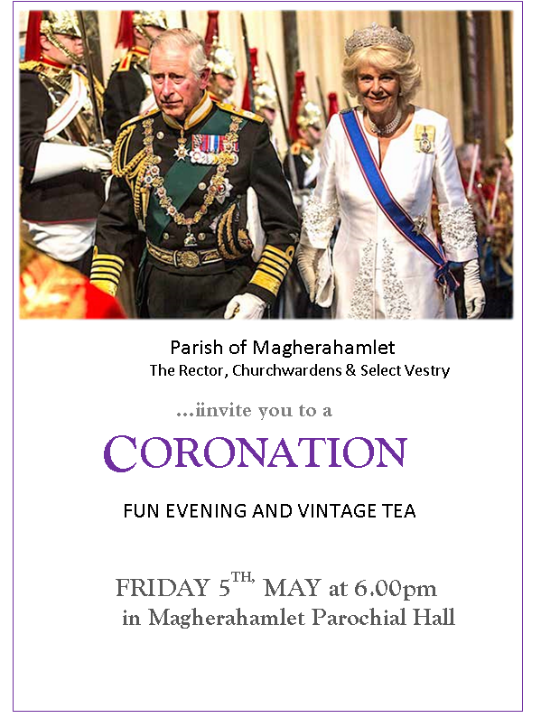

**Parish of Annahilt**

The Rector, Churchwardens & Select Vestry invite you to a **SERVICE TO CELEBRATE THE CORONATION of HIS MAJESTY KING CHARLES III** on **SUNDAY 7 MAY 2023** at **3.00 pm** in **THE CHURCH OF THE ASCENSION, ANNAHILT** Preacher: **THE RT REVD THE LORD EAMES OF ARMAGH** Music led by BAILLIES MILLS ACCORDION BAND followed by **PICNIC AT LARCHFIELD** (by kind permission)*Please bring your own food* ***ALL WELCOME***



*Annahilt and Magherahamlet Events for the Coronation weekend*

**Eve of Coronation Friday 5 May**

A Fun Evening and Vintage Tea Party will be held in Magherahamlet Parochial Hall beginning at **6.00 pm**

**Coronation Day Saturday 6 May**

The Coronation Ceremony of King Charles III will be televised and it is being anticipated that many people will wish to view the event in their own homes. Those wishing to view the event with their family, friends and neighbours may see it on the Big Screen in Market Square, Lisburn.

**Sunday 7 May — Celebration Church Services, followed by Picnic**

There will be Celebration Services in **Magherahamlet** Parish Church at **11.00 am** on Sunday morning and in the Church of the Ascension, **Annahilt** at **3.00 pm** on Sunday afternoon when Lord Eames, will be preaching. Lord Eames was Bishop of Down & Dromore from 1980 to 1986 and subsequently Archbishop of Armagh from 1986 - 2006. In retirement he & Lady Eames have been good friends to the Group of Parishes, regularly worshipping in both our Churches where they are always welcome visitors. The last time Lord Eames preached in Annahilt & Magherahamlet was on the occasion of the Platinum Jubilee of Her late Majesty Queen Elizabeth II last year.

Larchfield Estate will be open for individuals and families to get together following the Service in Annahilt. **Please bring your own picnic.**

The Bailies Mills Accordion Band will lead the Singing at the Service and also provide entertainment at Larchfield.

**PRAYERS  
  
For the King**

*(Based on a prayer in the 1953 Coronation Service)*

Lord God, in your power you provide for your people and rule over them in love:

Grant to your servant Charles, our King, the spirit of wisdom and government,

that being devoted to you with his whole heart, he may so wisely govern,

that during his reign your church may be protected, and Christian devotion may continue in peace;

that so persevering in good works to the end, he may by your mercy enter your everlasting kingdom;

through Jesus Christ, your Son, our Lord, who lives and reigns with you in the unity of the Holy Spirit,

one God now and for ever. **Amen.**

*(Based on a prayer from the Jubilee Resources)*

Lord God, the Ancient of Days, you are sovereign over all your people;  
Give to His Majesty, King Charles enduring wisdom and faith  
in the service of the people of this land and of you, his Lord and Master.

Grant that his faithful witness may be to others a source of hope,  
that they may come to know more fully your Son Jesus Christ,  
who is alive and reigns with you and the Holy Spirit,

one God, now and for ever. **Amen.**

**For the Queen Consort**

*(Based on a prayer in the 1953 Coronation Service)*

Almighty God, the fountain of all goodness:

hear our prayer and multiply your blessings

upon your servant Camilla, the Queen Consort  
as she offers herself with humble devotion to your service.

Defend her from all danger,

make her an example of virtue and godliness

and a blessing to the King and to his people;

through Jesus Christ our Lord,

who lives and reigns with you

in the unity of the Holy Spirit,

one God, world without end. **Amen.**

**I Was Glad**

*By Les Ryan, Mumbles Ministry, Swansea*

***Sir Charles Hubert Hastings Parry (18481918) is famous for several religious works: for example, the music for the hymn Jerusalem, the Coronation Anthem, I was glad, and the lovely tune Repton to the words Dear Lord and father of mankind.***

Parry was born in Bournemouth to a wealthy family. He attended *Public Domain* Eton and then Exeter College, Oxford. He had set his eyes on a business career and read Law and Modern History. However, music soon took over his life. He became an assistant editor writing 123 articles for the ground-breaking *Dictionary of Music and Musicians* compiled by George Grove.

By the 1880s Parry was Professor of Composition at the Royal College of Music and in 1895 became its principal. At the same time, he was also Heather Professor of Music at Oxford. An exceptional honour. Parry’s hobby when he was not involved in music was sailing and he became a member of the Royal Yacht Squadron – quite an achievement!

***DOUBLE CHOIR***

All Coronation services, since King Charles I in 1626, have featured a choral setting of words from Psalm 122 — *I was glad when they said unto me let us go unto the House of the Lord —* to be sung as an anthem when the monarch arrived at the west door of Westminster Abbey.

Parry’s majestic anthem was composed for King Edward VII in 1902 and revised for King George V in 1911 with additional brass and organ fanfares. The music features a double choir — two sections of sopranos, two of altos etc — organ and orchestra. The music has an overwhelming feeling of grandeur and empire.

Parry’s innovation in this piece was the addition of the Latin acclamations *Vivat Rex* — Long live the King — or *Vivat Regina* — Long live the Queen — which traditionally are sung, or rather, shouted, by scholars of Westminster School.

Not everything runs smoothly at these great national events. For example, one of Handel’s Coronation anthems in 1717 for King George II and Queen Caroline ended in confusion we are told, while another of the anthems in the order of service was left out altogether! In 1902, *I was glad* finished too early in the service. The King hadn’t arrived, so the quick-thinking organist improvised some tunes on the spot until King Edward VII turned up, rather late! Then the anthem was sung again!

More recently, in 2011, *I was glad* was sung for the bridal procession of Catherine Middleton at her marriage to Prince William. It had also been sung at the wedding of Prince Charles and Diana in 1981.

In 1898 Parry was appointed a Knight Bachelor and in the 1902 Coronation honours he was created a Baronet of Higham Court.

Parry died after catching Spanish flu in the 1918 pandemic



***PRAYER WARRIOR***

Do you have a concern or problem and would like someone to pray for you?

If so, contact the Rector who will be willing to help.

This is completely confidential and no details will be passed on to anyone else unless you want them to.

**028 9263 8218**

**Church Services in the Parishes of Annahilt and Magherahamlet**

*‘I was glad when they said to me: “Let us go to the house of the Lord”’*

Sunday 2 April **Lent VI (Palm Sunday)**

10.00 Family Communion Annahilt *Service Sheets*

12.00 Family Service Magherahamlet *Service Sheets*

*During Holy Week on Monday 3, Tuesday 4, Wednesday 5 & Good Friday 7 April there will be a series of addresses given by the Rector. On Maundy Thursday 6 the Preacher will be The Revd Bobby Liddle, Minister of Legacurry Presbyterian Church*

**Monday**

8.00 pm Evening Service Magherahamlet *Service Sheets*

‘Leave her alone. She is telling the truth’ **Tuesday**

8.00 pm Evening Service Annahilt *Service Sheets*

‘Let’s go into Jesus’

**Wednesday**

8.00 pm Evening Service Magherahamlet *Service Sheets*

‘Love and Betrayal’

**Maundy Thursday** *Commemoration of the Institution of the Lord’s Supper*

8.00 pm Holy Communion Annahilt *Service Sheets*

‘Remember’

*followed by Light Refreshments in the Parochial Hall*

**Good Friday**

8.00 pm Tenebrae Service Magherahamlet *Service Sheets*

‘The Hour has come’

Sunday 9 April **Easter Day**

8.30 Holy Communion Annahilt

10.00 Parish Communion Annahilt *Service Sheets*

12.00 Parish Communion Magherahamlet *Service Sheets*

Sunday 16 April **Easter II**

10.00 ‘Risen with Christ’ Annahilt *Service Sheets*

*An Easter Devotion of Readings and Hymns*

12.00 ‘Risen with Christ’ Magherahamlet *Service Sheets*

*An Easter Devotion of Readings and Hymns*

Sunday 23 April **Easter III**

10.00 Parish Communion Annahilt

12.00 Morning Prayer Magherahamlet

Sunday 30 April **Easter IV**

10.00 Morning Prayer & Litany Annahilt

12.00 Morning Prayer & Litany Magherahamlet

Sunday 7 May **Easter V**

*Coronation of Their Majesties The King and Queen Consort*

10.00***No*** *Service in Annahilt*

**11.00** am Parish Communion Magherahamlet

Preacher: The Rt Revd the Lord Eames of Armagh

**3.00 pm** Service of Celebration Annahilt

Preacher: The Rt Revd the Lord Eames of Armagh

Music led by Baillies’ Mills Accordion Band

*followed by Picnic at Larchfield (by kind permission)*

Sunday 14 May **Easter V**I (**Rogation Sunday)** *Launch of* *Christian Aid Week*

10.00 Family Service Annahilt

*followed by Light Refreshments in the Parochial Hall*

12.00 Family Service Magherahamlet

Thursday 18 May **Ascension Day**

**7.30 pm** Holy Communion Annahilt

Sunday 21 May S**unday after Ascension Day**

10.00 Morning Prayer Annahilt

12.00 Morning Prayer Magherahamlet

Sunday 28 May **Pentecost**

10.00 Parish Communion Annahilt

12.00 Parish Communion Magherahamlet

Sunday 4 June **Trinity Sunday**

10.00 Parish Communion Annahilt

12.00 Morning Prayer Magherahamlet

**GOOD FRIDAY TENEBRAE SERVICE 8.00 pm**

What is a Tenebrae Service? The word ‘tenebrae’ is Latin for shadows. The purpose of the Tenebrae service is to recreate the emotional aspects of the passion story and is one of solemnity.

The service is specially designed for Good Friday. It contains appropriate hymns, a sermon and several scripture readings. The church is in candlelight for the Tenebrae service. There are as many candles as there are readings, plus a white candle. As each reading is read a single candle is extinguished until only the white candle (representing the light of Christ) remains. Then the white candle is put out, leaving the congregation in near total darkness— and near total devastation. At this point, the service ends. There is no benediction and the Service ends in silence.

The purpose of the service is to recreate the betrayal, abandonment, and agony of the events and it is left unfinished, because the story isn’t over until Easter Day.

This service has been experienced in our Group of Parishes on Good Friday for 14 consecutive years and has been very well received.

The Tenebrae Service will take place on Good Friday evening, 7 April at **8.00 pm.** Following the usual schedule of rotation between our two Churches it will take place this year in **Magherahamlet**. However, it is, as always, very much a Group occasion for the parishioners of both Annahilt and Magherahamlet. Let us bring our Holy Week observances to a worthy climax this year with a full attendance on Good Friday evening.

**

**CHRISTIAN AID WEEK 14-20 MAY 2023**

Hello Robert & all Christian Aid supporters in Annahilt and Magherahamlet

Momentum is starting to build. Orders are coming in. Peas are being souped! Christian Aid Week 2023 is just around the corner and we’re praying for another incredible week during which we will see an outpouring of generosity from churches and communities across Northern Ireland and the Republic. Our team is here to support you as you prepare for the big week, so please let us know if there’s anything we can do to help – we couldn’t do Christian Aid Week without you.

Once again, thank you for all that you are doing and will do this Christian Aid Week. We are so blessed to have volunteers, reps and organisers, like you, who enable us to provide much-needed emergency relief and deliver long-term development projects in some of the most vulnerable communities around the world.

With every blessing,

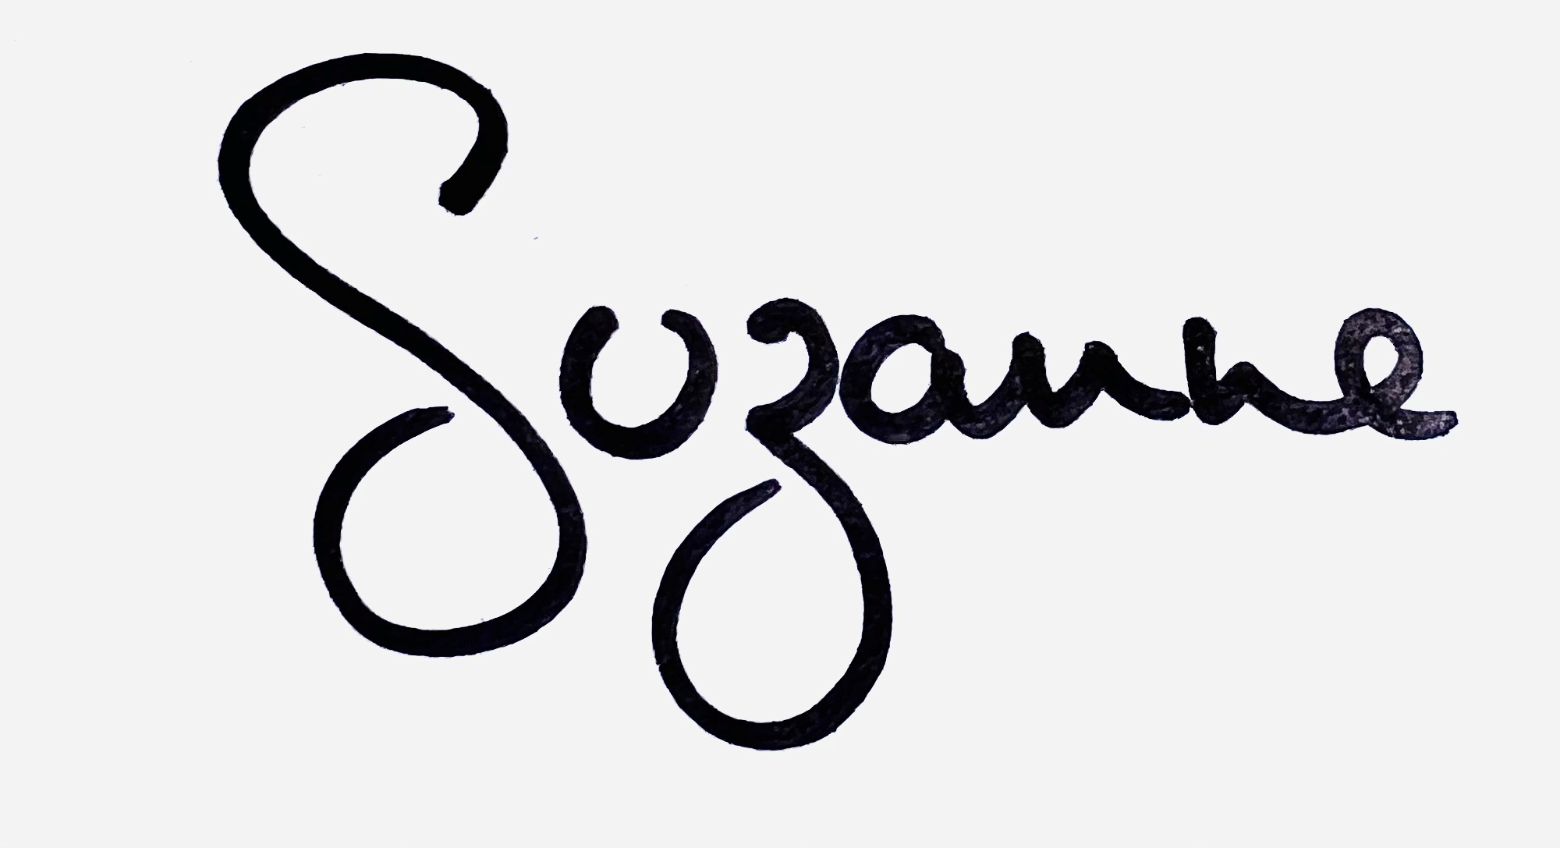

Suzanne Simpson

**Church Fundraising Project Officer**

**Christian Aid Ireland**

|  |
| --- |
|  |

**Flowers for the Churches**

**Annahilt Magherahamlet**

**April**

2

9 Mrs Alison Harrison-Mitchell Easter

16

23

30 Mrs L Anderson



**May**

7 The Rector The Rector

14

21 Mrs B Oliver Mrs F Magorrian

28

29 The Rector The Rector

**Church Cleaning, Annahilt**

**April**

1 Mrs A Maxwell Mr R Maxwell

7-8 Mrs H Hill Mr T Hill

14-15 Mrs L McCambley Mrs E Harrison

20-21 Mrs E Crawford

28-29 Mrs J Guiney Mrs H Cardosi

**May**

5 -6 Mrs E Ogle

12-13 Mrs A Maxwell Mr R Maxwell

19-20 Mrs J Bolas Mr A Bolas

26-27 Mrs H Hill Mr T Hill

**June**

2-3 Mrs L McCambley Mrs E Harrison

9-10 Mrs E Crawford

16-17 Mrs J Guiney Mrs H Cardosi

23-24 Mrs E Crawford

**July**

1 Mrs E Ogle



Dear All

At our March meeting of Annahilt Mothers’ Union we were delighted to have a good turnout of members. Our first task was to assemble Toiletry bags for donation to Hospitals and Refuges. A total of 40 filled bags have been delivered to Clare Stewart of MU Action and Outreach. She will make sure that they go to where they are needed most. Everyone present then focused their attention on planning the MU programme for the next three months.

On 6th April Mothers’ Union members will attend the Maundy Thursday Holy Week service in Annahilt Parish Church at 8.00 pm and all members of the congregation are invited to light refreshments in the Parochial Hall afterwards.

On Saturday 20th May between 11am-2pm there will be an opportunity to take a tour of Hillsborough Castle or spend time exploring the grounds or gardens.

The month of June will be the last meeting before the summer break and will be an ideal time for everyone to get together for a meal in the Millbrook Lodge Hotel. Suggested dates are Wednesday 14th or 21st at 7.30 pm and details will be finalised nearer to the time.

Please contact Esme at [esmeogle@gmail.com](mailto:esmeogle@gmail.com) or 07748736622 if you have any further queries.

On the Wednesday in Holy Week, 5 April at 8.00 pm members of the Magherahamlet Branch will attend the mid-week in Magherahamlet Parish Church. We are looking forward to our annual Dinner with Dromara Branch on Wednesday evening 24 May. Menus will be circulated in due course.

We very deeply regret the recent death of Mrs Ida Adair at the grand age of 100. We extend our deep sympathy to her daughter Jen, son-in-law David, grandsons and other family members in their great loss.

With Kind Regards,

Beth Avril Esme Frances

**Avril (Burrows)**



**Mothers’ Union - Midday Prayers - April 2023 Encounters with Jesus**

**Monday**: **The betrayal of Judas**

**in this moment, in our hearts, may we encounter afresh our loving Saviour.**

Jesus asked him, “Judas, are you betraying the Son of Man with a kiss?” ***Luke 22:48***

Lord, how could you bear the hate of betrayal expressed though a symbol of love?

We weep at the deed of a faithless friend.

And yet...

Daily we betray you afresh in deeds and words and silence. We sully the gift of your friendship through our kiss of faithlessness. We marvel at your love for us; constant despite our weaknesses and the poverty of our discipleship. Forgive us, loving Saviour. Accept our thanksgiving, and strengthen us to live our lives in total devotion to you. Amen.

**May our lives bear witness to an encounter with our loving Saviour.**

**Amen.**

**Tuesday: The abdication of Pilate**

**in this moment, in our hearts, may we encounter afresh our loving Saviour.**

Pilate took water and washed his hands in front of the crowd. “I am innocent of this man’s blood,” he said. “It is your responsibility!” ***Matthew 27:24***

When we wash our hands of your commission to us; when we turn aside from your people in need. When we pass the buck, when we close our eyes, we mirror the past; we shun you afresh. **Forgive us, dear Saviour,** and **renew our hearts.**

May we stand before you with hands open wide, ready to embrace your precious commission. For your burden is easy, your load is light, and your presence gives rest to our souls. **Inspire us, dear Saviour,** and **renew our hearts.**

**May our lives bear witness to an encounter with our loving Saviour.**

**Amen.**

**Wednesday: The revelation of the Soldier.**

**In this moment, in our hearts, may we encounter afresh our loving Saviour.**

When the centurion, who stood there in front of Jesus, saw how he died, he said, “Surely this man was the Son of God!”

**Mark 15:39**

Let our eyes behold the truth; let our lips declare the truth; this **man is the Son of God.**

Let our actions arise from the truth; let our lives bear witness to the truth; this **man is the Son of God.**

Open the eyes of those blinded to the truth; soften the hearts of those hardened to the truth; that together we may proclaim, throughout heaven and on earth: **this man is the Son of God.**  **May our lives bear witness to an encounter with our loving Saviour.**

**Amen.**

**Thursday: The joy of Mary**

**in this moment, in our hearts,** may **we encounter afresh our risen Lord.**

Mary Magdalene went to the disciples with the news: “I have seen the Lord!” ***John 20:18***

Risen Lord, open our eyes.

Give us a glimpse of your resurrection glory. Wipe away our tears of mourning; fill us with joy in your presence. Take away our spirit of heaviness; clothe us with a garment of praise. And send us out to spread the news: the Lord is risen.

Hope has been renewed; joy has been rekindled.

Death has been defeated; eternity beckons.

**The Lord is risen.**  **Hallelujah!**

**Glory to our God.**

**May our lives bear witness to an encounter with our risen Lord.**

**Amen.**

**Friday: The doubt of Thomas.**

**In this moment, in our hearts,** may **we encounter afresh our risen Lord.**  Jesus told him, “Because you have seen me, you have believed; blessed are those who have not seen and yet have believed.” ***John 20:29***

We pray for those whose faith is tested through trials of life; through challenging times. **As they struggle to believe,** help **them in their unbelief.**  We pray for those whose faith is tested through the mysteries of unanswered prayer; As **they struggle to believe,** help **them in their unbelief.**

We pray for those whose faith is tested in the face of suffering and pain. **As they struggle to believe,** help **them in their unbelief.**  When doubts fill our hearts; when faith dims and certainty fades;

**Lord, we believe; help us in our unbelief.** **May our lives bear witness to an encounter with our risen Lord.**

**Amen.**

**Saturday: The restoration of Peter.**

**In this moment, in our hearts,** may **we encounter afresh our risen Lord.**  Jesus said, “Simon son of John, do you truly love me?” He answered, “Yes, Lord, you know that I love you.” Jesus said, “Take care of my sheep.”

**John 21:16**

We hide in the shadow of our faithlessness & sin; We whisper our love for our Lord. We bathe in the light of forgiveness and mercy; We speak out our love for our Lord. We revel in the glow of restoration; We shout out our love for our Lord. Anyone who belongs to Christ has become a new person. The old life is gone; a new life has begun!

**2 Corinthians 5: 17**

**May our lives bear witness to an encounter with our risen Lord.**

**Amen.**

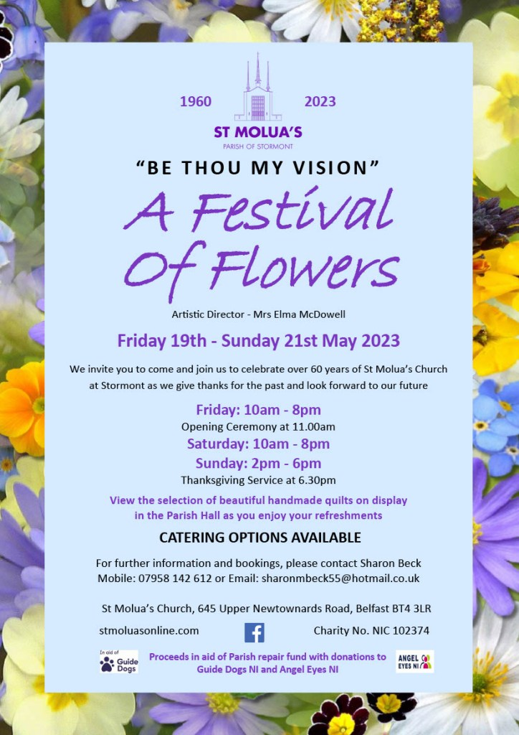

**Recording of Services**

During the Pandemic most were able to benefit from the audio recordings of our pre-recorded Services either online via the website or from a CD recording. Now, Services recorded in Annahilt on Sundays and other special occasions are later transmitted on line. Alternatively, CD recordings are transmitted.

If you are unable to attend Church in person, we hope that you are availing of one of the methods of listening to the services. If you require any advice on locating the website or audio recording on your device (phone/tablet/laptop) or would like a CD copy please do not hesitate to contact the Rector on 028 9263 8218.

We are indebted to Colin Robinette and William Mathers who make this possible.

**Annahilt Annual Report**

The Trustees Annual Report including Parish Accounts is now available to view on the Parish Website. Due to printing costs these will not be circulated to the Parish with the magazine however if anyone would like a paper copy, please contact Patricia on 028 92665310 or 07713 257 691 and she will provide you with one.

**LISBURN FOODBANK**

The Lisburn Foodbank is providing an essential service to those within our community who are experiencing difficult times, often due to circumstances beyond their control.

The Foodbank provides emergency food and support to local people in crisis in the Lisburn area.

Parishioners may leave items for the Foodbank in the basket in Annahilt Church Porch, on the FIRST and SECOND Sunday of each month.

A particular request from the Foodbank is for items listed below:

Cleaning products

Nappies

Sugar

Tea

Coffee

Biscuits

Rice Pudding

**YOUR HELP WOULD BE GREATLY APPRECIATED**.

**Parish Website:  AnnahiltAndMagherahamlet.org**

Parishioners are reminded that the website [annahiltandmagherahamlet.org](http://annahiltandmagherahamlet.org/) has been created to provide information on church related activities and organisations for parishioners and the wider community. Although circumstances have changed considerably since the various lockdown periods the website continues to host online services each Sunday. It also contains a list of upcoming church services and news from our group of parishes, as well as downloadable versions of the parish magazine.  The site will be continually developed, so if you have any submissions, suggestions or requests relating to the website, these can be sent to [admin@annahiltandmagherahamlet.org](mailto:admin@annahiltandmagherahamlet.org).



[www.annahiltandmagherahamlet.org](http://www.annahiltandmagherahamlet.org)

**Parish Magazine**

Any contribution for the next edition of the Parish Magazine should be left with the Rector or Roger Maxwell ([roger.maxwell1@btinternet.com](mailto:roger.maxwell1@btinternet.com)) by Sunday 21 May 2023.

Registered as a charity with The Charity Commission for Northern Ireland

NIC103246 (Annahilt) and NIC102122 (Magherahamlet*.*

Top of Form