News from the Parishes
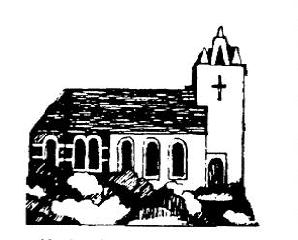
Church of the Ascension, Annahilt Magherahamlet Parish Church
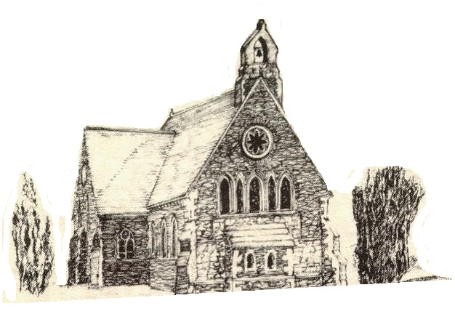

February 2021

Rector: The Revd Canon Robert Howard
15 Ballykeel Road, Hillsborough
BT26 6NW
Tel: 028 9263 8218
E-mail: jrobert.howard@btinternet.com
Website: www.annahiltandmagherahamlet.org

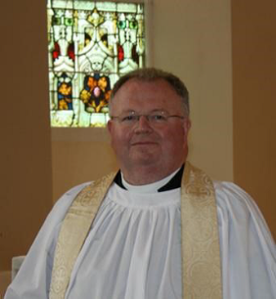The Rector writes….

My dear Parishioners

It is a long established practise going back over 150 years that the President of the United States who is about to leave office attends the Inauguration of his successor. In a not altogether surprising move outgoing President Donald Trump chose not to be present at the recent swearing in of the incoming President Joe Biden.
It is also usual for all living former Presidents to be invited to the ceremony. All bar one of these previous Presidents Bill Clinton, George W Bush and Barak Obama were present. However, former President Jimmy Carter was not, the first such event he has not attended in person since the completion of his term in 1981. Jimmy Carter is, of course, a man very senior in years. At 95 years of age, he clearly thought it unwise to make the challenging journey from Plains, Georgia to Washington, DC for an outdoor ceremony in the stabbing cold weather conditions in the middle of winter.
In addition, Mr Carter had brain cancer in 2015. He broke a hip in May 2019. Very recently, he fell at home requiring 19 stitches. Nevertheless, he showed up the next day to help build houses for Habitat for Humanity.
That significant gesture pointed out some of the important qualities of character that are part of President Carter’s approach to life. Whatever we might think of his policies or his presidency, it’s interesting to see that in retirement, he has dedicated his time to working with Habitat for Humanity, building houses and accommodation for families on low incomes who otherwise would not be able to afford them. Jimmy Carter is a man whose Christian faith has always informed his approach to life and indeed he left the denomination of his upbringing because of their position on not allowing women into leadership positions in the church. He believed it was a violation of human rights. Therefore, despite being a member for over 85 years, he made the decision to sever his ties with the denomination about 5 years ago.
As we journey into another lockdown and our church buildings are closed once more for public worship, there are some things I think President Carter can show us that are important.
The first is a willingness to serve. At the age of 95 he might well expect to take things a bit easier. Instead, as long as he has the skills and the energy, he wishes to dedicate his life to helping those less fortunate than himself. He could pursue more lucrative and high profile positions. There would be possibilities, one might imagine, in serving on the board of corporations or delivering lectures or writing books but he has chosen to live in relative anonymity helping out on these housing projects with Habitat for Humanity as a volunteer.
The second is the importance of character and principle. It can’t have been an easy decision to leave the denomination he had been part of all his life but when they took decisions he believed to be contrary to the way of Jesus, he was prepared to sever his connection.
We may really admire the character of someone who having overcome brain cancer and a broken hip in old age was not prepared to let a fall and stitches prevent him from showing up to do more work on a Monday morning when undoubtedly his body must have been sore and stiff but he could see the value of the work and how it might make a difference.
We may also draw on some of the ideas of that renowned church reformer Martin Luther. He spoke of the priesthood of all believers and argued that our baptism was essentially the occasion of our ordination. It was the point when we were set apart to do God’s work in the world. What that meant in practice for Luther, was doing whatever we normally do, with one difference. We no longer do it for ourselves or our employer but we do it for God.
He described our hands as being God’s hands whether those hands are operating a computer, making a meal, changing a nappy, tending the land or whether we are running a company, trying to home school our family or keep people safe during a global pandemic. He spoke about people who pray and intercede for others. We think about these things in a time of a global pandemic. How can we lead the church more effectively during a time of lockdown? Is it about setting people free to see what they can do for God? Is it about inviting more people who may now have more time through the circumstances we are in to pray for others, to care for others through phone calls or cards? Is it about providing tools and training to build up confidence to do whatever it is you do each day in God’s name and for God’s glory?
We have so many amazing volunteers in our community who have been doing incredible work over this past year but it takes the whole congregation to catch the vision and widen the impact of Christ’s love on the world around us. If any of us are spared to the age of 95 wouldn’t it be great to have something of the character of Jimmy Carter, to be willing to use whatever skills we might have in the service of others?. Wouldn’t it be wonderful to have the courage of our convictions and speak up and act wherever we believe there to be injustice? Wouldn’t it be powerful to simply keep showing up and doing the little we could for God and for His glory?
This month sees the beginning of the season of Lent and while we are not sure how our Lenten services will look just yet, we do have on-going opportunities of remembering our present and ongoing situation in prayer.

In the first instance, in the light of 1 in 11 households in Northern Ireland being unwell with COVID-19 related symptoms, do pray for people who need our prayers at the present time. Pray for public figures like our Government and our scientific and medical advisers. Pray for our NHS workers, retail workers and delivery drivers who are providing essential services alongside those working in education, those trying to police the present lockdown and the many hidden unknown people who are continuing to shield and isolate and live in fear in the current pandemic. Pray for our economy, for those who are furloughed or who have lost employment and are suffering financially. Let us be part of a praying community even if that very act is hidden from everyone else as we journey forward together in faith.

Your sincere friend and Rector

Robert Howard

Congratulations....

.....to Miss Rachel Cromie, Magherahamlet who recently celebrated her 92nd birthday
….to Derek Capper on being awarded the MBE in the recent New Year’s Honours List for services to young people. Derek served as Principal of Anahilt Primary School for 32 years. In total he worked in education for 46 years. Over this period Derek was also involved in various other organisations such as the Scouts, Stranmillis College and the Youth Council of Northern Ireland.
As a Group of Parishes, we join with Derek’s family and friends and all his former colleagues and past pupils in congratulating him on attaining this very high honour.

Memories of Christmas 2020

It was a very different celebration of Christmas last year on account of the various public health restrictions. Nevertheless all who attended and supported the various seasonal events in our Group of Parishes were very appreciative of everything that took place.
Unfortunately it was not practical for the Sunday Schools to hold their traditional Nativity Pageants. However, the Christingle services which took place in both Churches on 13 December went very well. As in recent years the wrapped presents generously given by families in both parishes were distributed afterwards to those in need by NSPCC.
On Sunday 20 December in the afternoon there was the Festival of Nine Lessons and Carols in Annahilt The music was led by Mr Timothy Wilson on the Organ along with his wife Ruth and two soloists. The lessons were read by representatives of the parochial organisations.
Regretfully it was not possible to have the usual United Carol Service in Magherahamlet this year. Instead a parochial carol service was held in the Parish Church on the morning of 20 December. The music, led by the Organist Mrs Frances Magorrian, consisted of many traditional congregational carols and a solo item.
The First Communion of Christmas was celebrated in Annahilt with representation from parishioners of ‘the Glebe’ and also from the Congregation of Legacurry Presbyterian Church and their Minister, the Revd Bobby Liddle preaching. A reciprocal visit to Legacurry followed on 31 December for the New Year’s Eve Watchnight Service at which the Rector preached. Both congregations were represented at this service also.
The customary Christmas Day Family Service in Annahilt and the Parish Communion Service in Magherahamlet also took place.
To all who contributed in any way we say ‘well done’ and a sincere ‘thank you’. The very positive feedback from parishioners has been very much appreciated.

Letter from NSPCC, Northern Ireland
Dear Canon Howard
On behalf of NSPCC I would like to take this opportunity to express our deep appreciation for the Christmas gifts which were donated by the parishioners of Annahilt and Magherahamlet. We would also wish to extend our heartfelt thanks to yourself and your Sunday Schools for organising the Gift Services and kindly permitting NSPCC to be the indebted beneficiaries of such tremendous generosity such as is displayed year by year by your congregations.
I have no doubt the children, young people and families who will receive the gifts would wish me to send their sincere thanks also.
With warmest wishes
Ruth Hills
Children’s Services Practitioner

Revision of Register of Vestrypersons 2021
Have you registered?
Please note that the annual review of the Register of Vestrypersons in both parishes will be carried out in February.
Any person aged 18 years or over and who subscribes to Parish funds and wishes to be registered as a resident or as an accustomed member must complete a Form of Declaration. Registration means you can vote and / or stand for office when elections for the incoming Churchwardens or Select Vestry take place.
Due to the COVID-19 restrictions which will curtail church worship during February, the forms for registration will be available on the Parish Website, and from the Secretary to the Select Vestry whose e-mail address is
Colin Hassard (Annahilt) secretary.annahilt@annahiltandmagherahamlet.org ; Abbie Stanford (Magherahamlet) abigailstanford@btinternet.com
Completed forms must be returned to the Secretary to the Select Vestry, preferably by e-mail, before the date of the meeting – Wednesday 24 February (Annahilt) Thursday 25 February (Magherahamlet).
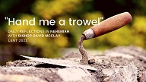
Introduction to Bishop David McClay’s Lent Series

This Lent, you are invited join the Bishop for a series of daily reflections in Nehemiah. The diocese will be sharing a short film online every day from Ash Wednesday 17 February, to Palm Sunday 28 March.
The Bishop explains why he has named the series, “Hand me a trowel”.
“My father was a farmer and not a builder, but as a young boy I remember him rolling up his sleeves and doing a lot of building around the farm. I would be hanging around at the foot of a ladder as my Dad was building, and he would shout down the ladder to me, ‘Hand me a trowel.’
“That’s the sort of picture we have in the Book of Nehemiah. Everybody’s involved in the work of building. They may not actually be builders, but they roll up their sleeves and they’re involved in this important work of building a people for God.
“’Hand me a trowel.’ I think God is saying this to us in the Church today. God wants us to be those who have an open hand and open hearts to work for his kingdom and to build a Church that is strong and healthy for these days.
“We need to be getting ready for a season of building and rebuilding. As we all get vaccinated and, hopefully, emerge back out into our churches and into the world to live for Christ, our prayer to God should be, ‘Lord, hand me a trowel. I want to be one of your workers, help me to be one of your builders.’”

Captain Sir Tom Moore 1920-2021

In memory of Captain Sir Tom Moore, who captured the hearts of the nation by walking 100 laps of his garden last spring, raising money for NHS Charities Together. His initial target was £1000 but he eventually raised almost £33 million and was knighted by HM The Queen in July 2020.

Church Missionary Society Children’s Resource 2021

CMSI’s Children’s Resource is specially produced each year for Sunday schools and youth groups in Ireland. It provides original and creative material for at least four sessions with four different age groups.
It’s an ideal resource for churches who want to encourage a greater interest in global mission.

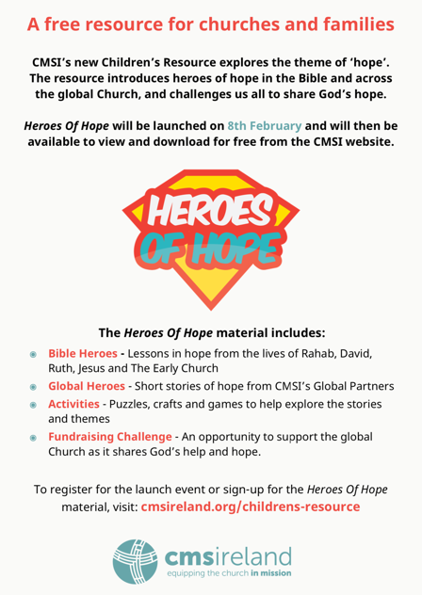

Rev. Trevor Stevenson, the founder of Fields of Life has written a book entitled ‘FROM KILLING FIELDS to FIELDS OF LIFE’. The book details his experiences as a curate in Magheralin Parish. Whilst on a pastoral visit to Uganda, he felt compelled by God to do something about the poverty and suffering he found there. It covers the 3 years Trevor and his wife Ruth spent in Uganda and the subsequent development and expansion of FOL in East Africa. It is a frank and sincere story of hardship and despair, success and joy, written frankly and honestly.
The cost of the book is £10.00. All proceeds go to Fields of Life funds. Anyone interested in purchasing the book can contact the Rector and he will arrange delivery.
.
A true story of hope from Fields of Life in Northern Uganda.

There is a lady called Atek, a grandmother living near Gulu. One morning she awoke to discover that her 12 year old son Hillary had been abducted as a child soldier by ‘The Lord’s Resistance Army’ (the terrorist leader Joseph Kony). Only two years later, her husband was killed, leaving her alone and in extreme poverty. Atek spent many years hoping and crying out to God that she one day would see her son again. 10 years later, a woman arrived at her door with a 5 year old child. This woman told her that she had also been abducted as a child soldier, and that during her many years living in the camp she married Atek’s son, Hillary. To her astonishment, Atek was not only being introduced to her daughter-in-law, but also her grandson, Denis.
Tragically, Atek was told that her son had been killed in a fight, freeing his wife to leave. Atek held Denis in her arms, weeping at the loss of her son, but also praising God that she had been granted the opportunity to embrace her grandson. At that moment, Atek knew that her newfound purpose was to look after her grandchild, and bring him up to have a future that her own son never had. Atek took Denis to Abura Primary school, where he is one of the Fields of Life's sponsored children. He wants to be a teacher and dreams of being able to look after his grandmother one day.
Atek’s story is one that exemplifies true hope. Atek never stopped hoping. Thanks to her resilience and strength, Denis has hope for his future.

Divine Healing Ministries — Everyday Prayers for this Time

Trusting God

O God our refuge and strength as we face the uncertainty and anxiety of the next few months give us the faith to believe that as we turn to you in prayer you will see us through the trials and tribulations that lie ahead. Help us to keep our eyes fixed on you so that your power and your peace may be released in our lives, for the protection and blessing of your people and to your honour and glory, through Jesus Christ our Lord.
Amen.

Gracious God, give skill, sympathy and resilience to all who are caring for the sick, and your wisdom to those searching for effective treatment and vaccines for COVID-19. We thank you that vaccines have been found and that vaccination programmes are being rolled out. Strengthen all in the frontline with your Spirit that through their work many will be restored to health or prevented from becoming ill; through Jesus Christ our Lord.
Amen.

God’s Creation and the Environment

Heavenly Father, teach us to recognise the beauty, wonder and diversity of your creation and to fulfil our responsibilities towards maintaining it. Teach us to protect the environment, to be mindful of your creation, and above all mindful of you the Great Creator. In Jesus’ name we pray through whom all was made.
Amen.
Church Services in the Parishes of Annahilt and Magherahamlet

‘I was glad when they said to me: “Let us go to the house of the Lord”’
Unfortunately, it is not possible to worship together in either the Church of the Ascension, Annahilt or Magherahamlet Parish Church during the current Lock-down. It is expected that there will be a review of this situation by the Church Leaders on 5th March. Please keep an eye on the parish website for updates. Alternatively, you can contact the Rector if you require any additional information.
However, we do invite you to join in worship online at www.annahiltandmagherahamlet.org
Sunday 7 February Presentation of Christ in the Temple
10.00 Parish Communion

Sunday 14 February Sunday before Lent
10.00 Family Service

Wednesday 17 February Ash Wednesday
7.30 pm Penitential Service

Sunday 21 February Lent I
10.00 Parish Communion

Sunday 28 February Lent II
10.00 Morning Prayer

Sunday 7 March Lent III
10.00 Parish Communion
From the Parish Registers

Christian Burial
‘In Christ shall all be made alive’

11 December 2020
Ian Charles Douglas, Dunmore Road
Following Services at home and in Magherahamlet Parish Church burial took place in adjoining churchyard
Ian was born in Dublin, the first child to John and Ethel Douglas. His father was a banker and in his early childhood the family moved from Dublin to Kingscourt, then Newtownbutler before settling in Fintona.
He attended school at Denamona Primary in Fintona and then Omagh Academy. During school holidays he spent many happy days first at the caravan in Rossnowlagh and later on his cousin’s farm in Caledon (when he could reach the clutch of a tractor). It was in these early days at the farm that he acquired his love of all things “agricultural”.
Ian followed his father into the bank in 1975 and his first posting was Fivemiletown. Over the next ten years he worked in various locations as a banker but during this time he also was a showjumper, farmer, car dealer, trucker and rally driver.
In 1984 he was posted to the Isle of Man, where he met fellow Dubliner, Sally-Ann Walsh in 1986. They married in the same year and lived in the IOM for some years before they both came back to Belfast, Ian in the corporate dealing desk of the Northern Bank and Sally-Ann in AV Brown Advertising. Though Ian enjoyed banking, his true passion of cars and machinery inspired him to make a very brave decision to leave the bank and go into a motor factors business. The business flourished, and this was down to the teamwork evident from Ian and Sally-Anne’s dedication and hard work. In 1993 Mark came along, followed by Josh two years later. Ian passed on his passion of cars, lorries and tractors to both of his sons, and through it all, their mother fully supported them.
Outside work he spent his time going to vintage shows, taking the boys to rallies, autotests, or just working in the garage. He let them find our own way, was always there for advice when asked. Ian built up a sizeable car/machinery collection over the years, peaking when he bought his dream car, the RS4.
Ian loved the craic in the shop but also enjoyed getting away from it now and again. Occasionally, Sally-Anne would take him on holidays. One year the family went to the Calgary Stampede and into the Canadian Rockies in a campervan.
Ian had been unwell this past year, which had left him not his usual self. He was diagnosed with a terminal illness which he fought right to the end, with little pain relief required.
Many have paid tribute to Ian as a ‘gentleman” and “kind” who made a wonderful impact on everyone he met. In turn, he greatly valued the friendship and council of friends and neighbours over the years.
We extend our deep and prayerful sympathy to Sally-Anne, Mark & Nicole, Josh & Laura, Ian’s brothers David and Richard, sister Val and the entire family circle in their great loss.

PRAYER WARRIOR

Do you have a concern or problem and would like someone to pray for you? If so, please contact the Rector (Tel 028 9263 8218) who will be willing to help. This is completely confidential and no details will be passed on to anyone else unless you want them to.

Prayers for use during lockdown

Merciful God, hear our prayers for a world that continues to grapple with a relentless virus, and our gratitude for the light beginning to emerge at the end of a long and deadly tunnel. As vaccines are at last becoming available for COVID-19 and as people begin to be inoculated around the globe, we give thanks for all whose tireless labours have brought us to this day: technicians, scientists, medical personnel, biotech
companies and Government agencies that have worked together to find a cure that will restore our communities to wholeness and health.
Amen.

Lord, we pray that the reach of the COVID-19 vaccines will encompass the world, especially those places where medical resources have far too often been inadequate to the need — places where under-resourced medical systems are overwhelmed by the essential work of caring for those who have been infected. We continue to pray for healthcare workers around the globe who are worn down and exhausted after months of high-risk essential work on the frontlines of this pandemic. Grant them strength, endurance, wisdom and courage for the living of these days.
Amen.

Dear Lord we pray for all who are desperately ill, for those who grieve the loss of loved ones and for those whose physical, mental and economic well-being have been most severely impacted by the havoc wrought by the pandemic. Grant wisdom to all entrusted with civic leadership as they discern and negotiate just ways in which to aid those most afflicted. We pray that our communities may be restored and revitalised. Let us live in the Spirit of Christ for one another and for our world.
Amen.

Prayers for the education system

Lord, we know you hold the future and walk with us even now on this unpredictable path of the pandemic. As we look to another change in the new school year, we worry about the ongoing impact of COVID-19. It seems to be a time of no right answers, no clear good choices and no comprehensive way for parents, educators and administrators to meet the pressing needs of students, teachers, staff and families. We do not want children to fall further behind in their learning. We do not want to endanger the health of any in our community. Already stretched resources are pushed to the limit as we attempt to expand the ways education is delivered and seek to enact needed safety precautions. We look to you, Lord, to take, bless and multiply our efforts to educate and nurture your children. As we make difficult decisions in an unprecedented time, grant us an unshakeable commitment to one another, especially to the most vulnerable among us.
Amen.

Dear Lord, we thank you that you are with us in every situation. We ask you will be with our school children and students during this time of uncertainty. We ask you to be with the teachers, as they prepare their lessons for children and try to devise new ways of teaching through technology. We ask that children will have peace as they attend their lessons in a virtual learning environment and that they can still have fun as they learn. We ask for your healing power to be with the members of staff, children and their families who are ill, that they may make a speedy recovery. We ask that you will give wisdom to our headteachers and senior leaders as they make decisions for their schools and seek to find creative ways of supporting the school during this time.
Amen.

FEBRUARY—SIGNS OF HOPE

The Snowdrop

Just as its name suggests, the Snowdrop (meaning ‘milk flower of the snow’) may not wait for the snow to fully melt before emerging from the ground. It is due to their traditional flowering time around February 2nd that the first spring flowers are also known as ‘Fair Maids of February’ or ‘Candlemas Bells’, from the name of the Christian holy day celebrated on that date.
The Candlemas Holy Day commemorates three Holy occasions in one: the presentation of the child Jesus; Jesus’ first entry into the Temple; and the Virgin Mary’s purification. The Candlemas Holy Day is based upon the account of the presentation of Jesus in Luke 2:22-40.
According to the Christian belief, the snowdrops flower at that time to symbolise hope and Jesus as the “light of the world.” Snowdrops are the first flowers of the Spring and a symbol of hope that warm times will enter our lives again.

The Snowflake Fairy

Robed in white comes Snowflake Fairy,
Braving wintry winds and ice,
Pearly “Maid of February”, Whom the glistening frosts entice.

Gladly welcome Snowflake Fairy, On your terrace give her room.
She alone in February Braves the cold to shed her bloom.

by Elizabeth Gordon

Seasoned firewood blocks for sale

Annahilt parishioners will recall that some of the trees within the grounds of the Church and Parochial Hall had to be removed on safety grounds. Thanks to the work of the Timber Team, we are again in a position to sell off the wood as seasoned firewood blocks. All proceeds are in aid of Church funds.

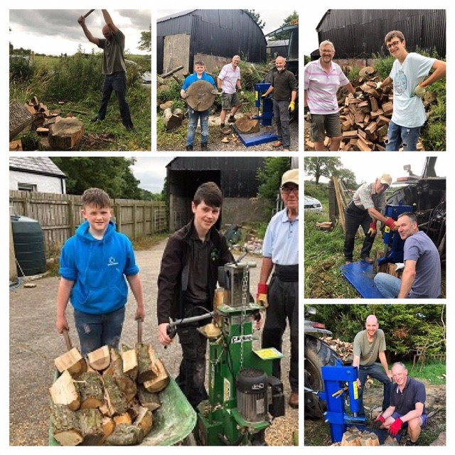

Contact Les Clarke on 07765504055 or John Erwin on 07720880087 for prices and delivery and/or collection options. Collection and/or delivery are available, subject to Covid-19 restrictions.
Thanks again to the Timber Team: Les Clarke, Ian Dunn, Dylan and Rhys Ewing, Graham and Jamie Galbraith, Bill Harrison, Colin Hassard, Will Mathers and Tom Wilson. All photographs were taken before the current Covid-19 restrictions.

Finance Annahilt
If you did not receive your 2021 Weekly Giving Envelopes prior to the recent "lockdown", they will currently be with the Parish Treasurer. These can either be collected from Patricia or she will endeavour to deliver them once travel restrictions are eased
Weekly giving, Gift Day and any other special collections may continue to be posted to the Treasurer or transferred directly to the bank.
The Treasurer's contact details are
Patricia Halliday, 35 Cabra Road, Hillsborough, BT26 6NB
Mobile 07713 257 691
Landline 028 9266 5310
Email patriciaapc@btinternet.com

Hello Everyone,

We hope that you and your family and friends are keeping as safe and well as possible in the present circumstances. We have received some correspondence from our Diocesan President Roberta Macartney and you will receive your own copy of this information as soon as possible.
In the meantime the main messages conveyed in this letter are as follows:-

- It is anticipated that Mothers’ Union groups will not be able to meet together in the first half of 2021. After this time the Mothers’ Union Trustees will be guided by government advice and keep you informed accordingly.

- Attention all knitters – There has been a request from one of the maternity units for first size (0-3 month) baby hats and cardigans.

- Our All-Ireland President, June Butler, intends doing a Sponsored walk in each Diocese over the next year to raise money for “Mums in May” to fund MU projects.

- All-Ireland Trustees will organise a competition for members to “Design and Make a Mascot or Logo” for June to carry on her walks. Happy crafting folks.

Take care everyone. May God bless you all.

Beth Avril
Esme Anne

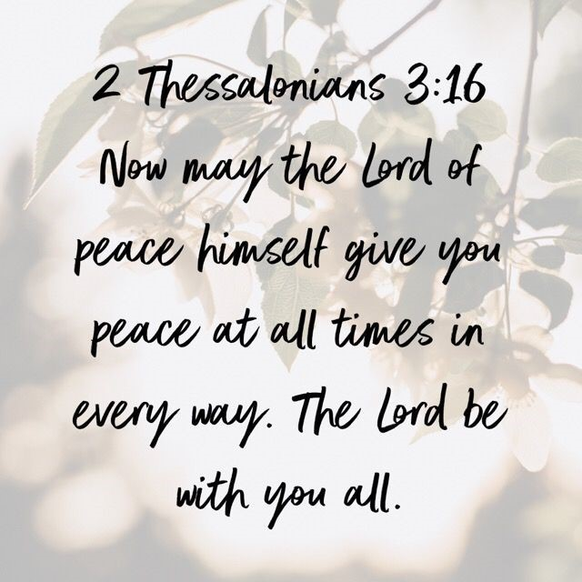
Mothers’ Union—Midday Prayers—February 2021
Hope and confidence in God’s Word

Monday: Jesus the living word
In the beginning was the Word, and the Word was with God, and the Word was God. The Word became flesh and made his dwelling among us. We have seen his glory, the glory of the one and only Son, who came from the Father, full of grace and truth.
John 1:1, 14 Sovereign Lord, your hand has touched the dry bones of our faith. Your Word has breathed new life where there was death. Your spirit raised us up from where we lay. Your love has brought us home and to your Cross. And by your grace we stand forgiven, free.
Hallelujah!
We thank you, God, for Jesus, the living Word. May your Word forever dwell among us, imparting hope and confidence in your enduring grace and truth.
Amen.

Tuesday: Inspiration of God’s Word
Your word is a lamp to my feet and a light for my path.
Psalm 119:105
God, we praise and thank you for your saving Word reaching out to us through the sacred scriptures. We thank you, too, for the brothers and sisters with whom we share your Word and discover together the abundance of your love. We pray for the light of your Holy Spirit, so that your word may lead and direct us into the unity you will for the sake of the world.
Give us grace, O Lord, not only to hear your Word with our ears, but also to receive it into our hearts and to show it forth in our lives; for the glory of your great name.
Amen.

Wednesday: Power of God’s Word
The word of God is alive and active. Sharper than any double-edged sword, it penetrates even to dividing soul and spirit, joints and marrow; it judges the thoughts and attitudes of the heart.
Hebrews 4:12
Your Word is the light we see, a guide for our footsteps to where you are found. Your Word is the strength we find when darkness threatens to overwhelm. Your Word is the power we need to become servants of a Heavenly King. Your Word is the reason we live in the sure knowledge you are everything.
We thank God for the power of his Word, which is living and active in our lives; which fills us with his strength and light, and directs our steps through every circumstance of life.
Amen.

Thursday: Security in God’s Word
As for God, his way is perfect: the Lord’s word is flawless; he shields all who take refuge in him.
Psalm 18:30
How perfect is our God! At the beginning of the day we receive your Word with joy and praise. Whatever our day holds, whether good times or hard, we are upheld by the Word of God, and his limitless provision. What a refuge is our God! At the heart of the day we trust in your Word for security and strength. Whatever our life holds, if certainties prove false, we are upheld by the Word of God and his infinite steadfastness.
How faithful is our God! At the end of the day we treasure your Word with gratitude and praise.
Amen.

Friday: God’s eternal Word
The grass withers and the flowers fall, but the word of our God stands forever. Your word, O Lord, is eternal; it stands firm in the heavens.
Isaiah 40:8; Psalm 119:89
From the very beginning was
Your Word which spoke this world into being,
Your Word which thunders from the skies,
Your Word which flows like mountain streams,
Your Word which whispers in morning breeze,
Your Word revealed through kings and prophets,
Your Word revealed through Angels' praise,
Your Word revealed in humble service,
Your Word revealed through a tiny child,
Your Word alive from the beginning of all things and to eternity.
May we be forever sustained by the written Word, inspired by the spoken Word, and bear witness to the Living Word, our Saviour, Jesus Christ.
Amen.

Saturday: Hope and confidence in God’s Word
God’s words are more precious than gold, than much pure gold; they are sweeter than honey, than honey from the honeycomb.
Psalm 19:10
Living Word, Author of Life, we praise you for your Word in all its forms. As we hear and read your Word, give us enquiring minds and open hearts; ready to respond to its challenge and to embrace its vision. Loving Father, send your Holy Spirit to bring life to your Word. Touch our minds and souls with the wonders in your message. Thrill our hearts by fresh insight in new and familiar scriptures.
Lord, we praise you for your Word. May it forever unite us together as we share in the wonder of your enduring grace and truth.
Amen.

LISBURN FOODBANK
The Foodbank provides emergency food and support to local people in crisis in the Lisburn area.
During the present government ordered restrictions it is not possible to leave items for the Foodbank at Church. However, if parishioners would like to continue to donate at this time, and it is hoped that many will, they may wish to know that the collection points at the two supermarkets, Tesco and Sainsbury’s, are permanent points and will allow people to continue to remember those who rely on the Foodbank in a very practical way.

A particular request from the Foodbank is for items listed below:

Toiletries
Small boxes of washing powder
Cleaning Supplies
Toilet Rolls (2 or 4)
Baby wipes
Nappies

The Lisburn Foodbank is providing an essential service to those within our community who are experiencing difficult times, often due to circumstances beyond their control.

YOUR HELP WOULD BE GREATLY APPRECIATED.

Parish Website: AnnahiltAndMagherahamlet.org
Parishioners are reminded that the website annahiltandmagherahamlet.org has been created to provide information on church related activities and organisations for parishioners and the wider community. Since lockdown began in March, the website has hosted online services each Sunday. It also contains a list of upcoming church services and news from our group of parishes, as well as downloadable versions of the parish magazine. The site will be continually developed, so if you have any submissions, suggestions or requests relating to the website, these can be sent to admin@annahiltandmagherahamlet.org.

www.annahiltandmagherahamlet.org

Parish Magazine
Any contribution for the next edition of the Parish Magazine should be left with the Rector or Roger Maxwell (roger.maxwell1@btinternet.com) by Sunday 21 February 2021.

Registered as a charity with The Charity Commission for Northern Ireland
NIC103246 (Annahilt) and NIC102122 (Magherahamlet)
Top of Form

