News from the Parishes

Church of the Ascension, Annahilt Magherahamlet Parish Church
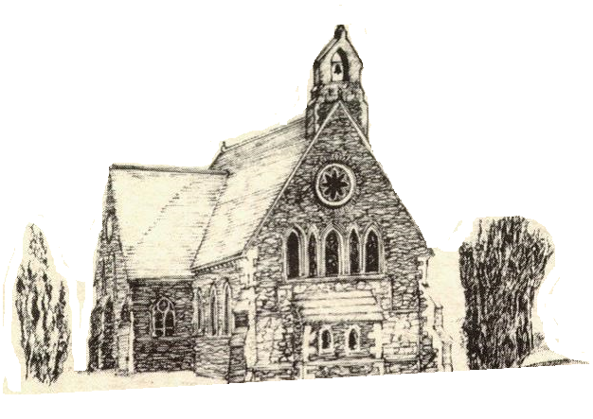

October 2021



Rector: The Revd Canon Robert Howard
15 Ballykeel Road, Hillsborough
BT26 6NW
Tel: 028 9263 8218
E-mail: jrobert.howard@btinternet.com
Website: www.annahiltandmagherahamlet.org

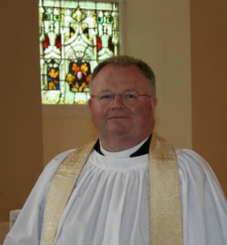
The Rector writes….

My dear parishioners

We are really pleased to report that the Sunday Schools in both Annahilt and Magherahamlet resumed face to face meetings as planned last month and will continue in October. The Rainbow Guides in Annahilt are also meeting again. In due course we hope to announce plans to resume some of our other regular and occasional parish activities. However, we need to look further at how to return to meeting in person safely. These processes are not without their complexity and I want to thank, on all our behalf, our dedicated leaders and volunteers who are working in partnership with the Health and Safety Officers and the Select Vestries in both Parishes to see if we can make these important activities happen again. In making preparations and any further plans for resuming face-to-face parochial activities we want to reassure you that the safety of parishioners is our paramount concern.
As the regulations have continued to change there have been new risk assessments in the Churches as measures have been put in place to allow for a gradual increase in numbers allowed to assemble at services. While these are really exciting and positive developments, we are also aware of the high infection rates at present. In order to keep ourselves and others safe, we ask you to continue to wear a face mask, to wash your hands and keep your distance as we gather together. I want to thank our Churchwardens, Health & Safety Officers and others for the way in which they have worked so hard and cheerfully to keep us all safe over this past 6 months since the buildings reopened after the last lockdown. The Mothers’ Union in both Parishes, the Indoor Bowling Club in Annahilt and the Badminton Club in Magherahamlet have also been exploring how best to approach their return. All these important discussions take time as we try to consult with people and see how they feel about returning. While we are doing all in our power to re-open we ask for your prayers and we recognise the ongoing challenges of the current situation.
Circumstances are constantly changing and we are doing our best to respond to these and put in place the best measures we can to keep all our parishioners safe. There is also the recognition that many people remain cautious and may not yet feel ready to return to such activities at the present time. Throughout this difficult season we have sought to be as open and transparent as we possibly can. We will continue to be so and communicate any information we have about the developing situation.

May I ask you to pray for all schools and teachers and pupils as they work their way through this term? It would be wonderful for students at primary, secondary and third level to get through this year without disruption.
Can we please remember also to stay in touch by phone or cards with those who live alone or have moved into nursing homes or sheltered accommodation?
One of the great strengths of this Group of Parishes is how people have supported one another. As we have seen the value of this in the past couple of years, let us continue to build upon that into the future.

With very best wishes to everyone.

Your sincere friend and Rector

Robert Howard

Reflections on Harvest Time in Annahilt
In Annahilt we gave thanks for the blessings of Harvest on Sunday 26 September. Although summer weather was ‘mixed’ with a somewhat inclement August, this year’s harvest yields were bountiful. Notwithstanding the very unusual circumstances of celebrating harvest in the midst of a global coronavirus pandemic, there was a very evident twin theme of celebration and thanksgiving throughout each of the services.
There were beautiful displays of flowers, along with some fruit and vegetables. As there would have been difficulties this year distributing fresh harvest produce afterwards, parishioners were instead encouraged to give non-perishable food items which were later donated to the Foodbank.
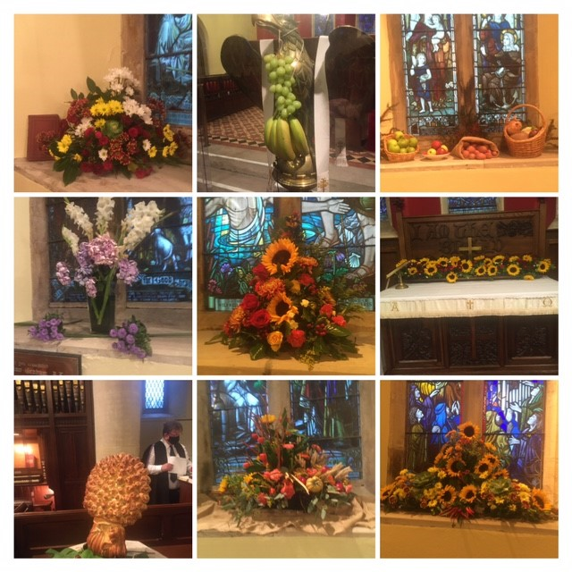
There was a lovely atmosphere of worship on Sunday. In the morning, a Celebration of the Holy Communion was presided over by the visiting Preacher, the Rt Revd Alan Harper, former Archbishop of Armagh and Primate of All Ireland, assisted by the Rector, Canon Robert Howard. The special music featured a solo ‘All things bright and beautiful’, sung by Mrs Hailey Howe, There was also a sung version of the Lord’s Prayer and a musical setting of the ‘Gloria in excelsis’.
In the evening, a Service of Evening Prayer was conducted by the Rector. The special preacher on this occasion was Canon Norman Porteus, Rector of Derryloran (Cookstown). ‘Let all creation dance’ was sung as a solo anthem.
At the conclusion of each Service the Rector thanked all those who had provided gifts and those who assisted with the decoration of the church. He expressed particular appreciation of the playing of our Organists, Mr Tim Howe in the morning and Mr Timothy Wilson in the evening. In addition, he expressed gratitude to the Churchwardens who co-ordinated the seating arrangements in addition to their normal duties, also to Colin Hassard for type setting the Orders of Service and to the visiting preachers.

SUNDAY SCHOOL IS BACK!

WHEN? Annahilt at 10.00am
Magherahamlet at 11.00 am

WHERE? Parochial Hall

After what seems like such a long time, we are delighted that Sunday Schools are back in the respective Parochial Halls at 10.00am in Annahilt and 11.00am in Magherahamlet.
It will be great to see everyone again and any children in P1-P7 who would like to come along will be very welcome. We will be having fun as always learning Bible stories, making crafts and playing games.
All Covid guidelines will be followed to ensure that everyone will be safe.
If you are thinking about sending your child and have any queries, please contact the Rector.
In-Church Worship in Church of the Ascension, Annahilt and Magherahamlet Parish Church

Numbers are reduced at Services in both Churches because of the legal requirement to facilitate safe distancing. Because of this, it would be very helpful if those intending to come to church would give notice of their intentions.
Annahilt
Trevor Hill trevorhill111@btinternet.com
Magherahamlet
Hillary Edgar hillary.edgar01@btinternet.com

Alternatively, you may contact by telephone:
Annahilt
Trevor Hill 07890552930
Magherahamlet
George & Sally McCurry 028 9756 3955
Hillary Edgar 028 4481 1361

For Annahilt, notification of attendance can also be given via the Parish website up to the Friday before.

Church Services in the Parishes of Annahilt and Magherahamlet

‘I was glad when they said to me: “Let us go to the house of the Lord’ Psalm 122 v1

Sunday 3 October Trinity XVIII
10.00 Parish Communion Annahilt Service Sheets
12.00 Parish Communion Magherahamlet Service Sheets

Sunday 10 October Trinity XIX
Prisons Week Sunday
10.00 Family Service Annahilt Service sheets
12.00 Family Service Magherahamlet Service sheets

Sunday 17 October Trinity XX
10.00 Parish Communion Annahilt Service Sheets
12.00 Morning Prayer Magherahamlet Service Sheets

Sunday 24 October Last Sunday after Trinity
10.00 Morning Prayer Annahilt Service Sheets

Magherahamlet Harvest Festival

Sunday 24 October 2021
12.00 noon Harvest Parish Communion Service Sheets
Preacher: The Revd Bruce Hayes
Rector of Dalkey (Dublin)

7.00pm Harvest Praise Service Sheets
Readings, Anthems & Hymns to celebrate Harvest

Sunday 31 October IV Sunday before Advent
10.00 Morning Prayer & Litany Annahilt Service Sheets
12.00 Morning Prayer & Litany Magherahamlet Service Sheets

Sunday 7 November All Saints’
10.00 Parish Communion Annahilt Service Sheets
12.00 Parish Communion Magherahamlet Service Sheets

Sunday 14 November Remembrance Sunday

10.00 Morning Prayer & Act of Remembrance Annahilt Service Sheets

12.00 Morning Prayer & Act of Remembrance Magherahamlet Service Sheets

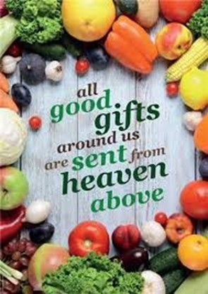

Decoration of Magherahamlet Church for Harvest
Thursday 21 October
From 2.00 pm
Gifts of flowers, greenery, corn, and other non-perishable foodstuffs will be gratefully received
Your assistance with the decoration will also be greatly valued

Magherahamlet Harvest Appeal
Harvest Thank Offering envelopes are included with this magazine. Once again we have the opportunity of thanking God for all his love and goodness, especially in the realms of nature. We can also do this by making as worthwhile and generous a thank offering as possible. The Thank Offering envelope may be returned at either of the Harvest Services.

Children’s Harvest Offerings
The younger members of the congregation are asked to bring a non-perishable item of food (eg a packet of biscuits or a tin of fruit) to the 12 noon service on Harvest Sunday. They will have the opportunity of making their own Harvest Offerings during the service.


In Memoriam
On the Sunday after All Saints Day (7 November) at the 10.00 am and 12 noon services in Annahilt and Magherahamlet respectively, we will remember by name those from each parish who have died during the past year.


From the Parish Registers

Christian Burials
‘In Christ shall all be made alive’

21 September 2021
Cecil Wright, Dunmore Road
Following Services at home and in Magherahamlet Parish Church burial took place in adjoining Churchyard
Advertisements
Cecil Wright, son of Cecil and Martha was brought up in Carrowdore where he received his primary education. Later the family, including his only brother Robert, moved to Sydenham in Belfast. He continued his education at Ashfield Boys School and subsequently at the College of Technology.
Following his education Cecil’s first job was as a van driver. Later he was employed in a clothing warehouse until he established his own business, a clothing factory and a shop on Castlereagh Road at John Long’s Corner in Belfast. This business developed very successfully over the years and the shop is still operating. Cecil set himself high standards in business which he also expected of his employees and his suppliers. He related very well to customers and also to all associated with his neighbouring retailers ‘Mission Possible’, ‘Quito’s’ Dry Cleaners and the Bible Shop.
Cecil served as a member of the Masonic Order and of the Loyal Orange Institution and the Royal Black Institution.
Cecil was devoted to Coleen, his wife. Together they raised a family of two, Amanda and Mark. When they moved to Dunmore Road they made Magherahamlet Parish Church their spiritual home. They were devoted attendees at worship. Cecil found particular spiritual refreshment in the sacrament of Holy Communion and made a point of being present on the first Sunday of the month when that took place.
Over the years, at home Cecil was a keen gardener growing various vegetables, tomato plants, chillies, garlic and some flowers. He kept up with the developing trends of horticulture by reading gardening magazines. He also enjoyed watching television, especially football.
Cecil’s period of illness was a long one, which he bore with dignity and grace. To the very end he was looking forward. He, Coleen and the Rector had a very moving celebration of Holy Communion at home very recently. He thought he would progress sufficiently to return to Church for the next Communion Service. Sadly, this was not to be and he passed away peacefully at home.
We extend our deep and prayerful sympathy to Coleen, Amanda and Mark and the family circle at this time of bereavement and loss.

Philippians 4:13 God gives me strength

Prayers for climate change

Creator of our common home,
You fill the earth and sea and sky with life
Forgive us our neglect of your creation
The choking waste of our pollution
The damage done by careless habits
And our indifference to future generations.
Help us to amend our lives
To refuse more plastic if we can’t reuse it
To lift our voice for lasting change
And to live well and gently on the earth
To the glory of your Son, the Living Word
Through whom you made this fragile world.

Amen.

Creator God,
We acknowledge that as your handiwork, we stand alongside all that you have made.
Trees and rivers, mountains and valleys, soaring birds and scuttling creatures, all are held within your care.
May we grow in our love and appreciation for the fabulous variety around us and may our awe and wonder draw us closer to the natural world and through it to you, the God of all things.
We pray in Jesus name,

Amen.

God of life, we praise you for the beauty of creation, its richness and variety; yet, through greed and ignorance, we scar your world with plastic waste and throw so much away.
Make us more like Jesus, treading gently on our common home, and breathe your Spirit on us, that we may care more deeply for your Earth.
We ask this through Jesus Christ our Lord.

Amen.

PRAYER WARRIOR

Do you have a concern or problem and would like someone to pray for you?
If so, contact the Rector who will be willing to help.
This is completely confidential and no details will be passed on to anyone else unless you want them to.

Telephone: 028 9263 8218
Flowers for the Churches

Annahilt Magherahamlet
October

3 Mrs A Edgar
10
17 Mrs B Harrison
24 Harvest
31

Church Cleaning, Annahilt

Month
October

1-2 Mrs J Guiney Mrs H Cardosi
8-9 Mrs E Ogle
15-16 Mrs L McCambley Mrs E Harrison
22-23 Mrs H Hill Mr T Hill
29-30 Mrs A Patterson
November
5-6 Mrs J Bolas

Church and Parish Hall Cleaning, Annahilt
New cleaning rotas for the Church of the Ascension, Annahilt, and Annahilt Parish Hall are currently being drawn up. If you are able to spare some time and are willing to become involved in cleaning the Parish Hall, please contact:
(Church) Colin Hassard 028 9263 8263 or colin.hassard@gmail.com
(Hall) Susan Wilson 07881940034.



Dear Mothers’ Union Members and Friends,
We hope that you are all keeping safe and well and have been able to get out into the fresh air to enjoy the lovely early Autumn sunshine that we have been blessed with.
At present there are no plans for us as Mothers’ Union members to meet up as a group until all safety directives have been clarified. However, we may be greatly encouraged by the fact that there are many ways that we can still provide support to new and ongoing Mothers’ Union projects from the comfort of our homes.
As we have mentioned in previous correspondence, June Butler, our All Ireland President, has been energetically and faithfully engaged in walking 21km in each of the twelve Diocese throughout Ireland in an effort to attract sponsorship money to fund Mums in May projects throughout All Ireland. The Mums in May Fund was established in 2012 in celebration of 125 years of Mothers’ Union in Ireland and every third year this fund needs to be replenished to ensure that all Mothers’ Union Projects can continue. This year, 2021, is the fourth occasion when Mothers’ Union fundraising will focus on this fund. Mothers’ Union Mums in May Projects reach out to all communities and families throughout Ireland to help in times of need, for example, providing vouchers for families experiencing food poverty during the Covid Pandemic, providing school books and uniforms for struggling families and clothing and food for those forced to leave their home due to domestic violence. Short breaks have also been arranged for families facing adversity. Any donations that you wish to make to the Mums in May Fund will be very much appreciated and arrangements can be made to collect your kind gift if you wish.
In a recent zoom meeting with Trustees of Down and Dromore Diocese, our Diocesan President Roberta indicated that she thought it was best to wait until the end of October to hear what Covid restrictions would be in place at that stage before deciding if arrangements could go ahead to support the 16 Days of Activism Campaign against Gender Violence - More about that next month.
Throughout the summer Mothers’ Union members and friends from both Magherahamlet and Annahilt have been busy preparing and delivering knitted baby items for use in the Baby Basics Project and also providing filled soap bags for use in emergency admissions to hospitals and Women’s Aid centres. Many thanks to everyone for all your hard work, love and generosity.
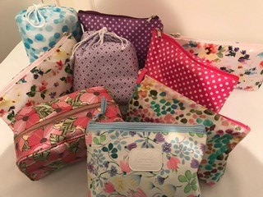
Please remember to pray for each other. Special requests for prayers can be made through the Mother’s Union Prayer Chain.

A Prayer from the Mothers’ Union Collection
“Dear Lord”
Is there ought that I can wish you, that has not been wished before?
Shall I wish that health and gladness be increasing more and more?
Or perhaps that you will be happy and all sadness stand apart?
No, I’ll simply wish “God Bless You” and I’ll wish it from my heart.
Written by Annie Blake 1949

With very kind regards and every blessing

Beth Avril
Esme Ann
Mothers’ Union—Midday Prayers—October 2021
Rebuilding hope and confidence
Hope for freedom

Monday: Freedom from sin
Loving Lord, break the chains of sin and set us free to follow you.
Long my imprisoned spirit lay,
Fast bound in sin and nature’s night;
Thine eye diffused a quickening ray— I woke, the dungeon flamed with light;
My chains fell off, my heart was free, I rose, went forth, and followed Thee.
Charles Wesley
Christ our Saviour, we struggle to break free from the bonds of sin and selfishness.
Loose their hold, through your atoning love, that we may follow you.
Through Christ Jesus the law of the Spirit who gives life has set you free from the law of sin and death.
Romans 8:2
When Christ makes us free, we are free indeed.
Praise be to God.
Amen.

Tuesday: Imprisonment
Loving Lord, break the chains of crime which bind both culprit and victim.
Lord, you offer freedom to all people:
We pray for those in prison.
Break the bonds of fear and isolation that exist.
Support with your love prisoners and their families and friends; prison staff and all who care.
Heal those who have been wounded by the activities of others, especially the victims of crime.
Help us to forgive one another. To act justly, love mercy and walk humbly together with Christ in His strength and in His Spirit, now and every day.
Amen.
www.prisonsweek.org
The Lord is merciful, compassionate, patient, and always ready to forgive.
Psalm 145:8
When Christ makes us free, we are free indeed.
Praise be to God.
Amen.

Wednesday: Mothers’ Union prisons work
Loving Lord, break the chains of troubles for families torn apart.
We pray for the work of Mothers’ Union to help those in prison and their families. Bless our efforts to support the families to cope with the challenges they face.
Give us favour with authority for access to those who need our care.
Renew and strengthen us to work together for a free and just society; to grow your kingdom on earth.
Amen.

“When did we see you sick or in prison and care for you?”
The King will answer, “I tell you the truth.
Anything you did for any of my people here, you also did for me.”
Matthew 25:39-40 (ICB)
When Christ makes us free, we are free indeed.
Praise be to God.
Amen.

Thursday: Freedom from captivity
Loving Lord, break the chains of captivity over body, mind and soul.
Proclaim your words of freedom to those enslaved by oppression.
Lord, break the chains that bind, and set the captives free.
Send your Spirit of freedom to those enslaved by fear.
Lord, break the chains that bind, and set the captives free.
Impart your power of freedom to those enslaved by addiction.
Lord, break the chains that bind, and set the captives free.
Reveal your way of freedom to those enslaved by adversity.
Lord, break the chains that bind, and set the captives free.
He has sent me to proclaim that captives will be released… that the oppressed will be set free.
Luke 4:18
When Christ makes us free, we are free indeed.
Praise be to God.
Amen.

Friday: Freedom in Christ
Loving Lord, break the chains of legalism and set us free to walk in grace.
Amazing grace!
We are set free from the shame of sin and clothed in righteousness.
All praise to our Redeemer; all glory to his name.
We are set free from failing God and share in the victory of Christ.
All praise to our Redeemer; all glory to his name.
We are set free from the fear of death. and given fullness of life.
All praise to our Redeemer; all glory to his name.
Christ has set us free! This means we are really free. Now hold on to your freedom and don’t ever become slaves of the Law again.
Galatians 5:1 (CEV)
When Christ makes us free, we are free indeed.
Praise be to God.
Amen.

Saturday: Freedom from poverty
Loving Lord, break the chains of poverty that all the world may flourish.
God of compassion, your eyes are turned to the poor and needy.
Turn our gaze to see the need around us.
Give us a vision of an equal world where poverty has no place.
God of justice, your face is set against poverty.
Shake us out of our comfort.
Challenge us to counter injustice whatever the cost to ourselves.
Envision us to act and pray.
Inspire us to work for a future hope of fullness of life for all.
Amen.

I know that the Lord secures justice for the poor and upholds the cause of the needy.
Psalm 140:12
When Christ makes us free, we are free indeed.
Praise be to God.
Amen.

New chairs for Annahilt Parochial Hall
Annahilt recently partnered with Larchfield Community Development Association in obtaining a grant from The Department for Communities Small Capital Grants Programme. We have been able to purchase 24 chrome and fabric stackable chairs for the Parochial Hall at nominal expense to the Parish. These new chairs will improve the comfort of those attending events and meetings in the hall, or at least those who opt to sit in the front rows!

TRESTLE TABLES FOR SALE
If interested please contact:
Colin Hassard Tel 028 9263 8263 or email colin.hassard@gmail.com

Annahilt Parish Bowling Club

Due to the continued spread of Covid-19, re-opening of the bowling club has once again been deferred. The officers of the club are very conscious of the potential risks to members and in addition the governing body have issue very stringent guidelines for re-opening which are nearly impossible for small clubs to comply with at this stage. The situation will be reviewed by the officers in late October.
Annahilt Harvest Envelopes
If you were unable to attend Annahilt Harvest Services but would still like to contribute to the collections towards the various Mission organisations, please send your envelope to Patricia at 35 Cabra Road, Hillsborough, BT26 6NB.
WEEKLY GIVING – ANNAHILT & MAGHERAHAMLET
The 2022 FWO envelopes will be prepared towards the end of November and if anyone wishes to have envelopes or wishes to amend their requirements, would they please contact the Hon Treasurers, as soon as possible.

Annahilt Miss Patricia Halliday 028 9266 5310
Magherahamlet Hillary Edgar 02844811361

We would also encourage parishioners to pay some of their giving by Bankers Standing Order and anyone who would be interested in discussing this should also contact Patricia or Hillary.
LISBURN FOODBANK

The Lisburn Foodbank is providing an essential service to those within our community who are experiencing difficult times, often due to circumstances beyond their control.

The Foodbank provides emergency food and support to local people in crisis in the Lisburn area.
Parishioners may leave items for the Foodbank in the basket in Annahilt Church Porch, on the FIRST and SECOND Sunday of each month.
A particular request from the Foodbank is for items listed below:

Sugar (most needed)
Tea
Coffee
Biscuits
Rice Pudding
Custard

The Lisburn Foodbank is providing an essential service to those within our community who are experiencing difficult times, often due to circumstances beyond their control.

YOUR HELP WOULD BE GREATLY APPRECIATED.

Parish Website: AnnahiltAndMagherahamlet.org
Parishioners are reminded that the website annahiltandmagherahamlet.org has been created to provide information on church related activities and organisations for parishioners and the wider community. Since the first lockdown began in March, more a year ago, the website has hosted online services each Sunday. It also contains a list of upcoming church services and news from our group of parishes, as well as downloadable versions of the parish magazine. The site will be continually developed, so if you have any submissions, suggestions or requests relating to the website, these can be sent to admin@annahiltandmagherahamlet.org.



www.annahiltandmagherahamlet.org

Parish Magazine
Any contribution for the November edition of the Parish Magazine should be left with the Rector or Roger Maxwell (roger.maxwell1@btinternet.com or magazine@annahiltandmagherahamlet.org) by Sunday 24 October 2021.

Registered as a charity with The Charity Commission for Northern Ireland
NIC103246 (Annahilt) and NIC102122 (Magherahamlet)
Top of Form

