News from the Parishes

Church of the Ascension, Annahilt Magherahamlet Parish Church

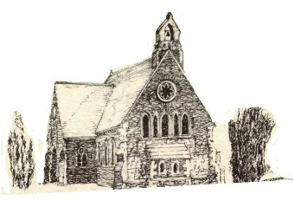

June 2026

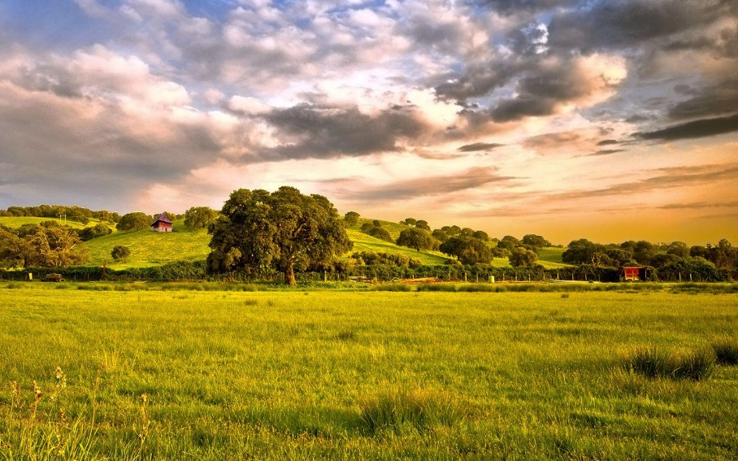

Rector: The Revd Canon Robert Howard
15 Ballykeel Road, Hillsborough
BT26 6NW
Tel: 028 9263 8218
E-mail: jrobert.howard@btinternet.com
Website: www.annahiltandmagherahamlet.org

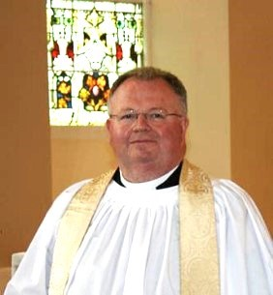
The Rector writes…..

My dear Parishioners

The simple pleasures of Ordinary Time

My dear Parishioners

One great phrase of the Church of Ireland, which is little known but carries with it a wealth of meaning, is ‘ordinary time’. The seasons of Advent, Christmas, Epiphany, Lent, Easter, and Pentecost all have their moments for focus and concentration; whereas the bulk of the summer months is called ‘ordinary time’! A very evocative phase – nothing particularly to focus on or to celebrate.
Just because it is ‘ordinary’, does not mean it is not important or of no significance to how God wants us to use our lives. For most of us, life is lived between high and low points: we look forward to something on the horizon or we are seeking to recover from something. So, it should be no surprise that ordinary time is the longest season in the Church calendar. Abraham Lincoln once said that: “God must love ordinary people because He made so many of them!”
Ordinary people, it seems to me, need ‘ordinary time’. Both the Sundays and the weekdays in between, enable us to sense God‘s presence with us in the day-to-day mundane, and ordinary comings and goings of life. Yes, He is there in the heights of resurrection joy and celebration. He is with us in the vulnerability and frailty of human weakness, modelled in the Incarnation. He is with us in our efforts to discipline ourselves and be moulded by him (Lent). But He is also with us whenever we are conscious of life just being mundane and ordinary.
When our eyes are opened to these ‘ordinary’ things, we will see what an extraordinary God we have!
You will know when it is ‘ordinary time’ because in church the clergy stoles, service booklets and altar dressing in the prayer chapel, will be green. In Advent and Lent they are purple or violet; Christmas and Easter they are white or gold.

With very best wishes.

Your sincere friend and Rector

Robert Howard

Thank You…
…to Magherahamlet Badminton Club for recently organising and hosting a Coffee morning with a Cake and Plant Sale in support of Parish Funds and to all who supported the event in any way. The splendid sum of £1600.00 was raised.

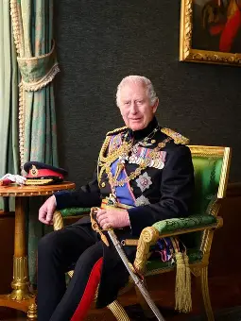

Prayers for The King on his official birthday 13 June 2026

Lord God, in your power you provide for your people
and rule over them in love:
Grant to your servant Charles, our King
the spirit of wisdom and government,
that being devoted to you with his whole heart,
he may so wisely govern,
that during his reign your church may be protected,
and Christian devotion may continue in peace;
that so persevering in good works to the end,
he may by your mercy enter your everlasting kingdom;
through Jesus Christ, your Son, our Lord,
who lives and reigns with you in the unity of the Holy Spirit,
one God now and for ever. Amen.

Lord God, the Ancient of Days,
You are sovereign over all your people;
Give to His Majesty, King Charles enduring wisdom and faith
in the service of the people of this land
and of you, his Lord and Master.
Grant that his faithful witness
may be to others a source of hope,
that they may come to know more fully
your Son Jesus Christ,
who is alive and reigns with you
and the Holy Spirit,
one God, now and for ever. Amen.



PRAYER WARRIOR

Do you have a concern or problem and would like someone to pray for you?
If so, contact the Rector (Tel 028 9263 8218) who will be willing to help.
This is completely confidential and no details will be passed on to anyone else unless you want them to.

Church Services in the Parishes of Annahilt and Magherahamlet

‘I was glad when they said to me: “Let us go to the house of the Lord”’ Psalm 122 v1

Sunday 7 June Trinity I

10.00 Parish Communion Annahilt

12.00 Parish Communion Magherahamlet

3.30 Evening Prayer Magherahamlet Service Sheets
Upper Crossgar Royal Black Institution in attendance
Preacher: The Revd Graham Spence

Sunday 14 June Trinity II

10.00 Children’s Day Service & Prize Distribution Annahilt Service Sheets
Preacher: Mr Andrew McClelland, Diocesan Youth Officer
followed by Light Refreshments in Parochial Hall in support of Christian Aid

12.00 Children’s Day Service, Holy Baptism & Prize Distribution Magherahamlet
Service Sheets
Preacher: Mr Andrew McClelland, Diocesan Youth Officer

Sunday 21 June Trinity III Fathers’ Day
10.00 Parish Communion Annahilt
12.00 Morning Prayer Magherahamlet

Sunday 28 June Trinity IV
10.00 Morning Prayer Annahilt
12.00 Morning Prayer Magherahamlet
3.30 Evening Prayer Annahilt Service Sheets . with Legacurry LOL 164 in attendance
Preacher: The Revd Mark Hawthorne . Minister of Legacurry Presbyterian Church

Sunday 5 July Trinity V
10.00 Parish Communion Annahilt
12.00 Parish Communion Magherahamlet

Sunday 12 July Trinity VI
10.00 Morning Prayer Annahilt
12.00 Morning Prayer Magherahamlet

From the Parish Registers


HOLY BAPTISM
‘Go therefore and make disciples of all nations, baptising in the name of the Father and of the Son and of the Holy Spirit’

Church of the Ascension, Annahilt
24 May 2026
Robert John Henri, son of Peter and Emeryn Verhoeven.

CHRISTIAN BURIAL
‘In Christ shall all be made alive’

29 May 2026
Mary Johnston, Glebe Road.
Following Services at home and in the Church of the Ascension, interment took place in adjoining Churchyard.
Mary was born the second of four daughters to Jim and Vera Hay of Lodge Hill in Clough. She attended Clough Primary School, along with refugees from Malta. Later she went to Down High School for six years. On leaving school, Mary’s first job was at Down County Council for four years. She went to Antrim Rural Council for seven years and in 1971 she joined the Army Headquarters in Lisburn.
Following her marriage to Norman Johnston, Mary moved to Dungannon where they lived for two years. When Norman got the chance of a transfer to Co Down, he and Mary moved to 17 Carricknadariff Road where they lived for six years. She returned to the Army Headquarters in Lisburn where she worked until their son, Lewis, was an infant. Their daughter, Lois-Jane, followed in due course.
In 1979, the family moved to 32 Glebe Road, Annahilt, at that time a small holding without electricity, telephone or mains water so they lived in a mobile home for two years. Norman and Mary were blessed with four grandchildren whom they loved dearly.
Not surprisingly Mary made The Church of the Ascension, Annahilt her spiritual home where she attended worship very regularly. She was also involved in the Mothers and Toddlers Group and the Church Creche. One mum particularly remembers Mary bouncing on her knee a very young boy she was looking after! She was also a proud and supportive member of The Mothers’ Union.
Mary was a hard worker. One never saw her sitting around because there was always something to do. She was always doing what she could with the gifts God had given her to make her house a home and to bless the lives of all who knew her.
We extend our deep sympathy to all the Family Circle especially Lewis and Emma, Lois-Jane, Mary’s grandchildren Jessica, Adam, Jack and Katy, her sister Lilian, Brother-in-Law David and their family.



A Prayer for Children

Loving God,
your Son told his disciples to become like little children.
Lead us to work for the welfare and protection of all young people.
May we respect their dignity that they may flourish in life,
following the example of the same Jesus Christ our Lord. Amen.

CHILDREN’S DAY & SUNDAY SCHOOL PRIZE-GIVING

The Church Loyalty and Sunday School prize-giving will take place in Annahilt and Magherahamlet on Sunday 14 June. This year the preacher will be Mr Andrew McClelland who has very recently been appointed as our new Diocesan Youth Officer.
As well as acknowledging the attendance of our children both in Church and in Annahilt JAM Group and Magherahamlet Sunday School over the past year, it is also an opportunity to thank the Leaders / Teachers who have worked with dedication and commitment to pass on the Faith to the next generation.
We invite parents, grandparents, relatives and other parishioners to join us on Children’s Day in support of our young people and those who lead their Activities.



Fathers’ Day, 21 June

On 21 June we celebrate fathers on Father’s Day. Unlike Mothering Sunday, this doesn’t have a distinctly Christian origin. However, it does provide an opportunity the celebrate God’s fatherhood and what it means for us.
At His baptism, as Jesus came out of the water: ‘heaven was opened, and He saw the Spirit of God descending like a dove and alighting on Him. And a voice from heaven said, ‘This is my Son, whom I love; with Him I am well pleased.’ (Matthew 3:16,17).
What can we learn about Jesus’ relationship with His Father, the role of fathers and our relationship with God?

The Father’s presence
When Jesus was baptized, the Father made His presence real by the Holy Spirit. It’s the Spirit who enables us to call God ‘Daddy’ (Abba, Galatians 4:6). God is with us and knows our joys and sorrows, fears and trials. In this way, Dads can relate to their children.

The Father’s love
The Father described His Son as ‘beloved’, who like us, is subject to His unconditional love. Dads should be constant in assuring their children of their love.

The Father’s pleasure
The Father tells Jesus that He is ‘well pleased’ with Him. We also need to hear this, if we feel that we are disappointing God or letting Him down. Fathers should use every opportunity to demonstrate their pleasure in their children, especially when things go wrong.

A Prayer for Fathers
Loving God, we thank you especially today for our fathers, for their love, care and protection, for all they do that we may have food, clothes and homes, for play-times and holiday-times with them.
We remember the boys and girls who have no Father, and ask that someone will look after them and make them happy.
We thank you that you gave your Son Jesus Christ for us, and we ask that we may be helped lovingly to trust him as our Saviour, joyfully to know you as our heavenly Father, and gladly to live lives that please you, by the help of your Spirit. Amen.

Flowers for the Churches
Annahilt Magherahamlet
June
7 The Rector Mrs L Compton

14
21
28

Church Cleaning, Annahilt

Month


June
5-6 Mrs E Crawford
12-13 Mrs S Chapman Mr S Chapman
19-20 Mrs A Maxwell Mr R Maxwell
26-27 Mrs S Chapman Mr S Chapman

July
3-4 Mrs L McCambley Mrs E Harrison
10-11 Mrs S Chapman Mr S Chapman
17-18 Mrs H Hill Mr T Hill
24-25 Mrs S Chapman Mr S Chapman
31-Aug 1 Mrs J Guiney Mrs H Cardosi

August
7-8 Mrs S Chapman Mr S Chapman
14-15 Mrs L McCambley Mrs E Harrison
21-22 Mrs S Chapman Mr S Chapman
28-29 Mrs E Finney Mr P Finney

The number on the rota of volunteers who clean the Church of the Ascension has significantly declined. It would now be unviable except that one couple has offered to clean the Church every 2nd week.
It really would be very helpful if there were additional volunteers who would ease the burden on those who already faithfully fulfil this important role. If you would be willing to help, please contact the Rector (Tel 028 9263 8218) or the Secretary to the Vestry, Colin Hassard (Tel 028 9263 8263)

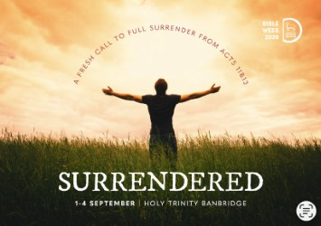

Join us for Bible Week ‘26
Please plan to join us at the start of September for this year’s Diocesan Bible Week with pastor and teacher Dr Tim Robinson. Tim has entitled his teaching series, Surrendered - A Fresh Call to Full Surrender from Acts 11&13.
We’ll be hosted by Banbridge Parish, and the Bible Week will run from 1-4 September beginning each evening at 7.45pm.
What’s in store
· Tuesday 1 September: Surrendered in Prayer & Worship (Acts 13:1-3)
· Wednesday 2 September: Surrendered to the Word & Spirit (part 1) (Acts 11:19-26)
· Thursday 3 September: Surrendered to the Word & Spirit (part 2) (Acts 13:1-5)
· Friday 4 September: Surrendered in Radical Discipleship & Worldwide Mission (Acts 13:6-12)
As well as inspiring teaching, the Bible Week includes worship and prayer ministry. It is a wonderful opportunity for clergy, leaders, and parishioners alike to be refreshed ahead of the busy autumn term.
Our speaker
Dr Tim Robinson is Assistant Professor of Pastoral Ministries at Dallas Theological Seminary. He was born in Belfast and pastored within the local church in Northern Ireland for 12 years. Tim is passionate about teaching and preaching the Scriptures in a way that is true, clear, relevant, and interesting. His greatest desire is that he might encourage and equip others to faithfully feed souls the Word of God, and form hearts into the likeness of Christ.
Come along!
1-4 September at 7.45pm in Holy Trinity Banbridge, Church Square, Banbridge BT32 4AA.



This year the annual CMSI Ignite conference is taking place on Saturday 12th September (with optional Friday night residential). Again, we are meeting in the beautiful Dromantine Retreat and Conference Centre, near Newry. Archbishop Samy Fawzy, one of our global partners from the Province of Alexandria, will be joining us in person. He and his wife Madalaine will bring stories of their ministry lives in the Middle East, a keen understanding and insight into the history and role of the church, and a warm passion for partnership in mission.
Our free children’s programme runs throughout Saturday 12th so all parents and carers can come along, listen and learn from the global church and have your little people’s needs catered for! Perhaps a spark for mission and the global church will be ignited in them!
Book now to secure the discounted rate (before the end of June). Go to Ignite|cmsireland to register or phone the office on 028 90 77 50 20 / 01 497 0931.


Dear Members
On Monday 18th May we had a great turnout in Annahilt for a presentation by Beth Wilson, Libraries NI.
Beth is the daughter of one of our members, Susan, and she started her chat by reminiscing about all the church activities she had been involved in over the years including rehearsals for the annual Nativity, attendance at Sunday School and Rainbow Guides.
Beth’s presentation outlined how Libraries NI has adapted to meet the needs and challenges of the current environment and the wide range of services offered free of charge to all age groups
Special thanks to Magherahamlet Branch for attending and helping to make the evening a great success.

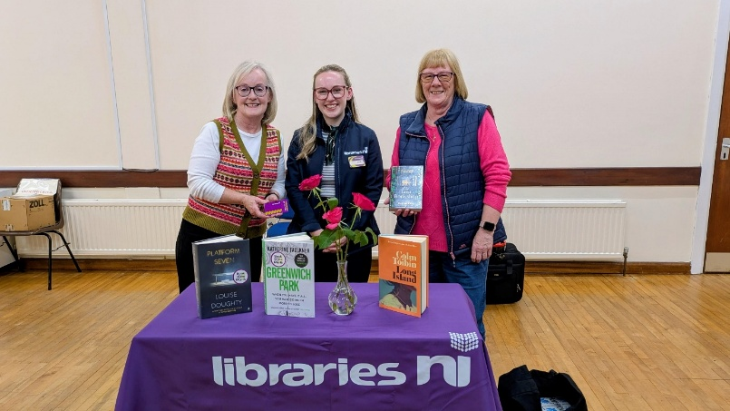
Beth Wilson, Libraries NI with Susan Wilson and Patricia Halliday

Other news
As many of you will know, Annahilt branch has been operating via a temporary planning committee over the last few months, and we are now pleased to announce that this committee of six has now been formally approved by branch members.
The committee comprises Edwina Crawford, Elaine Finney, Jen Guiney, Patricia Halliday, Linda Hassard and Susan Wilson and has recently developed an itinerary for the remainder of the year. Whilst the branch breaks for the summer, there is still an opportunity for parishioners, friends and keen gardeners to join us for our outing next month.
The outing will be to Fernhill Cottage Gardens, Ballynahinch (recently featured on BBC NI’s Greatest Gardens) on Thursday 18th June at a cost of £15 (light refreshments will be served) – if you would like to come along, please contact Susan on susancwilson31@gmail.com by Thursday 11th June - please note there is some walking involved (approx. 2 hours) but we can move at our own pace!
The committee would also like to highlight a date for everyone’s diary – Monday 21st September when we will be kickstarting the MU post summer season with a Pudding Party- more details will follow – everyone welcome!

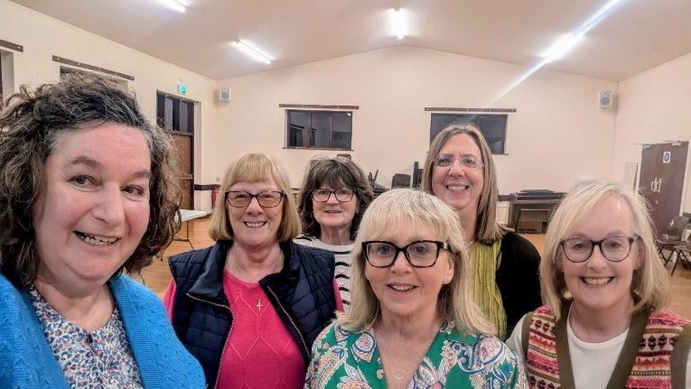

Annahilt MU Committee – Elaine Finney, Patricia Halliday, Edwina Crawford, Jen Guiney, Linda Hassard and Susan Wilson

With great regret we record the recent death of one of our longstanding members, Mary Johnston and extend our deep sympathy to her Family Circle. Amongst her many endearing qualities, Mary was a great baker. Her shortbread was legendary with one member remembering Mary sharing the recipe with her many years ago.
Magherahamlet Branch were delighted to host this year’s Diocesan Indoor and Senior Members’ Holy Communion Service in the Parish Church followed by an Afternoon Tea Party in the Parochial Hall on Thursday 30th April. Visitors commented most favourably on how splendid the church and hall both looked particularly with their setting overlooking Ballymacarn Lake. The weather was glorious with much sunshine.

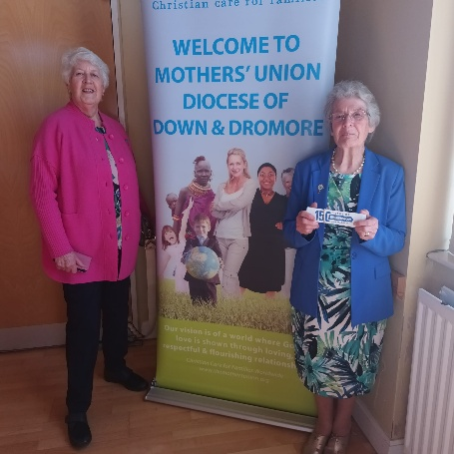

The Bishop gave a short reflection and our Diocesan President, Lynda Thompson, confirmed that one of the important roles of Mothers’ Union was to pray for the health and growth of all our parishes and the wellbeing of the clergy.
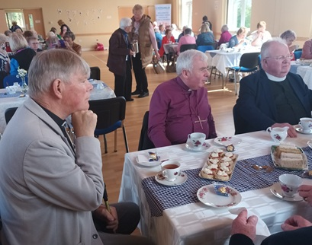
It is good to note also that this is the 150th Anniversary Year of the founding by Mary Sumner, from humble beginnings of the Mothers’ Union in the parish where her husband was Rector. A service is being held in St. Paul’s Cathedral, London on Wednesday 10th June 2026 at 5pm followed by the Annual Gathering on Thursday 11th June 2026 10:30am-4:30pm at the Emmanuel Centre next door to Mary Sumner House.

We wish you all a refreshing summer break.

Sincerely

Susan, Jen Avril, Frances.

THE MARY SUMNER PRAYER

All this day, O Lord
Let me touch
As many lives as possible for thee;
And every life I touch,
Do thou by thy spirit quicken
Whether through the word I speak, The prayer I breathe, Or the life I live. Amen.

THE MOTHERS’ UNION PRAYER
Loving Lord,
We thank you for your love so freely given to us all.
We pray for families around the world. Bless the work of the Mothers' Union as we seek to share your love through the encouragement, strengthening and support of marriage and family life.
Empowered by your Spirit, may we be united in prayer and worship, and in love and service reach out as your hands across the world.
In Jesus' name. Amen.

Mothers’ Union Midday Prayers - June 2026

Theme - ‘Join in and Celebrate!’

Father God, we praise you for the past 150 years, for the vision of Mary Sumner and for all who have followed her, praying and serving in Your name. We delight in all Your gifts to us, the joy of family, the wonders of Your creation, the fellowship of our fellow members, and, most of all, Your love to us through the gift of Your son, Jesus Christ. May we always walk in Your footsteps. Give us the strength to be different, to stand up for justice and peace, and be a sign of Your reconciling love for all. We ask this in your name. Amen.

Wave of Prayer
1-3 June: Johannesburg, South Africa; Kumi, Uganda; Nsukka & Idoani, Nigeria; Derby, England and Madhya Kerala, India
4-6 June: Ibba, South Sudan; Maseno North, Kenya; Isiala-Ngwa & Ondo, Nigeria; Fredericton, Canada and Amritsar, India.
8-10 June: Yambio, South Sudan; Garissa, Kenya; Mbamili, Nigeria; Hereford, England; Willochra, Australia; and Thailand.
11-13 June: Mahajanga, Madagascar; Mara, Tanzania; W Buganda, Uganda; Kwoi, Nigeria; Newcastle, Australia & E Kerala, India.
15-17 June: Bukavu, DR Congo; Nyahururu, Kenya; Gboko, Nigeria; Portsmouth, England; & New Guinea Islands, Papua New Guinea.
18-20 June: Rejaf, South Sudan; Military Episcopate in Kenya; Doko & Owo in Nigeria; Chelmsford, England and Jamaica & Cayman Islands.
22-24 June: Rumonge in Burundi; Tabora in Tanzania; Kabba & Bukuru in Nigeria; St Albans in England and Nagpur in India.
25-27 June: Table Bay in South Africa; Rift Valley in Tanzania; Evo & Ijebu in Nigeria; Adelaide in Australia and Taejon in South Korea.
29-30 June: Eastern Zambia in Zambia; Mombasa in Kenya; Gwagwalada & Ekiti West in Nigeria; Leicester in England and Temotu in Solomon Islands.

Annahilt Wednesday Club

The final meeting of the season will be on Wednesday 17th June at 11am and will take the form of an ‘End of Season Party”.
Those wishing to attend need to book for June for catering purposes. Contact Patricia on 07713 257691 or Violet on 07866 914651. All Seniors and Retirees welcome.



Lunch Club

The next time we meet will be Friday 26 June 2026 in the Pheasant at the usual time of 12.30pm.
Subsequent Lunch Club meetings will take place on the following dates:
- 31 July 2026
- 28 August 2026

The Lunch Club is a very relaxed and enjoyable occasion, giving retired and semi-retired members an opportunity to connect with each other. If you would like the opportunity of enjoying a lunchtime meal in the company of established friends or perhaps some new ones, do come along. Please contact Violet Swarbrigg (Telephone 07866914651) for further information.

Finance
Gift Aid on FWO giving.
With the freeze on Income Tax thresholds in recent years many people are once again paying Income Tax on their pensions/income. If you are have started to pay income tax again, please consider “Gift Aiding” your giving. This does not cost you anything and the Parish will benefit from the tax relief. Please contact Patricia (Annahilt) or Abbie (Magherahamlet) who will explain it in greater detail and get you to sign the appropriate form.

Parishioner Contact Details
Once again we appeal to Parishioners to update us with your current landline and mobile contact numbers and email addresses. Under Data Protection law we have to hold "up to date" and accurate information. Our contact details are later in the magazine.
If you have an email address send it to info@annahiltandmagherahamlet.org and we will update our records.

Annual Report
The Annahilt Annual Report is available to read on the website. Anyone who would like a paper copy should contact Patricia who will print one for you.

Honorary Treasurers
Annahilt
Patricia Halliday - 028 92665310, mobile 07713 257691
email patriciaapc@btinternet.com
Magherahamlet
Abbie Stanford - mobile 07753746940
email abigailstanford@btinternet.com

Thank you……

To all who contributed to recent special collections:

Annahilt

CMS Lent including CMS Coffee £355

Christian Aid Coffee May £125

LISBURN FOODBANK
The Lisburn Foodbank is providing an essential service to those within our community who are experiencing difficult times, often due to circumstances beyond their control.

The Foodbank provides emergency food and support to local people in crisis in the Lisburn area.
Parishioners may leave items for the Foodbank in the basket in Annahilt Church Porch, on the FIRST and SECOND Sunday of each month.
A particular request from the Foodbank for the following items is made during the month of June:
- Tinned fruit
- Bags for life
- Salt and pepper
- Super noodles
- Red and brown sauce
- Unisex / Male deodorant

YOUR HELP WOULD BE GREATLY APPRECIATED.

Recording of Annahilt Church Services
Free recordings (CD format) are available weekly of the Church services or requested special services.
These CDs are delivered free of charge. If you would like to receive a CD copy, please contact Shirley Robinette on 07974093382

Parish Website: AnnahiltAndMagherahamlet.org
Parishioners are reminded that the website annahiltandmagherahamlet.org has been created to provide information on church related activities and organisations for parishioners and the wider community. The website also continues to host online services most weeks. In addition, the website contains a list of upcoming church services and news from our group of parishes, as well as downloadable versions of the parish magazine. The site will be continually developed, so if you have any submissions, suggestions or requests relating to the website, these can be sent to admin@annahiltandmagherahamlet.org.



www.annahiltandmagherahamlet.org

Parish Magazine
Any contributions for the next edition of the Parish Magazine should be left with the Rector or Roger Maxwell (roger.maxwell1@btinternet.com) by Sunday 21 June 2026.

Registered as a charity with The Charity Commission for Northern Ireland
NIC103246 (Annahilt) and NIC102122 (Magherahamlet)

