News from the Parishes

Church of the Ascension, Annahilt Magherahamlet Parish Church
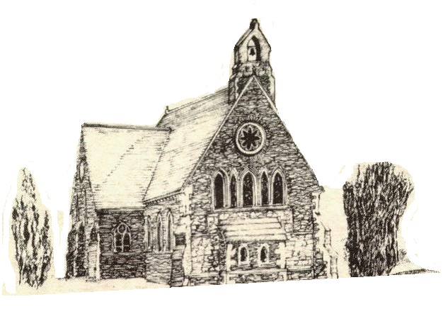

June/July/August 2022

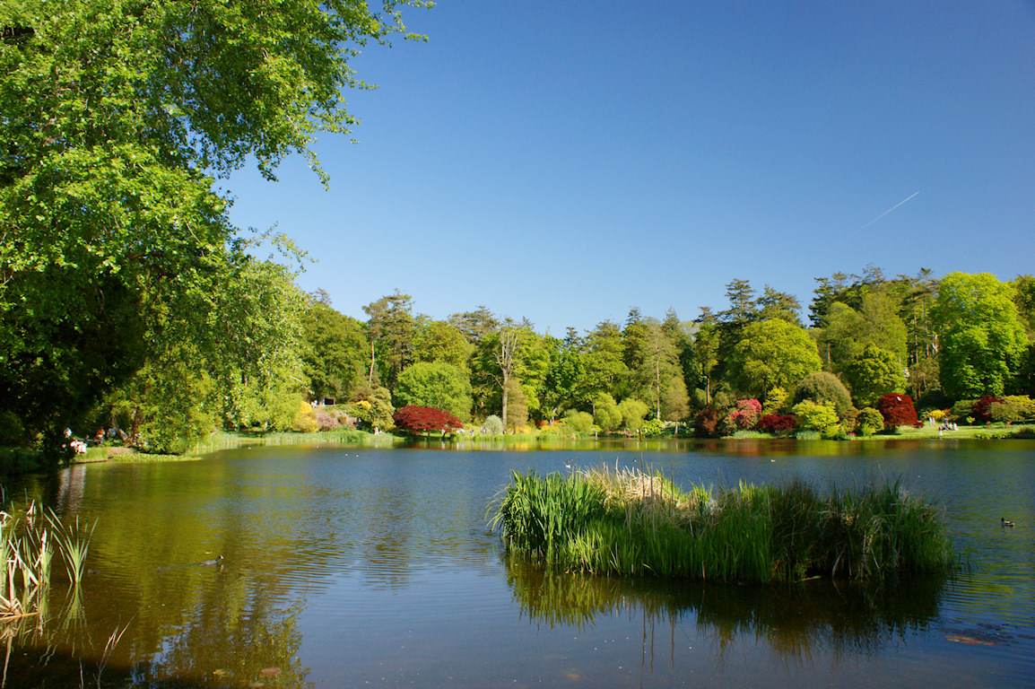

Rector: The Revd Canon Robert Howard
15 Ballykeel Road, Hillsborough
BT26 6NW
Tel: 028 9263 8218
E-mail: jrobert.howard@btinternet.com
Website: www.annahiltandmagherahamlet.org

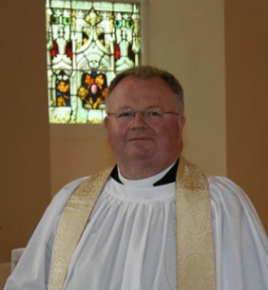
The Rector writes….

My dear Parishioners

On 6 February past, Her Majesty the Queen became the first British monarch to celebrate a Platinum Jubilee marking 70 years of service to the people of the United Kingdom, the Realms and the Commonwealth. A special four day bank holiday from Thursday 2 to Sunday 5 June was marked with events to celebrate this significant landmark.
On Wednesday 1 June, the eve of the holiday weekend, we began our Platinum Jubilee celebrations in the grounds of Magherahamlet Parochial Hall with a Fun Evening and Bar-b-que for all ages with a musical interlude by Ballies Mills’ Accordion Band. We were blessed with a beautiful sunny evening. The children and young people present thoroughly enjoyed playing games outside. The adults relaxed inside, sampling delicious food, enjoying the company of others present including some they had not seen in a very long time and delighting in the entertainment provided by the Band.
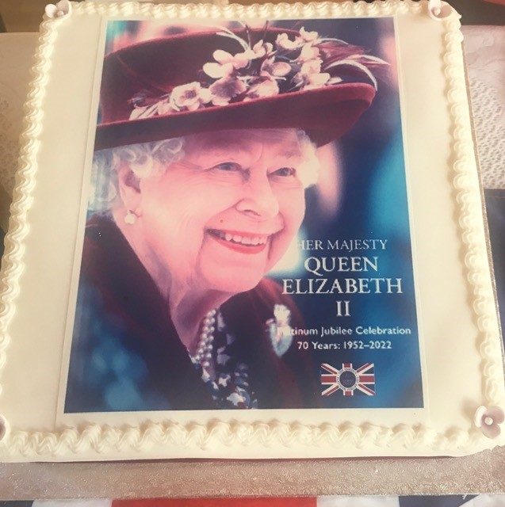

This was the first such gathering in the Hall since the lifting of restrictions and was a great success.
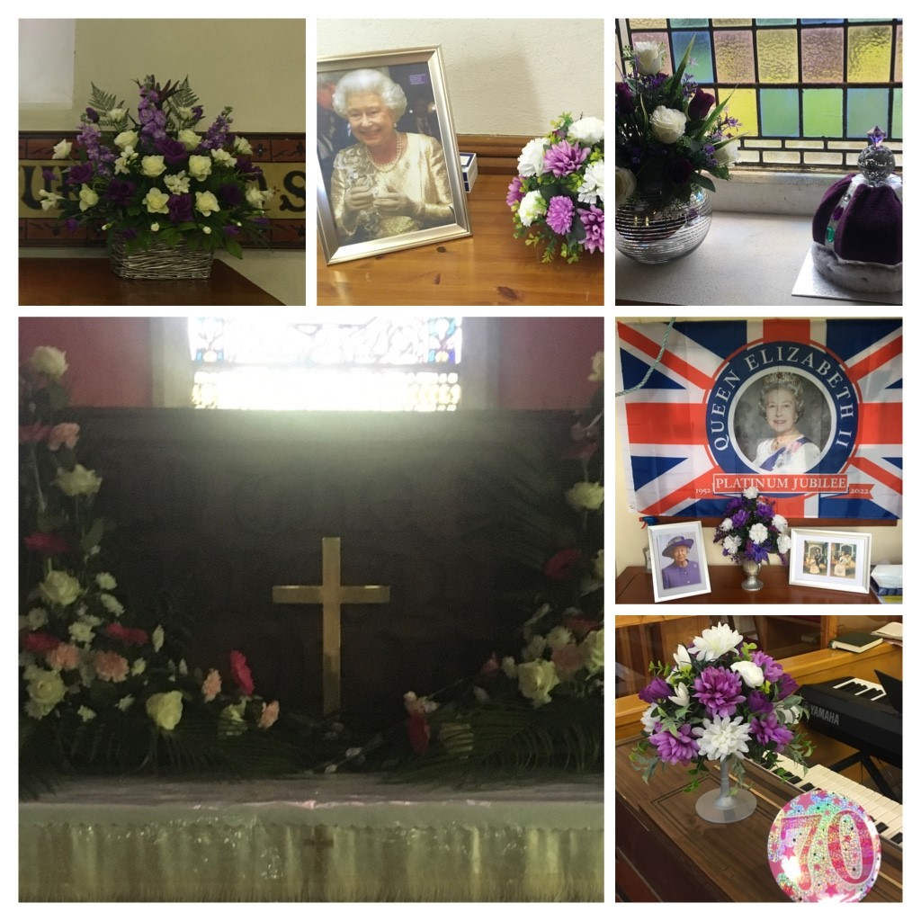
On Sunday 5 June (the Feast Day of Pentecost) the Church Services in both Annahilt and Magherahamlet were celebrations of Holy Communion, sometimes referred to as the Eucharist. The Greek word ‘Eucharist’ means remembrance and thanksgiving. Therefore, it was most appropriate that our worship that day was set in this context as occasions of thanksgiving for Her Majesty’s distinguished reign. We were delighted that the special preacher was the Rt Revd the Lord Eames of Armagh who has met the Queen on many different occasions.
Also on 5 June, in the afternoon, there was an event ‘Picnic & Praise’ at a marquee in the grounds of Anahilt Primary School, by kind permission of the Board of Governors and with the wholehearted co-operation and support of the Principal, Mr Andrew Smith. This was organised by our Parishes of Annahilt and Magherahamlet, as well as the Presbyterian Congregations of Loughaghery and Cargycreevy, Anahilt and Drumlough. It was a ‘Songs of Praise’ type Service with the music again led by Baillies Mills’ Accordion Band and followed by a Picnic. We were honoured to have The Mayor, Alderman Stephen Martin, with us on one of his last public engagements before the end of his term of office as well as our MP, the Rt Hon. Sir Jeffrey Donaldson. Following the Service, each household was presented with a specially commissioned book of photographs and prayers called “Our Faithful Queen” to celebrate this unique occasion. The young people present were given a Jubilee Drink bottle. After the extensive restrictions of the past number of years we all were very excited about being able to gather together in person to celebrate this unprecedented milestone in the life of our Nation and Commonwealth, and we were not disappointed.
The Queen has always been a wonderful ambassador for the Christian Faith, speaking very openly about how important it is in her own life. Faith has sustained her through difficult times for her personally. While addresses to the Nation and Commonwealth by her are rare, yet in times of crisis and adversity she has spoken words of hope and encouragement with great sensitivity.
The events we held to celebrate this first ever Platinum Jubilee were very well supported and enjoyed by parishioners together with families and friends. The feedback has been very positive and a real tribute to the team work shown by the Organising Committees and others who assisted behind the scenes. We are very grateful to everyone involved.
On Sunday 12 June we marked the 40th Anniversary of the Grouping of Annahilt and Magherahamlet Parishes. Most of those who were around in 1982 when the parochial amalgamation happened can scarcely believe so many years have since passed. It was good that the two Parishes were represented at both Church Services, especially by the Select Vestries, Choirs and Sunday School Teachers. As well as a memorable celebration of what our two parishes have succeeded in doing together since 1982, the Services were a genuine encouragement to us all in our ongoing pilgrimage as a Group of Parishes in the years and decades to come.
On Sunday 19 June, our Children’s Day Services took place which included our Sunday School Prize-giving. We took the opportunity to honour our children who have been learning about faith on Sundays throughout the past year. It was also an occasion to thank all our teachers who have worked with dedication and commitment to pass on the faith to the next generation. It was good that parents, grandparents and other parishioners were there in support of our young people and their teachers.
I take the opportunity to wish those who have been or are doing examinations well in their tasks. Some have been preparing for important examinations in schools and universities. Some are preparing to finish schools and move from primary to second level education and others are anticipating the transition from second to third level education, so we wish all our parishioners well in their educational endeavours.
Thank you to all our volunteers and groups who are facilitating meeting together after these past difficult years. It has been so good to see people mixing and mingling and enjoying one another’s company again at services and meetings of organisations over recent months.
On a personal note, may I express my heartfelt appreciation to all from both Parishes and other friends in both communities who joined my siblings, Rosemary, Mark & Mandy and me at the recent Service in memory of our dear mother and to those who could not be there who sent messages beforehand. The event was a huge comfort and encouragement to each of us and we are deeply grateful.
The summer holiday period looms large. Whether at home or away, I wish you all a refreshing, relaxing and enjoyable break from routine.
With very best wishes,

Your sincere friend and Rector

Robert Howard

A Prayer for Children

Loving God,
your Son told his disciples to become like little children.
Lead us to work for the welfare and protection of all young people.
May we respect their dignity that they may flourish in life,
following the example of the same Jesus Christ our Lord.
Amen.

Congratulations….
….to Ian Maxwell, Annahilt, on his recent engagement to Helen Moore, Jordanstown.

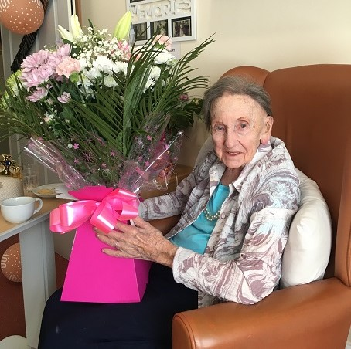
...... to Mrs Ida Rowlette, Annahilt, on the recent celebration of her 100th birthday. The Rector had the great pleasure and privilege of visiting Mrs Rowlette and presenting her with an arrangement of flowers on behalf of the Parish. She was also visited by the Mayor, Ald Stephen Martin. She received greeting cards from HM The Queen and the Lord Lieutenant of Co Down, Gawn William Rowan Hamilton DL.

Scenes at Vintage Jubilee Garden Party at Anahilt Residential Home with the Principal, Staff & Pupils of the Primary School

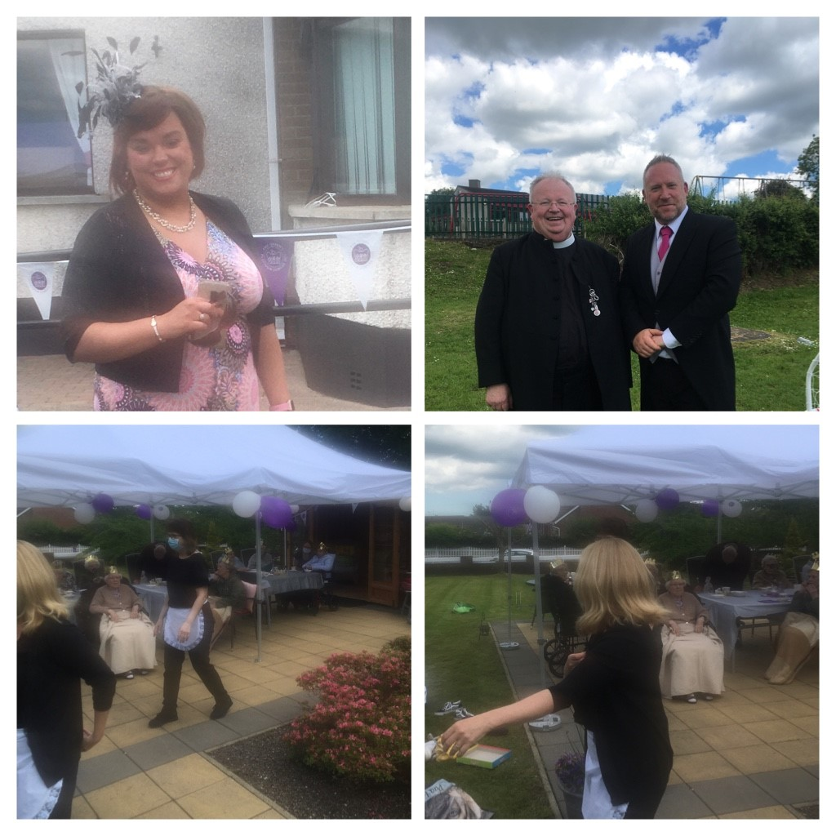
‘Picnic & Praise’ Jubilee event on Sunday 5 June
This Service was organised by our Parishes of Annahilt and Magherahamlet, as well as the Presbyterian Congregations of Loughaghery and Cargycreevy, Anahilt and Drumlough in the grounds of Anahilt Primary School.

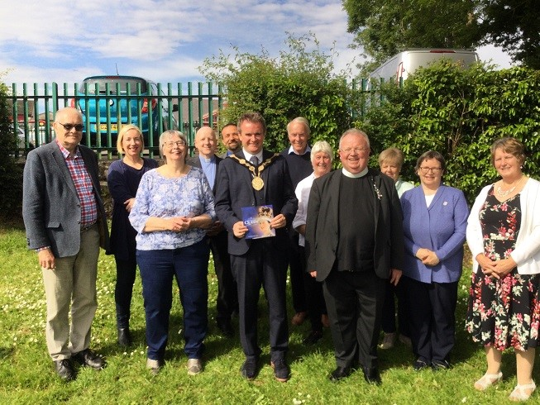

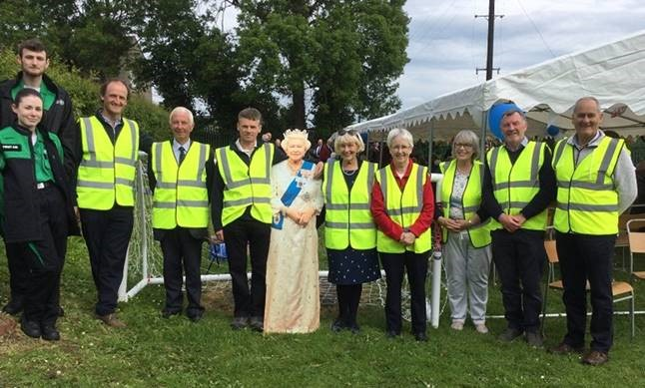
Seats start to fill up!

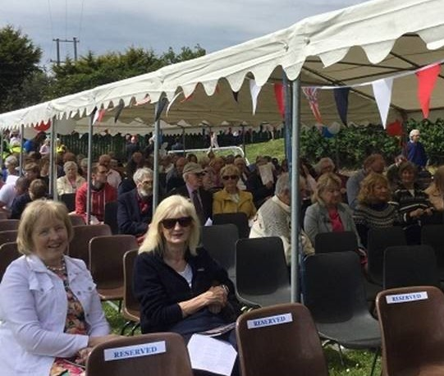

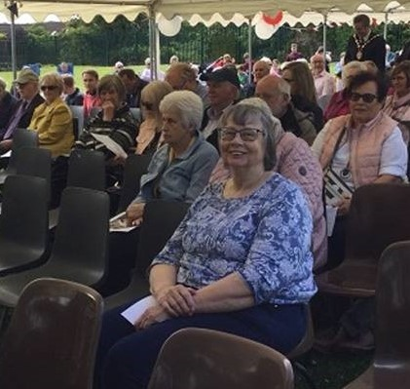
The music was again led by Baillies Mills’ Accordion Band.

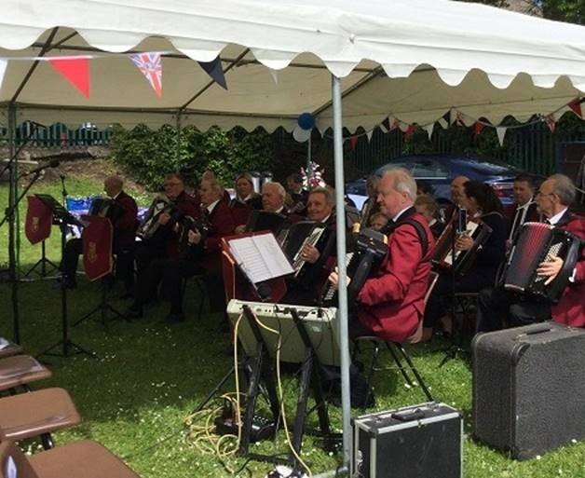

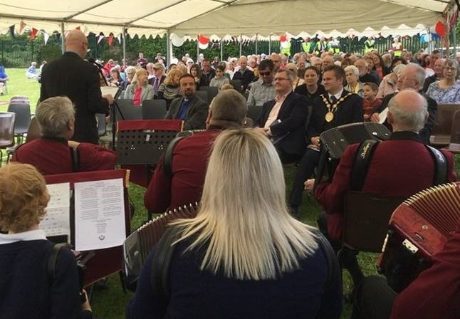

Dignitaries included the Mayor, Alderman Stephen Martin, as well as our MP, the Rt Hon. Sir Jeffrey Donaldson.

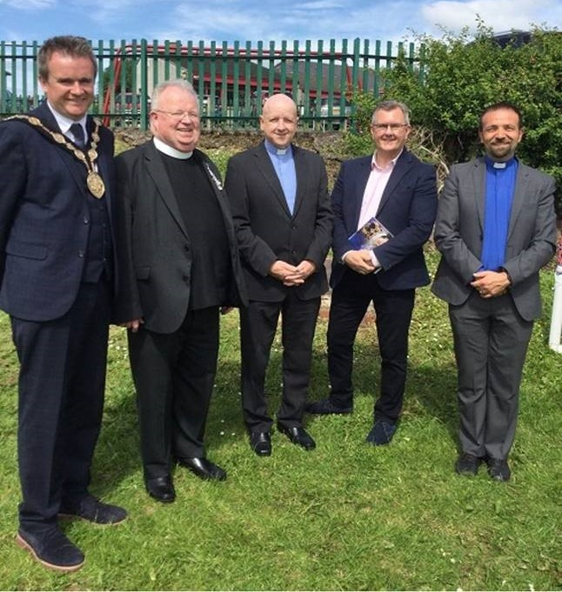

Following the Service, each household was presented with a specially commissioned book of photographs and prayers called “Our Faithful Queen” to celebrate this unique occasion.

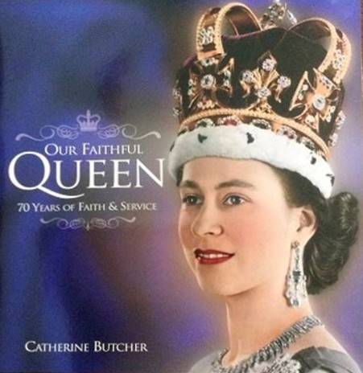
Church Services in the Parishes of Annahilt and Magherahamlet
‘I was glad when they said to me: “Let us go to the house of the Lord” Psalm 122:1

Sunday 19 June Trinity I Children’s Day
10.00 Children’s Service & Prize Distribution Annahilt
12.00 Children’s Service & Prize Distribution Magherahamlet

Sunday 26 June Trinity II
10.00 Morning Prayer Annahilt
12.00 Morning Prayer Magherahamlet
3.30 Evening Prayer Annahilt
Preacher: The Revd Canon Warren Russell, Rector of Magheradroll
with Legacurry LOL in attendance

Sunday 3 July St Thomas’s Day
10.00 Parish Communion Annahilt
12.00 Parish Communion Magherahamlet

Sunday 10 July Trinity IV
10.00 Morning Prayer Annahilt
12.00 Morning Prayer Magherahamlet

Sunday 17 July Trinity V
10.00 Parish Communion Annahilt
12.00 Morning Prayer Magherahamlet

Sunday 24 July Trinity VI
10.00 Morning Prayer Annahilt
12.00 Morning Prayer Magherahamlet

Sunday 31 July Trinity VII
10.00 Morning Prayer & Litany Annahilt
12.00 Morning Prayer & Litany Magherahamlet

Sunday 7 August Trinity VIII
10.00 Parish Communion Annahilt
12.00 Parish Communion Magherahamlet

Sunday 14 August Trinity IX
10.00 Morning Prayer Annahilt
12.00 Morning Prayer Magherahamlet

Sunday 21 August Trinity X
10.00 Parish Communion Annahilt
12.00 Morning Prayer Magherahamlet

Sunday 28 August Trinity XI
10.00 Morning Prayer & Litany Annahilt
12.00 Morning Prayer & Litany Magherahamlet

Sunday 4 September Trinity XII
10.00 Parish Communion Annahilt
12.00 Parish Communion Magherahamlet

Sunday 11 September Trinity XIII
10.00 Family Service Annahilt
12.00 Family Service Magherahamlet

Looking ahead….

Sunday School…

…Sunday School in both Parishes will resume on Sunday 4 September 2022. There will be further notification nearer the time.

Sunday 18 September….

Celebration of 70th Anniversary of Annahilt Mothers’ Union Branch and 60th Anniversary of Magherahamlet Mothers’ Union

Sunday 25 September

Annahilt Harvest Festival
Clergy Emergency Cover

During the period when the Rector is on holiday, please contact one of the following who will advise you of the Clergyperson answering emergency calls:
Norman Watterson (Rector’s Churchwarden, Annahilt) 07917 039757
Aubrey Campbell (People’s Churchwarden, Annahilt) 028 9263 8291
Colin Hassard (Honorary Secretary, Annahilt Vestry) 028 9263 8263
Mrs Avril McKeown (Graveyard Secretary, Annahilt) 07801 449244
Ms Abbie Stanford (Rector’s Churchwarden, Magherahamlet) 07753 746940
George McCurry (Rector’s Glebewarden, Magherahamlet) 028 9756 3955
Larry Fryers (People’s Churchwarden, Magherahamlet)

PRAYER WARRIOR
Do you have a concern or problem and would like someone to pray for you?
If so, contact the Rector who will be willing to help.
This is completely confidential and no details will be passed on to anyone else unless you want them to.
Telephone: 028 9263 8218


From the Parish Registers

Christian Marriage ‘Those whom God has joined together let no one put asunder’

Church of the Ascension, Annahilt
5 May 2022
Jonathan Timpany and Caralee Maguire

7 May 2022
Andrew Watson and Fiona Campbell

Magherahamlet Parish Church
4 June 2022
Aaron McKeown and Nikki Crompton

We congratulate each of these newly married couples and wish them every happiness.

General Prayers

Prayer for the Queen’s Platinum Jubilee
Almighty and eternal God, you uphold and govern all things both in heaven and on earth, and by your grace alone kings and queens do reign.
We thank you for all the blessings which you have bestowed upon us throughout the reign of our sovereign lady, Queen Elizabeth, whom you have set over us these threescore years and ten.
We thank you for the wisdom of her guidance and her love of peace, for the care and devotion with which she has served her people, for the example of her gracious life.
As we rejoice before you with thankful hearts, we pray that we may ever be united in love and service to one another, as people called to live according to your will, for the good of all the world, and the glory of your great name, through Jesus Christ our Lord. Amen.



Loving God, in Christ Jesus, the servant of all, you call us to the service of others. Grant to the Members of Parliament and the members of the Legislative Assembly of Northern Ireland, the skill to recognise its urgent needs and the strength to pursue the common good. Endow us all with patience and courage, that we may care for the suffering, feed the hungry, shelter the homeless and sustain the needy, through Jesus Christ our Lord.
Amen.

Christ be with me, Christ within me,
Christ behind me, Christ before me,
Christ beside me, Christ to win me,
Christ to comfort me and restore me,
Christ beneath me, Christ above me,
Christ in quiet, Christ in danger, Christ in hearts of all that love me,
Christ in mouth of friend and stranger.
Amen.

Spirit of wisdom, Creator God, we give you thanks for all the ways you inspire your people, the ways you provide for them, and set great paths before them. We are grateful for the many small business owners who felt your creative call and pursued their dreams.
Gracious God, we know that you are the sustainer of our dreams, in prosperity and in hardship.
We pray for all those businesses who are suffering hardship because of the economic crisis caused by COVID-19.
May the communities these businesses serve rally to support them. Provide for all the people being impacted by this economic crisis, O God, the people employed by these small businesses and the families that are supported by their income. Protect them in this time of economic uncertainty, and fill their spirits with hope.
Amen.

Dear Lord, You have commanded us to love our neighbours as ourselves. Help us to do that in our community and throughout our country. Help us understand the problems our fellow citizens are going through and find ways to help them in ways they need it most. Help us to love others no matter what their race, religion or other differences. Help us to receive their love as well. Help us to not allow grievances to block giving or receiving love.
Amen.

God, our rock, we pray for stability in this country that has been affected with disunity and discontent. Give us all wisdom to enable us to move forward successfully. Help us to strive to understand the others’ perspectives and to find common ground. Give us insight into what will best solve the complex problems we are facing. Help us to negotiate a new path that will be better and brighter than before. Amen.

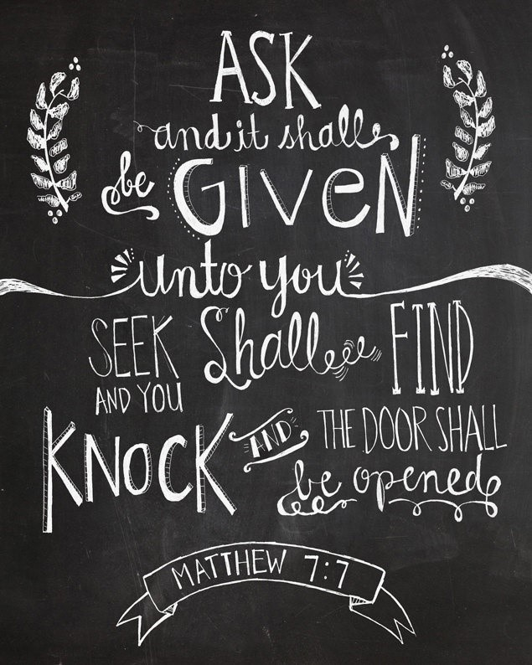
The Grouped Parishes of Annahilt and Magherahamlet
Celebration 40

The fortieth anniversary of the Grouping of Annahilt and Magherahamlet parishes was observed at special services in both Churches on Sunday 12 June. In Annahilt the Service took the form of a celebration of the Holy Communion, with the Rector presiding. In Magherahamlet the Rector conducted a Service of the Word. The Readings in each Church were led by representatives from both Parishes. The singing in each Church was led by a united choir. The Select Vestry of each Parish attended both of the Services at which the Rector, Canon Robert Howard preached.
In his sermon the Rector suggested 30 June 1982 was definitely a new day for both our Parishes when the late Revd (later Canon) Eric Kingston (the sitting Rector of Annahilt) was instituted as Rector of Magherahamlet by the then Bishop of Down & Dromore, The Rt Revd Dr Robin Eames. After a long vacancy in Magherahamlet following the Bishop’s Curacy of the late Revd (later Canon) Victor McKeon, both Annahilt and Magherahamlet entered into dialogue, sensing that they could fulfill their God-given mission better together than separately, with each maintaining a substantial measure of parochial independence. This was facilitated by forging a Group of Parishes with each having its own Select Vestry, its own representation on Diocesan Synod and also on any future Board of Nomination called to appoint a new Rector whenever a clerical vacancy arose. During the 40 years which have followed, both Annahilt and Magherahamlet together have explored new and evolving ways to join resources for the advancement of God’s kingdom.
The Rector asked ‘Where do we find parochial groupings in the Bible? Of course, the word isn’t there but the concept is supported throughout Scripture. The Apostle Paul taught there is “one body, one Spirit, one hope, one Lord, one faith, one baptism, one God and Father of all” (Eph. 4:4–5). The Psalmist declared “how good and pleasant it is when God’s people dwell together in unity!” (Ps. 133:1). The entire drama of the New Testament is the story of God bringing diverse groups together toward that divine reality.
That is not to suggest that every church should amalgamate with another church. However, it seems appropriate that parishes ought to consider doing so, as Annahilt and Magherahamlet did 40 years ago, if it would better fulfil the biblically driven mission of one’s church and better extend God’s kingdom in one’s community. Grouping is congruent with the heart of God, the principles of Scripture, and the ideal of more effectively using the resources God has provided.
Wherever churches have existed for as long as ours have (The Church of the Ascension, Annahilt, 166 years with a Church on site since the 8th century; 207 years in Magherahamlet) there is a potential for healthy and fruitful church groupings. Jesus said, “I will build my church and the gates of hell will not prevail against it” (Matt. 16:18). Jesus is building his church, a prevailing church at that. His desire for his bride is that she be healthy, unified, collaborative and effective. All local churches—the strong, the stable and the struggling ones—are churches that Jesus loves.
Today we give thanks to God that 40 years ago, people believed it was worth prayerfully exploring whether each parish would be a potential candidate for a parochial grouping as a means of building his church overall and extending his kingdom in new ways over the years which have followed.
For those good things to have happened, both parties in the grouping have had to take a risk—a step of faith with no guarantee of success. But together we have found ways of making the Grouping work and experiencing noteworthy good results.
In our individual lives, we take long shots on other dreams—maybe of owning our own home or business or rising to the top of our field, even though we know that in the final outcome only a few may actually make it. Challenges are still present for today’s groupings or amalgamations, but as Jesus told us, with God all things are possible (see Matt. 19:26). In the years to come, let us use our parochial partnership to fulfill Christ’s great commission (see Matt. 18:19–20) in ways that God is eager to bless.
Following the Annahilt Service, light refreshments were served in the Parochial Hall at which members of both parishes engaged with each other, many for the first time at an inter-parochial event, since pandemic restrictions were eased. Following the Magherahamlet Service, the Select Vestry members, Choir members and Sunday School Teachers from both Parishes, together with their spouses were entertained to lunch by the Rector. Thus came to an end a very happy and memorable day in the life of the Grouped Parishes of Annahilt and Magherahamlet.

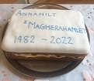
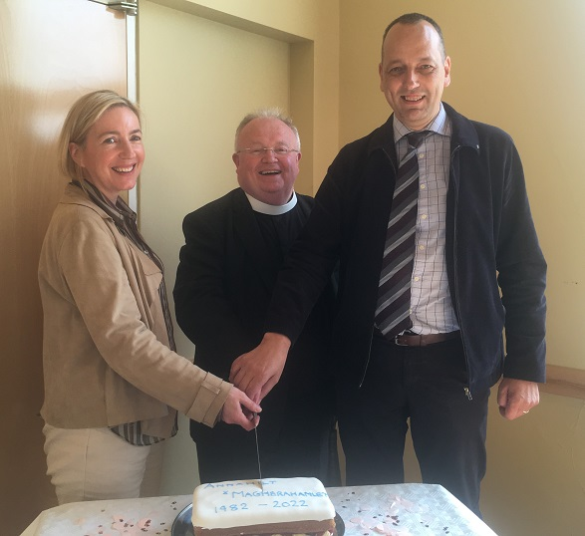

Flowers for the Churches
Annahilt Magherahamlet


June

5 The Rector Mrs L Crompton
12
19 Mrs B Harrison
r26 Mrs S McCurry

July
3
10 Mrs B Oliver
17 Mrs B Oliver
24
31 Dr W& Mrs Chambers

August
7 Miss V Begley
14 Mr & Mrs R Carlisle
21
28 Mrs M McCauley

Church Cleaning, Annahilt
June
24-25 Mrs E Crawford

July
1-2 Mrs L McCambley Mrs E Harrison
8-9 Mrs J Guiney Mrs H Cardosi

15-16 Mrs E Ogle
22-23 Mrs J Bolas Mr A Bolas
29-30

Aug
5-6 Mrs H Hill Mr T Hill
12-13 Mrs A Maxwell Mr R Maxwell
19-20 Mrs E Crawford
26-27 Mrs L McCambley Mrs E Harrison

Sept
2-3 Mrs J Guiney Mrs H Cardosi
9-10 Ms E Ogle
16-17 Mrs H Hill Mr T Hill
23-24 Mrs L McCambley Mrs E Harrison
Oct
1 Mrs A Maxwell Mr R Maxwell
Parish of Annahilt
Annual General Vestry Elections 2022
The adjourned Annual General Vestry Meeting of Annahilt Parish was reconvened on Sunday 15 May following Parish Communion and resulted in the following nominations and elections:

Rector’s Churchwarden Norman Watterson
People’s Churchwarden Aubrey Campbell
Rector’s Glebewarden William Mathers
People’s Glebewarden John Erwin

In addition to the above Officers, the following were elected to the Select Vestry:
David Brown Colin Hassard Bert Carlisle Mrs Helen Hill Stephen Chapman Trevor Hill Mrs Edwina Crawford Dr David Keith Ian Dunn Mrs Avril McKeown Miss P Halliday William Mathers

Independent Examiner
Kenneth Watterson

The following appointments were subsequently made by the incoming Select Vestry:
Honorary Secretary Colin Hassard
Honorary Treasurer Miss Patricia Halliday
Honorary FWO Treasurer Trevor Hill
Health & Safety Officer Roger Maxwell
Graveyard Secretary Mrs Avril McKeown



Hello Everyone,

Our Mothers’ Union members are delighted to be able to say that our Branches are at last up and running again, now that we are experiencing a very welcome respite from Covid. Inspired by the encouraging words of our All Ireland President, June Butler, when she came to the services in our churches on Mothering Sunday and motivated by Canon Howard kindly facilitating of our Triennial Elections, both Magherahamlet and Annahilt Branches have newly elected office bearers who are dedicated to leading us forward for the next three years.
In due course both Branches will be finalizing their programmes for the remainder of this year. In the meantime, we began by coming together for a Celebratory Meal in the Millbrook Lodge Hotel in Ballynahinch on 8 June 2022 at 6.45pm. The evening was a great success. The meal was delicious with everyone delighted to be relaxing in one another’s company after so long.
Before closing we would like to say “a very huge and sincere Thank you” to all the ladies who have spent the long, lonely hours of lockdown, knitting, and crocheting literally hundreds of items for the babies and children who were in hospital or in the refugee camps. Our grateful appreciation is also extended to those ladies who provided toiletries, again for literally hundreds of soap bags for emergency admission to hospitals or care facilities. Your skills and generosity are a truly welcome gift to humanity in times of need.
If you have any queries on Mothers’ Union matters, please feel free to get in contact:-
Esme: Mob: 07748736622 or esmeogle@gmail.com or Frances 07436 220852

With very kind regards

Beth Avril
Esme Frances

Mothers’ Union—Midday Prayers—June 2022
Steps to Transformation

Monday: Listening to God
The Lord came and stood there, calling as at the other times, ‘Samuel! Samuel!’
Then Samuel said, ‘Speak, for your servant is listening.’
1 Samuel 3:10

Loving Lord, we thank you that you speak to us as we rest in your presence.
Speak to us, Lord, as we draw near to you.
Still our restless thoughts and calm our active minds.
Quieten our spirits to hear your gentle voice. Open our ears to listen well; open our hearts to sense your will. Give us your grace to heed your words and follow where you lead. Speak to us, Lord, for your servants are listening.
Loving Lord, we thank you that you speak to us as we rest in your presence. May we continue to hear your voice throughout this day.
Amen.

Tuesday: Listening to others
Let everyone be quick to hear (be a careful, thoughtful listener), slow to speak (a speaker of carefully chosen words), and slow to anger (patient, reflective, forgiving).
James1:9

Word of God open the mouths of those who are silent and afraid.
Give speech to those who have no voice. Teach us to hear the words beneath the silence. Bear witness to the cries that are the beginning of speech. Open our ears to each other so that when we listen and speak, we may recognise in our words your Word and make it flesh.
Make us slow to speak and quick to listen; patient and forbearing with each other; that we may reflect the example of Christ.
Amen.

Wednesday: Discovering vision
I gain understanding from your precepts… Your word is a lamp to guide me and a light for my path.
Psalm 119:104-105

God of glory, open our eyes to discern your vision. May vision inspire us to worship and spur us to action. Thank you, Lord, for those who encourage us and share in making vision reality. For those who spur us on to acts of love and good works. Lord of all, unite us in our shared vision of a world which is transformed by the all-encompassing love of God, revealed through our words and deeds.
God of glory,
lead us forward as people of vision; may vision inspire us to worship and spur us to action.
Amen.

Thursday: Building relationships
When Jesus landed and saw a large crowd, he had compassion on them and healed those who were ill. The disciples said, send the crowds away, so that they can go and buy themselves some food. Jesus replied, They do not need to go away. You give them something to eat.
Matthew 14:14-16

God of relationship we look to your example to show us how to value the people you bring into our lives.
May we be slow to judge and quick to reach out; ready to treat others as we wish for ourselves.
Give us insight to build up confidence and energy; discernment to listen to what lies behind both words and silence; grace to model your love and compassion as we build positive relationships.
Amen.

Friday: Celebrating our resources
To those who use well what they are given, even more will be given, and they will have an abundance.
Matthew 25:29

Loving Lord, we thank you for your blessings, given to us in buds of gifting, ready to blossom and bear fruit as we set our hearts to using them well.
Open our eyes to your abundant provision; the resources already at hand to transform our communities and bring fullness of life.
Work deeply within us to develop our abilities, our creativity and personal qualities; that we may reach the full potential of all you have bestowed upon us.
Loving Lord, nurture our desire to use your gifts well; for the blessing of many, and the transformational growth of your Kingdom on earth.
Amen.

Saturday: Stepping out in faith Trust in the Lord with all your heart; do not depend on your own understanding. Seek his will in all you do, and he will show you which path to take.
Proverbs 3:5-6

Lord, as we put our trust in you, bless our tiny steps of faith that we may be transformed.
Almighty and loving God, take our faith, weak though it is. Kindle the sparks of life within us and fan a new flame within our hearts. And so may we set out with renewed purpose, resolved to live and work for you, in the assurance that you are with us, now and always.
Lord, as we follow your path, take our tiny steps of faith and use them to transform your world.
Amen.
Bible Week 2022

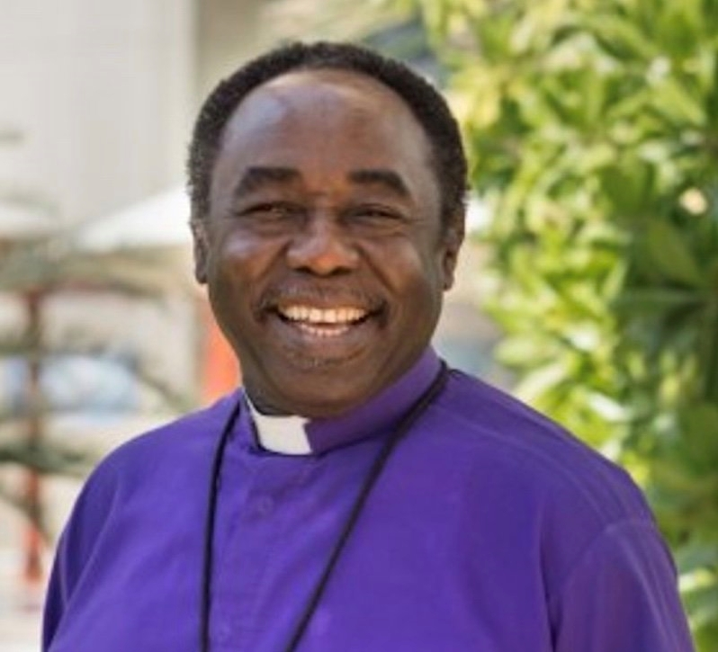
Bishop David is delighted to welcome back Most Revd Dr Benjamin Kwashi as the speaker at this year’s Bible Week running from Tuesday 30 August until Friday 2 September. He will also speak at a Bible Week Youth Night on Saturday 3 September.
Ben is Bishop of the Anglican Diocese of Jos and Archbishop of the Ecclesiastical Province of Jos in the Church of Nigeria and spoke at our Bible Week back in 2009. Many of us will remember him as a powerful and gifted communicator, passionate for the Gospel and willing to lay his life on the line in its cause. Ben has survived three assassination attempts at the hands of terrorists and more recently been declared cancer free after a diagnosis of stage 4 colon cancer which had also spread to his liver.
We very much look forward to Archbishop Ben’s testimony and Bible teaching.

Leadership
Bible Week will also be an occasion to celebrate leadership in the diocese with short acts of commissioning on Tuesday (Parish Readers) and Wednesday (Diocesan Readers). On Thursday Bishop David is inviting the clergy of the diocese to reaffirm their ordination vows.
On Friday we hope that choirs and worship teams will make a special effort to come along for ‘Let’s Sing’, an evening of worship and teaching from Archbishop Ben.

Time and place
Bible Week will begin each evening at 7.45 pm in Willowfield Church, 149 My Lady’s Road, Belfast, BT6 8FE.


Freewill Offering
The Parish Treasurers would like to thank those Parishioners who responded to previous invitations to arrange a standing order, make a direct bank payment to the Parish or post a cheque to the Treasurer in lieu of their weekly envelopes during the current emergency.
If you have not yet availed of one of these methods of temporary giving and would wish to do so please contact:
Annahilt – Miss Patricia Halliday Email patriciaapc@btinternet.com Telephone 028 9266 5310 Mobile 07713 257691
Magherahamlet – Hillary Edgar Email: hillary.edgar01@btinternet.com Telephone 028 4481 1361

LISBURN FOODBANK
The Lisburn Foodbank is providing an essential service to those within our community who are experiencing difficult times, often due to circumstances beyond their control.
The Foodbank provides emergency food and support to local people in crisis in the Lisburn area.
Parishioners may leave items for the Foodbank in the basket in Annahilt Church Porch, on the FIRST and SECOND Sunday of each month.
A particular request from the Foodbank is for items listed below:
Toiletries
Cleaning supplies
Small packs of toilet roll
Nappies
Baby wipes
Shower gel
Soaps
Small boxes of washing powder

YOUR HELP WOULD BE GREATLY APPRECIATED.
Parish Website: AnnahiltAndMagherahamlet.org
Parishioners are reminded that the website annahiltandmagherahamlet.org has been created to provide information on church related activities and organisations for parishioners and the wider community. Although circumstances have changed considerably since the various lockdown periods the website continues to host online services each Sunday.. It also contains a list of upcoming church services and news from our group of parishes, as well as downloadable versions of the parish magazine. The site will be continually developed, so if you have any submissions, suggestions or requests relating to the website, these can be sent to admin@annahiltandmagherahamlet.org.



www.annahiltandmagherahamlet.org

Parish Magazine
Any contribution for the next edition of the Parish Magazine should be left with the Rector or Roger Maxwell (roger.maxwell1@btinternet.com) by Sunday21 August 2022.

Registered as a charity with The Charity Commission for Northern Ireland
NIC103246 (Annahilt) and NIC102122 (Magherahamlet)
Top of Form

