News from the Parishes

Church of the Ascension, Annahilt Magherahamlet Parish Church
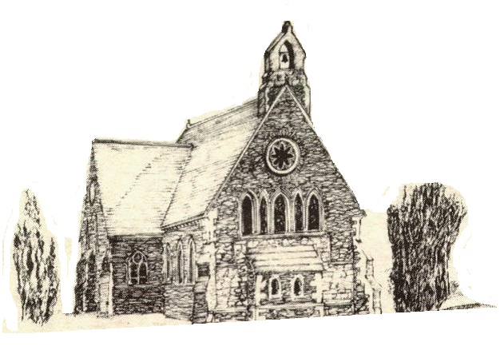

February and March 2022

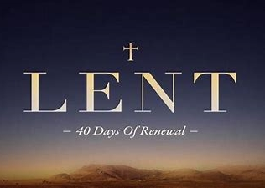

Rector: The Revd Canon Robert Howard
15 Ballykeel Road, Hillsborough
BT26 6NW
Tel: 028 9263 8218
E-mail: jrobert.howard@btinternet.com
Website: www.annahiltandmagherahamlet.org

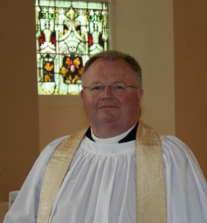
The Rector writes….

My dear Parishioners

As I write this there is now a very noticeable and welcome ‘stretch’ in the evenings. Yesterday I noticed some lovely narcissi in one of my outside flower pots. The arrival of spring, the emergence of flowers and brighter evenings are all important signs at this time of year. They remind us of better days ahead and point to beauty, hope and colour after another very challenging year in the grip of the pandemic.
With the easing of Covid-19 restrictions announced recently, there are some new updates which will affect the way we do things within our Church buildings, and the arrangements for acts of worship, parish meetings and organisations.
Despite the easing of the restrictions, we should remain mindful that the transmission rate is still high and therefore we have to continue to do everything we can to keep everyone in our parishes and wider community safe, while at the same time taking forward the mission and ministry of our church as we seek to recover from the past two years. We also need to be mindful that many who have regularly attended services in our church buildings throughout the pandemic have found reassurance and comfort in the mitigations that have been in place, so to instantly remove all mitigations would leave those same people feeling vulnerable and exposed. As we look to a brighter future, with more freedom and fewer restrictions, we need to move forward with courage, care and with a measure of restraint in the early stages in order that everyone feels safe as we return to some level of normality.
The recent updates will very shortly be considered by both Select Vestries in our Group of Parishes. The following guidance notes are simply to provide some help and assistance as together we all try to navigate our way forward.
Covid symptoms Anyone who has (or think they might have) any of the symptoms of Covid-19, or are just generally feeling unwell, should be encouraged not to come to services or other meetings to avoid the risk of spreading the virus to others.
Hand sanitisers will continue to be available at the entrance to buildings and used by everyone entering and leaving the premises.
Contact Tracing is no longer required.
Social Distancing is no longer a legal requirement but for the present the one metre rule will continue at the usual Sunday Services in our Churches. This will give time for the Select Vestries to reflect on what is right and appropriate in our own local situation as we consider reverting to more ‘normal’ seating patterns.
Face coverings It is recommended that they continue to be worn, for the time being, when people are in close contact with others inside. When entering and moving around inside a building and particularly during congregational singing, face coverings should be worn. Face coverings may be removed when people are seated and not singing. This guidance applies to services and meetings.
Sunday Schools and some Parish organisations are now meeting in Church premises. Those involved are asked to give thought to careful management of groups and their planned activities. The wearing of face coverings should be encouraged when individuals are moving around inside a building but may be removed when seated.
With the current trajectory, and if there are no new variants or major increases in the spread or seriousness of the symptoms of the virus, then it is hoped that in the not too distant future we should all be facing a much better situation as we move on into the summer months and beyond.
It has been a very difficult two-year period but the hard work, careful observance of the restrictions and general care for the well-being of the whole community has enabled us to reach this point in what has been one of the most difficult global situations in recent history. As we take forward the work of renewing, re-energising and rebuilding the life of the Church we give thanks to God for his presence with us in the midst of the storm.
Wednesday 2 March is Ash Wednesday which marks the beginning of the season of Lent. There will be a united Penitential Service for both parishes in the Church of the Ascension, Annahilt at 7.30 pm. The Service will also include special prayers for the people and government of Ukraine. It will be an opportunity to witness in prayerful solidarity with the population of Ukraine n the midst of their desperate plight and struggle to survive as a nation in the face of invasion by a hostile neighbouring country. I sincerely hope that you will make a special effort to be present.
I wish you a holy and spiritually refreshing Lent

Your sincere friend and Rector

Robert Howard

Congratulations....

..... to Miss Rachel Cromie, Magherahamlet who recently celebrated her 93rd birthday.

….. to Derek Capper who was invested in the State Rooms of Windsor Castle on 8 December 2021 as an MBE by Her Royal Highness, The Princess Royal, for ’Services to young people in Northern Ireland’.
Derek has worked for over 65 years in Scouting, education, the youth service, The Youth Council for Northern Ireland and the North South Education and Training Standards committee.

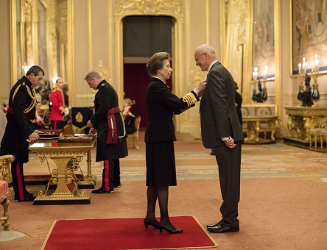

New Principal at Anahilt Primary School

Mr Andrew Smyth has now taken up duty as Principal of Anahilt Primary School.
Until recently, Mr Smyth was Principal of Inchmarlo, the Preparatory Department of RBAI. In previous years, he also was Vice Principal of Ballymacash Primary School and before that was on the Staff of Spa Primary School where he was highly regarded.

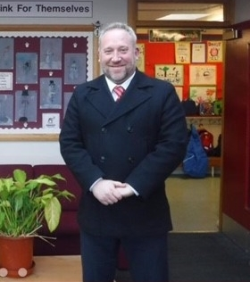

We congratulate Mr Smyth on his appointment and wish him very well in his new role.

Memories of Christmas 2021

It was another restricted celebration of Christmas on account of the ongoing public health restrictions. Nevertheless, all who attended and supported the various seasonal events in our Group of Parishes were very appreciative of everything that took place.
Unfortunately, it was not practical for the Sunday Schools to hold their traditional Nativity Pageants. However, the Christingle services which took place in both Churches on 12 December went very well. This year art materials, including canvases, paint, craft items, clay, drawing paper, felt tips and glitter donated by families in both parishes were given afterwards to Star NI.
On Sunday 19 December in the afternoon there was the Festival of Nine Lessons and Carols in Annahilt The music was led by Mr Timothy Wilson on the organ along with his wife Ruth and two soloists. The lessons were read by representatives of the parochial organisations.
Regretfully it was not possible to have the usual United Carol Service in Magherahamlet this year. Instead, a parochial carol service was held in the Parish Church on the morning of 19 December. The music, led by the Organist Mrs Frances Magorrian, consisted of many traditional congregational carols and a solo item.
The First Communion of Christmas was celebrated in Annahilt with representation from parishioners of ‘the Glebe’ and also from the Congregation of Legacurry Presbyterian Church and their Minister, the Revd Bobby Liddle preaching. A reciprocal visit to Legacurry followed on 31 December for the New Year’s Eve Watchnight Service at which the Rector preached. Both congregations were represented at this service also.
The customary Christmas Day Family Service in Annahilt and the Parish Communion Service in Magherahamlet also took place.
To all who contributed in any way we say ‘well done’ and a sincere ‘thank you’. The very positive feedback from parishioners has been very much appreciated.



Dear Canon Howard,

This morning we received a cheque in the post from Annahilt Parish Church as a donation to support our work. I just wanted to send you an email to express our thanks.

We also received a cheque from Magherahamlet Parish before Christmas and had assumed it was from both Parishes, so to receive another donation today has been a huge and wonderful surprise! Please pass on our heartfelt thanks to the parishioners of both Annahilt and Magherahamlet for their ongoing support and generosity, including the painting and other materials received at both Christingle Services. Everything is so appreciated.

We hope you had a lovely Christmas and wish you a happy and healthy 2022.

Best wishes,

Ruth Hutchinson and the rest of the STARNI team

A fresh LUKE
The Bishop, the Rt Revd David McClay has filmed forty devotionals for Lent that take a fresh look at the Gospel of Luke and the lessons that will shape our living.

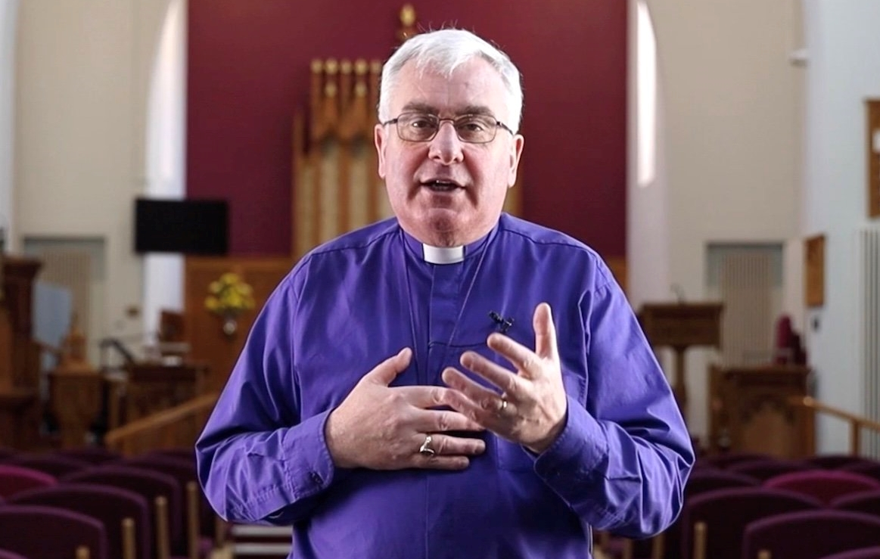

The Bishop says:
“Living lives of fruitfulness and fullness requires us to discover what following Jesus looks like and what loving Jesus means in times of uncertainty and change. The story of Jesus as told by Luke is transformational when we allow his story to change our story. I invite you to join me each day in Lent for a few minutes to look again at Luke’s account of Jesus then, and what that means for us now.”

The short films will be released early each morning on the diocesan website, Facebook, YouTube and Instagram accounts. Follow the links on www.downanddromore.org.


PRAYER WARRIOR

Do you have a concern or problem and would like someone to pray for you? If so, please contact the Rector (Tel 028 9263 8218) who will be willing to help. This is completely confidential and no details will be passed on to anyone else unless you want them to.
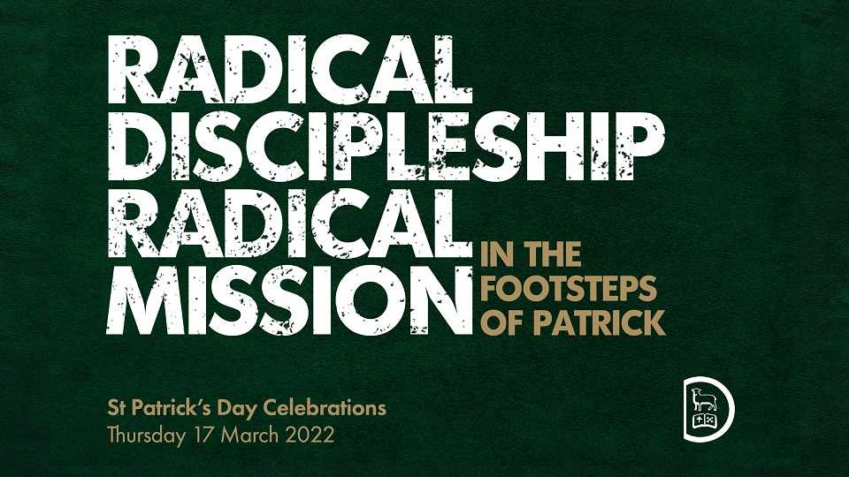
Saint Patrick’s Day in Saul and Downpatrick

You are warmly invited to our diocesan St Patrick’s Day celebrations on Thursday 17 March. The highlight is the Festival Service at Down Cathedral from 11.45am, which will be followed by a complimentary ‘Picnic in the Pews’.
Simon Guillebaud will speak at the Festival Service on the theme, Radical Discipleship, Radical Mission. Simon is the founder and International Director of the Great Lakes Outreach which is working to bring transformation to the people of Burundi in Central Africa. The author of several books, Simon has a large social media following and shares frequently on challenging and radical topics.

The day begins with Holy Communion at Saul and the Prayer Pilgrimage to the Cathedral.
Programme
9.15 am Holy Communion at Saul
Preacher: Capt George Newell, Leadership & Mission Development Coordinator, New Wine Ireland
10.15 am Pilgrimage from Saul to Downpatrick
11.45 am Festival Service in Down Cathedral
Preacher: Simon Guillebaud, Author and founder of Great Lakes Outreach, Burundi
Wreath laying ceremony at St Patrick’s Grave
1.15 pm Complimentary ‘Picnic in the Pews’ (tea and coffee will be provided)
Please note that advance booking is NOT required

Transport to Saul
From 8.15 am private buses will leave from the Mall for the communion service and pilgrimage.
The last bus for the communion service leaves at 8.45 am.
The last bus for the pilgrimage leaves at 9.45 am.
The last bus from Saul to the Cathedral leaves at 10.40 am.


A personal note in relation to the ‘Bishop’s Big Bike Ride Down and Dromore Lent Appeal 2022’.
Dear Friends
I would like to share with you what I am hoping this initiative will achieve.
Firstly, I am hoping that it will help raise the profile of the Bishops’ Appeal Fund. This fund has existed for decades as a way for our church to support those in greatest need in parts of our world that have been impacted by national disasters and other issues such as climate change. Our Diocesan Representatives, the Reverend Colin Darling and Canon Jono Pierce rightly want to raise awareness of the work of Bishops’ Appeal throughout our diocese. This is one of the reasons why I decided that I would join with them and others in this cycle run to every parish in Down and Dromore. We will, as you may already have gathered, be hoping to raise significant funds for two Bishops’ Appeal projects. One is a Christian Aid project in Honduras, working with their local partner organisation in eight communities that are particularly vulnerable to climate change. The second is a Tearfund project in Jordan, helping mobilise the Anglican church there to work amongst Jordan’s poorest communities.
Please look at how your parish might raise money during the season of Lent or, if for some reason it is not possible in Lent, at some time later in the year. We will be on our bikes for at least six days covering about 350 miles and it is our hope that parishes will raise significant sums of money for these two very worthwhile projects.
Another reason for me deciding to get on a bicycle after a break of 35 years is that I believe passionately that this is a season where all of us need to be willing to embrace things that will stretch us and take us out of our comfort zones. Covid-19 has very significantly impacted every aspect of our lives and the work of our churches. I am hoping that by undertaking the Bishop’s Big Bike Ride, we will inspire others to be creative and adventurous in the months ahead.
A third reason why I have decided to cycle around the whole diocese is that I am hoping and praying that by helping us focus on the needs of others our parishioners will become increasingly aware that it is our privilege as followers of Christ to be generous. I am hoping and praying that in some small way this initiative will help to light fires of generosity across the diocese enabling us to be generous in how we support ministry and mission in our parishes, our communities, our diocese, and in the worldwide church.
Finally, I am hoping and earnestly praying that after two years of us becoming more and more conscious of ourselves and of our own safety we might choose to become more acutely aware of the needs of others. While Covid-19 has made these past two years very difficult we have also learned many valuable lessons, not least the privilege that is ours in all our parishes to give and love and serve in many and varied ways.
I am so looking forward to meeting with all the clergy and some of your parishioners as we cycle into your parish.
Anything that you can do to raise awareness of the Bishop’s Big Bike Ride will be appreciated by all of us who will be cycling in your direction during the month of March.
Kindest regards,
Yours in Christ.
+David Down & Dromore
The Bishop and his bike riding team will stop briefly at Annahilt Parochial Hall on Monday 21 March 11.30 am. You are invited to be present and greet him and the other bikers.
Prayers for Ukraine and Aid collection

Prayers for Ukraine will be included at the Penitential Service in the Church of the Ascension, Annahilt, on Ash Wednesday 2 March at 7.30pm. This is a space to come together and lift up the people of Ukraine, as well as the whole situation and its implications for the wider world, to God.

The following prayers are appropriate for use at this time of conflict in Ukraine:

O Lord our Governor, whose glory is in all the world:
We commend to your merciful care the people and government of Ukraine that, being guided by your providence, they may dwell secure in your peace.
Grant to their leaders and all in authority, wisdom and strength to know and to do your will.
Fill them with the love of truth and righteousness, and make them ever mindful of their calling to serve their people; through Jesus Christ our Lord.
Amen.

Grant, O God, that your holy and life-giving Spirit may so move every human heart in the nations of the world, that working and witnessing together, we may live in justice and peace and change the hearts of those who would make for conflict and war;
through Jesus Christ our Lord.
Amen.

O God, who has knit together in one family all the nations of the earth: remove far from us the evil of war.
Pour out upon the leaders of the nations your spirit of peace, restrain the passions of those who plan aggression, strengthen the hands of those who strive for justice and peace and hasten the time when the kingdoms of this world shall become the kingdom of your Son, our Saviour, Jesus Christ.
Amen.

Almighty Father, whose will is to restore all things in your beloved Son, the King of all:
Govern the hearts and minds of those in authority, and bring the families of the nations, divided and torn apart by the ravages of sin, to be subject to his just and gentle rule; who is alive and reigns with you and the Holy Spirit, one God, now and forever. Amen.

Our Father, who art in heaven:
hallowed be thy name,
thy kingdom come,
thy will be done,
on earth as it is in heaven.
Give us this day our daily bread.
And forgive us our trespasses
as we forgive those who trespass against us.
And lead us not into temptation,
but deliver us from evil.
For thine is the kingdom, the power, and the glory
for ever and ever. Amen.


Items urgently needed for refugees leaving Ukraine and arriving in neighbouring countries are blankets, duvets and sleeping bags and personal hygiene items including soap, toothpaste, shower gel and sanitary items.
Food, clothes and shoes are not required at this stage as present resources can meet any need for these items among the arriving refugees.
Items can be delivered to either Annahilt or Magherahamlet Churches and should be packed in boxes and labelled to allow the goods to be loaded onto lorries bound for Romania. Items are being transported free of charge by Romanian transport company, Tarsin Transport.
Financial donations are also requested. On the first and second Sundays in March there will be special collections at all our Services in Church. Alternatively, donations may be sent to our Parochial Treasurers, Patricia Halliday (Annahilt) and Hillary Edgar (Magherahamlet). At this juncture all monies raised will be given to The Red Cross.
The people caught up in this conflict are desperate for support and protection.
As the security situation allows, the Ukrainian Red Cross Society (URCS) and the International Committee of the Red Cross (ICRC) will continue to respond to existing and emerging humanitarian needs. The Red Cross has supported people affected by this conflict for years and this will not stop now.
Your donation could help someone affected receive:
• food
• water
• first aid
• medicines
• shelter
Your donation will mean we can reach even more people in desperate need. Please give as generously as you can.

Church Services in the Parishes of Annahilt and Magherahamlet

‘I was glad when they said to me: “Let us go to the house of the Lord”’

If it is not possible to attend Church in person, we invite you to join in worship online at www.annahiltandmagherahamlet.org

Sunday 27 February Sunday before Lent
CMSI Sunday
10.00 Family Service Annahilt
Preacher: The Revd Roger Thompson
12.00 Family Service Magherahamlet
Preacher: The Revd Roger Thompson

Wednesday 2 March Ash Wednesday
7.30 pm Penitential Service Annahilt
Special Prayers will be said for Ukraine

Friday 4 March World Day of Prayer
8.00 Evening Service Magherahamlet
All welcome

Sunday 6 March Lent I
10.00 Parish Communion Annahilt
12.00 Parish Communion Magherahamlet

Sunday 13 March Lent II
10.00 Morning Prayer Annahilt
12.00 Morning Prayer Magherahamlet

Sunday 20 March Saint Patrick
10.00 Parish Communion Annahilt
12.00 Morning Prayer Magherahamlet

Sunday 27 March Lent IV (Mothering Sunday)
Clocks go forward 1 hour
10.00 Family Service Annahilt
Preacher: Mrs June Butler
All Ireland President of the Mothers’ Union
(followed by Light Refreshments in Parochial Hall)
12.00 Family Service & Holy Baptism Magherahamlet
Preacher: Mrs June Butler
All Ireland President of the Mothers’ Union


From the Parish Registers

Holy Baptism
‘Go therefore and make disciples of all nations baptising in the name of the Father, and of the Son and of the Holy Spirit’

12 December 2021

Church of the Ascension, Annahilt

Carter William Trevor, son of Gareth and Suzanna Simpson

Magherahamlet Parish Church

Charlie Ian, son of Mark and Nicole Douglas

Christian Marriage
‘In Christ shall all be made alive’

12 February 2022

Stormont Presbyterian Church

Nicholas Robinette and Alison Duffield

14 February 2022

Church of the Ascension, Annahilt

Joshua Colston and Emma Frank

We congratulate both of these newly married couples and wish them every happiness

Christian Burial
‘In Christ shall all be made alive’

16 December 2021
Isaac Harrison, Benson Street, Lisburn
Following Services at home and in the Church of the Ascension, Annahilt, burial took place in adjoining churchyard
Isaac Harrison was brought up on ‘The Hill’, New Road. He attended the local Primary School at Ballycrune and continued his education at Lisburn Tech. For a year or so afterwards he was a cabinet maker. Then he took up employment with Aerocrete where he would spend his entire working life, culminating in his appointment as Sales Director.
The story is told of how Isaac and a friend met up with two other friends who were going to the Harvest Thanksgiving Service at Loughaghery Presbyterian Church and invited them along. Knowing in their own minds who else was expected to be there, Isaac and his friend responded ‘Yes, we’ll go with you but WE’RE taking the girls home’. And they did! It all must have gone well as Isaac kept coming, culminating in he and Beth being married in Edengrove Presbyterian Church on 1 June 1963. They set up home in Benson Street, Lisburn where they would live throughout their entire married life of 58 years and where David, Linda, Helen and Alison were brought up. In due course, when they married and had their own families and later again great grandchildren came along, the entire family circle assembled at No 47 on Sundays for lunch. Isaac and Beth delighted in them all and how they made and were making their way in the world. They also remained close to Isaac’s parents and siblings and their families, with the whole connection gathering at Granny Harrison’s house on Christmas Eve. Isaac was a devoted family person. Isaac and Beth also went on coach tours over many years, very often with his sister Madeline and brother-in-law Cecil.
Isaac was a keen player in both indoor and outdoor bowls winning many prizes over the years. He was also a keen golfer who held membership of Spa and later Lisburn Golf Clubs. He also was an enthusiastic Table Tennis player at the Annahilt Cross Roads, not least when he played in competition with his father.
Isaac loved tending to and developing the garden of his home and was particularly pleased when his grandson Rhys asked for a greenhouse for a present.
Isaac and Beth made Annahilt Parish Church their spiritual home, where they attended worship every Sunday with Isaac ‘calling the faithful’ before each Service by ringing the bell. He served on the Select Vestry over many years holding the Office of Churchwarden and also Parochial Nominator.
Isaac will be remembered as a loving husband, father, grandfather, great grandfather and friend. Isaac’s faith in God, his love and loyalty to this church, and his concern for others will be an abiding memory of him. By his very life, he taught us about the love and grace of Jesus, and his legacy will be an enduring one.
We extend our deep and prayerful sympathy to Beth and the entire family circle in their great loss.

22 December 2021
Christopher (Christie) Hall, Hillside, Spa
Following Services at home and in Magherahamlet Parish Church, burial took place in adjoining churchyard
In 1935, Christie was born on Christmas Day to the late William and Isabel Hall, the eldest of five siblings, Billy, Kenny, the late Isabel and the late Sammy. He was initially brought up on Crabtree Road until the family moved to Downpatrick Road. Christie attended the local Primary School at Magheradroll which he left aged 14. For some time afterwards Christie delivered telegrams by bicycle until he was employed at Billy Young’s neighbouring farm. Then, for some 23 years Christie worked at S J Martin’s Quarry in Ballynahinch making blocks. Then, for another 17 years he was employed at Gilbert Ash Construction where he became Foreman. On attaining the age of 65 he retired as he always said he would!
The story of how Christie first met Anne is an interesting one. It was at a dance in Spa Orange Hall one 12th night and culminated in their marriage in Magherahamlet Presbyterian Church on 14 August 1963. Initially, they set up home on Dunmore Road until they moved to Hillside in Spa where they would live for the remaining 54 years of married life and where Lynda, Kenneth and Joanne were brought up. In due course, when they married and had their own families and later again great grandchildren came along, Christie & Anne were very proud of how they made and were making their way in the world, not least in the football success of his grandson Greg. Christie was and remained a devoted family person. He loved when the extended family came together particularly at barbecues during the summer.
Christie was a very keen sports person, playing hockey, football, cricket and golf over the years. Walking was a pleasurable means of transport and he completed the Mourne Walk seven times.
Christie loved tending to and developing the garden of his home which he found therapeutic. He was never one to sit still, always looking for something to do especially in retirement. He was obliging to anyone who needed his help with grass cutting, hedge trimming and moving sheds. He proved a very practical and resourceful Caretaker at Spa Presbyterian over 17 years.
Christie & Anne made Magherahamlet Parish Church their spiritual home where they attended worship with unfeigning regularity. He served on the Select Vestry at different times, holding the Office of Rector’s Churchwarden, a role he fulfilled with distinction. Anything Christie took on he carried out with discretion and dignity.
Christie will be remembered as a loving husband, father, grandfather, great-grandfather and friend. He will be fondly and gratefully remembered by all who knew him.
We extend our sincere sympathy and prayers to Anne and the whole family circle at this sad time.

7 January 2022

William John Charles (Bill) Job

Following a Service in the Church of the Ascension, Annahilt interment (after cremation) took place in adjoining churchyard
William John Charles Job was the youngest of five siblings (Charlie, Betty, George, Freddie and Bill) who was born and brought up in South Queen’s Ferry in Edinburgh, near the Forth Road Bridge Railway and was educated locally.
Aged 17, Bill joined the Army and served some 25 years. He served in Aden, Hong Kong, Kenya, Germany and three tours of duty in Northern Ireland. He ultimately became a Sergeant Major in the Royal House Artillery. Following his Army career. he held various jobs.
Bill was a very keen sportsperson. He loved horse racing especially on Boxing Day and when both the British and Irish Grand Nationals were run. He excelled in both the Long Jump and High Jump while in the Army. He enjoyed basketball and football following closely the progress of England in last year’s World Cup competition. He also liked to solve crossword puzzles.
Bill kept up with current affairs by reading a newspaper each day. He had a great sense of humour and loved banter.

Bill was a practical and resourceful person who was very much ‘hands on’ when his daughter Susie and Gareth were building their present home.
While in Germany, Bill and Angelica met and fell in love. They were married for 55 years. They moved about extensively during Bill’s Army postings and eventually settled in Edinburgh before retirement.
They had a family of four, Peter, Klaus, Andrew and Susie (married to Gareth). Bill particularly enjoyed being a Grandad to Christopher, Angelica, Hunter and Carter (whose Baptism he had attended only a fortnight before his unexpected death).
Bill’s period of illness was a short one, which be bore with dignity and grace.
To Bill’s wife Angelica all the family circle and to Paul (who was like another son) we extend our deep sympathy in their great loss.

11 February 2022
The Revd Canon Eric Kingston, former Rector of Annahilt and Magherahamlet, Kinedale Park, Ballynahinch

Following a service in the Church of the Ascension, Annahilt, burial took place in adjoining churchyard.

Eric was born in Bantry, Co Cork on 4 December 1924, one of four siblings along with Gladys, Ena and the late Doris, his twin. Initially he was a pupil of the local National School in Bantry. His secondary education began in Kilkenny College and was completed in Mountjoy School.
In 1944 Eric joined W S Magowan Printers in Newry as a Trainee for Management. In 1955 he joined the firm Magowan & Ingram in Belfast as a very successful Commercial Traveler, an occupation he held until he responded to the call to Ordained Ministry for which he began training at the then C of I Divinity Hostel.
On 7 September 1957 Eric married Kathleen McWhirter in Newry Methodist Church. They had two daughters Susan and Helen. As they raised their family at home and later when Susan married Aubrey and Helen married Stuart, they each were and remained very much a family one to the other with Eric remaining a loved and patriarchal influence.
Prior to Ordination, Eric had held many of the positions which are open to a Layperson in the Church of Ireland – Sunday School Teacher, Choir member, Select Vestryman and Parochial Nominator.
Eric was made Deacon on St Peter’s Day 29 June 1969 by Bishop Frederick Julian Mitchell to serve as Curate Assistant in St Patrick’s, Ballymacarret in Belfast during the Incumbency of the late Archdeacon Billy Macourt. He was ordained Priest the following year by Bishop George Quinn. From 1972 he began a second Curacy in St Columba’s Parish, Knock under the then Rector Canon William Whittaker until he was instituted as Rector of Annahilt on Thursday 7 October 1976. There began an Incumbency which blossomed and moved forward in the years which followed and was further extended when the Grouping of Annahilt and Magherahamlet Parishes took place and Eric was instituted as Rector of Magherahamlet.
In his parochial ministry in Annahilt and Magherahamlet Eric was a most diligent and faithful pastor to his parishioners both to the sick and the whole which ensured he got to know his people very well and they him. His ministry was one of ‘presence’ with his people in all of life’s circumstances but especially sharing in the joy of a baptism or marriage, offering prayer and ministering the Sacrament to the sick or housebound and giving comfort to the bereaved.
He worked effectively with the Select Vestries of both parishes in the development and refurbishment of both parochial halls and the extension of the hall in Annahilt as well as an extension to the then Rectory.
Eric was an excellent co-ordinator and overseer of voluntary work in the Parish. One of his parishioners is known to have said ‘I couldn’t refuse Mr Kingston because he would never ask me to do anything he wouldn’t do himself’. There is one parishioner who was made a Churchwarden at the age of 18, just as soon as it was legally possible and who since held office many times. Others in both our parishes who took on various positions while Canon Kingston was Rector still hold them!
Eric also had an excellent rapport with young people. He counted it a huge privilege to talk to the children at Morning Assemblies in both Annahilt and Spa Primary Schools. He also looked forward every two years to the preparation of young people for Confirmation which he saw a real opportunity of getting to know better the future membership of the Church.
In the diocese Eric became Diocesan Curate (i.e., the co-ordinator of Vacancy and Sickness Duty in parishes throughout Down & Dromore) in 1976 in succession to the late Revd Terry Sullivan He continued in that post until 2011, long after he retired from Stipendary Ministry. His excellent organisational skills made him eminently suitable for this task. These many years in so many facets of stipendiary ministry were recognized by Bishop Gordon McMullan when he appointed Eric as Canon on the Chapter of Dromore Cathedral in the office of Precentor, an honour he richly deserved prior to his official retirement on 7 September 1993. In retirement, he undertook pastoral visiting in Dromore Cathedral Parish for five years and officiated most Sundays at worship in churches throughout the diocese covering vacancy, holiday or sickness duty.
Eric was also hugely respected by his clerical colleagues in ministry. Since coming into Dromore diocese he was a very faithful member of the Lurgan Clerical Union (a clerical society for serving and retired clergy in the diocese)
In former years Eric was Secretary of the Committee which organized an annual Refresher Course for clergy which took place annually at Portrush during the week following Easter Day. More recently he was involved in the Retired Clergy Association.
In his incumbency here he enjoyed excellent relationships with the various local Presbyterian Churches and their Ministers, the Revd David McConaghy (Loughaghery and Cargycreevy), the late Revd Scott Martin, (Annahilt and Drumlough), the late Revds Cecil Adams and John Keenan (Spa and Magherahamlet) and the Revd Tom McCahan (Legacurry). With his colleagues in Annahilt, he served on the Board of Governors of the Primary School and as a Trustee on the Sharland Charity which resulted in a significant refurbishment of the Almshouses. In June 1977, in Annahilt he hosted a special united Service involving the other local clergy and their congregations as well as the Baillie’s Mills Accordion Band to mark the Silver Jubilee of HM The Queen. In Magherahamlet he enthusiastically took part in the Community Carol Service each year, the hosting of which by the clergy of Spa Presbyterian, Magherahamlet Presbyterian and Magherahamlet Parish rotated each year.
Eric was wonderfully supported throughout his ministry by Kathleen, Susan and Helen. He too was totally supportive of Kathleen in her very active membership of the Mothers’ Union, in particular as Enrolling Member of both branches in the Group of Parishes (the Silver Jubilee of both Annahilt and Magherahamlet Branches arose in Eric’s incumbency), as Down & Dromore Diocesan President and as Central All Ireland President.
As Eric and Kathleen’s extended family grew, they delighted in their grandchildren Katrina, Stephen and Gareth and great-grandchildren Mollie, Alfie and Caleb. As we mourn our former Rector, we extend to his devoted wife Kathleen and all the family circle our heartfelt and prayerful sympathy.


WORLD DAY OF PRAYER
FRIDAY 4TH MARCH

This year’s service has been written by the Christian women of England, Wales and Northern Ireland, with the title, “I know the plans I have for you”.

We haven’t had a home-grown service since 1945 so this is a bit of an occasion. The overarching theme is hope which is particularly relevant in these uncertain times.

Our service will be held in Magherahamlet Parish Church at 8.00 pm.

Everyone is warmly invited.

Parochial Annual General Meetings or Easter Vestries

Please note the Annual General Meeting or Easter Vestry of each parish in the Group:

Annahilt Monday 28 March 8.00 pm Parochial Hall

Magherahamlet Tuesday 29 March 8.00 pm Parochial Hall

As usual, the past year will be reviewed and the Churchwardens and Select Vestries for another year will be elected.
While only registered Vestrypersons may vote, attendance is open to all parishioners. The meetings are occasions when we may learn more about what is happening in our own parish, diocese and the wider Church, as well as participating in the annual elections afterwards.

Flowers for the Churches

Annahilt Magherahamlet
March
6 Mrs B Harrison
13
20
28 Mr & Mrs R Carlisle Miss V Begley

Church Cleaning, Annahilt
March
4-5 Mrs A Maxwell Mr R Maxwell

11 - 12 Mrs E Crawford Mrs M Clarke
18 - 29 Mrs J Bolas Mr A Bolas
25 - 26 Mrs L McCambley Mrs E Harrison
April
2 – 3 Mrs E Ogle
10-11 Mrs J Guiney Mrs H Cardosi
17-18 Mrs H Hill Mr T Hill

FOR SALE

2 TRESTLE TABLES

If interested please contact

Colin Hassard email: secretary.annahilt@annahiltandmagherahamlet.org

In memoriam

Donations in memory of Christie Hall to Magherahamlet Parish in lieu of flowers amounted to £1090. We thank Christie’s wife Anne and the family circle for thinking of the Parish in this way and everyone who subscribed so generously.

Thank you……

……to all who contributed to the special collections in support of the following charities:

Annahilt

Star NI £126.51

Dean of Belfast’s Sit Out £251.00

Save the Children £93.00

NI Hospice £50.00

Leprosy Mission NI £139.50

CMSI (in memory of Canon Eric Kingston) £150.00

Magherahamlet

Star NI £220.00

Dean of Belfast’s Sit Out £139.00

Marie Curie £194.00

Leprosy Mission NI £104.00

CMSI (in memory of Canon Eric Kingston) £152.00



Dear Mothers’ Union Members and Friends,

We sincerely hope that you all had a good Christmas and were able to spend some quality time with your families. We pray too that the year ahead will see a big reduction in Covid cases and provide us with the opportunity to get back to some form of normality.
Currently, with regard to Mothers’ Union meetings and especially considering the high incidence of Omnicron infections throughout the countryside, we feel that it is still too soon to resume our usual monthly group evenings. Perhaps as we journey towards Easter, the situation will have improved. In the meantime please continue to stay in touch with friends and neighbours, giving them a wave, a phone call or sending a little note. These small acts of kindness are very much appreciated.

In the wider world of Mothers’ Union we are delighted to introduce our newly appointed Diocesan President, Mavis Thompson and Mothers’ Union, Diocesan Chaplain, Revd Duncan Pollock. On the Mothers’ Union Down and Dromore Diocesan Facebook page Bishop David states that the Revd Pollock will bring so much to the task of encouraging Mothers’ Union and the Branches in Down and Dromore in his role as Chaplain. He has done outstanding work during Covid-19 and is much loved in the Parish of Groomsport where he is Rector. The Bishop continues to say that he is so pleased that the Diocese at large will now benefit from his many gifts and his understanding of God’s wonderful grace for his church and for his world. Revd Pollock has asked for all members of the Mothers’ Union in the Diocese to keep him in their prayers as he prepares himself to take up this new chapter in his ministry. Bishop David also thanked the outgoing Diocesan Chaplain, Gerald Macartney, for his faithful service and pastoral ministry.
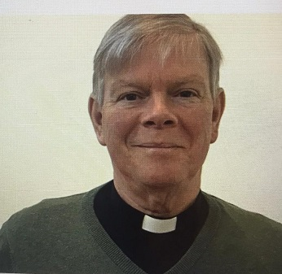

As we now focus our attention on Mavis Thompson we are aware that many of us have known Mavis as the very hard working and dedicated Secretary of Dromara Branch, an Area Representative of Ballynahinch Area and since 2020 the Worldwide Representative on the Mothers’ Union Trustees Board. Mavis is extremely well qualified to undertake the role of Diocesan President and she says that God has been with her in her decision to accept the position. The two bible verses -Philippians 4:6 ‘’Do not be anxious about anything‘’ and Deuteronomy 31:8 ‘’The Lord himself goes before you and will be with you‘’ have been particularly important when making her decision. Mavis’ many other talents include a Diploma in Lacemaking and she has served as a Committee member of The Lace Guild. She is also interested in knitting, sewing and crochet.

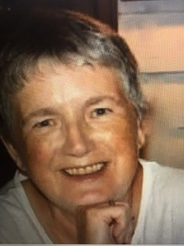

As members of Mothers’ Union we join together to wish both Mavis and the Revd Pollock ‘’God’s Blessing‘’ as they embark upon their positions of responsibility within the Diocese of Down and Dromore Mothers’ Union.
At this point we would also like to extend our ‘’Thanks and Appreciation‘’ to Roberta Macartney, our former DP for all her hard work and dedication.
As we open our arms and welcome 2022, let us join hands in prayer asking for God’s guidance and direction in the days to come and his Blessing as we remain faithful members of Down and Dromore Diocese Mothers’ Union.
Unfortunately, several of our members have been recently bereaved. We offer our deep and sincere sympathy to Beth Harrison on the death of her husband, Isaac, to Anne Hall on the passing of her husband, Christie, and to Kathleen Kingston on the loss of her husband and our former Rector, Canon Eric Kingston.

Esme Avril

Mothers’ Union—Midday Prayers—February 2022
Hope and confidence in God’s Word

Colours of Transformation

Monday: Rainbow
Like the appearance of a rainbow in the clouds on a rainy day, so was the radiance around him. This was the appearance of the likeness of the glory of the Lord.
Ezekiel 1:28
Christ our Lord, radiant in splendour and glory, shine your love into the darkness and paint our lives with the rainbow hues of your multi-faceted blessing. Lift our eyes that we may delight in the brightness and beauty of your transformational love which colours our lives with joy and hope.

O Christ our Morning Star, Splendour of Light Eternal, shining with the glory of the rainbow, come and waken us from the greyness of our apathy and renew us in your gift of hope.
Amen.

Tuesday: Red
Come now, let us settle the matter, says the Lord.
Though your sins are like scarlet, they shall be as white as snow; though they are red as crimson, they shall be like wool.
Isaiah 1:18
Christ, our spotless Redeemer, who cleanses us from sin, look upon us with mercy and grace.
In shame, I come to Christ, carrying the filthy rags of my sin, stained in crimson guilt.
In faith, I lay them at Christ’s feet, whispering words of penitence, helpless to make amends. In love, Christ transforms my life, making me clean as newly-fallen snow with his crimson blood of righteousness.
Christ our spotless Redeemer, who takes away the sin of the world, we bring you our worship and praise.
Amen.

Wednesday: Green
The Lord is my shepherd I shall not be in want. He makes me lie down in green pastures, he leads me beside quiet waters, he restores my soul.
Psalm 23:1-3
When our lives are dull and dry, the colour drained by the demands we face: Lord, lead us to pastures green. Transform our parched souls into abundant places of fruitfulness with your verdant refreshment.
Shelter us in leafy shade. Restore us in times of dryness by the waters of the Spirit as we soak in your Word. Plant us in fertile places. Transform our barrenness into lives that will produce a vibrant harvest of faith.
Surely your goodness and mercy will colour all the days of our lives, until we dwell in your house forevermore.
Amen.
Thursday: White
Jesus led them up a high mountain, where they were all alone. There he was transfigured before them. His clothes became dazzling white, whiter than anyone in the world could bleach them.
Mark 9:2-3
Chosen One, Beloved of the Father, lead us to the heights of your presence that we may behold your dazzling radiance. Bathe us in the rays of your glorious truth that we may be transformed by your perfect love. Open our ears to listen to your voice that we may be transformed by your words of life. Then lead us on by the light of your presence, renewed in spirit and envisioned in faith; to works that bring lasting transformation in the world you have called us to serve.
Amen.

Friday: Sparkling jewels
Afflicted city, storm-tossed and not comforted, I will rebuild you with stones of turquoise, your foundations with sapphires. I will make your battlements of rubies, your gates of sparkling jewels, and all your walls of precious stones.
Isaiah 54:11
Christ our King, you were storm-tossed by those you died to save; rejected by those you came to build into your kingdom. Yet now you shine with resurrection glory, radiating bejewelled light, as you stand on the foundations of eternity. So, in your mercy, transform us in our hardships and rebuild the foundations of our lives, with sparkling jewels of your love and grace. May we shine as precious living stones, reflecting the light of Christ our King, and may his light transform the world.
Amen.

Saturday: Colours of transformation We all are being transformed into his image with ever-increasing glory, which comes from the Lord, who is the Spirit.
2 Corinthians 3:18
Take your canvas, God, and sketch on it a new life for me. Shape me, style me and shade me with your Spirit.
Paint over the old me with all my blemishes and flaws and then, with Jesus as your model draw my heart again and colour it with love.
God, paint over the old me and draw me again so that I can see the world from your perspective. Then, after growth and in wisdom perhaps one day someone will look and see in me your masterpiece a portrait of the glory of Jesus.
Amen.

LISBURN FOODBANK
The Lisburn Foodbank is providing an essential service to those within our community who are experiencing difficult times, often due to circumstances beyond their control.

The Foodbank provides emergency food and support to local people in crisis in the Lisburn area.
Parishioners may leave items for the Foodbank in the basket in Annahilt Church Porch, on the FIRST and SECOND Sunday of each month.
A particular request from the Foodbank is for items listed below:
Cleaning items
Small packs of toilet roll
Nappies, baby wipes
Shower gel
Soaps
Washing powder

The Lisburn Foodbank is providing an essential service to those within our community who are experiencing difficult times, often due to circumstances beyond their control.

YOUR HELP WOULD BE GREATLY APPRECIATED.

Parish Website: AnnahiltAndMagherahamlet.org
Parishioners are reminded that the website annahiltandmagherahamlet.org has been created to provide information on church related activities and organisations for parishioners and the wider community. Since lockdown began, the website has hosted online services each Sunday. It also contains a list of upcoming church services and news from our group of parishes, as well as downloadable versions of the parish magazine. For those wishing to attend a service at Annahilt, notification of attendance can also be given via the Parish website up to the Friday before.
The site will be continually developed, so if you have any submissions, suggestions or requests relating to the website, these can be sent to admin@annahiltandmagherahamlet.org.



Parish Magazine
Any contribution for the next edition of the Parish Magazine should be left with the Rector or Roger Maxwell (roger.maxwell1@btinternet.com) by Sunday 20 March 2022.

Registered as a charity with The Charity Commission for Northern Ireland
NIC103246 (Annahilt) and NIC102122 (Magherahamlet)
Top of Form

