News from the Parishes

Church of the Ascension, Annahilt Magherahamlet Parish Church
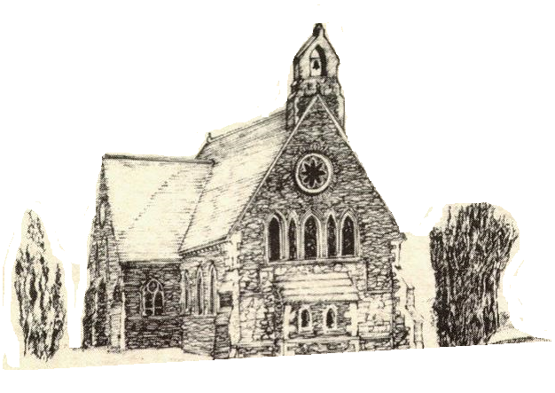

February and March 2023

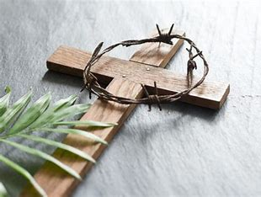

Rector: The Revd Canon Robert Howard
15 Ballykeel Road, Hillsborough
BT26 6NW
Tel: 028 9263 8218
E-mail: jrobert.howard@btinternet.com
Website: www.annahiltandmagherahamlet.org

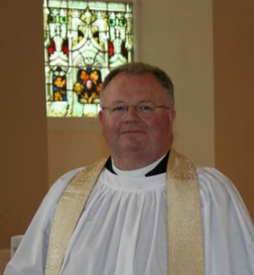
The Rector writes….

My dear Parishioners

We have entered the third month of 2023 and it seems as if there are many challenges to face. We think of the ongoing conflict in Ukraine and the huge implications of that in terms of loss of life in both that country and Russia. We think of the trauma experienced as people see homes and businesses flattened and the documented impact of this conflict all over the globe in terms of rising energy and food prices. The news coverage of the conflict has often overshadowed other global challenges like climate change and its impact around the world.
The daily media images of the consequences of the absolutely devastating impact of the earthquake in Turkey and Syria have also made an enormous impression on us. However, as time goes on, we need not be surprised if international coverage of this may well dwindle and fade from ‘The News’ altogether. We don’t hear as much about humanitarian disasters around other parts of the world such as the famine affecting the horn of Africa at the present time. Many millions are facing starvation because of drought and the rising food costs at the markets which no one is able to afford after the catastrophic impact of Covid-19.
As we emerge from the worst excesses of the pandemic, we are mindful of the impact it has had upon our mental health. People are understandably cautious about coming out to large gatherings and many have withdrawn. This means many groups and activities have seen their attendances suffer as people are fearful for their health or maybe they are shielding a loved one who is vulnerable. Those who have re-emerged into circulation find that much has changed and now seems unfamiliar. Many people find the ‘new’ situation difficult to cope with and, with so much change in so many different parts of our lives, it can seem somewhat overwhelming. People long for stability and familiar rhythms to help them feel grounded again. Perhaps this is particularly so in the Church seen by many as a place of sanctuary from the storms and changes that tend to sweep into our lives without warning. The reality for the Church, as with any organisation, is that it too needs to change or it will find difficulty in surviving. The message of Salvation remains the same. It is found in Jesus Christ and in His redeeming love. It’s a hope that was made possible by his sacrificial death on the Cross at Calvary and His rising from the dead. Let’s make no mistake about it - people still need to find peace with God and will find meaning and purpose through a relationship with Him through Jesus Christ.

We may have to communicate that in new ways. We may have to explore new possibilities of reaching out and connecting with this generation. Many people for all sorts of reasons have become disconnected and disengaged from the life of the church. Let us give our earnest and profound thought to how we may connect with this up-and-coming generation and reconnect with the lapsed. In all of the uncertainties going forward, we thank God for his steadfast love and faithfulness and we seek to make Him known to the world around us as this year progresses.
I wish you a holy and spiritually refreshing Lent.

Your sincere friend and Rector

Robert Howard

Congratulations…

..... to Lynn Green, Magherahamlet on being awarded a BEM for Service to Emergency Nursing in Northern Ireland in the King’s New Year’s Honours List
….to William McCurry, Magherahamlet on his engagement to Kirsty Walker

Memories of Christmas 2022

It was wonderful that we were able to celebrate this past Christmas without the public health restrictions of the past two years. All who attended and supported the various seasonal events in our Group of Parishes were very appreciative of everything that took place.
Unfortunately, it was not practical for the Sunday School in Annahilt to hold its traditional Nativity Pageant. However, a Christingle service which took place in the Church of the Ascension on 11 December went very well. Christmas gifts donated by families in both parishes were given afterwards to Star NI.
On Sunday 18 December in the afternoon there was the Festival of Nine Lessons and Carols in Annahilt The music was led by a united Choir of both Annahilt and Magherahamlet with Mr Timothy Wilson on the organ. Following an absence of some years on account of public health restrictions it was wonderful to have the Choir of Anahilt Primary School participating again. The lessons were read by representatives of the parochial organisations.
Regretfully it was not possible to have the usual United Carol Service in Magherahamlet this year. Instead, a parochial Carol Service was held in the Parish Church on the morning of 19 December. The music, led by the Organist Mrs Frances Magorrian, consisted of many traditional congregational carols and anthems.
The First Communion of Christmas was celebrated in Annahilt with representation from parishioners of ‘the Glebe’ and also from the Congregation of Legacurry Presbyterian Church and their Minister, the Revd Bobby Liddle preaching. A reciprocal visit to Legacurry followed on 31 December for the New Year’s Eve Watchnight Service at which the Rector preached. Unfortunately, the attendance at this Service was substantially diminished on account of widespread illness in the community and other mitigating factors.
The customary Christmas Day Family Service in Annahilt and the Parish Communion Service in Magherahamlet, which included a Baptism also took place.
To all who contributed in any way we say ‘well done’ and a sincere ‘thank you’. The very positive feedback from parishioners has been very much appreciated.



Dear Canon Howard,

We are writing to express our sincere thanks to the Parishioners of Annahilt and Magherahamlet for their support of STAR NI through the donation of Christmas Gifts and monetary donations at Christmas time.

All of the gifts were delivered to children and families in time for Christmas. The money from the Church Collections will be used to provide therapeutic counselling sessions over the coming year.

We really appreciate your generosity and support of our work

Ruth, Jolene, Katie, Cara & Michelle

STARNI

PRAYER WARRIOR

Do you have a concern or problem and would like someone to pray for you?
If so, contact the Rector who will be willing to help.
This is completely confidential and no details will be passed on to anyone else unless you want them to.
028 9263 8218

TRANSFORMATIONS
The Bishop, the Rt Revd David McClay commends this year’s diocesan Lenten Initiative:
Each day from Ash Wednesday, 22 February until Palm Sunday, 2 April, we’re looking forward to sharing ‘Transformations’, our Lent film series for 2023. The videos feature 40 short stories of God at work in Down and Dromore, told to us by a real mix of people from around the diocese. Follow the series on the diocesan website, YouTube and Facebook channels. from 22 February - 2 April 2023.

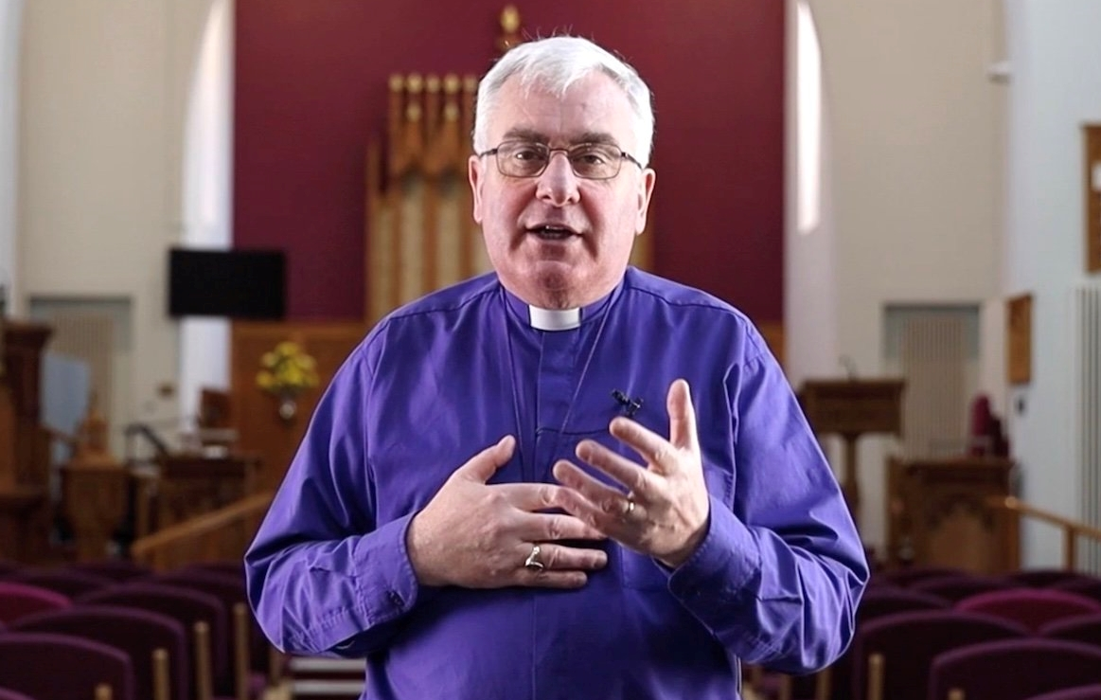

Saint Patrick’s Day in Saul and Downpatrick

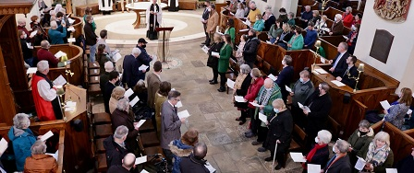

The Diocese of Down and Dromore will celebrate St Patrick’s Day on Friday 17 March. The highlight will be the Festival Service at Down Cathedral from 11.45am, followed by a complimentary ‘Picnic in the Pews’.
The day begins with Holy Communion at Saul and the Prayer Pilgrimage to the Cathedral where our guest speaker will be The Most Revd Laurent Mbanda, Archbishop of Rwanda.
Our theme is ‘Reconciliation’, a topic familiar to Archbishop Laurent who has been at the forefront of helping many in Rwanda deal with the impact and aftermath of the 1994 genocide.
Bishop David says: “I have asked Archbishop Laurent to help us to look together at how we can deal with some of the pain that continues to be part of life and living for many of us because of what we call ‘The Troubles’. All of us have a responsibility to continue to support, understand and pray for those who have been impacted by loss and trauma and I hope that this special day of worship and prayer will be a source of healing for many.”
The archbishop was himself a child refugee from the ethnic tensions that erupted into organised massacres in Rwanda in 1959. He fled to Burundi with his mother at the age of five and has written about his experiences in From Barefoot to Bishop: A Rwandan Refugee’s Journey.

Programme
9.15am Holy Communion at Saul
Preacher: The Very Revd Henry Hull, Dean of Down

10.15am Pilgrimage from Saul to Downpatrick

11.45am Festival Service in Down Cathedral
Preacher: The Most Revd Laurent Mbanda, Archbishop of Rwanda

1.00pm Wreath laying ceremony at St Patrick’s Grave

1.15 pm Complimentary ‘Picnic in the Pews’

Transport to Saul
From 8.15 am private buses will leave from the Mall for the communion service and pilgrimage.
The last bus for the communion service leaves at 8.45 am.
The last bus for the pilgrimage leaves at 9.45 am.
The last bus from Saul to the Cathedral leaves at 10.40 am.

Prayers for Ukraine

The following prayers are appropriate for use at this time of conflict in Ukraine:

O Lord our Governor, whose glory is in all the world:
We commend to your merciful care the people and government of Ukraine that, being guided by your providence, they may dwell secure in your peace.
Grant to their leaders and all in authority, wisdom and strength to know and to do your will.
Fill them with the love of truth and righteousness, and make them ever mindful of their calling to serve their people; through Jesus Christ our Lord.
Amen.
Grant, O God, that your holy and life-giving Spirit may so move every human heart in the nations of the world, that working and witnessing together, we may live in justice and peace and change the hearts of those who would make for conflict and war;
through Jesus Christ our Lord. Amen.
Church Services in the Parishes of Annahilt and Magherahamlet

‘I was glad when they said to me: “Let us go to the house of the Lord”’

Sunday 26 February Lent I
CMSI Sunday
10.00 Family Service Annahilt
Preacher: The Revd Roger Thompson
12.00 Family Service Magherahamlet
Preacher: The Revd Roger Thompson

Sunday 5 March Lent II
10.00 Parish Communion Annahilt
12.00 Parish Communion Magherahamlet

Sunday 12 March Lent III
St Patrick
10.00 Parish Communion Annahilt
12.00 Morning Prayer Magherahamlet

Sunday 19 March Lent IV (Mothering Sunday)
10.00 Family Service Annahilt Service Sheets
12.00 Family Service Magherahamlet Service Sheets

Sunday 26 March Lent V (Passion Sunday)
Clocks go forward 1 hour
10.00 The Cross of Christ’ Annahilt Service Sheets A Devotional Service of Readings & Music
Followed by light refreshment in Parochial Hall
12.00 The Cross of Christ Magherahamlet Service Sheets A Devotional Service of Readings & Music

HOLY WEEK
Palm Sunday 2 April
10.00 Annahilt 12.00 Magherahamlet
Monday 3 – Good Friday 7 April
8.00 pm Monday, Wednesday, Good Friday Magherahamlet 8.00 pm Tuesday, Maundy Thursday, Annahilt
Full details in April Magazine


From the Parish Registers

Holy Baptism
‘Go therefore and make disciples of all nations baptising in the name of the Father, and of the Son and of the Holy Spirit’

Magherahamlet Parish Church

25 December 2022
Finley John Douglas

11 February 2023
William Donald McCoubrey

26 February 2023
Charlotte Ashley Douglas

Christian Burial
‘In Christ shall all be made alive’

9 January 2023
Rachel Bowles Cromie, Spa Nursing Home (formerly of Edendariff Road, Ballynahinch)
Following Service in Magherahamlet Parish Church, burial took place in adjoining churchyard
Rachel was born in Spa, the eldest of 10 children born to the late Samuel and Susan Cromie. The family then moved to Dromagh Road and ultimately to ‘Whitepark’ on Edendarriff Road. On leaving School, Rachel devoted her life to working on the family farm, ‘my passion’ as she described it, keeping hens, geese, turkeys, lambs, pigs and cows. She is remembered milking cows the traditional way sitting on a stool. Rachel was affectionately known within the family as ‘The Boss’ keeping house, managing the affairs of the Farm and her other passion, looking after her other siblings, ‘my boys’ as she referred to them. She kept house as a farmer’s daughter or sibling, using those time-honoured manual methods of yesteryear. Rachel was also a great cook and baker, making her own bread, lemon meringue pies, buns, apple tarts and current squares. She also baked and iced her own Christmas cake. One Christmas Eve, the Rector called and saw the most beautiful turkey, plucked and waiting for Rachel to clean and prepare the bird before cooking it on Christmas Day. Each Thursday Rachel made a routine outing to the Market and other shops in Ballynahinch to get the provisions she needed for the week.
We fondly remember Rachel as a very hardworking, caring, modest and unassuming person, who enjoyed the ‘simple’ things in life. She drew great pleasure from the pet cats she kept, and TV especially the programme ‘Last of the Summer Wine’. In her association with Magherahamlet Parish she maintained a keen interest in all its activities over the years. She remained at home until her health declined when she moved into nursing care.
We extend our deep sympathy to Rachel’s brothers, Jim and Wesley, in their bereavement and loss.

24 January 2023
Elizabeth Esther Halliday, (nee Johnston) Fulmar Avenue, Lisburn
Following Service in the Church of the Ascension, Annahilt burial took place in adjoining Churchyard
Elizabeth grew up in Co Monaghan with her three sisters, until she began her nursing studies in Belfast in the early 1960s. It was in the then newly opened Ulster Hospital in Dundonald that she first met a young lift engineer from Legacurry called Jim Halliday, and they later married in Legnacrieve Presbyterian Church, Co Monaghan in 1968. Jim and Elizabeth began their married life in Cork, before returning to Northern Ireland, and finally to their family home in Lisburn in 1972, where they brought up their daughter Jayne and son Andrew.
Elizabeth continued to work in nursing in the Royal Victoria Hospital and then Lisadian Care Home until her retirement. She was first and foremost a wife and mother, and took great joy in her family and her granddaughter Hannah, but her heart for service to God and others was apparent in all that she did.
Elizabeth was involved in many groups and activities, including the Mothers’ Union and Tuesday Crafters in St Mark’s Church, Ballymacash helping with First Lisburn Christian Aid soup lunches, Killultagh Womens’ Institute, the Ladies Loyal Orange Lodge 151 Magheragall district and Larchfield Community Development Association.
In everything she undertook, Elizabeth lived life to the full. She gave, served and enjoyed all of life, and never missed an opportunity to do good wherever she went.
Her warm generous servant heart, her kindness and humour and her quiet faith will be greatly missed by her family, friends, her church, and the very many people whose lives she impacted.
We extend our deep sympathy to Jim and the entire family circle.

30 January 2023
Bassett Morwood, 44 Ballycrune Road
Following Cremation, a Service of Thanksgiving took place in St Polycarp’s Parish Church, Finaghy
Bassett was born in Lurgan, although his family soon moved to the Donegall Road area of South Belfast, where he spent much of his early life. One of the doctors who helped to deliver him was called Dr Bassett and so the new arrival was called ‘Bassett’.
Family was at the very heart and foundation of Bassett’s life, a loving and much-loved husband to Angela for 61 years, stretching back to their marriage in St Simon’s on the Donegall Road in June 1961. It was a marvellous record of mutual love, care and devotion.
Angela was absolutely unstinting in her care and faithfulness to Bassett, especially over recent years, when his debilitating illness meant that life became difficult, and when, in reality, she saw him slipping more and more away from her. Her courage and spirit never flinched or wavered. Bassett was also a totally devoted and loving father to Michael and Sharon, to whom he imparted values of uprightness and decency; a loving father-in-law to Raine and Andrew;
Bassett was an adoring grandfather to his six grandchildren, Callum, Megan and Alfie, Harrison, Grace and Elijah, each one of whom, he followed equally, with much grandfatherly interest and justifiable pride; and a highly respected brother-in-law to Alan and Elizabeth and uncle to his nephews and nieces.
And it is to all of them that we reach out in sympathy, prayer, support and love.
Having lived initially in Ladybrook in Finaghy and then in Stranmillis following their wedding, Bassett and Angela moved to a lovely bungalow in Annahilt which Bassett enjoyed so much, not least the picturesque garden and the views over the hills of South Down and beyond, and where welcoming and gracious hospitality was always lavished on their guests.
Bassett worked in the textile and clothing business all his life, initially with Irish Linen, which, in the early days, took him all over the world, including South Africa, where, much to his continuing pride, he shook hands with Nelson Mandela.
He eventually moved to the men’s outfitters department of S.D. Kells in Lurgan, where literally thousands visited the menswear department were assured of being attended to by a friendly figure, with a reputation as a much-valued, knowledgeable and totally trustworthy salesman, attentive to customers’ needs and able to spot very quickly what would suit and fit and match and what wouldn’t.
One also knew that Bassett had spent a lifetime in the clothing industry, for he himself was always immaculately turned out, everything fitting perfectly and matching and all rounded off by that shock of white hair which gave him a patrician, distinguished appearance.
Church - its life, work, witness and music - was in Bassett’s DNA. He loved and valued the richness of the language of Anglican worship, and his steadfast faith - grounded in the days of his membership of the Boys’ Brigade - meant so much to him.
Shortly after joining St Polycarp’s in 1961, Bassett joined the choir, having already sung in St Simon’s choir; he was eventually joined by Angela and then by Michael and Sharon when they were old enough to hold a hymn book.
That rich, melodic, tenor voice was so much to the fore. Not only in the rhythm and cycle of weekly Sunday services, but also in the special music of the great liturgical occasions - Easter, Christmas, the Festival of Nine Lessons and Carols - and in the numerous summer choir tours to various English cathedrals and colleges, including three to Westminster Abbey, and not forgetting the many choir concerts in St Polycarp’s, when lighter music was often the order of the day. Following his move to Annahilt, he and Angela also helped out in the Choirs of Annahilt and Magherahamlet on special occasions in both parishes.
Bassett loved and enjoyed it all and let me say this: he didn’t just sing his music, he lived it out, lived out in daily life the meaning and message behind the words, especially of hymns and anthems. Praise with us the God of grace. Bassett certainly did that throughout his life not only in music but also in word and deed.
And let’s not forget too that Bassett‘s singing prowess wasn’t just confined to St Polycarp’s. He joined the Clarence Male Voice Choir at the age of 16 and later became a member of the Lindsay Chorale, spending many very happy years, enjoying the camaraderie of his Chorale colleagues and taking part in concerts and church services all over the country.
All who knew Bassett will have particular and very personal memories of him. He was talented, honest, kind, encouraging, supportive, compassionate, uncomplaining. At all times, he displayed totally unconditional and non-judgmental love. His example and legacy will be enduring.

3 February 2023
Agnes Bell, Dunmore Road, Ballynahinch

Following Service at Home, burial took place at Aghalee Graveyard
Agnes was the younger of two daughters born to the late James and Mary Jane Bell and attended the Wallace Avenue Day Centre at Lisburn.
Despite the limitations of Down Syndrome, Agnes led a fulfilling life, just short of the biblical span of three score years and ten. She was originally cared for devotedly by her mother and, following their mother’s death, by her elder sister, Elizabeth. They were close and devoted siblings, despite the tongue in cheek message written on a cushion that Elizabeth once gave to Agnes, ‘I smile because you’re my sister and laugh because there’s nothing you can do about it!’
Agnes was very skilled at knitting. She knitted the most beautiful blankets which were donated to the charity ‘Save the Children’. Some years ago, Canon Eric Kingston received a very appreciative letter from ‘Save the Children’ in appreciation of Agnes’s knitting. It read ‘Most of the countries where ‘Save the Children’ operates are in the tropics, but they still can get extremely cold at night and on high ground. Warmth is essential if children are to be kept healthy. For those who are brought to us desperately ill, good warm clothing and a blanket is essential if intensive care is to succeed. Any child, no matter how young, lucky enough to have one of the lovely coloured blankets for ‘keeps’ has assurances that he/she is truly cared for and loved’. Agnes also loved to be amongst young people including the children of her great nephew Aaron & his wife Sarah and the children of Avril and Ian Burrows living nearby.
Agnes also loved Country & Western music especially the songs sung by Dominic Kirwin. Agnes’ life was a long and fulfilling one.
Elizabeth remained an ever-present instrument of God’s love and care for Agnes especially during her final weeks and months. Agnes also felt very much the love shown by her brother-in-law Maurice, and appreciated his mischievous sense of humour. Some years ago he gave Agnes a bowl of snow for her breakfast!
We extend our deep sympathy to Elizabeth and Maurice and the family circle in their great loss.

3 March 2023
Ada (Ida) Rowlette, Lisburn intermediate Care Home (formerly of Glenview, Annahilt). Aged 100 years.
Following burial in Annahilt Parish Churchyard, a Service of Thanksgiving took place in the Church of the Ascension.
Ida was christened Ada but was always called Ida, without anyone ever able to explain why. She grew up in North Belfast with her mother Mary, father William and her three elder sisters Gladys, Alice and Doris. Following her education at Miss Elliott’s Secretarial School and Connell’s Institute, Ida worked in the Belfast Ropeworks and Darbishire, Malcomson & Coates stockbrokers, before moving on to run her own business, a confectionary shop on the Lisburn Road. This shop, while rarely mentioned by Ida in later life, was always fondly remembered by her nieces Joyce, the late Barbara and Carolyn who enjoyed visiting, helping out and of course sampling the sweets free of charge. It wasn’t just a case of nieces’ privileges. She also apparently bought Christmas presents for her customers’ children!
Just before Ida embarked on her retail career, at a local church badminton club she met Harry Rowlett who had come to live in Belfast from Tullamore in Offaly. They married in 1955 and started out in an apartment above the new venture which became a venue for entertaining family and friends.
Ida and Harry lived happily on the Lisburn Road for many years but when Jen arrived in 1962, Ida gave up the shop and they moved to Crawfordsburn where Ida was more than content to be a Mum and homemaker, a role in which she excelled.
When Ida and Harry moved to Co Down, Ida became involved with Bangor Parish Church, joined the Mothers’ Union and also (once Jen was at school) served meals at the church’s Tuesday Club for the older parishioners
“Giving” could really have been Ida’s missing middle name since she continued this trend throughout her life from giving instructions, advice, encouragement, love, time and numerous gifts to family and friends. Many of these gifts were lovingly baked by Ida and included her famous coffee cake and Christmas puddings.
After more than 40 happy years in Crawfordsburn, Ida and Harry took the decision to move to be near Jen, David and the boys and settled just around the corner from them in 2008. This new location allowed them to become even more closely involved with their much-loved grandsons and they were a great support to Jen and David, assisting with after school care and providing an invaluable taxi service. This taxi service was even extended to Jen, David and friends when out for evenings.
It wasn’t all about “The Guineys”, however. Ida and Harry joined Annahilt Parish and enjoyed the numerous events organised by the church through the years. Ida could hardly wait to buy hamper tickets at the Christmas Fairs and her lucky streak for bagging at least one hamper at this event continued for a number of years. They also made many friends through the parish and enjoyed the various lunches and afternoon teas to which they were invited.
Ida was a gifted letter writer, always using cream (never white) Basildon Bond paper, corresponding when times were sad or just to brighten someone’s day with a funny anecdote or quirky joke.
Sadly, Ida lost her soulmate, Harry, in June 2016 after faithfully nursing him at home for over six months. Whilst she missed him deeply, she showed her characteristic inner strength and embraced her new life without him with the support of course of the many friends and relatives who popped in to say hello.
Ida continued to live in her own home until February 2020 when after a series of medical issues, she was admitted into hospital just before lockdown. She never managed to return to live in Annahilt but was moved to Lisburn Intermediate Care Home where she remained until the week before her passing. Again, Ida’s resilience shone through and she fought off Covid in December 2020 and again in 2021. She also got herself through a ten month period without being able to see her family with the help of her new family in LICC where undoubtedly the nursing care and genuine affection shown by all the staff assisted her to come out the other side relatively unscathed.
Ida went on to celebrate her 100th birthday in June 2022 and was delighted to learn that she was sharing that important milestone with the late Queen’s Platinum Jubilee Celebrations. Ida embraced the whole weekend and thoroughly enjoyed being ‘Queen’ for the day at the Care Home, complete with crown, gloves and pearls bought for the occasion. Ida had gifts, flowers and cards from all directions and was particularly delighted to receive another card from HM The Queen to complement her 60th Wedding anniversary card, together with letters from the Lord Lieutenant and Irish President. She also thoroughly enjoyed a birthday party held at The Pheasant and attended by a wide circle of family and friends.
Ida certainly touched the lives of many. Following her death, Jen received numerous lovely messages from friends, relatives and also individual Care Home staff members, one of which summed it all up when she wrote “Ida won a place in my heart a long time ago”.
We extend our deep sympathy to Jen & David, also Ida’s grandsons Chris, Connor & Cammy in their great loss of a dear mother, mother-in-law and grandmother who will also be sadly missed by all who knew her.

WORLD DAY OF PRAYER

England, Wales & Northern Ireland

FRIDAY 3 MARCH

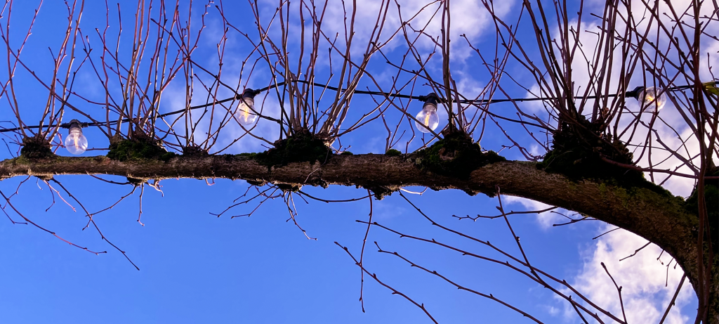

A new year has dawned.
The World Day of Prayer took place this year on Friday 3 March – we joined in the huge wave of prayer for Taiwan which encircled the earth for at least 38 hours. It was awesome to be part of something so huge! Services were held the length and breadth of England, Wales and Northern Ireland. Locally we worshipped in Magherahamlet Presbyterian Church and we shared in stories of faith of Taiwanese women.
Over the past year, people, and their faith, have been tested and challenged. Even at this still relatively early stage in 2023, this year certainly has also had its challenges as well as opportunities, and will continue to do so. Therefore, let us resolve to refocus our faith and trust in God anew. Let us bring everything to Him in prayer – our hope and fears, our dreams and tears – and walk through the unknown months of this year, with what it will bring, with our hand securely held in His. For there is no better place to be.
From Together in Prayer: I have heard about your faith by Jacqui Keenan, 2023
Lord of all, today with your people around the world, we pray:
for faith to believe that you rule the world in truth and righteousness;
for faith to believe in the power of your love to melt our hard hearts and lovingly to forgive our sin;
for faith to see your purposes of love unfolding in the happenings of today;
for faith to believe that if we seek first your Kingdom and righteousness, you will provide for all our needs;
for faith to take no anxious thought for tomorrow but to believe that you will be with us in the future as you have been in the past;
for faith to be calm and trusting in the face of challenges and difficulties as we seek obediently to follow you knowing that in your power alone we are made strong and that your love will never fail us;
for faith to leave in your hands the care of all those whose lives are intertwined with ours.
Thank you for the blessings you have given us and grant us strength to walk in the ways you lead us. May we know your deep peace through Jesus Christ our loving Lord.
Amen

Parochial Annual General Meetings or Easter Vestries 2023

Please note the Annual General Meeting or Easter Vestry of each parish in the Group:

Annahilt Tuesday 21 March 8.00 pm Parochial Hall

Magherahamlet Monday 27 March 8.00 pm Parochial Hall

As usual, the past year will be reviewed and the Churchwardens and Select Vestries for another year will be elected.
This is also a Triennial Year when Diocesan Synodspersons and Parochial Nominators are elected. The Synodspersons represent the Group of Parishes at the annual meeting of the Diocesan Synod.The Parochial Nominators would represent the Group of Parishes at a Board of Nomination called to appoint a new Rector if a vacancy in the Incumbency arose during the next 3 years.
While only registered Vestrypersons may vote, attendance is open to all parishioners. The meetings are occasions when we may learn more about what is happening in our own parish, diocese and the wider Church, as well as participating in the annual and triennial elections.


Flowers for the Churches

Annahilt Magherahamlet
March

5 Mrs B Harrison The Rector
12 The Rector
19 Mrs J Bradford
26

Church Cleaning, Annahilt

March
3-4 Mrs E Crawford
10-11 Mrs J Guiney Mrs H Cardosi
17 - 18 Mrs E Ogle
24 - 25 Mrs J Bolas Mr A Bolas
April
1 – 2 Mrs A Maxwell Mr R Maxwell
-8-9 Mrs H Hill Mrs T Hill
15-16 Mrs L McCambley Mrs E Harrison
22-23 Mrs E Crawford
29-30 Mrs J Guiney Mrs H Cardosi
May
5-6 Mrs E Ogle
12-13 Mrs A Maxwell Mr R Maxwell
19-20 Mrs J Bolas Mr A Bolas
26-27 Mrs H Hill Mr T Hill
June
2-3 Mrs L McCambley Mrs E Harrison

Thank you……

……to all who contributed to the special collections in support of the following charities:

Annahilt

Bible Society NI £ 31.94

Star NI £192.00

Dean of Belfast’s Sit Out £203.70

Save the Children £ 90.00

Leprosy Mission NI £77.00

Royal National Lifeboat Institute £65.00

Earthquake Relief in Turkey & Syria £380.00

Ukraine Relief (Ash Wednesday) £ 42.00

CMSI Coffee Morning £273.00

Magherahamlet

Bible Society £ 34.00

Star NI £134.00

Dean of Belfast’s Sit Out £120.30

Leprosy Mission NI £75.00

Royal National Lifeboat Institute £ 75.00

Turkey & Syria Earthquake Relief £294.00

CMSI Famine Lunch £305.00


Dear Mothers’ Union Members and Friends,

At our Visitors Evening in Annahilt on Monday 20th February we were delighted to welcome our friends from Magherahamlet and Dromara Mothers’ Unions as well as the members from Cargycreevy PWA. Our guest speaker for the evening was Clare Stewart who is our Mothers’ Union Trustees representative for Action and Outreach. Clare presented a very comprehensive overview of the impressive work being undertaken by Mothers’ Union organisations at home and overseas. Thanks to your generous support of our ‘Bring and Buy Sale’, we will be able to forward a very worthwhile amount to each of these ongoing projects. Our thanks go to everyone for your participation on the evening and also for your kind contributions.

Our next Mothers’ Union Meeting in Annahilt will take place on Monday 20th March at 8.00pm in the Parochial Hall and will take the form of a Workshop for assembling Toiletry Bags for Hospitals/Refuges (all items have already been sourced so no need to bring anything, just yourself). We also hope to complete the planning of our 2023 Mothers’ Union Programme and are looking forward to your participation in this process. Please feel free to bring along a friend.

In Magherahamlet, at our February meeting, Sarah Chambre gave us a comprehensive and informative talk on ‘Homelessness’. It was very worthwhile hearing the facts surrounding an increasing problem in society and how it may be addressed.

The Magherahamlet Branch was also well represented at the World Day of Prayer Service in Magherahamlet Presbyterian Church on 3 March.

With Kind Regards to Everyone

Beth, Esme, Elaine Avril, Frances, Virginia

Mothers’ Union - Midday Prayers – March 2023 Remain in me

Monday: My Father is the gardener
I am the true vine, and my Father is the gardener. He cuts off every branch in me that bears no fruit, while every branch that does bear fruit he prunes so that it will be even more fruitful. John 15:1-2
Abundant God, dig deeply in our lives to prepare us for acts of service that will produce a good return.
Loving Father, our heavenly gardener, we open ourselves to your spiritual nurture. Clear away the debris amassed over time – the dead works, the lurking selfishness, the weeds of doubt and disappointment. Draw us close to the truest of vines, to the blessing of relationship with Christ, that we may yield a fruitful harvest of service and love for a needy world.
Amen.

Tuesday: Remain in me
Remain in me, as I also remain in you. No branch can bear fruit by itself; it must remain in the vine. Neither can you bear fruit unless you remain in me. John 15:4
Lord, we would grow with you
New shoots reaching out
Hands stretched upward
Like leaves newly formed soaking up your light and warmth Lord, we would grow with you.
Lord, we would grow with you
In sunshine and rain
In darkness and light
In cold days and summer days From Springtime to Winter Lord, we would grow with you.
Lord, we would grow with you
And bring forth fruit
That is pleasing to you
Fed by your living water
Giving sustenance to others Lord, we would grow with you.
Amen.
Wednesday: Remain in my love
As the father has loved me, so have I loved you. Now remain in my love. If you keep my commands, you will remain in my love, just as I have kept my Father’s commands and remain in his love. John 15:9-10
Christ, the true vine, beloved of the Father, we would remain in your love.
Nurture us with your lavish grace to follow your teaching and keep your commands.
Water us with your life-giving Spirit that we may flourish and grow in service to God and his world. Cultivate within us a heart of compassion reflecting the love of our heavenly Father as we seek to obey his life-giving Word.
Christ, the true vine, beloved of the Father, we would remain in your love.
Amen.

Thursday: Complete joy
I have told you this so that my joy may be in you and that your joy may be complete.
John 15:11
Christ, the true vine, beloved of the Father, we open our lives to your presence. Work deeply within that your joy may be in us and our joy may be complete.
As we remain in your wondrous love may we be filled with your perfect joy, that no one can take away; by which we can know abundance of life. Christ, the true vine, beloved of the Father, help us be deeply rooted in you that the Spirit may bear fruit in us; that your joy may be in us and our joy may be complete; for the growth of your Kingdom on earth.
Amen.

Friday: The greatest love
Greater love has no one than this: to lay down one’s life for one’s friends. John 15:13
Christ the true vine, beloved of the Father, we marvel at your selfless love; your supreme act of friendship for a helpless people, that we may have eternal life.
Love poured out on that cruel cross, a blood offering so we might go free. Love poured out, infusing this world with rivers of grace and hope of rebirth. Love poured out, and into these hearts, who drink from a stream that never runs dry.
Christ the true vine, beloved of the Father, we stand in awe of your supreme act of friendship; we are blessed that you call us your friends.
Amen.
Saturday: Love one another
You are my friends if you do what I command. This is my command: love each other.
John 15:14, 17
Christ, the true vine, beloved of the Father, as we remain in your love and are filled with your joy, give us the grace to follow your command to love one another.
Jesus offers a new-old commandment, that we should love each other. With the incredible power and the unfathomable depth of God's love for us we can, we must love one another. And it is in this our love for one another that the world will know whom and what we worship.
Come, children of God, let us love one another.
Amen.

LISBURN FOODBANK
The Lisburn Foodbank is providing an essential service to those within our community who are experiencing difficult times, often due to circumstances beyond their control.

The Foodbank provides emergency food and support to local people in crisis in the Lisburn area.
Parishioners may leave items for the Foodbank in the basket in Annahilt Church Porch, on the FIRST and SECOND Sunday of each month.
A particular request from the Foodbank is for items listed below:
Cleaning items
Small packs of toilet roll
Nappies, baby wipes
Shower gel
Soaps
Washing powder

YOUR HELP WOULD BE GREATLY APPRECIATED.

Stainer’s Crucifixion at St Columba’s, Knock



St Columba’s, Knock will be the venue for a performance of The Crucifixion by John Stainer on Sunday 26 March at 7.30pm.
The performance will feature the St Columba’s Cantors & Choir directed by Joe McKee with organist, Alfred Casement, and guest soloists:

- Fr Martin O’Hagan (Tenor)
- Adam Reaney (Bass)
Voluntary donations will go church funds.

Tea and coffee will be available after the performance.


Victoria McGregor- London Marathon April 2023
On 23rd April 2023, I will be putting on my trainers and running the London Marathon for the charity WellChild. This will be my first ever marathon and a huge milestone!
I have decided to run for WellChild which supports many families in Northern Ireland and all across the UK, to care for and look after their seriously ill children in as normal circumstances as possible. Many of these children spend a great part of their lives in unfamiliar hospitals surrounded by scary machines and beeping alarms. WellChild supports families to make the transition from hospital to home through funding nurses who play a crucial role in supporting them both practically and emotionally, also providing training and information programmes to parents, carers and siblings.
Daire, a young boy from Belfast has been supported by WellChild following lifesaving surgery when he was 2 years old. His WellChild nurse Ruth provides a vital link between Daire’s family and his medical team, as well as training and care of his tracheostomy and other medical needs. Read more about Daire’s story here: https://www.wellchild.org.uk/about-us/family-stories/daire
WellChild gives seriously ill children and their families the best chance to thrive at home. For more information on the amazing work of WellChild visit their website.
If you would like to help me raise vital funds for the charity, you can use the following link or QR code below: https://www.justgiving.com/fundraising/victoria-mcgregor4
You can follow along my journey on the day by using the London Marathon app!

Thank you so much for helping me on my way to 26.2miles!!

Dander in the gardens of Hillsborough Castle.

Larchfield Community Association (LCDA) is affiliated to Historic Royal Palaces Hillsborough Castle and Gardens, Community Access Scheme. This provides opportunities for members of the community accompanied by a CAS Leader to visit the castle grounds and also (pre-booked) tours of the castle.
LCDA visit the grounds for a “bit of a dander and craic” monthly from spring through to the autumn and have extended an invitation for anyone from the Parish who would like to join them. This is a tremendous opportunity to have £free access to the grounds of the castle. The first planned date of this season is Thursday 27th April starting at 11am from the main reception area at the top of the car park off the A1. Walks are scheduled on various Wednesdays, Thursdays and Saturdays.
If you are interested or want more details, please contact Patricia on 07713 257691. As group numbers have some restrictions, booking in advance with Patricia is necessary. If there are quite a few from the Parish, separate visits can be organised.
If you would like to go along but don’t want to walk too far, the walled garden has plenty to see and it’s right beside the coffee shop and the entrance.

PARISH LUNCH CLUB

It has been suggested that now might be an appropriate time, following the various Lockdowns and the removal of other pandemic restrictions, to resuscitate the Lunch Club which used meet monthly in The Pheasant Restaurant.
As a first step any interested parishioners from Annahilt or Magherahamlet are asked to meet at the ‘The Pheasant’ on Friday 21 April at 12.30 pm. Previously it was those who were retired who tended to come but parishioners of all age groups are welcome.
If you would like the opportunity of enjoying a lunchtime meal in the company of established friends or perhaps some new ones, do come along. Please contact Violet Swarbrigg (Telephone 028 9263 8952) for further information.

Parish Website: AnnahiltAndMagherahamlet.org
Parishioners are reminded that the website annahiltandmagherahamlet.org has been created to provide information on church related activities and organisations for parishioners and the wider community. Although circumstances have changed considerably since the various lockdown periods, the website continues to host online services each Sunday. It also contains a list of upcoming church services and news from our group of parishes, as well as downloadable versions of the parish magazine. The site will be continually developed, so if you have any submissions, suggestions or requests relating to the website, these can be sent to admin@annahiltandmagherahamlet.org.



www.annahiltandmagherahamlet.org

Parish Magazine
Any contribution for the next edition of the Parish Magazine should be left with the Rector or Roger Maxwell (roger.maxwell1@btinternet.com) by Sunday 19 March 2023.

Registered as a charity with The Charity Commission for Northern Ireland
NIC103246 (Annahilt) and NIC102122 (Magherahamlet)
Top of Form

