News from the Parishes

Church of the Ascension, Annahilt Magherahamlet Parish Church
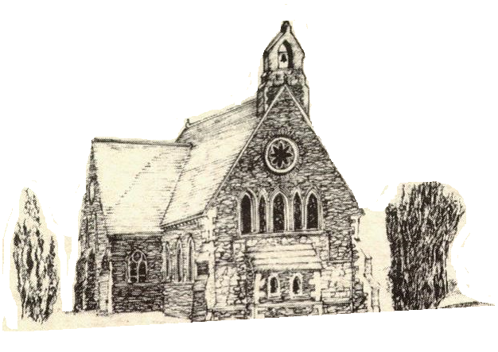

December 2021 and January 2022

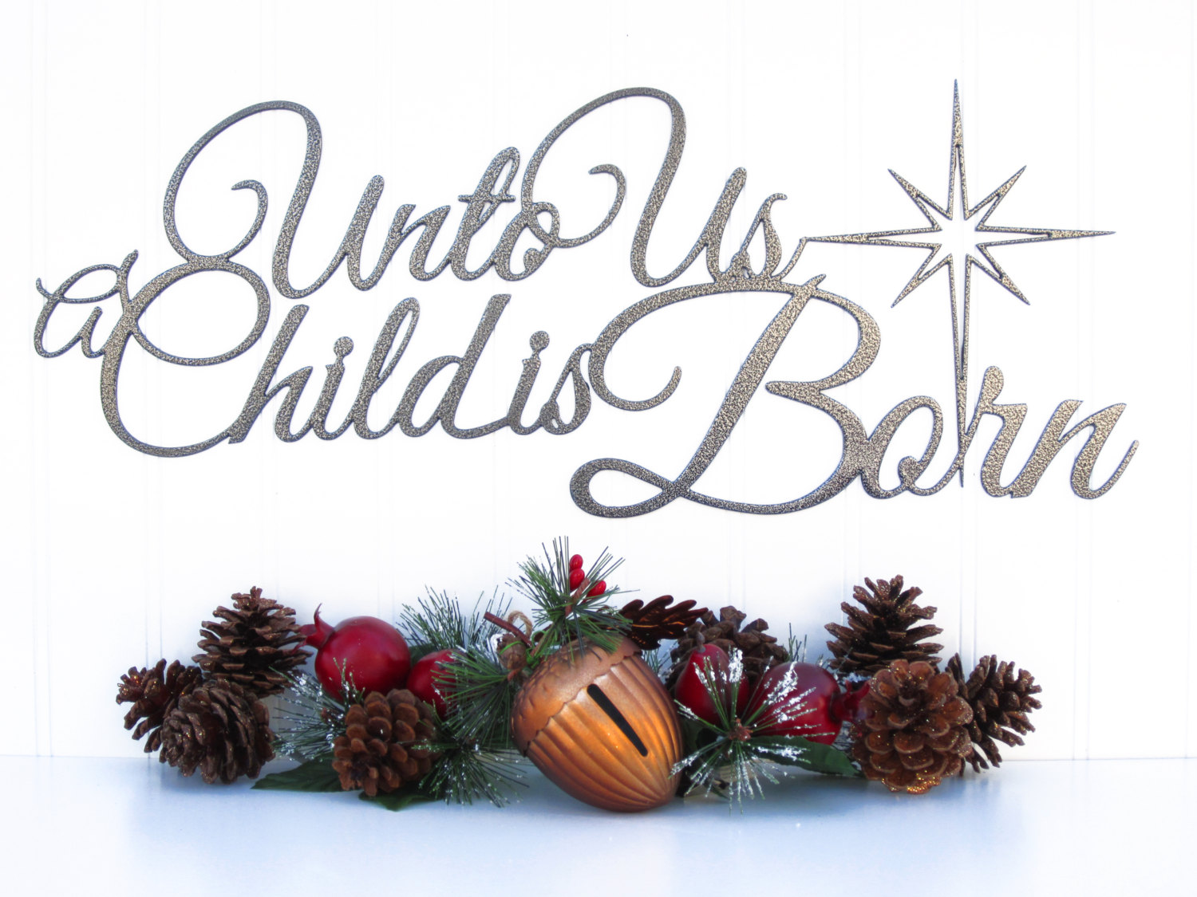

Rector: The Revd Canon Robert Howard
15 Ballykeel Road, Hillsborough
BT26 6NW
Tel: 028 9263 8218
E-mail: jrobert.howard@btinternet.com
Website: www.annahiltandmagherahamlet.org

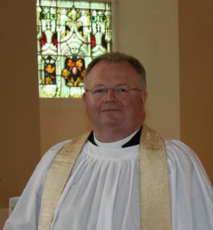
The Rector writes….

My dear Parishioners

Over these ‘dark days before Christmas’, many morning commuters to work are leaving home in darkness and at the end of their working day are returning in darkness. We feel a significant drop in the temperatures and the leaves are falling at a rate which we find it hard to keep up with. In the gloom and darkness of winter many people feel a heaviness in their spirit and that sometimes may lead to changes in mood and even feelings of depression. The News is full of concern about rising numbers in cases of COVID-19 and how overstretched many hospitals are at the present time. As I write the devastating announcement has been made of the discovery of a new variant of the virus in South Africa and its neighbouring countries which very speedily reached our ‘doorstep’ in Belgium, with cases now reported in the United Kingdom. There continues to be a high level of uncertainty about restrictions and various measures that health experts are recommending in order to keep people safe. There are others involved in business who want to see restrictions lifted further in order to allow people to go out and spend and boost the economy after the challenges of the past 20 months.
Here in Annahilt and Magherahamlet, we are trying to offer services that mean something to our parishioners at this time of year. Last month, for the first time we had a Service of Lessons and Carols to mark the beginning of Advent. The focus was on the prophets and was well received by all who participated. As our young people celebrate the birth of the Christ child at the Christingle service in both our Churches (10.00 in Annahilt and 12.00 in Magherahamlet) it is very appropriate that both Services will include a Baptism.
On the Sunday before Christmas, 19 December, there will be the traditional Service of Nine Lessons and Carols (11.30 am in Magherahamlet and 3.00 pm in Annahilt).
In Annahilt, we will also be sharing the First Communion of Christmas with the Minister & Congregation of Legacurry Presbyterian Church at 11.15pm on Christmas Eve and enjoying a Christmas Morning Family celebration at 10.00 am. In Magherahamlet on Christmas Day there will be a celebration of the Holy Communion at 11.30 am. As St Stephen’s Day falls on a Sunday this year, there will be Services in both Churches (10.00am in Annahilt and 11.30am in Magherahamlet). We look forward to joining our friends in Legacurry for the Watchnight Service on New Year’s Eve at 6.30 pm.
It goes without saying that we can make the best possible plans but in current circumstances and without warning, the goalposts can suddenly shift.
One of the tremendous encouragements of this season for people of faith is that Jesus will enter our world afresh during this season of Advent and Christmas. If we engage with him and make space in our hearts to receive Him, He wants to find a home with us wherever we are. That’s a beautiful thing to connect into but it’s perhaps not as straightforward as it appears.
There seems to be a myriad of things that will distract us away. We become so busy at this time of year buying presents, decorating the house, writing Christmas cards and preparing food for those family members and friends we hope can join us around our table. We also feel acutely the pain of remembering those who are no longer physically with us and the weight of our burdens seems heavier to carry in this season.
I ask you to continue to book in to attend our Services especially those which are particularly popular over this season. Of course, I recognise that with the current restrictions and concerns, not everyone will manage to come in person. That is why I encourage those who can, to avail of the technology that allows services to be recorded and be heard on our parish website or on CD. If you cannot come on the day, these give you the opportunity to worship on a day and time that works best for you. My little word of advice is to try to make that time and set it aside it for that spiritual purpose. Let us engage as fully as we can at the time we have allocated or designated to our spiritual preparations for this season. If you need help with booking please speak to one of our Churchwardens.
I always find it exciting to think about the light breaking into the darkness. I rejoice in the birth of our Saviour who has come to bring new life and hope and meaning to all who search for those things in this life. If there’s anyone or anything you would like us to pray for please let me know and we would be glad to do that.
I wish you all a blessed Advent and peaceful Christmas. Thank you for all you have done throughout this past year to support the Church, as well as phoning and staying in touch with people and taking an interest in God’s work locally and in other parts of the world.
I wish you all an enriching and fulfilling Advent, a peaceful and blessed Christmas and a hopeful New Year.

Your sincere friend and Rector

Robert Howard

Congratulations….
……to Canon Eric Kingston on the recent celebration of his 97th birthday. The Rector visited Canon Kingston and presented him with an arrangement of seasonal plants as a token of the good wishes of all in Annahilt and Magherahamlet. Our former Rector expressed his great pleasure at being remembered in this way and asked for his grateful thanks to be conveyed to all in the Group of Parishes.

Thank you……
…..to all who contributed to recent special collections for the Poppy Appeal
Annahilt £312.78
Magherahamlet £143
…..to all the various volunteers who have assisted in the Church cleaning, as well as all who provided flowers for the Churches during the past year.
The cleanliness of the Churches for public worship does not go unnoticed and is much appreciated by all, especially during present circumstances.
The floral arrangements which are given each week are also valued and admired by all who worship in both Churches.
….to Colin Robinette and William Mathers for their ongoing assistance in the online transmission of Services.

Annahilt Parish Gift Day

We thank all who have returned their Gift Day envelopes.

If you have not yet had the opportunity of doing so envelopes may be returned at any of the Church Services before Christmas. Alternatively they may be returned directly to the Parochial Treasurer, Patricia Halliday. Patricia’s contact details may be found elsewhere in this magazine.



The season of Advent
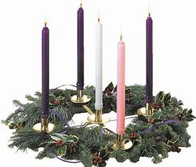
‘Advent’ means ‘coming’ and marks the four weeks leading up to the celebration of the Nativity and the coming of Christ. It is traditionally a season of penance and preparation before Christmas. The official Church liturgical colour is purple, a symbol of penitence. Weddings used to be forbidden during this season, as they once were during Lent.
Tradition has given its own flavour to each of the Advent Sundays. The Sunday next before Advent was known as ‘Stir up Sunday’, so named because it was the day for ‘stirring up’ Christmas puddings. The second Sunday was known as Bible Sunday when our focus was on the reading, preaching and distribution of God’s Word as revealed in the books of the Bible. The third Sunday is the ‘Gaudete’ Sunday from the Latin word for ‘rejoice’. On that day everyone took a break from the penitential theme. A rose coloured candle is lit on this Sunday.
In our Churches an Advent wreath is often among the decorations made with evergreen branches such as holly, yew or pine. The four Advent candles are fixed into the wreath along with a white candle which represents the Light of Christ coming into the world at Christmas.
Advent calendars are still popular today, usually a card with twenty-four small doors, one to be opened each day from the first day of December until Christmas Eve. Each door conceals a picture, which originally had biblical themes. Every morning children open one door to see a pretty picture or find a chocolate inside. This popular tradition arose in Germany in the late 1800s and soon spread throughout Europe and North America.





The True Gift of Christmas

The gifts I’d leave beneath your tree
Aren’t those that you can touch or see,
No toys meant just for pointless play,
But gifts to bless you every day.
The gift of friendship warm and true,
Is one that I would leave for you.
Good health and happiness and cheer
To keep you smiling through the year.
The gift of peace that comes from God,
With prayer to guide each path you trod.
And when your heart has lost its song,
The gift of hope to cheer you on.
These are the gifts I’d leave for you.

Kay Hoffman


Once in a Manger

Once in a manger, a long time ago,
Before there was Santa and reindeer and snow, A star shone down on humble beginnings below Of a baby just born who the world would soon know.
Never before had there been such a sight.
Would the Son of a King have to suffer this plight?
Are there no armies to lead? Are there no battles to fight?
Shouldn't He conquer the world and demand His birth right?
No, this frail little infant asleep in the hay
Would change the whole world with the words He would say.
Not about power or demanding His way, But mercy and loving and forgiving God's way.
For only through humbleness would the battle be won, As shown by the actions of God's only true son.
Who gave up His life for the sins of everyone,
Who saved the whole world when His journey was done.
Many years have now passed since that night long ago
And now we have Santa and reindeer and snow
But down in our hearts the true meaning we know, It is the birth of that child that makes Christmas so.

Tom Krause


Gifts at Christmas
On Christmas Day, at the 10.00 am Family Service in Annahilt and at Parish Communion at 11.30 am in Magherahamlet, the young people attending are asked to bring with them a present which they have been given for Christmas. There will be an opportunity during the service to show their gift to the congregation and to say a prayer of thanksgiving.


Holy Communion in Church
There will be three celebrations of the Holy Communion in the Group of Parishes over the Christmas period.
Unfortunately, it is not practical to have an early Communion Service in Annahilt on Christmas Day this year. Instead, there will be a SAID Communion Service on the Sunday BEFORE Christmas, 19 December, at the later time of 9.30 am. This may be of particular interest to those who usually attended the early celebration prior to its suspension at the beginning of the Pandemic. In present circumstances it may also suit those who prefer a shorter and ‘quieter’ act of worship.
On Christmas Eve, 24 December at 11.15 pm the First Communion of Christmas will be shared with the Minister and Congregation of Legacurry Presbyterian Church.
On Christmas Day, 25 December at the earlier time of 11.30 am the Parish Communion of Christmas Day will be celebrated in Magherahamlet Parish Church.
On St Stephen’s Day, 26 December at 10.00 am there will be Parish Communion in Annahilt at 10.00 am

Private Communion at Christmas
Any parishioners who are ill or housebound or who in present circumstances are not in a position to attend church and would like Holy Communion in their own home before Christmas should contact the Rector who will only be too pleased to make the arrangements. Tel 028 9263 8218.

Christmas Carol Services

In present circumstances it has been necessary to maintain the somewhat different arrangements which were made last year for our traditional Carol Services in both Parishes.
In Annahilt, on account of the necessity of safe distancing it is not possible for either the Parish Choir or the Choir of Anahilt Primary School to participate as in past years. However, a congregational Service of Lessons and Carols will take place on Sunday 19 December at 3.00 pm in the Church of the Ascension.
There will be NO service in Annahilt at 10.00 am
This year in Magherahamlet Parish, Spa Presbyterian and Magherahamlet Presbyterian, it has again been left to each Church to make its own arrangements.
A congregational Carol Service will be held in Magherahamlet Parish Church on Sunday morning 19 December at the earlier time of 11.30 am.

In-Church Worship in Church of the Ascension, Annahilt and Magherahamlet Parish Church

Numbers are reduced at Services in both Churches because of the legal requirement to facilitate safe distancing. Because of this, it would be very helpful if those intending to come to church would give notice of their intentions.
This can normally be done via email up to the Friday before.
Annahilt
Trevor Hill trevorhill111@btinternet.com
David Keith
Magherahamlet
Hillary Edgar hillary.edgar01@btinternet.com
Alternatively, you can make contact by telephone:
Annahilt
Trevor Hill 07890552930 up to the Friday before
David Keith 028 9263 8352 up to the Friday before
Magherahamlet
George McCurry 028 9756 3955 up to the Friday before
Hillary Edgar 028 4481 1361 up to the Friday before

For Annahilt, notification of attendance can also be given via the Parish website up to the Friday before.

Church Services in the Parishes of Annahilt and Magherahamlet

‘I was glad when they said to me: “Let us go to the house of the Lord”’

Sunday 5 December Advent II Bible Sunday
10.00 Parish Communion Annahilt
12.00 Parish Communion Magherahamlet

Sunday 12 December Advent III
10.00 Children’s Christingle & Gift Service Annahilt
12.00 Children’s Christingle & Gift Service Magherahamlet

Sunday 19 December Advent IV
9.30 am Holy Communion Annahilt
10.00 No Service Annahilt
11.30 am Festival of Nine Lessons & Carols Magherahamlet
3.00 pm Festival of Nine Lessons & Carols Annahilt

Friday 24 December Christmas Eve
11.15 pm The First Communion of Christmas Annahilt
with the Minister & Congregation of Legacurry Presbyterian Church
Preacher: The Revd Bobby Liddle
Saturday 25 December Christmas Day
10.00 Family Service Annahilt
11.30 am Parish Communion Magherahamlet

Sunday 26 December St Stephen’s Day
10.00 Parish Communion Annahilt
11.30am Morning Prayer Magherahamlet

Friday 31 December New Year’s Eve
7.00 pm United Watchnight Service Legacurry Presbyterian Church
Preacher: The Rector

Sunday 2 January 2022 Christmas II
10.00 Parish Communion Annahilt
12.00 Parish Communion Magherahamlet

Sunday 9 January Epiphany I
10.00 Family Service Annahilt
12.00 Family Service Magherahamlet

Sunday 16 January Epiphany II
10.00 Parish Communion Annahilt
12.00 Morning Prayer Magherahamlet

Sunday 23 January Epiphany III World Leprosy Day
10.00 Morning Prayer Annahilt
12.00 Morning Prayer Magherahamlet

Sunday 30 January Epiphany IV
10.00 Morning Prayer & Litany Annahilt
12.00 Morning Prayer & Litany Magherahamlet

Sunday 6 February Presentation of Christ in the Temple 70th Anniversary of the Accession of HM The Queen
10.00 Parish Communion Annahilt
12.00 Parish Communion Magherahamlet
From the Parish Registers


Christian Burial
‘In Christ shall all be made alive’

27 October 2021

Hilary Stroud, Ballynahinch Road, Hillsborough

Burial in Annahilt Churchyard preceded a Service in the Parish Church

Hilary will be remembered as a devoted daughter to her late parents, a dearly loved and loving wife to her late husband Michael and a wonderful mother to Jackie and Anthony. Jackie and Anthony became the people today because of what Hilary instilled in them and the way she helped them in so many ways. It is they and their families who will miss her most and we extend to them our deepest sympathy.
Hilary was an independent thinker, very determined and hardworking, with strong views on many subjects. She was always very kind and generous towards others. She had a great passion for horse racing, art, interiors, furniture and people.
Hilary lived in Annahilt for some 60 years and always loved the farm. She maintained a circle of close friends in the locality, particularly the Mackie and the Stronge families.
Her memory and example will be enduring.

29 November 2021

Robert Trimble, Laird’s Road

Following a Service in the Church of the Ascension cremation took place at Roselawn Crematorium.

Robert was one of a family of four born to the late John & Charlotte Trimble and was brought up in Glarryford, Ballymena. He began his education at the local primary school and subsequently at Dalriada Grammar School at Ballymoney. Later, he graduated in Civil Engineering at the Queen’s University of Belfast.
Following his graduation Robert was initially employed by Down County Council until he left for Nigeria in 1961. After a year and a half he returned home and met Trudy in 1963. They became engaged a year later and were married in St Mark’s Church, Portadown in 1965 after which they lived in Holland until January 1966. They then moved to Canada, close to Montreal, where their son Paul was born. Some eight months after his birth the family returned to Northern Ireland, setting up home in Knock, Belfast. Sometime after their daughter Karen was born they moved again and went to South Africa, living at Pinetown near Durban where Robert worked for Durban County Council. They left South Africa in 1972 and went to Nigeria for another 1½ years before finally returning to Northern Ireland.
Robert resumed his career as a Highway Engineer and designed part of the ring road from Knock to Forestside. He retired in 1994. He and Trudy moved to their present surroundings on Laird’s Road in 1999 where he designed the garden. They made this Parish Church their spiritual home and were regular attendees at worship. Robert was also a devoted reader of the Bible on a daily basis.
Over the years, Robert was a keen golfer and also enjoyed playing squash. He played weekly at both sports until his health declined. He won medals from Queen’s University for discus throwing. He was also a skilled artist.
Robert’s period of illness was an extended one, which he bore with dignity and grace.
We extend our deep and prayerful sympathy to Robert’s wife Trudy, son Paul, daughter Karen, son-in-law Rob, grandsons Max and Joshua, sister Maureen, brother-in-law Jim and other family members in their great loss.

PRAYER WARRIOR

Do you have a concern or problem and would like someone to pray for you?
If so, contact the Rector who will be willing to help.
This is completely confidential and no details will be passed on to anyone else unless you want them to.
028 9263 8218



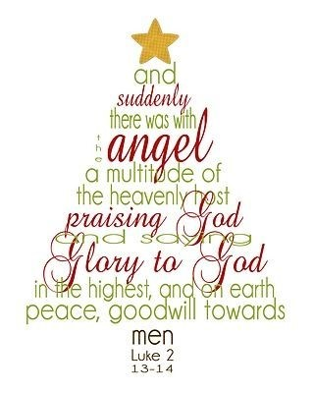

Flowers for the Churches
Annahilt Magherahamlet
December
5 Mrs F Magorrian
12 Mrs R Carlisle
19 The Rector The Rector
26 The Rector The Rector

Church Cleaning, Annahilt

December
3-4 Mrs A Maxwell Mr R Maxwell
10-11 Mrs H Hill Mr T Hill
17-18 Mrs E Crawford Mrs M Finlay
23-24 Mrs J Bolas Mr A Bolas

January

Dec 31/Jan 1 Mrs L McCambley Mrs E Harrison
7-8 Mrs E Ogle
14-15 Mrs J Guiney Mrs H Cardosi
21-22 Mrs A Maxwell Mr R Maxwell
28-29 Mrs H Hill Mr T Hill

February
4-5 Mrs E Crawford Mrs M Finlay


With the closure of direct services in the local area, five experienced Social Workers have set up a not-for-profit Community Interest Company called STARNI to continue providing support to children and families impacted by sexual abuse. STARNI is based in Millennium Court Arts Centre in Portadown. Our mission is to create a safe and nurturing environment where children feel comfortable and safe enough to explore their thoughts and feelings.
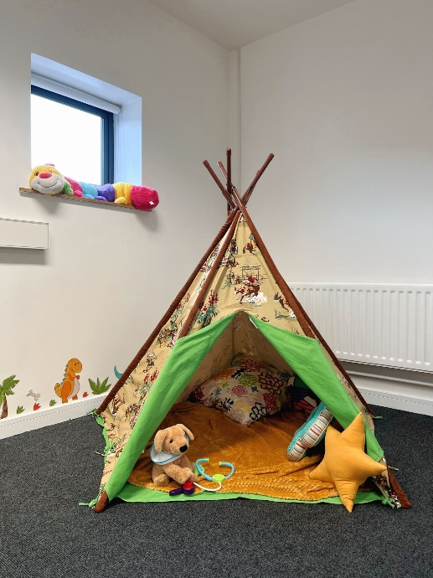
As STARNI has only been running since the beginning of November, we are not currently working with many children as we would have been in previous years. We expect that by next Christmas we will be working with more children and would love to be able to give them Christmas gifts at that time.
This year, at the Christingle Services in both Annahilt and Magherahamlet we are asking whether you might consider donating art materials that we can use in children’s sessions to help them express difficult emotions as we know that often it is too difficult for children to talk about this. Some ideas include canvases, paint, craft items, clay, drawing paper, felt tips and glitter. Alternatively, if you would like to donate the money you might have otherwise spent on a Christmas gift, this would go directly to the running costs of STAR NI and would greatly assist us as we get up and running.
If you would like to know more about STARNI, you can find us on Facebook and Instagram. We are looking forward to meeting you when we attend the Christingle Services on Sunday 12 December at 10.00 am in Annahilt and at 12.00 noon in Magherahamlet. As always, thank you so much for you your ongoing support, it is greatly appreciated and makes a big difference.

Dear Mothers’ Union Members and Friends,

We hope that you are all keeping well and are managing to keep cosy and warm on these really chilly winter days.
At the present time the main focus of the Mothers’ Union work is on highlighting and supporting the international campaign to raise awareness of, and call for an end to, gender based violence in all forms and in all societies.
A service in St. Mark’s, Dundela was organized by representatives of our Diocesan Prayer and Policy Unit which took place on 27th November to mark the 16 DAYS OF ACTIVISM AGAINST GENDER-BASED VIOLENCE. In addition, representatives of the Mothers’ Union Diocesan Action and Outreach Team have also been working hard to co-ordinate supplies for the Woman’s Aid Shelters which are generally the only safe places to go when women and children are forced to leave home due to domestic adversity. Everyone involved in this work have stated that they would like to pass on to our Mothers’ Union members, their sincere thanks and appreciation for all the gifts and donations that they have received for this cause. A Prayer Diary has also been sent to each Mothers’ Union member and it means that we can all join together in praying for an end to gender-based violence throughout the world.
Another date for our diary is the Advent Carol Service to be held in St. Ignatius Parish Church, Carryduff on Wednesday 8th December at 7.30pm. Please email pwhiteside48@outlook.com as soon as possible if you wish to attend.
We are sorry to record that Ruth Carlisle has been unwell resulting in surgery following a fall while convalescing from an earlier period of hospitalization. We continue to wish Ruth and her husband Bert well in the days ahead.
We pray that we will all be blessed with the health and opportunity to join family and friends to celebrate Christmas.
May the calming peace of Jesus gently wash your fears away.
May the power of God’s spirit fill your life with love. And God’s healing grace pour over you with blessings from above.

With kind regards

Beth Avril
Esme Anne

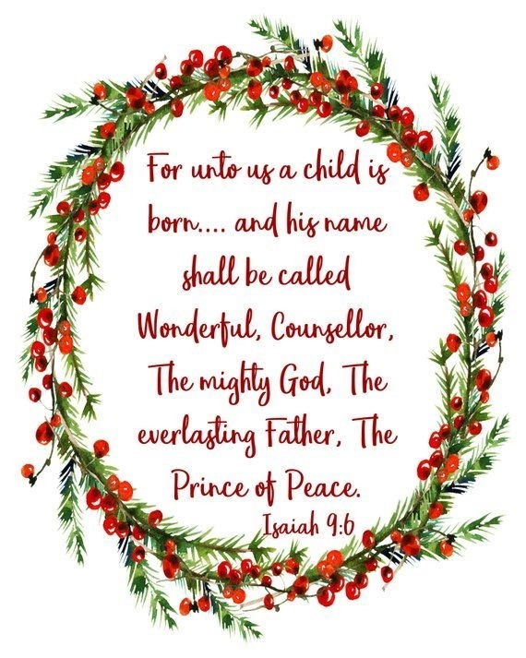
Mothers’ Union—Midday Prayers—December 2021
Rebuilding hope and confidence
Advent words of hope

Monday: Living Word
In the beginning was the Word, and the Word was with God, and the Word was God. The Word became flesh and made his dwelling among us.
John 1:1-2, 14
The Word became flesh and lived among us.
In wonder and reverence we bring him our praise.
The Word:
The one who spoke the earth into being, who flung stars into space, who set the planets in orbit and breathed life into humankind.
The Word:
The Son of God, Light of the World; fully God, fully man; our Rescuer.
The Word:
To all who received him
He gave the right to be called children of God.
The Word became flesh and lived among us.
With gratitude and joy we bring him our praise.
Amen.

Tuesday: Words of hope
A voice of one calling:
‘In the wilderness prepare the way for the Lord; Then the glory of the Lord shall be revealed, and all people shall see it together, for the mouth of the Lord has spoken. Isaiah 40:3, 5
In the lonely places: the wilderness where we stand forlorn windswept and alone your voice calls out
Prepare the way for the Lord.
In the dark places: where the shadows embrace our tears your voice calls out
Prepare the way for the Lord.
Prepare the way for the Lord!
He is the strength that comes to our weakness, he is the light that comes to our darkness.
The Lord is near! Prepare the way, and sing of his glory, all his people.
Amen.

Wednesday: Names of the Messiah
He will be called Wonderful Counsellor, Mighty God, Everlasting Father, Prince of Peace.
Isaiah 9:6
Wonderful Counsellor, our hope is in you.
Give us your wisdom throughout our lives. Direct our paths in the ways of grace that we may follow you well.
Mighty God, our strength is in you.
Hold us firm in times of weakness. Fill us with the power of the Spirit that we may serve you well.
Everlasting Father, our trust is in you.
Surround us with your steadfast love. Adopt us into your family that we may abide in you.
Prince of Peace, our hope is in you.
Quieten our hearts in troubled times. Assure us of your constant presence that we may have no fear.
Amen.

Thursday: Words of praise
Mary said:
My soul magnifies the Lord and my spirit rejoices in God my Saviour. The Mighty One has done great things for me – holy is his name.
Luke 1:46-47, 49
We will sing of your steadfast love, O Lord, forever;
Our souls magnify the Lord;
With our mouths we proclaim God’s faithfulness to all generations Our spirits rejoice in God our saviour.
We declare that your steadfast love is established forever;
His mercy is to those who fear him from generation to generation.
Your faithfulness is as firm as the heavens.
He has filled the hungry with good things, and sent the rich away empty.
You are our God and the Rock of our salvation. We will sing of your steadfast love, O Lord, forever;
Our souls magnify the Lord.
Amen.

Friday: Good news
The angel said to them,
Do not be afraid. I bring you good news that will cause great joy for all the people. Today in the town of David a Saviour has been born to you; he is the Messiah, the Lord.
Luke 2: 10-11
Like the choir of angels on the night of his birth we sing your praise and tell out the good news. Like the shepherds, returning from the manger, we give you the glory for all that we have heard and seen. Like the Magi, kneeling in wonder, we offer our gifts as a token of our love and sign of our commitment.
Amen.
Glory to God in the highest, and on earth grace and peace to those on whom his favour rests.
Amen.

Saturday: Words of truth
Mary treasured all these words and pondered them in her heart.
Luke 2.19
In this Advent season we ponder in our hearts the riches of God’s mystery – that Christ has come to live in us giving the hope of glory.
May this eternal truth be always on our hearts that the God who breathed this world into being placed stars into the heavens and designed a butterfly's wing is the God who entrusted his life to the care of ordinary people, became vulnerable that we might know how strong is the power of Love.
A mystery so deep it is impossible to grasp. A mystery so beautiful it is impossible to ignore.
We open our hearts to the riches of your presence.
Come Lord Jesus.
Amen.

Annahilt Parish Bowling Club
The Bowling Club resumed in mid-November and at present on Wednesday evenings only at 8pm. Covid restrictions permitting, we will continue until shortly before Christmas. Lots of hand gel, disinfecting of bowls, face coverings and social distancing are just some of the mitigations in place to keep everyone as safe as possible. If anyone would like to join us on a Wednesday evening, please feel free to come along (ideally phoning Patricia in advance).

Finance Matters – Annahilt
Gift Aid Declarations
If you have recently become a tax payer and have not yet completed a Gift Aid declaration to enable the Parish to claim tax back at no additional cost to you, it would be very beneficial to the Parish to do so. If however you have recently stopped paying tax then any existing Gift Aid declarations need to be cancelled. Please contact the Annahilt Treasurer, Patricia Halliday should you need to update Gift Aid.
Annahilt Parishioners are welcome to post cheques for Annual Giving, magazines or other giving to the Treasurer, Miss Patricia Halliday, 35 Cabra Road, Hillsborough, Co Down, BT26 6NB.
Annahilt Parish FWO
Envelopes for 2022 are now available from the Treasurer and in Church. We will endeavour to deliver envelopes to those who are unable to attend church at this time. If you would like to collect them directly from Patricia please contact her. On an ongoing basis we encourage parishioners to give by monthly/annual standing order, which can be in addition to or instead of FWO envelopes.
If you wish to check how much you have paid in to the FWO scheme up to the end of November 2021, you may do so after 8th December.
Patricia may be contacted on 028 92665310, M 07713 257 691 or via email patriciaapc@btinternet.com

Finance Matters – Magherahamlet
If you are a UK taxpayer, you can boost the amount of every donation you make by giving through “Gift Aid”. This is an Income Tax relief scheme created to help charities like our church get the most out of funds that they receive. Gift Aid enables the church to recover the base rate of tax on your donation. The scheme adds 25 pence on each £1.00 you give at no extra cost to you.
We would ask all taxpayers who give to parish funds to give through “Gift Aid”. All that is required is the completion of a “Gift Aid Declaration” form. If you have recently stopped paying tax then any existing Gift Aid declaration needs to be cancelled. Please contact the Treasurer, Hillary Edgar on 028 44811361 should you require a “Gift Aid Declaration” form or need to update an existing Gift Aid Declaration.

LISBURN FOODBANK

The Lisburn Foodbank is providing an essential service to those within our community who are experiencing difficult times, often due to circumstances beyond their control.

The Foodbank provides emergency food and support to local people in crisis in the Lisburn area.
Parishioners may leave items for the Foodbank in the basket in Annahilt Church Porch, on the FIRST and SECOND Sunday of each month.
A particular request from the Foodbank is for items listed below:

Sugar (most needed)
Tea
Coffee
Biscuits
Rice Pudding
Custard

The Lisburn Foodbank is providing an essential service to those within our community who are experiencing difficult times, often due to circumstances beyond their control.

YOUR HELP WOULD BE GREATLY APPRECIATED.
Parish Website: AnnahiltAndMagherahamlet.org
Parishioners are reminded that the website annahiltandmagherahamlet.org has been created to provide information on church related activities and organisations for parishioners and the wider community. Since lockdown began in March, the website has hosted online services each Sunday. It also contains a list of upcoming church services and news from our group of parishes, as well as downloadable versions of the parish magazine. For those wishing to attend a service at Annahilt, notification of attendance can also be given via the Parish website up to the Friday before.
The site will be continually developed, so if you have any submissions, suggestions or requests relating to the website, these can be sent to admin@annahiltandmagherahamlet.org.



www.annahiltandmagherahamlet.org

Parish Magazine
Any contribution for the next edition of the Parish Magazine should be left with the Rector or Roger Maxwell (roger.maxwell1@btinternet.com) by Sunday 23 January 2022.

Registered as a charity with The Charity Commission for Northern Ireland
NIC103246 (Annahilt) and NIC102122 (Magherahamlet)
Top of Form

