News from the Parishes

Church of the Ascension, Annahilt Magherahamlet Parish Church
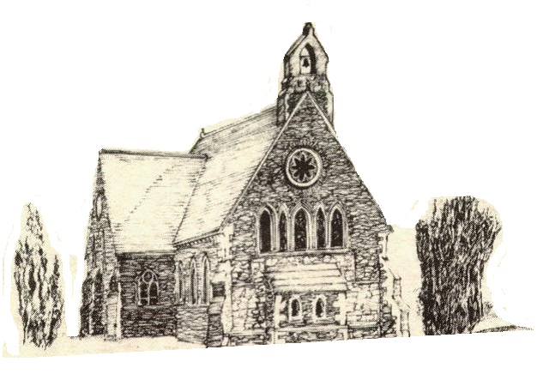

April and May 2022



Rector: The Revd Canon Robert Howard
15 Ballykeel Road, Hillsborough
BT26 6NW
Tel: 028 9263 8218
E-mail: jrobert.howard@btinternet.com
Website: www.annahiltandmagherahamlet.org

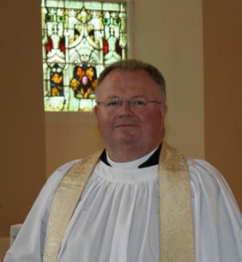
The Rector writes….

My dear Parishioners

As we journey through the season of Lent, it’s often a season when we strip things back. Perhaps we’ve been making the effort to ‘give up’ some of our usual treats or occasional luxuries. Or maybe we have committed to immerse ourselves in some spiritual disciplines like Bible reading or prayer or to attend some special services during this season which might awaken us further to the presence of God in our lives?
Some people may like to avail of the opportunity which will be re-opened to us this year of worshipping daily in Church during Holy Week. Hopefully this will both encourage and challenge us as we seek to follow Jesus in our daily lives as we recall his journey to and crucifixion on the Cross and his triumphal resurrection three days later.
During Holy Week (11 – 15 April) we look forward to welcoming the Revd Canon Dr Ian Ellis as our speaker from Monday to Good Friday. Ian is a former Rector of Newcastle. He is going to speak on the topic ‘Scenes from the Passion: “The Consolation of The Cross”. This series is designed as we emerge from the pandemic which has affected our lives in so many ways over these past two years. We now also have the backdrop of the conflict in Ukraine and there is a sense that our world is in need of God’s consolation perhaps more than ever before. The Holy Week services will all be recorded and transmitted on-line as soon as possible afterwards and we thank the technology team, Colin Robinette and William Mathers for all their work in making this opportunity available to those who cannot be with us ‘In Church’ for various reasons.
We do want to encourage people to try to come to these services in person if at all possible. They are always a very special focus in our mission and ministry in this Group of Parishes, in particular the Tenebrae Service on Good Friday at 8.00 pm. In addition, this year both Churches will be open on Good Friday (Magherahamlet 12.00 noon to 1.00 pm; Annahilt 2.00pm to 3.00 pm) for prayer. Good Friday is always a special and sombre day and it would be good to have that extra stream of prayer for the world and our parish flowing throughout those periods. I will be present and will, of course, facilitate and contribute. However, each of these hours of prayer are intended for you to pray individually. You will be free to come and go as you wish during either hour. Your prayers are greatly needed at this very worrying time for the world as we particularly invite people to pray for peace and for all our world leaders and those who are in positions of influence.

Over this season of Lent we often turn our thoughts to those going through times of difficulty. We have coordinated our parochial financial response to the Ukraine Crisis through the Red Cross. We have also made up boxes of clothes, duvet covers and other bedding, also toiletries to those working with partners on the ground offering help and support to refugees making their way across the Ukrainian borders to neighbouring countries. We have also been inviting those who can to continue supplying various items for the Lisburn Foodbank.
The impact of the war in Ukraine is being felt through rising fuel and gas bills as well as other significant increases in the cost of living. Consequently, many people are finding it difficult to manage. If you find yourself in that position, please get in touch with me and I will do all in my power to offer some practical assistance, albeit in a small way. The Church is a family and we need to work together and support one another in these very challenging times. I want to take this opportunity to say ‘thank you’ to our organisations and their leaders who have been endeavouring to get up and running in person again in recent months. It’s not easy as we try to follow the Guidance and enable everyone who comes to feel both welcome and safe. Yet, I also know those who participate in these activities have really valued the opportunity to meet again in person.
On a personal note, may I draw your attention elsewhere in this Magazine to a Service in the Church of the Ascension, Annahilt on Saturday 28 May 2022 at 2.00 pm to celebrate the life and mark the passing of my dear mother, Violet Howard, Unfortunately, at the time of her death it was not possible to hold a Funeral Service in Church on account of the restrictions in place. Please see this as your personal invitation to be there from my siblings and me. Mum appreciated so much being part of this Group of Parishes and the kindness shown to both her and Dad particularly during their latter years. We took so much comfort from the cards, messages and prayers we received from you all at the time of her passing. It would be lovely to have your support on this occasion. All are welcome. To facilitate catering, it would be very helpful if you would let me know if you are in a position to come.
As together we seek to slow down and pray and reflect during this Holy Season may we find the presence and peace of God in your life.
I wish you all a blessed Easter

Your sincere friend and Rector

Robert Howard
Parish of Annahilt – Easter General Vestry Meeting – Monday 28 March 2022

In his Remarks from the Chair, the Rector reported that in 2021 the Parish’s official membership (those households who are subscribers) stood at 109 family units. However, there are additional households who have called on the Rector’s ministrations although they have no formal link with the Parish or who wish to identify with the Parish without making any official commitment.
The Rector remarked that we were approaching the first anniversary of the death of His Royal Highness, the Prince Philip, Duke of Edinburgh. As a parish, as a community, as a city and as a nation and Commonwealth we had joined in the countless tributes already paid to the late Duke, giving thanks for the unprecedented span of years he served Her Majesty The Queen as her Consort and the nation and Commonwealth at large.
He also paid tribute to a number of very faithful parishioners who were also ‘called home’ in the months which followed.
Isaac Harrison devoted a lifetime of service to our Church and Parish. He was a weekly attendee at worship and devout communicant who summoned the faithful by ringing the Church bell Sunday by Sunday. He served on the Select Vestry over a long period, was a former Churchwarden, served as a Parochial Nominator and was also a keen Bowler in the Parish.
Dorothy Ervine was also a hugely respected member of the Parish. For many years she was a devoted member of the Choir with her lovely alto voice. She also served on the Select Vestry over an extended period and was the second woman in the Parish to hold the office of Churchwarden. She was also a very faithful member of the Mothers’ Union serving for a time as Enrolling Member.
Canon Eric Kingston, Rector of this Parish from 1976 until 1993 (with Magherahamlet from 1982) died at the wonderful age of 97. He exercised a most effective Ministry of Word and Sacrament in the worship at which he officiated over the years and a devoted Pastoral ministry to all his parishioners especially the sick, the lonely and the worried. In retirement he and his gracious wife, Kathleen, remained firm friends of the parish and were present at many events over the years especially during the 150th Anniversary of the Church of the Ascension.
The Rector expressed sympathy with all who have been bereaved over this past year.
On account of the coronavirus pandemic services in Church were suspended during the Lockdown period (Sunday 10 January to Maundy Thursday 1 April 2021. However, a Service was transmitted online on each Sunday and also during Holy Week (Monday to Thursday before Easter) and on Ascension Day. When restrictions on opening churches were eased and in-church worship resumed the numbers in congregations at services were limited as it was necessary to practice social distancing. The Bishop, the Rt Revd David McClay, administered the Rite of Confirmation in Church on Sunday 20 June, the first such Service in the Group of Parishes since 2017. The distance length was reduced from 2 metres to 1 metre in time for the traditional Harvest Festival Services in September. The annual Christmas Carol Service took place in December. A long-standing reciprocal arrangement was continued whereby the Minister and Congregation of Legacurry Presbyterian Church attended the First Communion of Christmas in the Parish Church on Christmas Eve, and the Rector and Parishioners of Annahilt Church of Ireland attended the Watchnight Service in Legacurry on New Year’s Eve. Both events were proportionately attended by members of both the Church of Ireland and Presbyterian Church as well as other visitors.
The Parochial Hall is a very useful facility which has again more than proved its worth in advancing Christian activity in our parish. Its use will no doubt continue to develop in a post-covid situation. On 13 June 2021 a Children’s Day Service and Prize Giving (postponed from 2020) was held in the Hall. Sunday School and the Rainbow Guides resumed in September. The Parish Indoor Bowling Club also resumed a limited schedule of activity. In the ongoing circumstances of social distancing, The Mothers’ Union was unable to resume its meetings.
On account of the Lockdown and various other public health restrictions the annual dinner to celebrate Burns’ Night in January in the nearby Larchfield Estate and Grounds and other fundraising events were unable to take place. The monthly collection of items for the local foodbank continued and proved to be of immense benefit for those in our community who are less fortunate than others.
The Report following the 2019 Quinquennial Inspection of the Church and Rectory was on the agenda of the Select Vestry and its recommendations continue to be acted upon. The routine maintenance of the Parochial Hall continued throughout the year. The Select Vestry remain committed to the upkeep and development of all parochial property and assets for the future benefit of the Parish and the public.
Various steps were taken throughout the year to ensure that the Parish is compliant with new GDPR regulations.
The Rector concluded by thanking all who had contributed to Parish Life over the year.
The Trustees’ Annual Report was presented by the Parochial Treasurer, Miss Patricia Halliday.
It was not possible for the Rector to nominate an incoming Churchwarden or for the registered Vestrypersons to elect a new People’s Churchwarden. In these circumstances it was recognized that there would be considerable legal and constitutional difficulties in proceeding with elections to the remaining positions on the Select Vestry. The meeting was adjourned and light refreshments were served.
The Easter General Vestry meeting will be reconvened in Church on Sunday 15 May 2022 following Morning Service

Parish of Magherahamlet – Easter General Vestry Meeting – Tuesday 29 March 2022
In his Remarks from the Chair, the Rector reported that in 2021 the Parish’s official membership (those households who are subscribers) stood at 63 family units. However, there are additional households who have called on the Incumbent’s ministrations although they have no formal link with the Parish or who wish to identify with the Parish without making any official commitment.
The Rector mentioned that earlier on the day of meeting, a Memorial Service in Westminster Abbey had been broadcast on national television to mark the impending first anniversary of the death of His Royal Highness, the Prince Philip, Duke of Edinburgh. As a parish, as a community, as a city and as a nation and Commonwealth, we had all joined in the many tributes already paid to the late Duke and given thanks for his outstanding and enormous legacy, not least in The Duke of Edinburgh Award Scheme originally set up in 1956 and still thriving.
The Rector recorded with deep sadness the death of two very faithful members of the Parish:
Christie Hall, a very regular attendee at worship and who served both as a Churchwarden on different occasions and was a serving Select Vestry member at the time of his passing. He would be fondly and appreciatively remembered as a devoted family person who was ‘hands-on’ in any situation and any person who needed his help.
Canon Eric Kingston who faithfully and conscientiously pioneered the Grouping of this Parish with Annahilt from 1982 until his retirement in 1993, and lived to the wonderful age of 97. His cheerfulness and friendliness were infectious which enriched his devotedly caring and understanding pastoral ministrations. In retirement both he and Mrs Kingston remained firm friends of the Parish. Amongst the special events in which he took part were the Laying of the Foundation Stone of the new Parochial Hall and later its Official Opening. He also revisited the Parish during the 200th Anniversary Year of the Parish Church. Ultimately, they both resumed membership of the Parish in recent years.
The Rector extended sympathy to all who had been recently bereaved.
Worship and prayer were paramount during 2021, although nobody could have foreseen the resumption of the national lockdown and the closure of churches to public worship on 10 January which would continue until Services resumed on Good Friday 2 April. Both In Church and online the principal Sunday service the sacrament of Holy Communion was celebrated monthly, an All Age / Family Service was also usually held monthly while the Office of Morning Prayer was normally conducted on other remaining Sundays. Regrettably for the second successive year it was not possible have the annual Community Christmas Carol Service which alternates each year with our parish and the two local Presbyterian Churches. However, a parochial carol service was held on the Sunday morning before Christmas of which the feedback was very positive.
The new Parochial Hall is a splendid facility which in the nine years since its official opening has more than proved its worth in advancing Christian activity in our parish. The Hall’s use will no doubt continue to develop now that health restrictions are gradually being restricted.
The Bishop, the Rt Revd David McClay administered the Rite of Confirmation on Sunday 20 June, in Annahilt in the afternoon and in the evening. in Magherahamlet. It the first such occasion in Magherahamlet since 2017. We warmly congratulate our newest full members of the Church and offer them every support and encouragement as they develop their role of Christian discipleship.
The Report following the 2019 Quinquennial Inspection of the Church and Rectory was on the agenda of the outgoing Select Vestry. Attention to those items identified as urgent were given priority.
Fortunately, thanks to the expertise and very generous time commitment of Colin Robinette and William Mathers (both parishioners from Annahilt) we were able to broadcast Services on line. It was wonderful that on Passion Sunday, Palm Sunday, each night of Holy Week Day we were able to participate in worship while churches remained closed. We appreciate their full co-operation in maintaining online services while safe distancing continued to be observed.
The Rector concluded his remarks by thanking all who had contributed to parish life during the past year.
The Trustees’ Annual Report was presented and the annual elections were held.

Parish of Magherahamlet
Annual General Vestry Elections 2022
Rector’s Churchwarden Ms Abbie Stanford People’s Churchwarden Larry Fryers Rector’s Glebewarden George McCurry People’s Glebewarden Norman Hughes
In addition to the above Officers the following were elected to the Select Vestry
Miss Virginia Begley Walter Kelly Mrs Avril Burrows Mrs Frances Magorrian William Chambre Mrs Sally McCurry Hillary Edgar Mrs Linda Vladeanu

Independent Examiner Mrs Carol Shields
Honorary Secretary Ms Abbie Stanford Honorary Treasurer Hillary Edgar
Honarary FWO Treasurer Larry Fryers
Health & Safety Officers Hillary Edgar . Mrs Linda Vladeanu

The Big Bike Ride crosses the Finish Line
They did it! At 6.00 pm on Monday 4 April the Bishop, the Rt Revd David McClay arrived on the steps of Belfast Cathedral having cycled into every parish in the diocese with the Bishop’s Big Bike Ride. The cycle highlighted the work of Bishops’ Appeal, the Church of Ireland’s own World Aid and Development Programme and is the focus of the Down and Dromore Lent Appeal for 2022.
The Bishop’s Big Bike Ride set out from Holywood Parish Church on Monday 7 March and over 6 (non–consecutive) days Bishop David and the Revd Colin Darling (Bishops’ Appeal Rep for the diocese) made 83 stops.
Other clergy and parishioners hopped on their bikes and joined the ride for sections of the route, including the Dean of Dromore, the Very Revd Geoff Wilson, who completed 5 days and 61 stops but couldn’t continue because of changes to the schedule.
The Bishop and Colin were greeted by supporters in every parish and kept going by multiple cups of tea and biscuits. They covered roughly 350 miles cycling through North Down and Ards, South Down, Newry and Mourne and, on the last day, Belfast and Castlereagh.
Bishop David hadn’t been on a bike for 35 years and had just recovered from Covid–19 when the ride began so he was grateful for a little electric power to his wheels, especially in the drumlins of County Down.
Cycle helmets off to every one of our riders for a magnificent achievement!

Patricia Halliday (Hon Treasurer, Annahilt Parish) presents a cheque the Revd Colin Darling (Bishops Appeal Diocesan Representative)

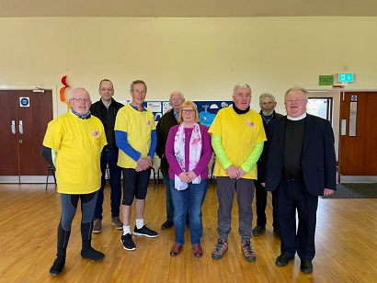

The Rector and other parishioners who greeted the Bishop and his cycling Team when they called at Annahilt Parochial Hall.

Magherahamlet Sunday School
During Lent, the Sunday School in Magherahamlet have been working through the resources of the Church Missionary Society. The theme for this session was HOPE.



Church Services in the Parishes of Annahilt and Magherahamlet
‘I was glad when they said to me: “Let us go to the house of the Lord”

Sunday 10 April Lent VI (Palm Sunday)
10.00 ‘The Cross of Christ’ Annahilt
A Holy Week Meditation of Readings and Music

12.00 ‘The Cross of Christ’ Magherhamlet
A Holy Week Meditation of Readings and Music

During Holy Week on Monday 11, Tuesday 12, Wednesday 13, Maundy Thursday 14 & Good Friday 15 April there will be a series of addresses ‘Scenes from the Passion: The Consoling Power of the Cross’ given by the Revd Canon Dr Ian Ellis, former Rector of Newcastle.
Monday
8.00 pm Evening Service Magherahamlet
‘Betrayal’ Tuesday
8.00 pm Evening Service Annahilt
‘Pilate’
Wednesday
8.00 pm Evening Service Magherahamlet
‘The Crown of Thorns’
Maundy Thursday Commemoration of the Institution of the Lord’s Supper
8.00 pm Holy Communion Annahilt
‘The Upper Room’
followed by Light Refreshments in the Parochial Hall
Good Friday
12.00 noon – 1.00 pm Hour of Prayer Magherahamlet
2.00 pm – 3.00 pm Hour of Prayer Annahilt
8.00 pm Tenebrae Service Annahilt
‘The Cross of Calvary’

Sunday 17 April Easter Day
8.30 Holy Communion Annahilt
10.00 Parish Communion Annahilt
12.00 Parish Communion Magherahamlet

Sunday 24 April Easter II
10.00 ‘Risen with Christ’ Annahilt
An Easter Devotion of Readings and Hymns
12.00 ‘Risen with Christ’ Magherahamlet
An Easter Devotion of Readings and Hymns

Sunday 1 May Saint Philip & Saint James
10.00 Parish Communion Annahilt
12.00 Parish Communion Magherahamlet

Sunday 8 May Easter IV Christian Aid
10.00 Family Service Annahilt
followed by Light Refreshments in the Parochial Hall
12.00 Family Service Magherahamlet
Sunday 15 May Easter V
10.00 Parish Communion Annahilt
followed by reconvened Easter General Vestry Meeting

12.00 Morning Prayer Magherahamlet

Sunday 22 May Easter VI (Rogation Sunday)

10.00 Morning Prayer Annahilt

12.00 Morning Prayer Magherahamlet

Thursday 26 May Ascension Day

7.30 pm Holy Communion Annahilt

Saturday 28 May

2.00 pm Memorial Service for the late Violet Howard Annahilt

Sunday 29 May Sunday after Ascension Day

10.00 Morning Prayer & Litany Annahilt

12.00 Morning Prayer & Litany Magherahamlet

Sunday 5 June Pentecost Platinum Jubilee of HM The Queen

10.00 Parish Communion Annahilt Preacher: The Rt Revd the Lord Eames of Armagh OM

12.00 Parish Communion Magherahamlet Preacher: The Rt Revd the Lord Eames of Armagh OM

3.00pm ‘Picnic and Praise’ Anahilt Primary School
Singing of Hymns and Songs of Praise led by Baillies Mills Accordion Band followed by Picnic

GOOD FRIDAY TENEBRAE SERVICE 8.00 pm

What is a Tenebrae Service? The word ‘tenebrae’ is Latin for shadows. The purpose of the Tenebrae service is to recreate the emotional aspects of the passion story and is one of solemnity.
The service is specially designed for Good Friday. It contains appropriate hymns, a sermon and several scripture readings. The church is in candlelight for the Tenebrae service. There are as many candles as there are readings, plus a white candle. As each reading is read a single candle is extinguished until only the white candle (representing the light of Christ) remains. Then the white candle is put out, leaving the congregation in near total darkness— and near total devastation. At this point, the service ends. There is no benediction and the Service ends in silence.
The purpose of the service is to recreate the betrayal, abandonment, and agony of the events and it is left unfinished, because the story isn’t over until Easter Day.
This service has been experienced in our Group of Parishes on Good Friday for ten consecutive years and has been very well received.
The Tenebrae Service will take place on Good Friday evening, 15 April at 8.00 pm. Following the usual schedule of rotation between our two Churches it will take place this year in Annahilt. However, it is, as always, very much a Group occasion for the parishioners of both Annahilt and Magherahamlet. Let us bring our Holy Week observances to a worthy climax this year with a full attendance on Good Friday evening.

300,000 steps Challenge for Christian Aid

Christian Aid Week this year will take place from 15th to 21st May and will focus on the plight of drought which numerous countries around the world face on a daily basis.
To raise awareness of the issues, as well as vital funds for communities battling the worst of the ongoing climate crisis, and the effects of the rising costs of food prices caused by the war in Ukraine, Christian Aid is promoting a 300,000 steps challenge during the month of May, which clocks in at just under 10,000 steps a day.
Below is an extract from the Christian Aid website:
“We are each taking 300,000 steps in the month of May to turn hunger into hope. Every step we take could help restore justice in our world. With every step, every pound, every prayer, we're determined to help people around the world change their lives for good. For the first time in a generation, global poverty is rising. Covid-19, conflict, and the climate crisis are pushing more of our global neighbours into a struggle for survival.
For Jessica, a loving mum in Zimbabwe drought means every day is a struggle for survival. Like many women, she toils on her farm, but no food can grow on her dry land. Every step we take this May could help people like Jessica fight hunger: from sowing drought-resistant seeds, to building a storeroom to help her family bounce back from future droughts. Help us keep going on our challenge, and help us turn hunger into hope.”
A number of Parishioners have decided to take on this challenge and if you would like to join us, please contact me at the number below.
As part of the challenge, and to mark Christian Aid Week, a number of us will meet at Hillsborough Forest Park at 7pm, on Wednesday 18th May, to walk and chat our way around the lake.
Whether or not you are taking on the challenge, please come and join us to show your support.
If you would like to make a donation, you may do so through the Just Giving page for the Parish, which may be accessed by using the link

https://www.justgiving.com/fundraising/annahiltparish300kstepschallenge

Or use the QR code:


Alternatively, donations may be given to Patricia Halliday or myself.

Thank you.

Louise McGregor
Mob: 07790517916


From the Parish Registers

Holy Baptism
‘Go therefore and make disciples of all nations, baptising them in the name of the father and of the Son and of the Holy Spirit’
Magherahamlet Parish Church
26 March 2022
Reuben Sam, son of Paul and Rachel Johnston.

Christian Marriage ‘Those whom God has joined together let no one put asunder’
Church of the Ascension, Annahilt
19 March 2022
João Gonçalves and Elizabeth Dowling

We congratulate João and Elizabeth and wish them every happiness.

Christian Burial ‘In Christ shall all be made alive’
11 March 2022
Dorothy Ervine, Annahilt Residential Home, formerly of Ballycrune Road
Following a Service in the Church of the Ascension, Annahilt burial took place in Edengrove Presbyterian Burying Ground
Dorothy was born and brought up in Lisburn, the third daughter of Dickie and Peggy Murphy. She excelled at primary school and completed her education at Lisburn Technical College where she studied commercial subjects. On leaving school she began her working career with McMahon Fashions in Bow Street as a secretary. Not far from McMahon's premises was Cavendish Furniture Store in Market Square where a young man worked, Basil Ervine, who spotted Dorothy through the shop window!
Advertisements
Basil became the love of Dorothy’s life and they married some 46 years ago in Christ Church, Lisburn. The description in the Marriage Service in the Prayer Book of the ‘mutual health and society that the one ought to have of the other’ was the foundation of their very happy marriage based on mutual faithfulness. They initially set up home in an apartment in Hillsborough but throughout most of their married life they lived in Ballycrune where they became very happy residents in the community.
In earlier years Dorothy was a very faithful parishioner of Christ Church, Lisburn and a member of the Silvertones Ladies Choir together with her eldest sister, Heather.
Then and for many years afterwards Dorothy was a very active member of the Girls’ Friendly Society when she attended many international GFS conferences on behalf of the branch at Christ Church.
On coming to live at Ballycrune, Dorothy made this Parish Church her spiritual home where she worshipped regularly and faithfully making a significant contribution to the music by singing devotedly in the Choir with her lovely alto voice. She also was a member of the Select Vestry over an extended period and was the second woman to be elected Churchwarden.
Dorothy loved flowers and arranging them. She made a major contribution to the decoration of the Church each year for the Harvest, Easter and other festive occasions. Her big job every Christmas was, with Basil’s assistance, decorating the Church Christmas Tree. The end result was always a sight to behold!
Dorothy was also a very skilled seamstress. She herself made the dresses her bridesmaids wore the day she got married.
Dorothy was also a very faithful member of the Mothers’ Union Branch in this Parish, serving for a period as Branch Leader or Enrolling Member as the position was then called. At a Christmas Party hosted by the MU for the Over 60’s Club and other senior parishioners. Dorothy and the present Rector were ‘persuaded’ to do an item for the entertainment. There was much hilarity – one of the husbands present went into ‘convulsions’ – at the sight of the Rector dressed in farmer’s clothing carrying a bucket and Dorothy dressed as a farmer’s wife in overalls and a matching linen hat with sewing in her hands, both alternating to sing the lyrics of ‘There’s a hole in the bucket, dear Lisa, dear Lisa’, and ‘Then fix it dear Henry, dear Henry, dear Henry’! We reprised the role many years later at the Birthday Party of a Choir member with the staff of the restaurant where the event took place discreetly…or perhaps not so discreetly ‘duking’ on the stairs to have a good look at what was going on! Dorothy was always great fun and great company.
Dorothy retired after many years working with her brother Harry at Modern Machinery Supplies, where she held a very senior position in the Accounts Department.
During their working lives and in retirement Dorothy and Basil had some wonderful holidays. Dorothy loved the sun and they both enjoyed ‘getting away’ always to somewhere warm! At home Dorothy always enjoyed watching the TV.
Unfortunately, in her later years Dorothy’s health declined and was very appreciative of the support of her neighbours on Ballycrune Road and the carers who attended her. Sometime following the passing of her beloved Basil, she became a resident of Annahilt Care Home where she settled immediately and remained very happy and content. Although no longer able to attend Church, she continued to receive the sacrament of Holy Communion at the home and loved to hear the recordings of Services which took place in the Church. She was most grateful to the staff at Annahilt Care Home for all their care and attention and most especially to her sister-in-law Amy and her family for their kindness over these past number of years, also her sister-in-law Janet and blood niece Rachel who visited Dorothy throughout her illness in hospital. The family were particularly grateful to the medical and nursing staff at the Royal Victoria Hospital who attended to her so devotedly during her time in hospital until she passed away.
Dorothy will be deeply missed and fondly remembered by her brother,
Seymour, his wife Liz and the wider family circle both at home and abroad. We extend to each our deep and prayerful sympathy.

Thank you….

to all who contributed to the following special collections :

The Red Cross (Ukrainian Refugees) Annahilt £880 Magherahamlet £465

Make a Mothers’ Day Appeal Annahilt £175 Magherahamlet £126.10

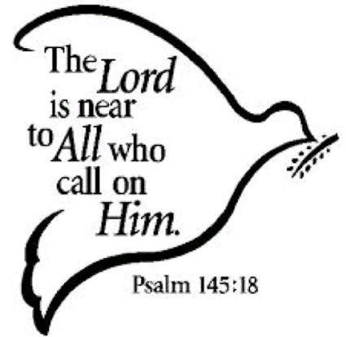

Flowers for the Churches
Annahilt Magherahamlet
April
3
10 Mrs Alison Harrison-Mitchell Mrs I Cull
17 Easter Easter
24

May
1 Mrs L Anderson
8
15 Mrs B Oliver Mrs F Magorrian
22
29 The Rector The Rector

Church Cleaning, Annahilt

April
8 -9 Mrs J Guiney Mrs H Cardosi
15-16 Mrs H Hill Mr T Hill
22-23 Mrs L McCambley Mrs E Harrison
29-30 Mrs A Maxwell Mr R Maxwell

May
6 -7 Mrs E Crawford
13-14 Mrs J Bolas Mr A Bolas
20-21 Mrs E Ogle
27-28 Mrs J Guiney Mrs H Cardosi
June
3-4 Mrs H Hill Mr T Hill
10-11 Mrs L McCambley Mrs E Harrison
17-18 Mrs A Maxwell Mr R Maxwell
24-25 Mrs E Crawford
July
1-2 Mrs J Bolas Mr A Bolas
8-9 Mrs E Ogle
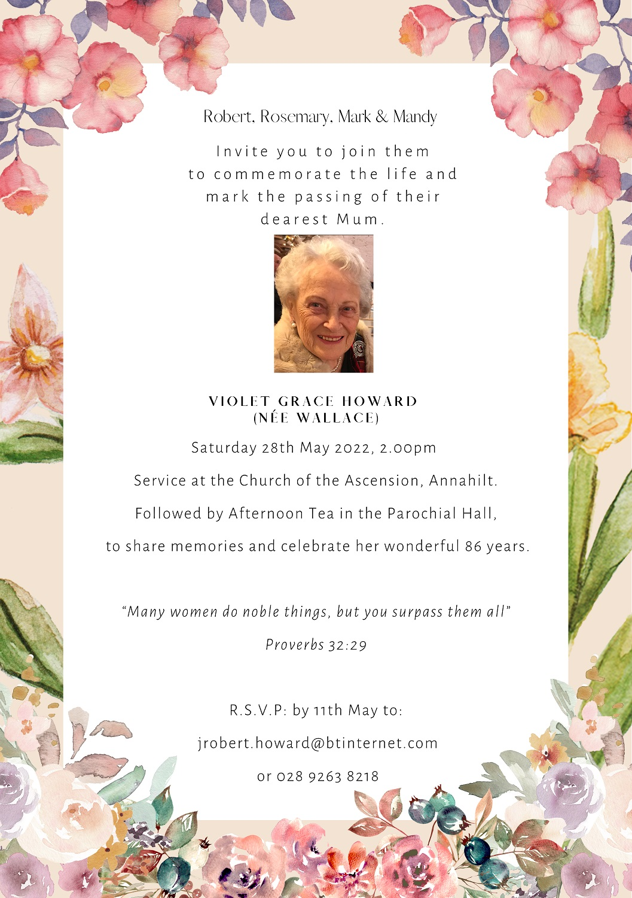


Dear All

We do hope that you are keeping well at present and have been cheered and uplifted by the lovely spells of Spring sunshine that we have been blessed with at this time. Beth and I, Avril, Frances & Avril Burrows are delighted to be able to offer our Mothers’ Union members the opportunity of meeting up again at Church or in our respective Parochial Halls in an environment which adheres to the current Covid safeguarding guidelines.

There was a very good turn out of members in both Churches for the Mothering Sunday Family Service. It was our great pleasure and privilege to have our All Ireland President, Mrs June Butler as our visiting preacher. Avril Burrows was officially enrolled as a member of The Mothers’ Union and we warmly welcome her amongst us.

The Triennial General Meetings in both Branches have now taken place with the election of the following Office Bearers:

Annahilt
Branch Leader Beth Harrison Hon Secretary Esme Ogle Hon Treasurer Elaine Finney

Edwina Crawford, Patricia Halliday, Maud Harrison, Linda Hassard, Madeline McMullan, May McCauley, Susan Wilson

Magherahamlet
Branch Leader Avril McKeown Assistant Branch Leader Sally McCurry Joint Hon Secretaries Avril Burrows . Frances Magorrian
Hon Treasurer Virginia Begley

Anne Hall, Georgie Hughes

Both Branch Committees are currently engaged in drawing up a programme for the coming season. Meanwhile you may wish to consider attending the following events:

Wednesday in Holy Week Evening Service on Wednesday 13 April at 8.00 pm in Magherahamlet Parish Church.

Maundy Thursday Holy Week Service on Thursday 14th April at 8.00 pm in Annahilt Parish Church Light refreshments in hall afterwards in the Parochial Hall.

We very deeply regret the recent death of our dear friend and fellow member Dorothy Ervine, a one-time Enrolling Member of Annahilt Branch. We extend our prayerful sympathy to sister-in- law Amy Patterson and the entire family circle.

With Kind Regards,

Beth Avril Esme Frances Avril (Burrows)



Mothers’ Union—Midday Prayers—April 2022
Praise and thanksgiving

Monday: Praise and thanksgiving
Praise be to the God and Father of our Lord Jesus Christ! In his great mercy he has given us new birth into a living hope through the resurrection of Jesus Christ from the dead, and into an inheritance that can never perish, spoil or fade.
1 Peter 1:3-4
Praise be to the God and Father of our Lord Jesus Christ!
We come before you with thanksgiving!
God of Promise and God of Hope, who through your great mercy have granted us new birth through the death and resurrection of Jesus Christ, we praise your wonderful name!
God of Glory and God of Might who through your great power have granted us new strength to endure all things through faith in Christ our risen King, we praise your wonderful name!
Amen.

Tuesday: Grace and peace
Grace, mercy, and peace, which come from God the Father and from Jesus Christ—the Son of the Father—will continue to be with us who live in truth and love.
2 John 1:3 (NLT)
Praise be to the God and Father of our Lord Jesus Christ!
We come before you with thanksgiving!
Grace to you and peace from him who is and who was and who is to come, and from Jesus Christ, the faithful witness, the firstborn of the dead, and the ruler of the kings of the earth.
To him who loves us and freed us from our sins by his blood, made us to be a kingdom, priests serving his God and Father, to him be glory and dominion forever and ever.
Amen.

Wednesday: Praise and thanksgiving
Praise be to the God and Father of our Lord Jesus Christ, who has blessed us in the heavenly realms with every spiritual blessing in Christ.
Ephesians 1:3
Praise be to the God and Father of our Lord Jesus Christ!
We come before you with thanksgiving!
Through Jesus Christ, you have lavished on us every spiritual blessing we could possibly imagine! Before the world was created, you already knew us and loved us. You adopted us as your own children, and redeemed us through the blood of Christ. Even more, you have made us your heirs, and given us your own Spirit as a sign and guarantee. How we praise you!
May our worship bring you honour and glory, for you alone are worthy of our praise.
Amen.

Thursday: Grace and peace
Grace and peace to you from God our Father and the Lord Jesus Christ, who gave himself for our sins to rescue us from the present evil age, according to the will of our God and Father,
Galatians 1:3-4
Praise be to the God and Father of our Lord Jesus Christ!
We come before you with thanksgiving! For peace beyond understanding – Shalom –
your desire for all that is good and fruitful, all that makes us whole, we thank you.
For grace we do not deserve, freedom, forgiveness for all that is wrong in our lives that keeps us from you, we thank you.
For life poured out on a cross – salvation – That divine mystery of love by which all might know you as Abba, Father, we thank you.
Amen.

Friday: Praise and thanksgiving
Praise be to the God and Father of our Lord Jesus Christ, the Father of compassion and the God of all comfort.
2 Corinthians 1:3

Praise be to the God and Father of our Lord Jesus Christ!
We come before you with thanksgiving!
Dear Heavenly Father, thank you for the joy, peace, help and blessings that you give to us each day. Thank you for this wondrous world filled with all the wonderful gifts you have given to us.
Thank you for our families, friends and the fellowship of your Church.
And we thank you for the most wondrous gift of all – the forgiveness of our sins, bought for us by the love of your most blessed Son, our Saviour Jesus Christ.
Amen.

Saturday: Lives of thankfulness
Just as you received Christ Jesus as Lord, continue to live your lives in him, rooted and built up in him, strengthened in the faith as you were taught, and overflowing with thankfulness.
Colossians 2:6-7

Risen Lord,
You love us, You call us, You change us.
Let us recognise your coming however gently or dramatically you approach us. Let us recognise your coming whoever you use to make your coming known to us. Let us recognise your coming whatever time or situation you use to approach us. Let us recognise your compassionate emergence into the dark places of our lives,
Your generous summons which you constantly utter, your transforming touch upon the bleak places of our world. Lord of Life, of hope, of resurrection, we make our prayer in your name, Jesus.
Amen

Recording of Services
For the past year most have been able to benefit from the audio recordings of our Sunday and other special occasion Services either online via the website or from a CD recording.
If you are unable to attend Church in person we hope that you are availing of one of the methods of listening to the services. If you require any advice on locating the website or audio recording on your device (phone/tablet/laptop) or would like a CD copy please do not hesitate to contact the Rector on 028 9263 8218.

Annahilt Annual Report
The Trustees Annual Report including Parish Accounts is now available to view on the Parish Website. Due to printing costs these will not be circulated to the Parish with the magazine however if anyone would like a paper copy, please contact Patricia on 028 92665310 or 07713 257 691 and she will provide you with one.

Grant from All Churches Trust

Recently Annahilt Parish was successful with a funding application to All Churches Trust Limited in respect of a grant towards the building of our new toilet facilities. An amount of £2,700 was awarded and while this may not seem very much, the Trust receives over 1200 applications each year for projects costing anything up to one million pounds. They like to give something to most applicants, which does mean their grants can be quite small. The Select Vestry is however grateful for these funds.

LISBURN FOODBANK
The Lisburn Foodbank is providing an essential service to those within our community who are experiencing difficult times, often due to circumstances beyond their control.
The Foodbank provides emergency food and support to local people in crisis in the Lisburn area.
Parishioners may leave items for the Foodbank in the basket in Annahilt Church Porch, on the FIRST and SECOND Sunday of each month.
A particular request from the Foodbank is for items listed below:
Cleaning items
Small packs of toilet roll
Nappies, baby wipes
Shower gel
Soaps
Washing powder

YOUR HELP WOULD BE GREATLY APPRECIATED.

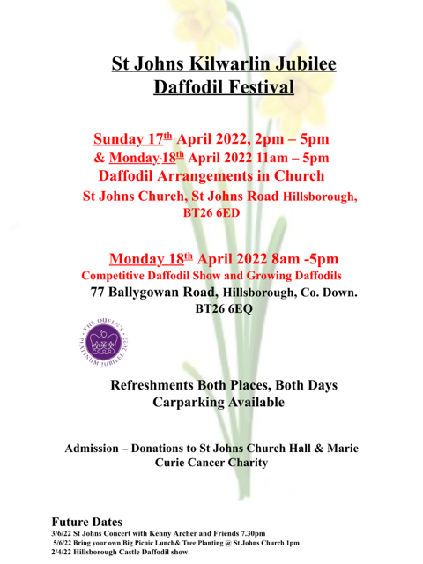

Parish Website: AnnahiltAndMagherahamlet.org
Parishioners are reminded that the website annahiltandmagherahamlet.org has been created to provide information on church related activities and organisations for parishioners and the wider community. Since the first lockdown began in March, a year ago, the website has hosted online services each Sunday. It also contains a list of upcoming church services and news from our group of parishes, as well as downloadable versions of the parish magazine. The site will be continually developed, so if you have any submissions, suggestions or requests relating to the website, these can be sent to admin@annahiltandmagherahamlet.org.



www.annahiltandmagherahamlet.org

Parish Magazine
Any contribution for the next edition of the Parish Magazine should be left with the Rector or Roger Maxwell (roger.maxwell1@btinternet.com) by Sunday 15 May 2022.

Registered as a charity with The Charity Commission for Northern Ireland
NIC103246 (Annahilt) and NIC102122 (Magherahamlet)
Top of Form

