News from the Parishes

Church of the Ascension, Annahilt Magherahamlet Parish Church
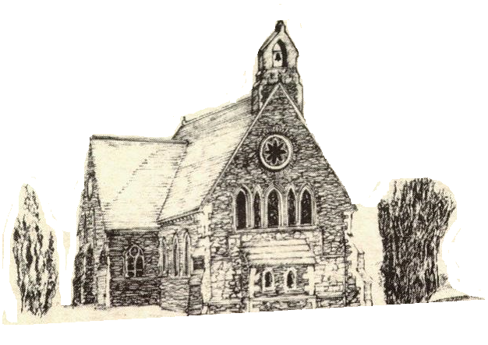

July and August 2021

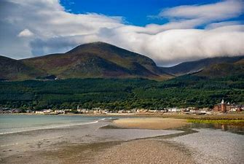

Rector: The Revd Canon Robert Howard
15 Ballykeel Road, Hillsborough
BT26 6NW
Tel: 028 9263 8218
E-mail: jrobert.howard@btinternet.com
Website: www.annahiltandmagherahamlet.org

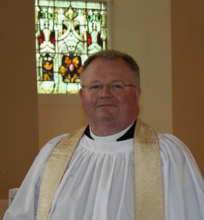
The Rector writes….

My dear Parishioners

As this combined July/August magazine goes to print, albeit somewhat later this year, the country continues to make its way cautiously out of lockdown. We see restrictions easing on different sectors of society and we are grateful in the first instance for the successful rolling out of the vaccination programme. Many of our parishioners have received one, if not both, of their vaccinations and this helps to give a sense of protection as we enter more fully into various activities again. The church, like many other organisations, has been working behind the scenes to prepare the ground for returning to face-to-face activities again. As we welcome back people to public worship we have continued to focus on people’s safety. We are all deeply grateful to our Churchwardens and other volunteers who continue to steward our arrival and departure from Sunday services. For the foreseeable future the pre-booking systems for the 10.00 am and 12.00 noon services to manage our numbers will continue so as to ensure we are maintaining social distancing.
In June we were able to honour our children, some of whom have been participating in Sunday School over much of the Lock Down periods by Zoom in a special Children’s Day Service and Prize-Giving. We are especially grateful to our dedicated teachers who moved beyond their comfort zone to make this possible and do everything to keep our children together during these difficult months. It’s exciting also this month to be able to record that 9 young people were confirmed and that in recent months 2 couples got married in church.
It has been particularly challenging for couples making their plans with all the changing restrictions and many over the past year have had to cancel or postpone their weddings because of the pandemic.
Over the coming weeks we hope to conduct further risk assessments and have conversations with our organisations and leaders about the best way forward in resuming these face-to-face activities. I am particularly grateful to our Health & Safety Officers and the Select Vestries as the Parishes’ trustees who have been vigilant in overseeing our governance and compliance with all the exacting regulations. We understand that people feel frustrated at not being able to meet together and that many are also feeling understandably cautious at the prospect of coming out again after shielding for such a considerable time. Many people are considering not only their own wellbeing but also the wellbeing of more vulnerable members of their families especially those with underlying health conditions. For this reason we have to be constantly vigilant and cautious and ensure that people’s safety remains our priority in recommencing activities.
Throughout this past 16 months there have been very strict regulations governing visitation in hospitals and nursing homes and clergy have not been allowed to visit, even in exceptional and extreme circumstances. For a time, these restrictions began to ease and we were allowed to visit by making arrangements with wards and nursing homes. Unfortunately in some of these, restrictions on parochial clergy visiting have recently been reimposed. Nevertheless, please don’t hesitate to get in touch if you want me to visit as I would be delighted to do so if permitted.
I have paid tribute before to our parishioners who have been so faithful in making phone calls to stay in touch with people throughout this difficult period. Please don’t allow those contacts to stop as they have been such a lifeline of support to many people. Parishioners have been so appreciative of the calls they have received from fellow members of different organisations and even having calls from people they didn’t know previously. These contacts have lifted the spirits and boosted morale through difficult times.
Technology has made a huge difference to so many through the recording of services and the opportunity to listen to services on the parish website. We owe a huge debt of gratitude to Colin Robinette, William Mathers and all who make these things possible for us. For now, we will endeavour to continue our present hybrid mixture of in-person worship and the ongoing provision of recorded services for those who are unwell or shielding for various reasons.
I hope that you are enjoying a good summer. Whether you are / have been away or are enjoying / have enjoyed some time off at home, I trust you will be refreshed and be able to reconnect with family and friends if that opportunity is there for you. Our In Church services are continuing on Sundays at 10.00 am and 12.00 noon over the summer months.

With very best wishes.

Your sincere friend and Rector

Robert Howard

Congratulations…

……to Mrs Evelyn Wightman, Magherahamlet, on the recent celebration of her 90th birthday. The Rector was pleased to call with Mrs Wightman at her home, where he presented her with a floral arrangement as a token of the congratulations and very best wishes of all in Magherahamlet Parish on attaining this milestone.

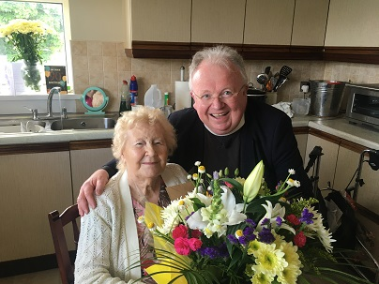

…..Mr & Mrs William McCoubrey, Magherahamlet, on the recent celebration of their Diamond Wedding Anniversary. On behalf of all in the Parish the Rector was delighted to mark this special event by calling at William and Tilly’s home and presenting them with an arrangement of flowers as a token of congratulations on this wonderful achievement and very best wishes for many more happy years together.

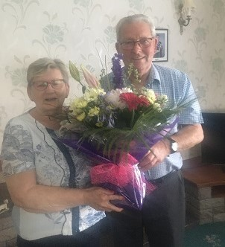

Children’s Day in Annahilt & Magherahamlet

This year’s annual Children’s Day Services took place on Sunday 13 June. On account of social distancing the Services took place in the respective Parochial Halls.
The Rector expressed his great pleasure that it was possible to hold a face to face Children’s Day Service this year. This had not been possible in 2020 on account of the Lock-down which was in force at that time. He congratulated the Sunday School teachers & young people who had met by Zoom during the period of restriction. He also expressed a general ‘thank you’ for the work of all the Sunday School teachers and everyone who assisted with Children’s Ministry in the Group of Parishes over the past year.
The customary Distribution of Sunday School Attendance & Church Loyalty Prizes also took place.

Christian Aid Walk for Water
Christian Aid was founded in 1945 when Christians wanted to offer relief and reconciliation in post-war Europe. From its early days Christian Aid has assisted people and communities on the basis of need, regardless of race and religion.
Today it is the official relief, development and advocacy agency of 41 sponsoring churches in Britain and Ireland, and it is part of the worldwide church community.
Christian Aid is self-evidently a Christian organisation. The board, appointed by the sponsoring churches, is trustee of the vision, purpose and values of Christian Aid, supplying a mandate to work for the eradication of poverty. The organisation is active in some of the world’s poorest countries.
This year Annahilt Mums went on a ‘Walk for Water’ during Christian Aid week. They walked 5k whilst carrying buckets of water to resemble what many women in the world have to do every day in order for their families to survive.

If anyone would like to support this cause, they can do so by leaving a donation in church or by posting/giving it to Louise McGregor or to the Annahilt Parochial Treasurer, Patricia Halliday. To date over £1400, including Gift Aid, has been raised.

Confirmation in Annahilt and Magherahamlet

On Sunday 20 June 2021 the Bishop, the Rt Revd David McClay administered the Rite of Confirmation in our Group of Parishes. In the exceptional circumstances of the current pandemic There was a Service in both the Church of the Ascension, Annahilt and Magherahamlet Parish Church. This facilitated the attendance of family and friends of the candidates as well as parishioners while maintaining social distancing. We are very grateful to the Bishop for his consideration in making this possible.
Both Services were very memorable and were appreciated by everyone present.

Please continue to remember the candidates for Confirmation in your prayers:

From Annahilt:

Rhys Ewing
Alana Jiandani
Joshua McKeown
Emily O Neill
Zara Saulters

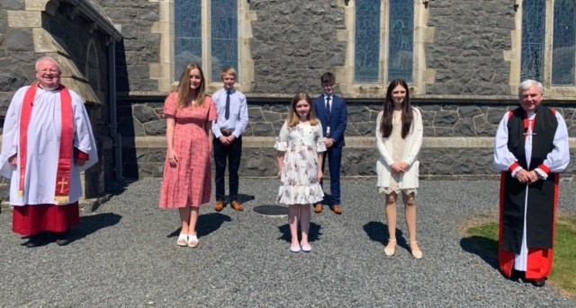

From Magherahamlet:

Charlotte Moore
Mark Stanford
Sarah Wightman
Jenny Wightman

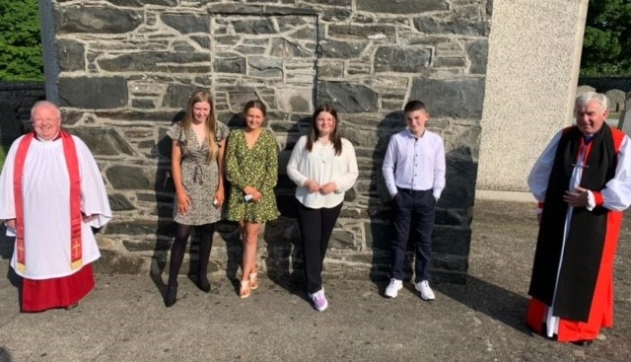

Bible Week

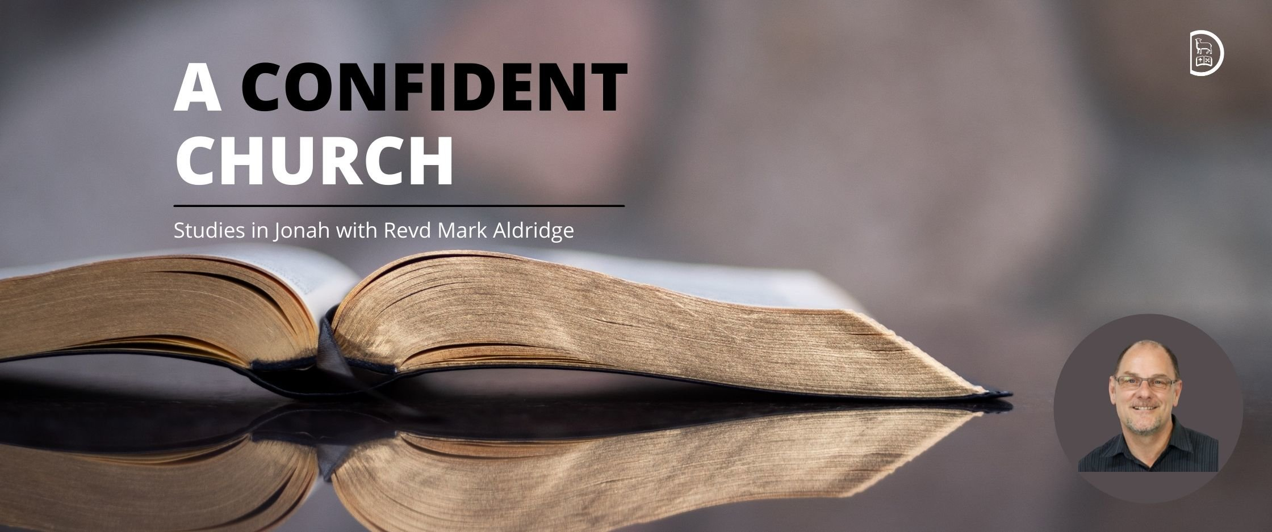

We’re looking forward to some excellent bible teaching, worship and ministry at this year’s Bible Week.
Our speaker is Revd Mark Aldridge, who will lead us in four studies in Jonah under the title ‘A Confident Church’. Mark is an Assistant National Leader for New Wine and Director of Church Leadership Development.
Tuesday 31 August (online and for Select Vestries only)
Running from the call of God (Jonah 1:1–2:7)
In–person at Shankill Parish Church, Lurgan
Wednesday 1 September
Grace, resurrection and a bolder confidence (Jonah 2:8–3:3)
Thursday 2 September
Confidence in the toughest places (Jonah 3:4–3:10)
Friday 3 September
Confidence in the compassion of God (Jonah 4:1–11)
Everyone is welcome to Shankill Parish Church on Wednesday, Thursday, and Friday nights. Each evening will also be shared live via social media.

Please plan to join us!
Church Services in the Parishes of Annahilt and Magherahamlet

‘I was glad when they said to me: “Let us go to the house of the Lord”’

Sunday 8 August Trinity X
10.00 Morning Prayer Annahilt
12.00 Morning Prayer Magherahamlet

Sunday 15 August Trinity XI
10.00 Parish Communion Annahilt
12.00 Morning Prayer Magherahamlet

Sunday 22 August Trinity XII
10.00 Morning Prayer Annahilt
12.00 Morning Prayer Magherahamlet

Sunday 29 August Trinity XIII
10.00 Morning Prayer & Litany Annahilt
12.00 Morning Prayer & Litany Magherahamlet

Sunday 5 September Trinity XIV
10.00 Parish Communion Annahilt
12.00 Parish Communion Magherahamlet

Sunday 12 September Trinity XV
10.00 Family Service Annahilt
12.00 Family Service Magherahamlet

In-Church Worship in the Church of the Ascension, Annahilt and Magherahamlet Parish Church

Numbers are reduced at Services in both Churches because of the legal requirement to facilitate safe distancing. Because of this, it would be very helpful if those intending to come to church would give notice of their intentions.
Annahilt
Trevor Hill trevorhill111@btinternet.com
Magherahamlet
Hillary Edgar hillary.edgar01@btinternet.com

Alternatively, you may contact by telephone:
Annahilt
Trevor Hill 07890552930
Magherahamlet
George & Sally McCurry 028 9756 3955
Hillary Edgar 028 4481 1361

For Annahilt, notification of attendance can also be given via the Parish website up to the Friday before.

Sunday School…

….We hope to resume face-to face meetings of the Sunday Schools in both Parishes on Sunday 5 September. There will be further notification nearer the time.
PRAYER WARRIOR
Do you have a concern or problem and would like someone to pray for you? If so, contact the Rector who will be willing to help. This is completely confidential and no details will be passed onto anyone else unless you want them to. Telephone: 028 9263 8218

General Prayers

Heavenly Father, as I come before you in prayer,
I give you thanks for the gift of my life, and for all those good things I have received in it.
I offer you all that is broken within me and within my relationships, and ask for your healing.
I hold before you all those people I know who are suffering and in need today.
I ask you to bless my community and all those who care for others.
I place into your eternal arms all those I love who have died.
O Lord, you hear the voice of all people, and your ears are open to our calling.
Receive all the prayers of my heart,
and be with me each day as I continue my journey of life.
Amen.

Almighty God, whose Blessed Son Jesus Christ went about doing good, and healing all manner of sickness and disease
among the people, continue in our hospitals his gracious work among us; console and heal the sick; grant to the physicians, nurses, and assisting staff wisdom and skill, diligence and patience; prosper their work, O Lord, and send down your blessing upon all who serve the suffering; through Jesus Christ our Lord.
Amen.

Lord, thank you for the small businesses in our communities, for the hard work, the blood, sweat, and tears that have gone into them. For many, their businesses are not just shops or companies, they are the fabric of their lives and the lives of their loved ones. We pray God that You will guide these small business owners and provide for their families during this difficult and uncertain time.
Amen.
Magherahamlet Parochial Hall Cleaning

The ‘spring clean’ of the Parochial Hall would normally be arranged at this time of year but in present circumstances has been postponed. We hope to arrange the work day when it becomes clearer that we are in a position to resume parochial activities

Clergy Emergency Cover
During the period when the Rector is on holiday, please contact one of the following who will advise you of the Clergyperson answering emergency calls:
Trevor Hill (Rector’s Churchwarden, Annahilt) 07890 552930
Dr David Keith (People’s Churchwarden, Annahilt) 028 9263 8352
Colin Hassard (Honorary Secretary, Annahilt Vestry) 028 9263 8263
Mrs Avril McKeown (Graveyard Secretary, Annahilt) 07801 449244
Miss Virginia Begley (Rector’s Churchwarden, Magherahamlet) 028 9756 3489
George McCurry (Rector’s Glebewarden, Magherahamlet) 028 9756 3955
Larry Fryers (People’s Churchwarden, Magherahamlet)
Ms Abbie Stanford (Hon Secretary, Magherahamlet Vestry) 07753 746940

Flowers for the Churches

Annahilt Magherahamlet


August

1 Mrs J Bradford Miss V Begley
8
15 Mr & Mrs R Carlisle
22 Mrs A Edgar
29

Church Cleaning, Annahilt

Aug
13-14 Mrs E Ogle
20-21 Mrs L McCambley Mrs E Harrison
27-28 Mrs H Hill Mr T Hill

Sept
3-4 Mrs E Crawford Mrs M Finlay
10-11 Mrs A Patterson
17-18 Mrs J Bolas Mr A Bolas
24-25 Mrs A Maxwell Mr R Maxwell

Oct
1-2 Mrs J Guiney Mrs H Cardosi

Training for Sunday School Teachers

As we think ahead to the new autumn term, Julie Currie, the diocesan Children’s Development Officer has scheduled two training events for existing and new Sunday school teachers and creche leaders:

- Tuesday 24 August from 7.30 pm–9.00 pm in Seapatrick Parish, Banbridge
- Wednesday 25 August from 7.30 pm–9.00 pm in St Mark’s Dundela

These training evenings will be in–person and offer practical advice, ideas and resources for starting back to Sunday school and creche in September. Not to be missed!

Please contact Julie for more information: julie@downanddromore.org


Dear Mothers’ Union Members and Friends,
We sincerely hope that you are all keeping safe and well and are enjoying the beautiful sunshine that God has blessed us with at this time. The warmth of the sun helps us to relax, cheers us and instils in us a sense of peace and wellbeing. Some of you may have come across a poem written way back in 1885 by Robert Louis Stevenson entitled “Summer Sun”. Here is what it says –

Great is the sun, and wide he goes
Through empty heaven with repose;
And in the blue and glowing days
More thick than rain he showers his rays.

Though closer still the blinds we pull
To keep the shady parlour cool,
Yet he will find a chink or two
To slip his golden fingers through.

The dusty attic spider- clad
He, through the keyhole, maketh glad;
And through the broken edge of tiles
Into the laddered hayloft smiles.

Meantime his golden face around
He bares to all the garden ground,
And sheds a warm and glittering look
Among the ivy’s inmost nook.

Above the hills, along the blue,
Round the bright air with footing true,
To please the child, to paint the rose,
The gardener of the World, he goes.

To bring us back to the present day, the results of the Mother’s Union Hymn Writing Competition have been announced and the overall winner is Yvonne Woods, Milltown MU, Armagh Diocese. She has written “Come unto me”- It is a really beautiful hymn-

Come unto me, I am the door
Our faithful Lord did say
We can go in, and pastures find-
He is the only way.

I am the way, the truth ,the life
God calls us, let us hear-
So we might know of his great love;
To trust and not to fear.

His Peace is like a calming stream-
And faithfulness is sure,
His grace and love and mercy great;
As long as life endures

From darkness into glorious light
Whoever follows him,
His life he gave that we might live;
To rescue us from sin.

So let us now, all with one voice –
Sing praises to our King,
The hills and valleys shout for joy;
Our thanks to God we bring.

We wish you all a very pleasant and relaxing summer break and promise to keep in touch to pass on any news or important correspondence.
With Love and Best Wishes to all.

Beth Avril
Esme Anne

Mothers’ Union—Midday Prayers— August 2021
Rebuilding hope and confidence
Praying with purpose

Monday: Praying with purpose
We take a moment in the quiet to focus on our various prayer needs and make ready to bring them to God.
Jesus said:
Ask and keep on asking and it will be given to you; seek and keep on seeking and you will find; knock and keep on knocking and the door will be opened to you.
Matthew 7:7-8 (AMP)

With faith and trust we ask: We keep on asking for the needs we have or for those who are too weak to pray.
With prayerful purpose we seek:
We keep on seeking the answers we long for to find the way ahead.
With hope and confidence we knock:
We keep on knocking on heaven’s door to open the resources we need. With faith and trust we bring our prayers, trusting in God’s readiness to hear and his power to answer.
Amen.

Tuesday: Praying with thanksgiving
We take a moment in the quiet to remember our reasons for gratitude and make ready to pray with thanks to God.
Do not be anxious about anything, but in every situation, by prayer and petition, with thanksgiving, present your requests to God.
Philippians 4:6

With faith and hope we bring our prayers to God; we enter his presence with joy.
Praise be to God, who never discounts my prayer or withholds his steadfast love from me! May we cherish these times: Precious moments with God to pour out our hearts and listen for his reply. Praise be to God, who always listens to our prayers and lavishes his steadfast love on us! With joy and praise we bring our prayers to God; we enter his presence with faith.
Praise be to God for the privilege of drawing near to him in prayer.
Amen.

Wednesday: Praying in steps
We take a moment in the quiet to focus on our prayer requests and make ready to take our first step in prayer.
Jesus said:
If you have faith as small as a mustard seed, you can say to this mountain,
“Move from here to there,” and it will move.
Nothing will be impossible for you.
Matthew 17:20

God of miracles bless our tiny steps in prayer that mountains may be moved.
Almighty and loving God, take our faith, weak though it is. Kindle the sparks of life within us and fan a new flame within our hearts. We set out on our journey in prayer, with each step strengthening our faith to continue to ask for the answers we seek from our powerful, generous God.
God of miracles take our tiny steps of prayer and use them to bless your world.
Amen.

Thursday: Praying creatively
We take a moment in the quiet to thank God for his inspiration and make ready to engage creatively in prayer.
May my prayer be set before you like incense; may the lifting up of my hands be like the evening sacrifice.
Psalm 141:1-2
May our prayers to God be as incense as our intercessions rise heavenward. May the lifting of our hands be an offering of praise as we linger in your presence.
Lord, you keep the lamp of my life burning brightly.
Psalm 18:28
By the lighting of a candle I am reminded to be your lamp in this dark world.
I am reminded to share your warmth with others.
I am reminded of lights that have gone before.
I am reminded of lights that even now grow dim.
I am reminded to bring my prayerful offering.
I am reminded to go from this place in joy.
Amen.

Friday: Praying with others
We take a moment in the quiet to give thanks for our unity and make ready to pray together to God.
If two of you on earth agree about anything they ask for, it will be done for them by my Father in heaven.
Where two or three come together in my name, I am there with them.
Matthew 18:19-20

Loving Lord, we thank you for the joy of coming together into your presence; to petition and plead in unity and faith.
In unity and faith, as the family of God, we offer you our prayers. We thank you for the joy of finding our numbers are swelled by the company of the Holy Spirit, who shows us how to pray and adds his prayers to ours. Through the prompting of the Spirit, as the family of God, we offer you our prayers.
Amen.

Saturday: Praying as Jesus taught
We take a moment in the quiet to give thanks for Christ’s example and make ready to pray as he showed us. One day Jesus was praying in a certain place.
When he finished, one of his disciples said to him,
“Lord, teach us to pray.”
Luke 11:1

Lord God, like the disciples we ask, teach us how to pray. Teach us the secret of prayer – when to speak and when to keep silent, when to accept and when to go on seeking, when to persevere and when to let go, teach us how to pray.
Teach us the power of prayer – its ability to challenge, to encourage, to transform all life, teach us how to pray. Teach us the joy of prayer - to express our worship, discover your will, and hear your voice.
In the name of Christ.
Amen.

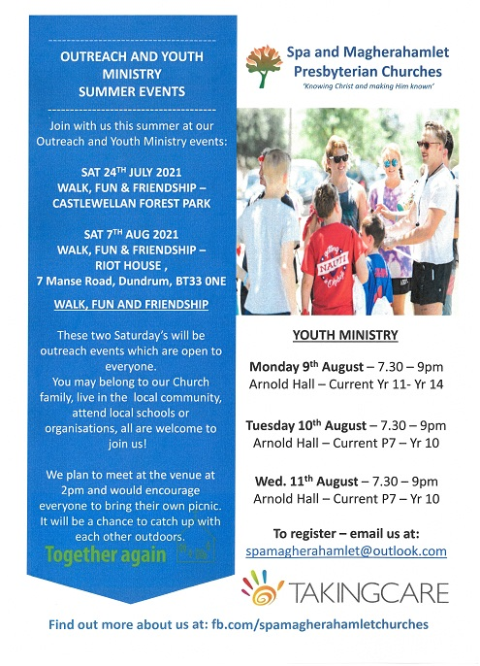

LISBURN FOODBANK

The Lisburn Foodbank is providing an essential service to those within our community who are experiencing difficult times, often due to circumstances beyond their control.

The Foodbank provides emergency food and support to local people in crisis in the Lisburn area.
Parishioners may leave items for the Foodbank in the basket in Annahilt Church Porch, on the FIRST and SECOND Sunday of each month.
A particular request from the Foodbank is for items listed below:

Toiletries
Small boxes of washing powder
Cleaning Supplies
Toilet Rolls (2 or 4)
Baby wipes
Nappies

The Lisburn Foodbank is providing an essential service to those within our community who are experiencing difficult times, often due to circumstances beyond their control.

YOUR HELP WOULD BE GREATLY APPRECIATED.

Freewill Offering
The Parish Treasurers would like to thank those Parishioners who responded to previous invitations to arrange a standing order, make a direct bank payment to the Parish or post a cheque to the Treasurer in lieu of their weekly envelopes during the current emergency.
If you have not yet availed of one of these methods of temporary giving and would wish to do so please contact:
Annahilt – Miss Patricia Halliday Email patriciaapc@btinternet.com Telephone 028 9266 5310 Mobile 07713 257691
Magherahamlet – Hillary Edgar Email: hillary.edgar01@btinternet.com Telephone 028 4481 1361

Parish Website: AnnahiltAndMagherahamlet.org
Parishioners are reminded that the website annahiltandmagherahamlet.org has been created to provide information on church related activities and organisations for parishioners and the wider community. Since the first lockdown began in March, more a year ago, the website has hosted online services each Sunday. It also contains a list of upcoming church services and news from our group of parishes, as well as downloadable versions of the parish magazine. The site will be continually developed, so if you have any submissions, suggestions or requests relating to the website, these can be sent to admin@annahiltandmagherahamlet.org.



www.annahiltandmagherahamlet.org

Parish Magazine
Any contribution for the next edition of the Parish Magazine should be left with the Rector or Roger Maxwell (roger.maxwell1@btinternet.com) by Sunday 22 August 2021.

Registered as a charity with The Charity Commission for Northern Ireland
NIC103246 (Annahilt) and NIC102122 (Magherahamlet)
Top of Form

